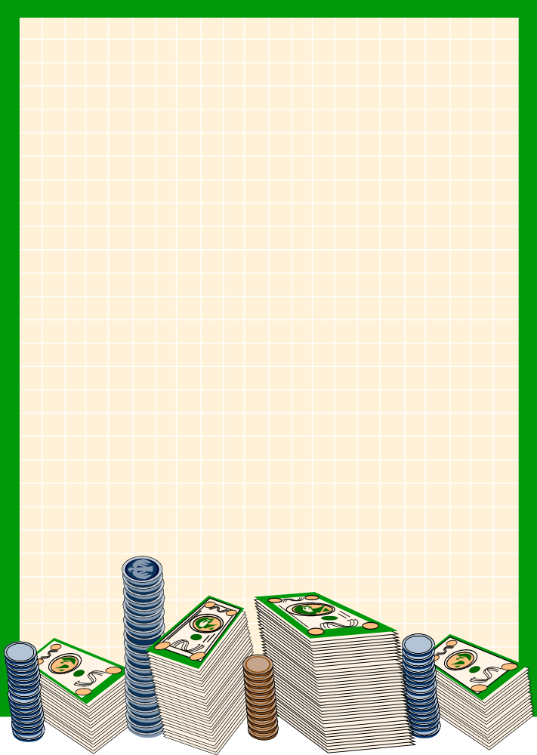Program 213v
(checking it out)

Program Description: Write a program that maintains a checkbook register and reports a summary of the current months transactions. An external file provides the following information. The first number in the file is the beginning balance of the account. The beginning balance is followed by sets of transactions (character-number). The valid characters are C(check), D(deposit) and S(service charge). The character E represents the end of data and should not be processed.

Deposits are automatically added to the account balance. Checks are subtracted from the balance if there is enough money in the account to cover the check, otherwise the check is not processed but the account is charged $10.00 for "insufficient funds". Service charges are automatically subtracted from the account. Any other transaction code is output as an "illegal transaction code" and the balance is unaffected.

In addition to maintaining the running balance of the account, a summary report of the Deposits and Withdrawals (checks, insufficient funds, and service charges) is to be maintained and printed.

Data Location: prog213v.dat

Statements Required: input, output, loop control, decision making

Sample Output:

Transaction Amount Balance
Beginning Balance 20.05 20.05
Check 15.00 5.05
Deposit 100.00 105.05
Insufficient Funds 10.00 95.05
Illegal Transaction Code
Service Charge 5.00 90.05
=========================================================
Account Summary
Number Amount
Beginning Balance 20.05
Plus Deposits 1 100.00
Less Withdrawals 3 30.00
Ending Balance 90.05
=========================================================

