Program 213x
(penitentiary employment)

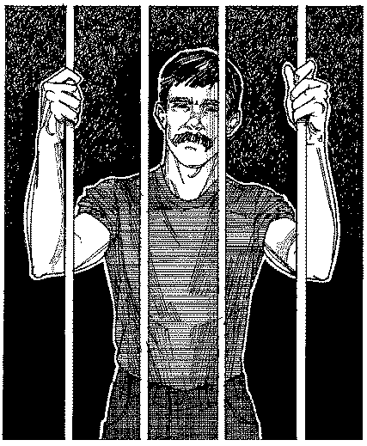
Program Description: In many states, license plates contain three letters and three numbers, e.g., UBK 878. Naturally, license plates are manufactured in sequence, starting with AAA 000, AAA 001, and going to AAB 000, and eventually ZZZ 999. Write a program that takes as input a license plate’s letters and numbers, and then outputs the contents of the next plate to be manufactured.

Required Statements: input, output, decision-making

Sample Output:

LAST TAG NUMBER: AAZ999
THE NEXT TAG IN SEQUENCE IS ABA0

LAST TAG NUMBER: AAA0
THE NEXT TAG IN SEQUENCE IS AAA1

LAST TAG NUMBER: ZZZ999
ALL DIGITS AND LETTERS HAVE BEEN USED AAA0


LAST TAG NUMBER: ABA100
AAA 101

THE NEXT TAG IN SEQUENCE IS ABA101
ABA 100
ZZZ 999

