
Program 428a
(very busy jailer)

Program Description: A king once decided to grant amnesty to some of his prisoners due to lack of jail space rather than build a new prison. He instructed his jailer to carryout the following procedure to determine which prisoners were to be set free. The jailer was to first unlock each of the 1000 cells. Then starting with the 2nd cell (number 2), he turned the key in every 2nd cell. Then starting with the 3rd cell he turned the key in every 3rd cell; then starting the 4th, he turned the key in every 4th cell, etc. Each turn of the key either locked or unlocked the cell door. When he was completely done those with the unlocked doors could leave. Who were the lucky ones?

Statements Required: input, output, loop control, decision making, loop control
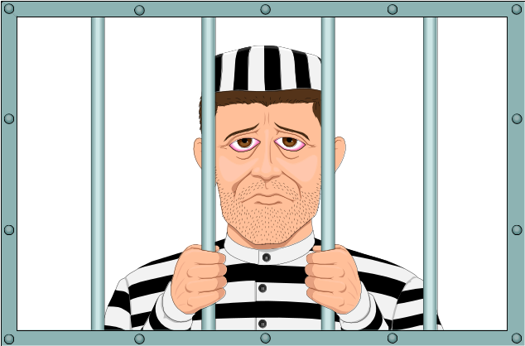

Sample Output:

The free prisoners are
1 4 9 16 25
36 49 64 81 100
121 144 169 196 225
256 289 324 361 400
441 404 529 576 625
676 729 734 841 900
961
or--all the prisoners are free because they stormed the
jailer when he first unlocked the doors!

