Program 433b
(roman numerals)

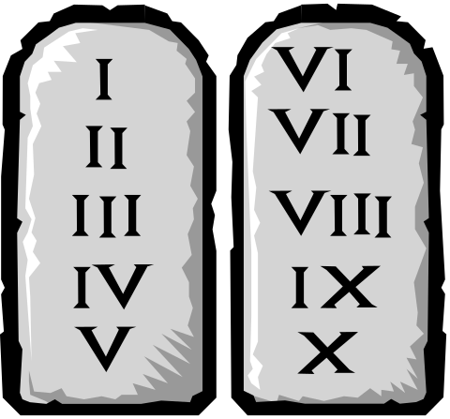Program Description: Write a function Roman that takes a character array containing Roman numerals and returns the corresponding decimal value. The valid characters that may appear in the Roman numeral are:

Roman Decimal
I 1
V 5
X 10
L 50
C 100
D 500
M 1000

Data Location: prog433b.dat

Statements Required: input, output, loop control, decision making, array

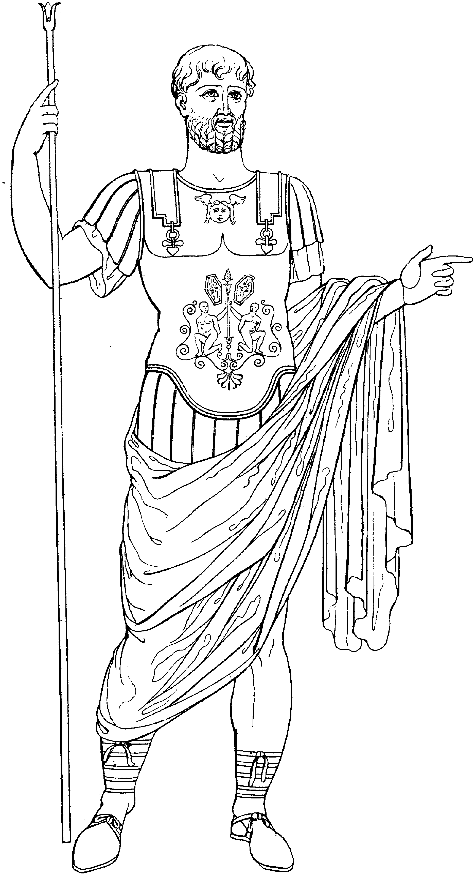
Sample Output:

Roman Numeral: CCLIX
Decimal Equivalent: 259

Roman Numeral: IV
Decimal Equivalent: 4

Roman Numeral: MCMLXXXIII
Decimal Equivalent: 1983

Roman Numeral: MXXI
Decimal Equivalent: 1021

Roman Numeral: DXXI
Decimal Equivalent: 521

Roman Numeral: MCMXCIV
Decimal Equivalent: 1994

