Program 505c
(in between)

Program Description: Write a program that will read words from an external file and determines if the word falls between dinosaur and walrus in the dictionary. Print out the word and either “between” or “not between”. Continue processing the words until end of file is reached.

Required Statements: external file input, output, character array, loop control, decision making

Data location: prog505c.dat
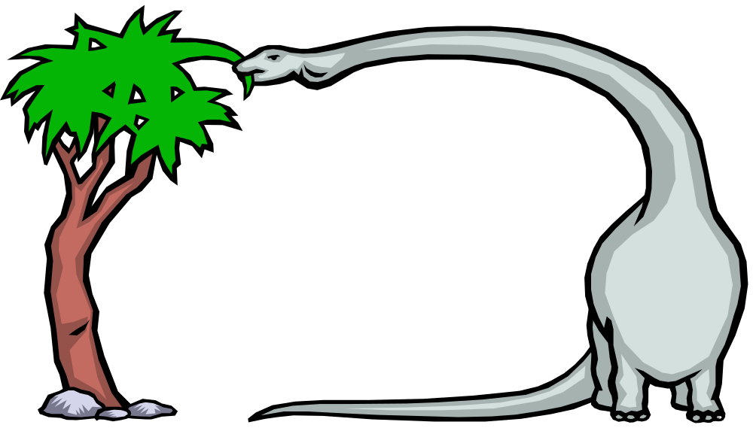

Sample Output:

Vampire between
Monkay between
Elephant between
Ape not between
Lion between
Hippopotamus between
Ant not between
Zebra not between
Yak not between
Antelope not between
Dingo not between
Whale not between

