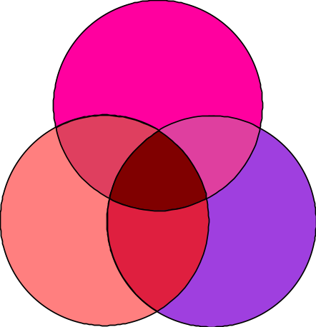Program 54c
(circles)

Program Description: Write a program to print out the radius, area, and circumference of a circle. The radius of the circle is to be stored in a variable called Radius. Use a constant definition to store the value of Π (3.14159). The circumference of a circle is calculated by the formula: Circumference = 2ΠR. Format the output to three decimal places.

Statements required: Input, Output

Sample Output:

The Radius of the circle = 3.712
The Area of the circle = 41.337
The Circumference of the circle = 22.272

