Program 58h
(computing interest)

Program Description: Have the computer calculate how much interest you could earn on a savings account for a specific amount at a specific rate for a specified time. Run your program three times using the following test data:

Amount Rate Time
5,000 11 1/2% 30 months
10,000 16 1/2% 90 days
1500 8 1/2% 1 year

The formula for calculating interest is as follows: (A is the amount, r is the rate of interest in percent, n is the number of days compounded per year, t is the number of days the money is to be kept in the savings account and p is the amount originally saved.

Use the equation:
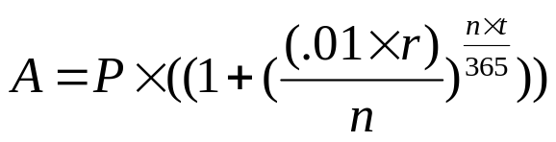
Special Problems: Exponents

Statements Required: input, output, assignment.

Sample Output:

Amount Saved 5000
Interest rate? 11.5
Number of times compounded per year? 365
Number of days at interest? 900

The interest earned is $1638.96
The total amount in savings is now $6638.96

Amount Saved 10000
Interest rate? 16.5
Number of times compounded per year? 365
Number of days at interest? 90

The interest earned is $415.14
The total amount in savings is now $10415.14

Amount Saved 1500
Interest rate? 8.5
Number of times compounded per year? 365
Number of days at interest? 365

The interest earned is $133.06
The total amount in savings is now $1633.06

