Program 58i
(monthly payment)
Program Description: The object of this program is to generate the facts about a loan for a particular amount to be borrowed at a specific rate and time. We want to compare these car loans:

$7500 for 3 years at 14.5%
$7500 for 4 years at 14.5%
$7500 for 3 years at 7.5%

The program should print out three lines for each loan, giving the amount of monthly payments, the interest paid over the life of the loans, and the total amount paid back over the life of the loan, with appropriate wording.

Processing: The monthly payment (MP) can be calculated using the following formula:
Where P is the amount borrowed, R is the rate in percent, M is time in months. The total interest would be the sum of all the payments less the amount borrowed. The total amount repaid would be the sum of all the payments. Round all dollars to the nearest cent.
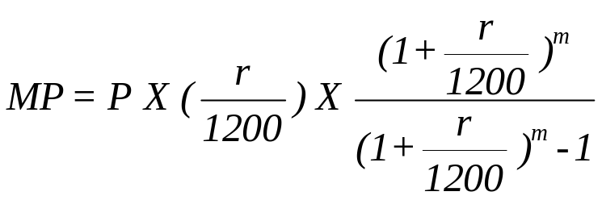

Required Statements: input, output

Sample Output:
The amount I wish to borrow is? 7500
The loan rate I can get is? 14.5
The number of months it will take me to pay off the loan is? 36

My monthly payments will be $ 258.16
Total Interest Paid is $ 1793.66
Total Amount paid is $ 9293.66

The amount I wish to borrow is? 7500
The loan rate I can get is? 14.5
The number of months it will take me to pay off the loan is? 48

My monthly payments will be $ 206.83
Total Interest Paid is $ 2428.06
Total Amount paid is $ 9928.06

The amount I wish to borrow is? 7500
The loan rate I can get is? 7.5
The number of months it will take me to pay off the loan is? 36

My monthly payments will be $ 233.30
Total Interest Paid is $ 898.68
Total Amount paid is $ 8398.68

