Program 602a
(greatest common divisor)

Program Description: You are to write a Class to find the greatest common divisor of two numbers.

Examples: The GCD of 8 and 30 is 2
The GCD of 8 and 24 is 8
The GCD of 18 and 37 is 1

The GCD of two numbers is the largest number that will go into each exactly. Process the data from an external file. Each line of data has exactly two integer values.

Read in two numbers, say A and B. Make A the larger of the two. Subtract B from A. If A is equal to zero, then B is the GCD. Otherwise, rearrange A and B and start over again

For example: A = 8 and B = 30

1. Make sure A is the larger of the two A = 30 B = 8 A = 12 B = 8 A = 8 B = 4
2. Find the difference and reassign it to A A = 12 A = 4 A = 4
3. If A is not equal to 0 repeat step one A = 12 A = 4 A = 4

A = 4 B=4
A = 0
B is the GCD

Data Location: prog280a.dat

Statements Required: output, loop control, decision making, class

Sample Output:
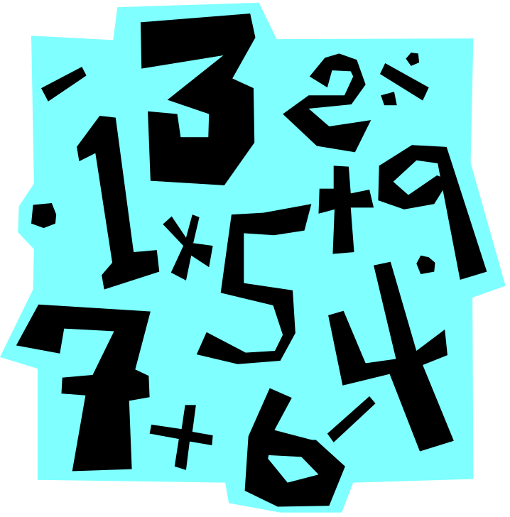
The GCD of 25 and 10 is 5
The GCD of 81 and 41 is 1
The GCD of 255 and 138 is 3
The GCD of 847 and 624 is 1
The GCD of 84 and 420 is 84
The GCD of 182 and 637 is 91
The GCD of 620 and 420 is 20
The GCD of 36 and 24 is 12
The GCD of 75 and 125 is 25
The GCD of 1 and 17 is 1

