Program 610a
(Heron's formula)

Program Description: You are to read an external file, with a lead value indicating the number of triangles to be evaluated followed by the three sides of a triangle. Your program will print out the sides and the area of the triangle using Heron's Formula. If a triangle cannot be formed you should output the sides and the message "this is not a triangle".

Heron's Formula is: If a, b, and c are the three sides of a triangle, and s = (a + b + c) / 2 then the area of the triangle will be:
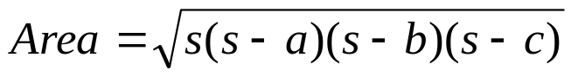

Data Location: prog206a.dat

Required Statements: input, output, loop control, decision making, class

Sample output:

A B C AREA
7 8 9 26.8328
9 9 12 40.2492
6 5 21 This is not a triangle
24 7 25 84.0000
13 12 5 30.0000
50 40 30 600.0000
10 10 10 43.3013
82 34 48 This is not a triangle
4 5 6 6.4807



