Program 615t
(Locker Search)

Program Description: There are 1000 lockers in a school. There are 1000 students outside the school. The first student goes into the school and visits every locker and opens it. The second student goes into the school and closes every locker that is a multiple of two. The third student goes into the school and visits every locker that is a multiple of three. If the locker is open he/she closes it, if the locker is closed he/she opens it. The fourth student goes into the school and visits every locker that is a multiple of four. Again if the locker is open he/she closes it, if the locker is closed he/she opens it. This continues until all 1000 students have gone into the school and gone to the appropriate lockers.

Write a program that will determine and display the status of each locker after all of the students have gone into the school.

If each student who goes into the school places a quarter into each locker he/she visits, which locker will have the most money deposited into it? What is the total amount of money that will be placed into all of the lockers? Output a list of all of the lockers listed in decreasing order of the amount of money in each.

Required Statements: loop control, decision making, array, class

Sample Output:

The lockers in order are:

Locker #840 8 Locker #720 7.5 Locker #960 7
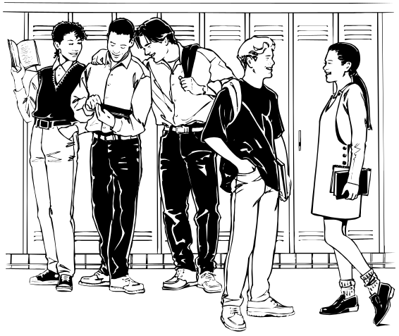
Locker #900 6.75 Locker #360 6 Locker #420 6
Locker #480 6 Locker #504 6 Locker #540 6
Locker #600 6 Locker #630 6 Locker #660 6
Locker #672 6 Locker #756 6 Locker #780 6
Locker #792 6 Locker #864 6 Locker #924 6
Locker #936 6 Locker #990 6 Locker #576 5.25
Locker #240 5 Locker #336 5 Locker #432 5
Locker #528 5 Locker #560 5 Locker #624 5
Locker #648 5 Locker #810 5 Locker #816 5
Locker #880 5 Locker #912 5 Locker #180 4.5

output omited to reduce size to one page

Locker #919 0.5 Locker #929 0.5 Locker #937 0.5
Locker #941 0.5 Locker #947 0.5 Locker #953 0.5
Locker #967 0.5 Locker #971 0.5 Locker #977 0.5
Locker #983 0.5 Locker #991 0.5 Locker #997 0.5
Locker #1 0.25

