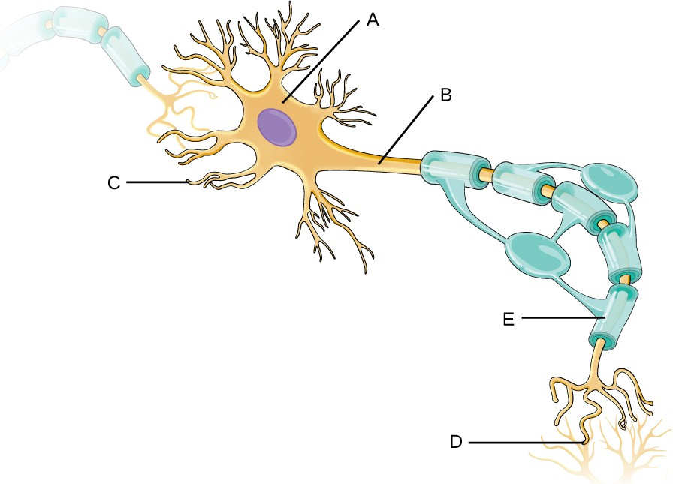
Program 7300p
(Perceptron Logic Gates)

Program Description: Write a program that trains Perceptrons (Artificial Neuron or Single-layer Neural Network) to recognize the following logical gates (one neuron per gate):
- AND
- OR
- NOT
- NAND
- NOR

For each training cycle (epoch), report the epoch number and the loss. After training, run a prediction on each gate and compare the predicted output to the actual labels; also report the weights and bias of each neuron. Try a learning rate between [0.0001, 0.1] and [10, 50] epochs; keep the number of epochs as low as possible until the loss reaches (at least close to) 0. You may need to refer to the truth tables for the various gates to help define the datasets. Make sure the output of the neuron exactly matches the expected labels!

Note the absence of XOR and XNOR gates. XOR and XNOR require a combination of logic gates (OR, NAND, AND, and NOR, OR, AND, respectively) to be wired together; this is not possible with the Perceptron because the output is not linearly separable. It would thus require a Multilayer Perceptron, also known as an Artificial Neural Network.

The dataset for the AND gate is provided:

double[][] X_train = {
{0, 0},
{0, 1},
{1, 0},
{1, 1}
};
double[] y_train = {0, 0, 0, 1};

Required Statements: input, output, class, decision making, loop control

Sample Output:

AND Neuron:

Epoch 1: Loss: 0.75

Epoch 2: Loss: 1.0

Epoch 3: Loss: 0.75

Epoch 4: Loss: 0.75

Epoch 5: Loss: 0.75

Epoch 6: Loss: 0.75

Epoch 7: Loss: 0.75

Epoch 8: Loss: 0.75

Epoch 9: Loss: 0.25

Epoch 10: Loss: 0.0

Prediction: [0.0, 0.0, 0.0, 1.0]

Actual: [0.0, 0.0, 0.0, 1.0]

Weights: [0.1552852178659986, 0.12261418671691832]

Bias: -0.19999999999999987

