**Program 54a**

**(miles per gallon)**

**Program Description:** Using the following data, calculate and print out the average miles per gallon for each vehicle. Round the output to the nearest 10th gallon. Be sure to use variables with easily recognizable names.

Vehicle Miles Gallons

1970 VW Bug 286 9

1979 Firebird 412 40

1980 Subaru 361 18

1975 Cutlass 161 11

**Statements Required:** Assignment, Cout, Endl

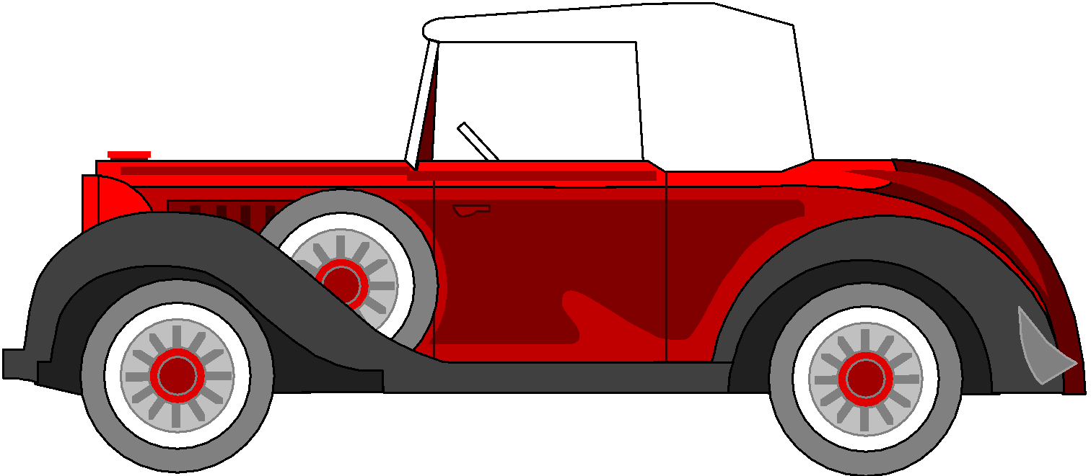

**Sample Output:**

Kansas City Grand Prix

Miles/Per Gallon

1970 VW Bug averaged 31.8 m/g

1979 Firebird averaged 10.3 m/g

1980 Subaru averaged 20.1 m/g

1975 Cutlass averaged 14.6 m/g