Program 505T

(cows and horses)

**Program Description:**

* Read from the data file, the first number of the data file will represent the number of **hay bales** the farm currently has. It is followed by the cost of each hay bale.
* The next number is the number of **corncobs** the farm has, followed by the cost of each corncob.
* The data file will then provide the number of **cows** that are stored in the data file. Each cow has a weight, followed by pounds of milk produced per day, followed by the number of hay bales eaten each day per cow, followed by a number of corncobs eaten each day per cow.
* The next set of data will have an int for the number of **horses**. Their weight comes next. This will be followed by the number of hay bales eaten each day, followed by the number of corncobs eaten each day, followed by the number of rides that horse gave and the cost per ride for that horse.
* Complete the farm, horse and cow classes - be sure to create constructors for each of the classes.
  + The program should report the income of the day,
  + Report the cost of feeding the animals for a day
  + report the cumulative weight of all animals.
  + It should determine if there is enough food to feed all the animals, if so, feed all the animals and report how many bales of hay and cobs of corn are left in the barn. If there is not enough food for ALL the animals, none of the animals get fed ☹ - report that there is insufficient food to feed the animals and request an immediate shipment of hay and corn for the amount of needed of each.

o Sell off the 3 cows that generate the lowest amount of milk.

o Sell off the two horses that generate the lowest amount of ride income.

o Change the first cow. The cow has a weight of 1250, followed by 80 pounds of milk produced per day, followed by the number of 3 hay bales eaten each day, followed by 4 corncobs eaten each day.

o Report the total number of cows and horses on the farm.

* A pound of milk sells for $0.20.

**Statements Required**: input, output, loop control, arrays, classes

**Data Location prog505t.dat**

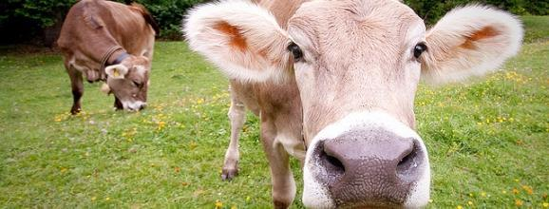

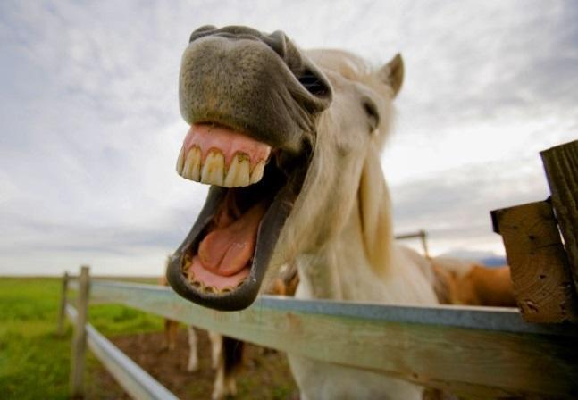

**public interface IFarm** {

/** Feeds all cows where farm has enough food */

private boolean feedCows() { return false; }

/** Feeds all horses where farm has enough food */

private boolean feedHorses() { return false; }

/** Feeds all cows and horses where farm has enough food */

public boolean feedAllAnimals();

/** Calculates the value of the milk produced by the

* cows price for each cow's milk is the same per pound */

private double cowIncome(double perPound) { return 0; }

/** Calculates the value of the rides given by the horses

* ride value of each horse changes based on the horse */

private double horseIncome() { return 0; }

/** Calculates the daily income of the farm */

public double farmIncome();

/** Calculates the total weight of all the farm animals */

public int getWeight();

/** Calculates the amount of money it will

* take to feed the animals for the day */

public double getCost();

/** Returns the cows in an ArrayList */

public ArrayList<Cow> getCows();

/** Returns the horses in an ArrayList */

public ArrayList<Horse> getHorses();

}

**public class Farm implements IFarm** {

private ArrayList<Horse> myHorses;

private ArrayList<Cow> myCows;

private int myNumHayBales;

private int myNumCorn;

private double myHayCost;

private double myCornCost;

// …

}

**~~OLD:~~**

**~~public class Farm // classes for 505t (cows and horses)~~**

~~{~~

~~private ArrayList<horses> myHorses;~~

~~private ArrayList<cows> myCows;~~

~~private int myHayBales;~~

~~private int myCorn;~~

~~private double myHayCost;~~

~~private double myCornCost;~~

~~….~~

~~// feeds all cows where farm has enough food (amount stored in barn decreases)~~

~~private boolean feedCows()~~

~~//feeds all horses where farm has enough food (amount stored in barn decreases)~~

~~private boolean feedHorses()~~

~~//feeds all cows and horses where farm has enough food~~

~~public boolean feedAllAnimals()~~

~~// calculates the value of the milk produced by the cows~~

~~//price for each cow’s milk is the same per pound~~

~~private double cowIncome(double perPound)~~

~~// calculates the value of the rides given by the horses~~

~~//ride value of each horse changes based on the horse~~

~~private double horseIncome()~~

~~//calculates the daily income of the farm~~

~~public double farmIncome(perPound)~~

~~//calculates the total weight of all of the farm animals~~

~~public int getWeight()~~

~~//calculates the amount of money it will take to feed the animals for the day~~

~~public double getCost()~~

~~//returns all of the cows on the farm~~

~~public ArrayList<Cows> getCows()~~

~~//returns all of the horses on the farm~~

~~public ArrayList<Horses> getHorses()~~

~~}~~

**~~public class Cows~~**

~~{~~

~~private int myWeight;~~

~~private int myMilk;~~

~~private int myCorn;~~

~~private int myNumBales;~~

~~//Returns the weight of the cow~~

~~public int getWeight()~~

~~//returns the value of the milk produced~~

~~public double value(double perPound)~~

~~//returns the amount of corn eaten by this cow~~

~~public int getCorn()~~

~~//returns the amount of hay eaten by this cow~~

~~public int getHay()~~

~~//calculates the amount of money it will take to feed the cows for the day~~

~~public double getCost(int cornCost, int hayCost)~~

~~}~~

**~~public class Horses~~**

~~{~~

~~private int myWeight;~~

~~private int myNumRides;~~

~~private double myCostPerRide;~~

~~private int myCorn;~~

~~private int myNumBales;~~

~~//Returns the weight of the horse~~

~~public int getWeight()~~

~~//returns the value of the rides this horse gave~~

~~public double value()~~

~~//returns the amount of corn eaten by this horse~~

~~public int getCorn()~~

~~//returns the amount of hay eaten by this horse~~

~~public int getHay()~~

~~//calculates the amount of money it will take to feed the horses for the day~~

~~public double getCost(int cornCost,int hayCost)~~

}