505 W

(Cows and Horses which are both animals!)

**Program Description:**

* Read from the data file, the first number of the data file will represent the number of **hay bales** the farm currently has. It is followed by the cost of each hay bale.
* The next number is the number of **corncobs** the farm has, followed by the cost of each corncob.
* The data file will then provide the number of rows in the barn for cows and the number of pens in each row for **cows** that are stored in the data file. Each cow has a name, followed by a weight, followed by pounds of milk produced per day, followed by the number of hay bales eaten each day per cow, followed by a number of corncobs eaten each day per cow.
* The data file will then provide the number of rows in the barn for horses and the number of pens in each row for **horses** that are stored in the data file. Their name comes first then their weight comes next. This will be followed by the number of hay bales eaten each day, followed by the number of corncobs eaten each day, followed by the number of rides that horse gave and the cost per ride for that horse.
* Complete the super class, animal and then the sub classes, the horse and cow classes - be sure to create constructors for each of the classes.
* The program should report the income of the day and the cumulative weight of all animals. The program should then determine if there is enough food to feed all the animals. The program should report the cow location that makes the most money. The program should report the horse location that makes the least money. The amount of money a cow makes is the money made for milk minus the cost of the feed for that animal for that day. The amount of money a horse makes is the money generated from giving rides minus the cost of the feed for that animal for that day. When a horse gives it name, it always reports it twice.
* A pound of milk sells for $0.20.

**Statements Required**: input, output, loop control, 2D-arrays, super classes, sub-classes

**Data Location prog505w.dat**

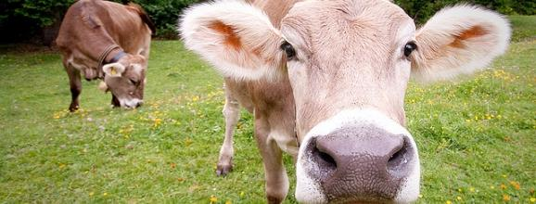





Sample Data File

275 2.25

392 0.32

4 3

Betsy 1250 75 3 2

Mary 1100 60 1 1

Patty 1350 50 2 3

Susan 1450 45 3 3

Debby 1550 70 3 4

Karen 1250 63 2 4

Barb 1175 80 4 1

Nancy 1450 75 3 2

Donna 1800 60 1 1

Sandy 1220 50 2 3

Pam 1550 45 3 3

Sharon 1250 70 3 4

3 4

James 1250 3 2 6 2.25

Mike 1100 1 1 5 3.00

John 1350 2 3 4 2.75

Mark 1450 3 3 5 2.50

Carol 1550 3 4 6 2.50

Dennis 1250 2 4 3 4.50

Janet 1175 4 1 7 3.80

Patty 1450 3 2 6 2.25

Amy 1800 1 1 5 4.25

Mark 1220 2 3 4 3.75

Bill 1550 3 3 4 4.25

Anne 1250 3 4 5 5.25