Accelerometer data were collected using the “Accelerometer” iPhone app by DreamArc. Measurements were taken at 30Hz with the phone lying screen up, with three crossed variables: three insulation treatments (none, insulating foam under speaker and speaker being held at chest height), at the three test frequency ranges (0-150Hz, 150-300Hz and 300-450Hz), and at three distances from the speaker (0cm, 85cm and 170cm). These data were accompanied by a negative control, measuring acceleration at all three test distances with no sound playing. Each treatment combination was measured in three separate trials.

These data were output as acceleration in x, y and z dimensions. The y dimension reflected vertical-aligned movement that related to floor vibrations. Measurement units were acceleration in units of gravities; we multiplied all measurements by 9.8 to convert to ms-2. We then cropped measurement intervals to the 2 seconds (60 measurements) in the centre of each measurement interval, to avoid edge effects when the sound was not played or when the technician was moving across the floor to start and stop the recording.

Given our intention to measure the magnitude of floor vibrations, we converted these measurements to absolute deviations from local gravitational acceleration with two steps. First, we averaged acceleration measurements in the negative control treatment. Actual gravity varies based on longitude, latitude and elevation, so we treated this average as “local gravity”. We subtracted this value from all measurements, creating a “deviation from local gravity” variable. As we were only concerned with the magnitude of acceleration, not directionality (i.e., whether the phone was accelerating up or down), we then took the absolute of these deviation measurements, obtaining an absolute deviation from local gravity measured in ms-2 at a 30Hz sampling rate.

Our test variables were not completely crossed when considering our negative control (which did not have foam treatment). We combined foam and frequency treatments together to obtain 10 aggregate categories (No sound plus all nine frequency x insulation combinations). We modelled absolute delta acceleration as a response variable (square root-transformed) as a function of these categories, interacting with distance (treated as a continuous variable), in a hierarchical Bayesian model. We nested each set of 60 measurements from each trial as a random effect. Coefficients from this model are shown in Table S5. Only two treatment combinations showed a significantly increased acceleration relative to the no sound control: the 0-150Hz frequency with no insulation or foam.

We created a model without the distance and interaction effects to obtain mean and credible interval estimates for each treatment combination, which are shown in Figure S1.

To better understand the magnitude of vibrations from the significant treatments, we compared the 0-150Hz treatments with a position control, which were acceleration measurements obtained by a technician jumping on the floor immediately beside the phone. These are shown in Figure S2.

**Table S5:** Ground vibration acceleration model summary

|  |  |  |  |  |  |  |  |
| --- | --- | --- | --- | --- | --- | --- | --- |
| Fixed effects | Estimate | SE | Lower 95% CI | Upper 95% CI | Ȓ | Bulk ESS | Tail ESS |
| Intercept (negative control) | 0.068 | 0.006 | 0.056 | 0.081 | 1.036 | 144.124 | 242.289 |
| **0-150HzFoam** | **0.096** | **0.009** | **0.079** | **0.113** | **1.022** | **196.215** | **292.722** |
| 0-150HzHeld | 0.015 | 0.008 | -0.002 | 0.031 | 1.019 | 232.045 | 407.782 |
| **0-150HzNoInsulation** | **0.086** | **0.009** | **0.069** | **0.104** | **1.031** | **206.833** | **362.045** |
| 150-300HzFoam | 0.006 | 0.009 | -0.010 | 0.023 | 1.021 | 185.682 | 231.100 |
| 150-300HzHeld | -0.009 | 0.008 | -0.024 | 0.008 | 1.030 | 162.029 | 523.757 |
| 150-300HzNoInsulation | 0.000 | 0.008 | -0.016 | 0.017 | 1.027 | 216.301 | 364.369 |
| 300-450HzFoam | 0.007 | 0.008 | -0.008 | 0.024 | 1.033 | 164.850 | 414.623 |
| 300-450HzHeld | -0.004 | 0.008 | -0.021 | 0.013 | 1.022 | 251.284 | 411.078 |
| 300-450HzNoInsulation | -0.006 | 0.008 | -0.023 | 0.010 | 1.023 | 213.055 | 392.739 |
| Distance from speaker | -2.223E-05 | 5.923E-05 | -1.373E-04 | 9.340E-05 | 1.026 | 235.942 | 607.221 |
| 0-150HzFoam:Distance | -4.817E-05 | 7.759E-05 | -2.021E-04 | 9.874E-05 | 1.014 | 306.462 | 655.615 |
| 0-150HzHeld:Distance | 3.929E-05 | 7.771E-05 | -1.145E-04 | 1.901E-04 | 1.018 | 339.530 | 592.873 |
| 0-150HzNoInsulation:Distance | 6.625E-05 | 7.962E-05 | -8.571E-05 | 2.325E-04 | 1.022 | 277.988 | 464.487 |
| 150-300HzFoam:Distance | -3.076E-08 | 7.786E-05 | -1.549E-04 | 1.537E-04 | 1.012 | 304.729 | 753.008 |
| 150-300HzHeld:Distance | 5.980E-05 | 7.513E-05 | -9.087E-05 | 2.050E-04 | 1.020 | 280.482 | 894.499 |
| 150-300HzNoInsulation:Distance | 4.431E-05 | 7.747E-05 | -1.031E-04 | 1.969E-04 | 1.026 | 306.532 | 746.601 |
| 300-450HzFoam:Distance | -4.595E-05 | 7.449E-05 | -1.944E-04 | 9.826E-05 | 1.020 | 305.144 | 1085.318 |
| 300-450HzHeld:Distance | 4.433E-05 | 7.723E-05 | -1.155E-04 | 1.963E-04 | 1.020 | 351.307 | 786.411 |
| 300-450HzNoInsulation:Distance | 1.749E-05 | 7.492E-05 | -1.288E-04 | 1.671E-04 | 1.017 | 416.981 | 717.801 |
|  |  |  |  |  |  |  |  |
| Random effects | Estimate | SE | Lower 95% CI | Upper 95% CI | Ȓ | Bulk ESS | Tail ESS |
| Trial grouping | 0.008 | 0.001 | 0.007 | 0.011 | 1.001 | 1444.739 | 2262.327 |
|  |  |  |  |  |  |  |  |
|  |  |  |  |  |  |  |  |
| Uniformity test | D | p-value |  |  |  |  |  |
| One-sample Komogorov-Smirnov test | 0.041 | 3.709E-8 |  |  |  |  |  |
|  |  |  |  |  |  |  |  |
| Leave-one-out cross validation | Estimate | SE |  |  |  |  |  |
| Elpd LOO | 9417.3 | 75.4 |  |  |  |  |  |
| P LOO | 70.9 | 2.1 |  |  |  |  |  |
| LOOIC | -18834.6 | 150.7 |  |  |  |  |  |
| Pareto K | 97.5% <0.5 |  |  |  |  |  |  |

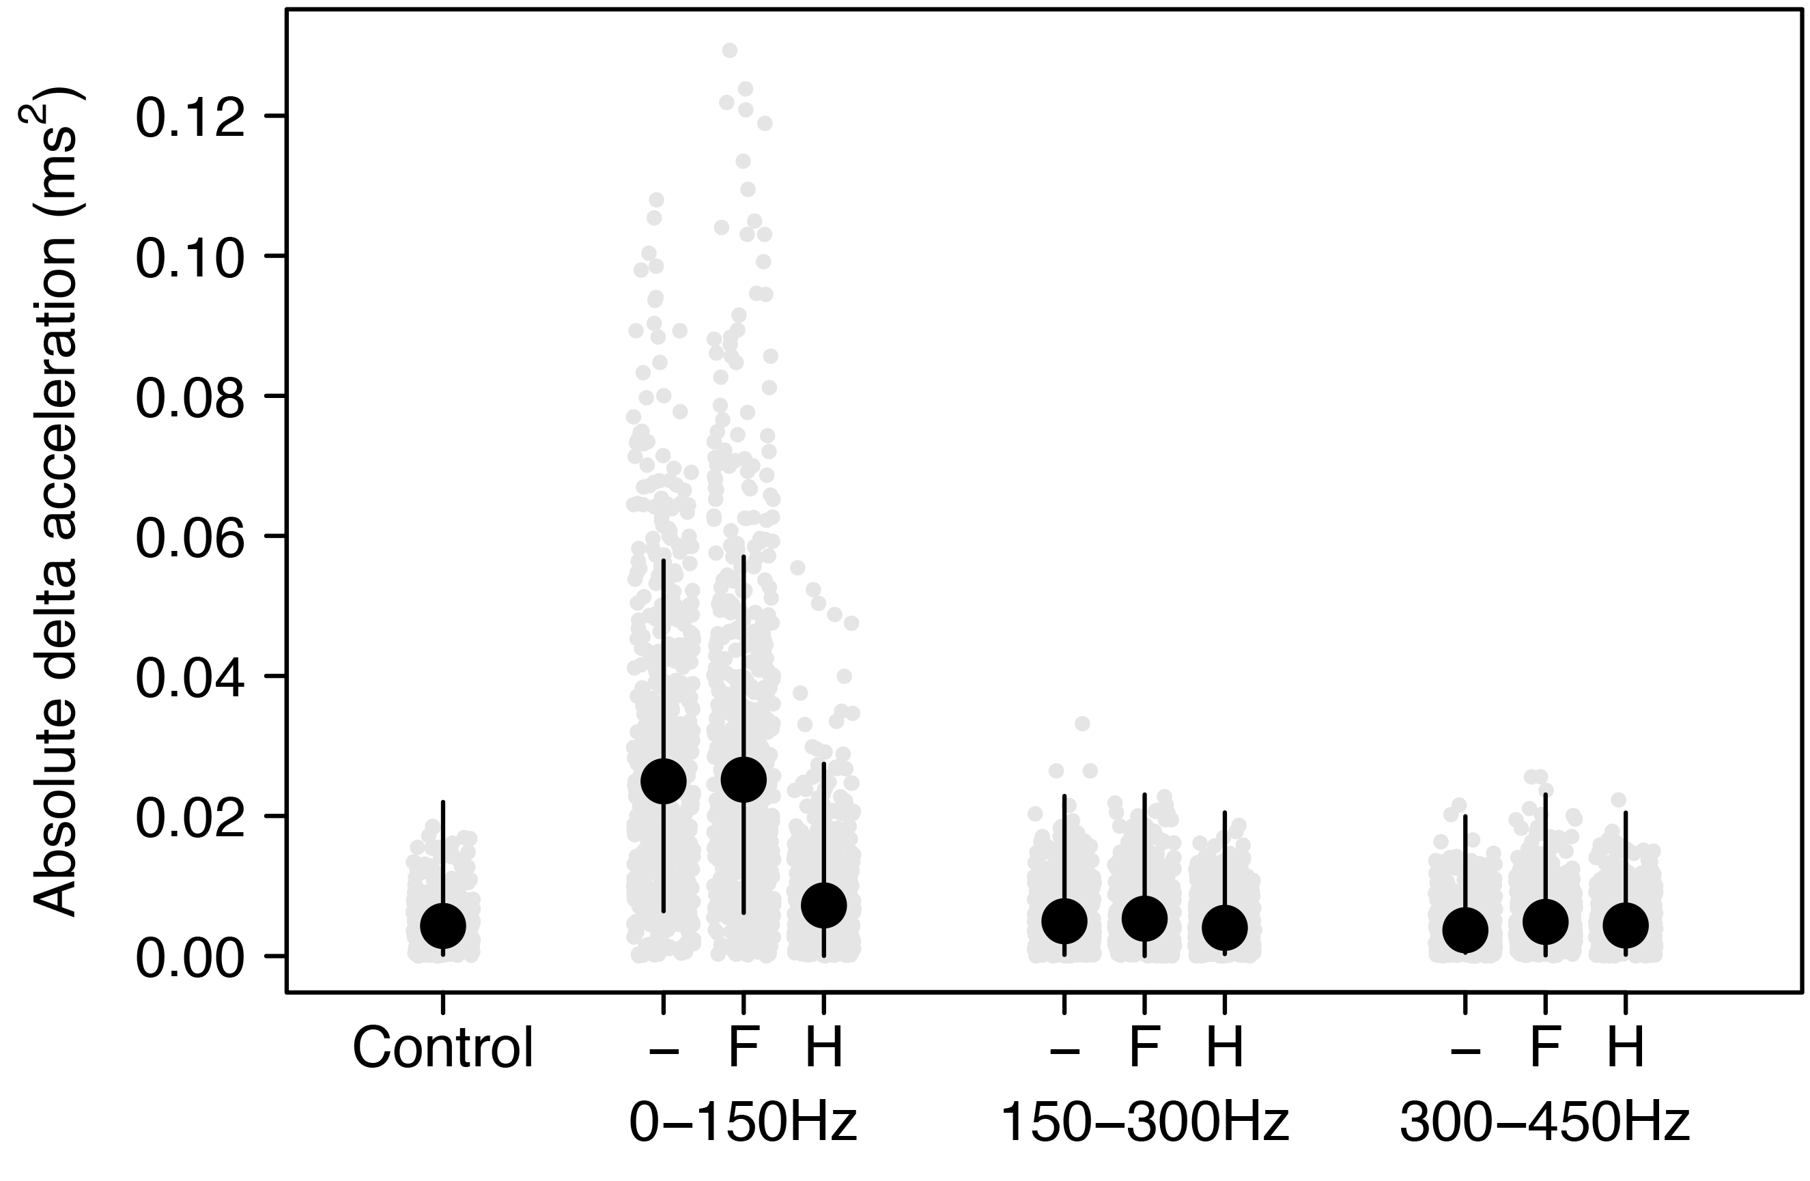

**Figure S1:** Floor vibration measured as absolute delta gravitational acceleration from the mean of no sound controls, as a function of three sound frequencies and three insulation treatments (“-“ = no insulation, “F” = foam under speaker, “H” = speaker held by technician). Black points and lines are mean and 95% credible intervals obtained from a hierarchical Bayesian model. Grey points are individual measurements obtained at 30Hz. Measurements were taken at three distances from the speaker, but as distance was not significant (Table 1), are shown in aggregate here. Several measurements in the 0-150Hz no insulation and foam treatments are beyond the y-axis limit (n=3, to a maximum of 0.170).

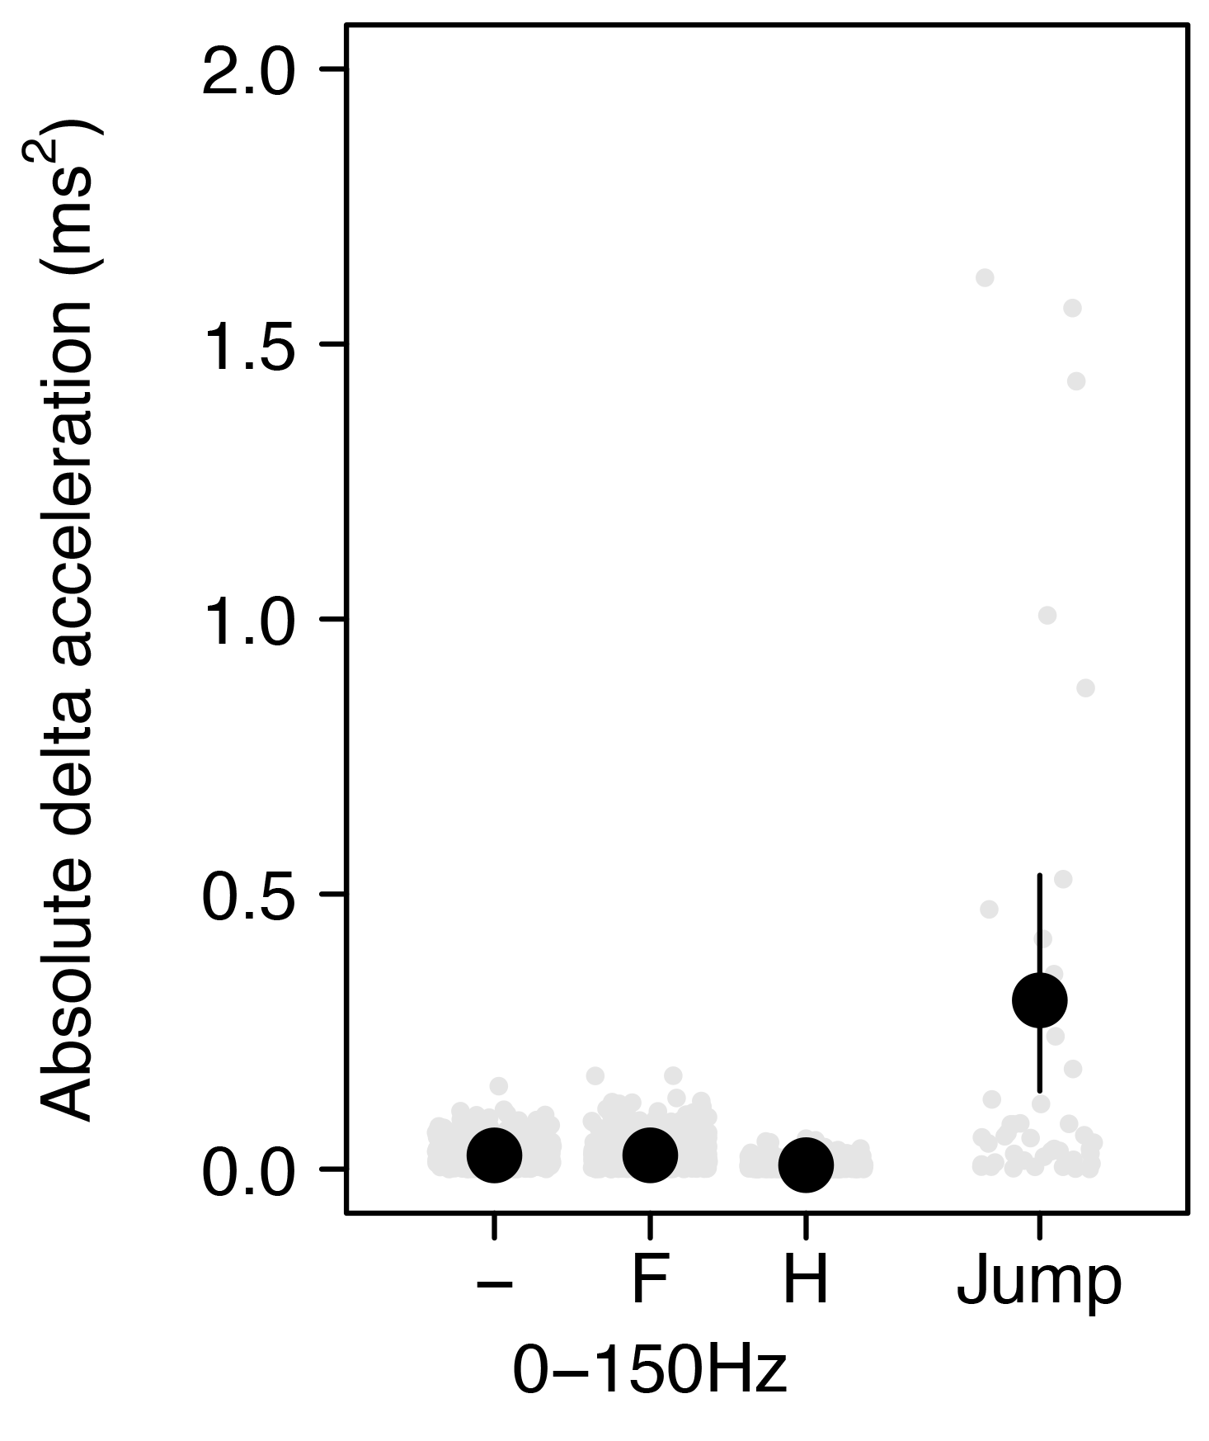

**Figure S2:** Floor vibration measured as absolute delta gravitational acceleration from the mean of no sound controls, with the 0-150Hz results across three insulation treatments (“-“ = no insulation, “F” = foam under speaker, “H” = speaker held by technician) compared with a positive control: a technician jumping immediately adjacent to the phone. Black points and lines are mean and 95% credible intervals obtained from a hierarchical Bayesian model. Grey points are individual measurements obtained at 30Hz. Measurements were taken at three distances from the speaker, but as distance was not significant (Table 1), are shown in aggregate here. Several measurements in the Jump positive control were beyond the y-axis limit (n = 7, max of 7.810).