Front Matter

Full Title
Sound Garden: How snakes respond to airborne sounds

Short Title
How snakes respond to airborne sounds

Authors
Christina N. Zdenek*¹, Chris Hay², Timothy Staples³, Lachlan Bourke⁴, Damian Candusso⁵

Affiliations
¹ Venom Evolution Lab, School of Biological Sciences, The University of Queensland, St. Lucia QLD 4072, Australia. Orcid: 0000-0002-0385-500X
² ﻿Australian School of Herpetology, Southport, QLD, Australia. Tropidechis@hotmail.com
³ Marine PaleoEcology Lab, The University of Queensland, St. Lucia QLD 4072, Australia. t.staples@uq.edu.au. Orcid: 0000-0002-8550-2661
⁴ Venom Evolution Lab, School of Biological Sciences, The University of Queensland, St. Lucia QLD 4072, Australia. Orcid: 0000-0002-9474-3192
⁵ Queensland University of Technology (QUT), School of Creative Practice, Kelvin Grove, Australia. d.candusso@qut.edu.au.

* Corresponding author: ChristinaZdenek@gmail.com

Dr Christina N. Zdenek
School of Biological Sciences
The University of Queensland
Gehrmann Building #60
St. Lucia, QLD 4067
Australia
T: +61 (0)475 267 909

Keywords: snakes, snake behaviour, sound, vibrations, snake movement, airborne sound

Abstract (max 150 words)
Evidence suggests that snakes can hear, but how snakes naturally respond to airborne sound is still unclear. We conducted 304 trials on 19 snakes across five genera, observing the effects of airborne sounds on snake behaviour, compared to controls. All snake responses were strongly genus dependent. Only one genus (Woma Pythons) significantly increased their probability of movement in response to sound, but three other genera (death adders, taipans, and brown snakes) were more likely to move away from sound, signaling potential avoidance behavior. Taipans significantly increased their likelihood of displaying defensive and cautious behaviors in response to sound, but three of the five genera exhibited significantly different types of behaviors in sound trials compared to the control. Our results highlight potential heritable behavioral responses of snakes to airborne sound, clustered within genera. Variability among different snake genera, and across sound frequencies, contributes to our understanding of snake behaviour.

Teaser
Natural behavioral responses of snakes to airborne sounds vary by frequency and may be at least partly heritable.

MAIN TEXT

The manuscript should be a maximum of 15,000 words.

Introduction
While snakes lack external ears and a tympanic middle ear, they are not deaf (Young 1997). Hearing in snakes predominantly occurs via sound-induced head vibrations which are received by the quadrate and stapes bones attached to the jawbone. It is thought that, when stimulated by vibration, these bones relay a signal to the cochlear duct through the columella and the ﻿perilymphatic fluid of the inner ear (Wever et al. 1960; Friedel et al. 2008; Christensen et al. 2012; Hartline 1971).

Snake responses to airborne sound suggests greeatest sensitivity to low frequencies. Crotalus atrox rattlesnakes responded to airborne sounds between 200 and 400Hz (Young & Aguiar 2002), Hydrophis stokesii sea snakes also exhibited responses to sounds between 40 and 600Hz, peaking at 60Hz and 500Hz (Chapuis et al. 2019) and royal pythons (Python regius) had the greatest sensitivity to substrate vibration and sound-pressure at 80–160 Hz. By contrast, human hearing is most sensitive at 2,000-5,000Hz: more than 10x higher (Gelfand 2016).

Despite understanding the mechanisms of snake hearing, it is still unclear how important sound is to snake behavior, and how they naturally respond to different sounds. Hearing is thought to aid snake foraging, with some evidence supporting this hypothesis, particularly in snake avoidance of potentially dangerous prey via sound cues (Randall et al. 1997, Hoare et al. 2013). Sound cues may also be used by snakes alongside sight and smell to accurately strike prey (Young and Morain 2002). Finally, hearing in snakes may also provide warning of snake predators, or larger animals that could trample snakes (Burger 1988).

Past studies have focussed solely on behavioral responses within individual snake species. Here we study whether snake behavioral responses to airborne sound are divergent across five genera with different life history and hunting strategies: an ambush elapid (Acanthophis), an active python (Aspidites), an arboreal elapid (Hoplocephalus) and two active elapids (Oxyuranus and Pseudonaja). We measured behavioral responses of 19 snakes across 304 trials, exposing them to three sets of sound frequencies (0-150Hz, 150-300Hz and 300-450Hz), along with no sound controls. In particular, we asked: Do sound stimuli influence (1) the likelihood and variety of snake behavioral responses, particularly defensive or cautious behaviors, and (2) the likelihood and direction of snake movement.

Results

Genus-based responses

In control trials we observed substantial inter-genus differences in our target behaviors: tongue flicks, head movement, and a collection of behaviors grouped as ‘defensive or cautious’ (‘Freeze’ response, head jerks, hisses, dropping lower jaw, periscoping and fixation behaviour) (Fig. 1, Table 2). Trials in all genera except Acanthophis contained a close to 100% tongue-flick response (Fig. 1). Exhibiting defensive and cautious behaviors was less common, with genera likely to exhibit a target behavior in 20-30% of control trials, with the exception of Hoplocephalus (15%) and Acanthophis (0%) (Fig. 1). Substantial head movement was greatest in Oxyuranus snakes, although was observed in at least c. 50% of trials for all genera except Acanthophis (Fig. 1).
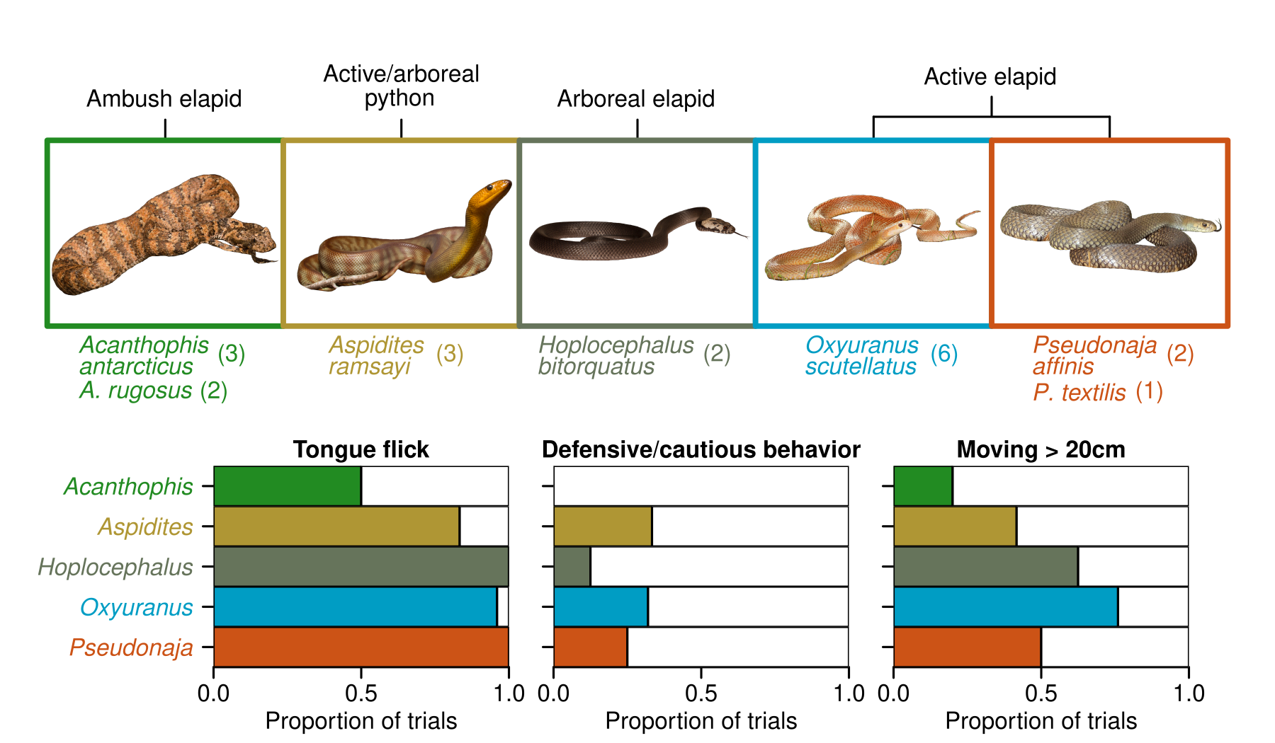
Figure 1: Genus-level behavioral comparisons of snakes in control trials. Genus groupings of snakes, snake count per species and presence of three dominant behaviors (tongue flicks, defensive/cautious behaviors and >20cm movement) as a proportion of control trials. Defensive/cautious behaviors included cautious exploration, fixation, freezing, hisses, head jerks, jaw drops and periscoping (Table 2). Snake images are not to relative scale. Image credits to CNZ: Acanthophis, Aspidites, Hoplocephalus; to CJH: Oxyuranus, Pseudonaja.

Defensive/cautious behaviors

We first modeled the probability of defensive and cautious behaviors as a function of genus identity and sound treatment, accounting for individual snake variation, trial blocks and speaker arrangement via random effects. Bayesian R² scores for this model were 0.206 (marginal, fixed effects only: 95% CIs 0.084-0.317) and 0.425 (conditional, fixed and random effects: 95% CIs 0.372-0.475), suggesting random effects were equally important as genus identity and sound treatment factors in explaining the likelihood of defensive or cautious behaviors. Estimates of the standard deviation of random effects were 2.90 for snake identity, 1.04 for speaker location and 0.71 for block of trials. This suggests most of the conditional variance was due to between-snake differences in the likelihood of exhibiting a defensive or cautious behavior, which captures variation due to snake sex or age. This within-snake variation contributed to results with wide credible intervals of population predictions (Fig. 2A-B). Even so, we observed an increase in the likelihood of defensive or cautious behaviors in Oxyuranus in all three sound treatments (relative to control), and a lesser effect with Aspidites in the S1 and S3 treatment (Fig. 2B).

While the probability of observing these behaviors was not strongly linked to sound treatment, especially in Pseudonaja, we observed differences in the composition of these behaviors across each genus and between sound treatments (Fig. 2C). We found that genus identity explained 88.913% of the variation in behavior composition (F_{4,17} = 36.279, P = 0.001), with sound treatment contributing an additional 3.605% (F_{1,17} = 5.884, P = 0.001), and no significant variation explained by their interaction (2.580%: F_{4,17} = 1.053, P = 0.421). All three genera in the probability model (Aspidites, Oxyuranus and Pseudonaja) were defined by different sets of behaviors in the control trials, with behavior composition changing across the three sound treatments. As sound frequency increased, Aspidites became more likely to freeze and less likely to periscope, Oxyuranus increased in freezing, head jerks and was less likely to hiss and cautiously explore, and Pseudonaja became less likely to hiss and more likely to freeze, head jerk and periscope (Fig. 2C). Behavior composition became more similar between the genera as sound frequency increased; Bray-Curtis dissimilarities between control trials for these three genera were c. 2x larger than behavior composition in the S3 sound treatment (Aspidites-Oxyuranus, 0.657 vs 0.298; Aspidites-Pseudonaja, 0.786 vs 0.444; Oxyuranus-Pseudonaja, 1.000 vs 0.576).

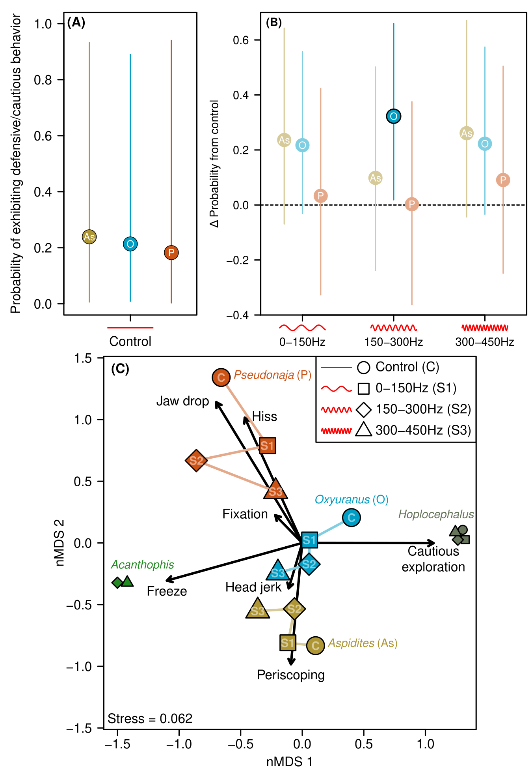
Figure 2: Defensive/cautious behaviour responses of snakes to sound compared to controls.
(A) Mean probability of exhibiting defensive or cautious behavior in control trials for three snake genera with sufficient response (Fig. 1). Behaviors included cautious exploration, fixation, freezing, hisses, head jerks, jaw drops and periscoping. Lines represent 95% credible intervals. (B) Change in probability of exhibiting defensive or cautious behaviors from the control to each of three sound treatments. Values above zero indicate increase in probability, and vice versa. Faded points had credible intervals crossing zero, suggesting no change in probability from control. (C) Non-metric multidimensional scaling of defensive/cautious behaviour composition for each genus-sound treatment combination. Points with similar behavior composition are clustered on the plot, and are sized based on the total count of behaviors. Points in the same direction as arrows exhibited more of those behaviors, with arrow length proportional to strength of influence. Differences between control (“C”) and treatment points (“S1”, “S2” and “S3”) suggest the type of exhibited defensive behaviors changed in response to sound treatments. Symbols for the control and S1 are omitted for Acanthophis due to no behaviors being exhibited in those trials. Numbers are omitted from Acanthophis and Hoplocephalus symbols due to space constraints.

Snake movement

Snake movement patterns varied by genus. Acanthophis was the least likely to move and Hoplocephalus, while likely to move, rarely moved more than 50cm from starting position (Fig. 3A). The other three genera exhibited a range of movement, with Aspidites showing uniform patterns of movement between 0cm and 1m, and Oxyuranus and especially Pseudonaja likely to either stay still or move a substantial distance (Fig. 3A).

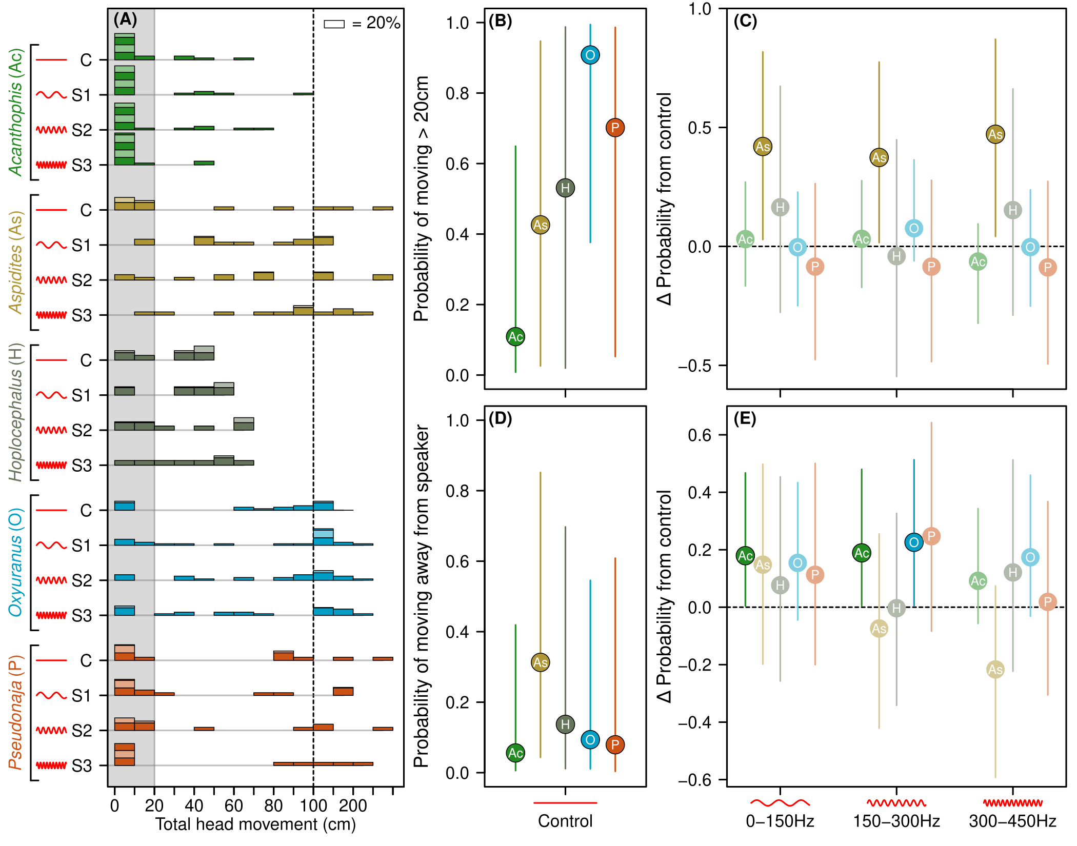
Figure 3: Snake movement in response to sound compared to controls. (A) Histogram of snake movement by genus (colored groupings) and sound treatment (C, S1-S3). Histogram bars are grouped in units of 10cm, except above 100cm (right of dashed line) where they are grouped in units of 50cm. Alternating colors on bars represent blocks of up to 20% of trials. Grey shading indicates the cut-off used to distinguish 20cm threshold for binary movement response used in probability model. (B) Mean probability of >20cm snake movement in control. (C) Change in probability of movement from the control to each of three sound treatments. Values above zero (dashed line) indicate increase in probability, and vice versa. (D) Mean probability of movement away from speaker for each genus in control trials, using only snakes with >20cm of movement. (E) Change in probability of movement away from speaker compared to control means for each of three sound treatments, as per (B). Lines in (B-E) represent 95% credible intervals from Bayesian hierarchical models. Points in C and E with 95% credible intervals that do not cross zero are highlighted as significant effects.

The probability of head movement greater than 20cm also varied by genera. Acanthophis was the least likely to move in control trials, Oxyuranus the most, and the other three genera varied strongly across individual snakes (Fig. 3B). Marginal and conditional R² values were 0.365 (95% CIs = 0.256-0.454) and 0.504 (CIs = 0.469-0.538) respectively. As with the probability model of defensive and cautious behaviors, most random variation was explained by differences between individual snakes (SD = 2.04), compared with trial blocks (SD = 0.23) and speaker sides (SD = 0.92).

In the three sound treatments, we observed a consistent increase in the probability that Aspidites moved compared with controls, especially in S3, where almost all trials resulted in movement (Fig. 3A, C). Other genera showed no response in the probability of movement.

When considering the direction of movement, all genera showed a low likelihood of movement away from the speaker, consistent with random choice of direction (c. 25%). We found Acanthophis was more likely to move away from the sound in S1 and S2 treatments, and Oxyuranus was more likely to move away in S2, with slightly lower probabilities in S1 and S3 (Fig. 3D). Pseudonaja showed a weak propensity towards greater probability of movement away from the sound source in treatment S2, but not in S1 and S3. While no Aspidites differences were likely to be non-zero, we observed a trend from movement away from the sound source in treatment S1 to a trend to move towards the sound source in treatment S3.

Discussion

We found the behavioural response of free moving, non-anaesthetised snakes to airborne sound differed based on sound frequency and was strongly linked to genus identity. We included nineteen captive snakes across five genera and six species, covering a range of foraging modes and body morphology. The similar proportion of variation in behavior explained by genus identity and sound frequency and within-snake clustering, suggests that snake behavioral responses are a complex of heritable and environmental components.

In particular, the composition of defensive and cautious behaviours exhibited across all trials (sound and no sound) were strongly genus dependent. Oxyuranus exhibited all behaviours except for periscoping. Acanthophis and Hoplocephalus responses were dominated by freeze and cautious exploration responses, respectively, with essentially no other behaviours exhibited. Being ambush predators, Acanthophis snakes have low mobility, so a freeze response to potential danger—in combination with physical (and possibly chemical) camouflage (Miller et al. 2015) —may help them escape detection. Behavioral responses in these less ‘reactive’ snakes may be subtle, and potentially detectable via physiological ﻿responses such as heart rate or hormone levels (e.g., Mathies et al. 2001; Moore et al. 2000)...

Pseudonaja responses were dominated by jaw drops and hisses, whereas Aspidites exhibited mostly periscoping and head jerk behaviour. A suite of genus-specific behaviours may indicate that these behavioural responses are are an inherited trait, like a preprogrammed response to certain stimuli. While no studies have confirmed the existence of inheritable behaviour traits in snakes, four New Caledonian Crows (﻿Corvus moneduloides) that were laboratory-born and hand-reared exhibited inherited species-typical action patterns regarding tool-oriented behaviours (Kenward et al. 2006). The fact that multiple individuals within each genus in the present study exhibited a similar suite of behaviours to each other which was different to other genera, therefore, suggests that the traits are likely heritable and increase survivorship of the species within its specific niche (Webb et al. 2005; Arnold 1972). Thus, future work should investigate the heritability of genus-specific behaviours in snakes.

We observed evidence of acoustic orienting, i.e., orientation of the snake relating to the source of the sound. Aspidites exhibited a trend away from the sound source in treatment S1 and a trend to move towards the sound source in treatment S3. In contrast, three other genera (Acanthophis, Oxyuranus, and Pseudonaja) were more likely to move away from the source of sound, signaling potential avoidance behavior. These contrasting responses may be explained by a difference in the number of predators of these snakes, and therefore their nervous disposition. Aspidites are large (up to 2.7m and 5kg) pythons that prey largely upon monitor lizards (Varanus gouldii) and are mostly active nocturnally (Bruton 2013), when raptors are not active. On the other hand, adult snakes within the genera Acanthophis, Oxyuranus, and Pseudonaja are much smaller in weight (40g–2kg), either partially or mostly diurnal, with many predators such as monitor lizards, raptors, and feral cats (Whitaker et al. 2000). These results differ from Young and Aguiar (2002), which found no acoustic orientation in an ambush predator (Western Diamondback Rattlesnake Crotalus atrox), yet similar to Young and Morain (2002) which observed an ambush viper Cerastes cerastes localise small, free-moving mice spatially using groundborne vibrations. Thus, while animals with external and middle (tympanic) ears can hear a greater range of frequencies (10Hz–100kHz) (Fay et al. 1994) than snakes can (<1kHz)(Christensen et al. 2012), with about 40dB increase in hearing sensitivity (Christensen et al. 2012), snakes are still able to orient with respect to sound.

The genus Pseudonaja was included here due to their frequent conflict with humans (Welton et al. 2017), their reputation as an irritable species, and the presence of overt defensive behaviours (e.g. ﻿maintained elevated coiling) (Shine 1991). Interestingly, Pseudonaja snakes exhibited a largely dichotomous response to sound, whereby they either remained still or moved a large distance. This ‘all or nothing’ response aligns with previous work: when humans approached wild Eastern Brown Snakes in paddocks, about half of the time the snakes retreated and on most other occasions the snakes relied on crypsis (staying still) (Whitaker et al. 1999).
In our study, the types of behaviours exhibited by the snakes depended on the presence of sound and the type of sound (S1, S2, and S3). Like Young & Anguiar (2002), we observed fewer tongue flicks overall in response to sound. One genus (Oxyuranus) significantly increased their likelihood of displaying defensive or cautious behaviors in response to sound (only to S2), suggesting an awareness and fear of that particular sound. Snakes in this genus are active foragers, travelling to find and pursue their prey; this likely results in greater risk of—and therefore trepidation for—encountering predators. Unfortunately, comparison of S2 (150–300Hz) to the frequencies of non-vocal sounds emitted by approaching predators (across various habitats) is unknown.

Further evidence of perceptive distinction of different sound types was the change in behaviour composition with increasing sound frequency. Aspidites became more likely to freeze and less likely to periscope, Oxyuranus increased in freeze behaviour, head jerks and was less likely to hiss and cautiously explore, and Pseudonaja became less likely to hiss and more likely to freeze, periscope, and head jerk. In addition, the behavior difference between genera in S3 was c. 50% of that in controls, highlighting a potential convergent behavioral response of snakes to airborne noise across both elapid and python species. This potential convergent response may indicate the presence of an archetypal response to airborne sound that evolved prior to splitting of the two families around 10 million years ago (Kumar et al. 2017) and may dominate the genus-based differences discussed earlier. Christensen et al. (2012) reported significant differences (head vibrations of partially anaesthetized snakes) at multiple frequencies between 80Hz and 500 Hz, with peak sensitivity at 160Hz, but no other behaviours were able to be recorded. Our results provide some behaviour-based evidence of perceptive distinction of different sounds by snakes.

The use of captive snakes instead of wild snakes resulted in the length of captivity (and thus domestication level) being positively correlated with the age of our snakes. As such, we were unable to discern whether age or domestication level was responsible for the lack of responsiveness to sound exhibited by older, domesticated individuals. While there is unlikely to be substantial genetic differences between captive and wild snakes, their behaviour may differ, with this difference becoming more pronounced with longer duration in captivity due to their previous exposure and possible habituation to many sounds (e.g. vacuum, voices, music). However, if snakes are mostly driven by innate, instinctual behaviours, and since there is no biological suggestion that genetics can change in captivity over the course of an individual’s life, our results may be applicable to wild snakes. Regardless, future research should conduct similar controlled experiments to test the behavioural response of wild snakes to sound, including ultrasonic snake repellent devices. Future work should also investigate how head size and form (e.g. fatty tissue density) within a snake’s ‘acoustic window’ affects function regarding sound.

Snake behaviour is depauperate in the literature relative to other taxa (e.g., birds, mammals). The common perception of snakes being deaf likely derives from a combination of 1) their limited hearing ability (regarding frequency range and sensitivity), and 2) peoples’ limited ability to notice and interpret many subtle snake behaviours. Our data reveals that Australian snakes respond to airborne sound, at least within the frequency range of 0–450Hz, and that responses differ significantly according to genus. Our study measured natural, free-moving behaviour of elapid snakes in response to sound, including snakes with active foraging modes, arboreal species, as well as elapid species of snakes. Our study provides a framework for researching even subtle snake behaviour, and our results improve our limited understanding of snake behaviour, which may help humans avoid snakebite and/or possibly deter snakes.

Materials and Methods
In January 2021, we conducted controlled experiments during the day in a sound-proof room to investigate the effects of sound on snake behaviour and movement.

The snakes
We included 19 captive, adult, Australian snakes across five genera (Table 1). Our snakes ranged in morphological body shapes and foraging types, including active foragers, ambush predators, arboreal dwellers, and constrictor feeders.

We used captive snakes rather than ‘wild’ snakes because we only had access to captive snakes. Snakes were ﻿kept at 27–28ºC (tested four times daily using a laser thermometer), provided with water ad libitum and maintained on a diet of pre-killed mice prior to the experimental period. All snakes were fed on the same day prior to experiments (10 days prior), and none were fed during the study, ensuring any venom-load-related differences in behaviour (Piao et al. 2021; Herzog et al. 1987) were eliminated as a confounding variable.

All care, testing, and transport of animals from their permanent residence to the testing location conformed to federal regulations and institutional guidelines for research with venomous snakes and were approved by Biosecurity (Biosecurity QLD Permit #PRID000343) and the QUT Animal Ethics Committee (Approval #2000000816).
Snake name | Species | Common name | Sex | Total length | Age (years) | Foraging mode | Individual temperament
Squishy | Oxyuranus scutellatus | Coastal Taipan | m | 2.2 m | 22 | active | domesticated
Boss | Oxyuranus scutellatus | Coastal Taipan | f | 1.8 m | 14 | active | alert
Fibonacci | Oxyuranus scutellatus | Coastal Taipan | m | 1.6 m | 11 | active | alert
Lower Jaw | Oxyuranus scutellatus | Coastal Taipan | f | 1.1 m | 4 | active | alert
Mawa | Oxyuranus scutellatus | Coastal Taipan | m | 1.1 m | 4 | active | alert
Lumpy | Oxyuranus scutellatus | Coastal Taipan | m | 1.4 m | 11 | active | alert
Upgrade | Pseudonaja textilis | Eastern Brown Snake | m | 1.8 m | 12 | active | alert
El Diablo | Pseudonaja affinis | Dugite | m | 1.2 m | 15 | active | alert
Mr Naughty | Pseudonaja affinis | Dugite | m | 1.2 m | 15 | active | domesticated
Perth Girl | Acanthophis antarcticus | Common Death Adder | f | 350 mm | 6 | ambush | unknown
Briggs | Acanthophis antarcticus | Common Death Adder | m | 400 mm | 8 | ambush | unknown
Glory | Acanthophis antarcticus | Common Death Adder | m | 400 mm | 6 | ambush | unknown
Dull Sister | Acanthophis rugosus | Rough-scaled Death Adder | f | 600 mm | 7 | ambush | unknown
Bright Sister | Acanthophis rugosus | Rough-scaled Death Adder | f | 600 mm | 7 | ambush | unknown
Bitey Boy | Aspidites ramsayi | Woma Python | m | 1 m | 10 | constriction | domesticated
Dorsal Girl | Aspidites ramsayi | Woma Python | f | 1 m | 10 | constriction | domesticated
Elapid Boy | Aspidites ramsayi | Woma Python | m | 900 mm | 8 | constriction | alert
Casper | Hoplocephalus bitorquatus | Pale-headed Snake | m | 350 mm | 5 | arboreal | moderate
Chris' Hoplo | Hoplocephalus bitorquatus | Pale-headed Snake | m | 380 mm | 7 | arboreal | moderate
Table 1. Individual snakes included in the study and their foraging modes*.

*(Bruton 2013; Shine 1991; Shine 1983; Hagman et al. 2008).

The sounds
Since we included a broader array of species than has previously been tested, we included a broader frequency range than was previously shown to evoke brain electrical responses from snakes (Young & Aguiar 2002; Christensen et al. 2012).

The sounds were generated by filtering pink noise. Pink noise is a random signal, filtered to have equal energy per octave. To keep the energy constant over octaves, additional 24db/octave low-pass and high-pass filters were used to restrict each frequency range. Pink noise was also used due to previous research showing elevated sensitivity to low frequencies (Christensen et al., 2012).

Filtering via a low-pass and high-pass filter was applied at the following ranges:
- 0-150Hz. A 24db/octave low pass filter was applied at 150 Hz
- 150- 300 Hz - A 24db/octave high pass filter was applied at 150 Hz and a 24db/octave low pass filter applied at 300hz
- 300-450 Hz - A 24db/octave high pass filter was applied at 300 Hz and a 24db/octave low pass filter applied at 450hz

We played airborne sounds from three speakers at a combined loudness of 85 ± 0.5 decibels (calibrated daily using a sound meter level (Dick Smith Electronics, Q1362) with a C weighting for consistent calibrated loudness). This level is 10–30dB louder than previous work (Wever and Vernon, 1960; Young and Aguiar, 2002) due to the relatively large (4.9 x 4.9m) room and testing area (2.4 x 2.4 m) in which we conducted the trials.

The room
Behavioural experiments were conducted in a 4.8 x 4.9 m sound-proof room at 27–28ºC, within the snakes’ normal activity range. The room was set up as two mirrored halves, with a total of six speakers on the floor surrounding and facing the snake hutch (60 x 60 x 40 (w x l x h)) in the middle of the room (Figure 1). Speakers were buffered at their base with a 3cm layer of dense acoustic foam (Auralex Acoustic Foam) to limit vibrations from transmitting through the floor to keep the sounds airborne. The speakers were 1.7 m speakers away from the centre point of the room, and the edge of the snake hutch was placed at 1.2 m from the speakers for each trial.

The trials
Trials were conducted in January, which is an active-period month for Australian snakes. All trials were conducted during daytime because all the included snake species are either diurnal or known to be occasionally active diurnally. A 10%-bleach cleaning solution was used to clean the floor between trials. Prior to beginning experimental trials, one snake at a time was given one 5-minute period of familiarization to freely explore the room.

Trials included a 30 second settling period for the snake inside a snake hutch, then a 30 second period of either sound or no sound for the controls. We randomized the side of the room the sound played from during each trial, as well as randomizing the order of snakes per block (replicate) of treatment. Across the study each snake was exposed to four replicates each of three sounds and negative control. For each period and trial, we quantified the response variables listed in Table 2, some of which were adapted from Young & Aguiar (2002).

Data collection was not able to be blind due to various logistical constraints (Kardish et al., 2015). While most behaviors were too subtle to observe from video or from a distance without binoculars, many of the traits were straight forward to measure and not at risk of bias (e.g. hisses, head movement, periscoping), requiring little or no interpretation. In addition, all observed behaviour were categorical variables except one (body movement), which was collected by a dedicated individual and cross-checked by a different individual via video after each trial. Furthermore, we used five people to live collect data for a maximum of three infrequent variables (e.g. hissing, periscoping) collected per person, or one variable for frequent behaviours (i.e. tongue flicks, body movement).

Table 2. Nine behaviours recorded for snakes.
Behaviour | Description
Directional movement | The distance (cm), direction (toward, away, or orthogonal of the sound), and length of time (sec) in which the snake moves. Measured at the head. Body movement independent of head noted but not measured directly.
Cautionary exploratory  movement | The first 1/3rd of body moves in multiple directions while whole body travels no distance.
Tongue flicks | The number of times the tongue goes in and out of the mouth. One motion of the tongue in and out = 1.
‘Freeze’ response | While snake is alert (head elevated and body tense), a sudden stop of body movement, not in relaxed posture.
Head jerks | Rapid lateral movements of the head independent body movement.
Hisses | Rapid exhalation of air through the mouth to make a hissing noise.
Dropping lower jaw | A distinctive drop of the lower jaw for a period, which exposes the fangs in a defensive manner.
Periscoping | Lifting of the head (and sometimes part of body) upwards with a 45º angle or greater.
Fixation behaviour | Head facing same direction while body moves laterally.

Statistical Analysis
All data processing and statistical analyses were conducted in R version 4.02 (R Development Core Team, 2018)⁠.

Summarizing snake behavioral responses

Defensive and cautious behaviors included six distinct behaviors: freezing, hissing, fixation, head jerks, lower jaw drops, periscoping and cautionary exploration (Table 2). We converted the sum of these for each trial into a binary variable, whether at least one defensive/cautious behavior occurred. This binary variable was modeled as a response variable in one of the probability models.

Many snakes recorded small head movements during trials. We summed head movement in all directions to reflect the magnitude of movement. We observed a natural division between snakes with < 20cm head movement and those with substantially larger movement. We divided movement into less than and greater than 20 cm binary categories for probability modeling.

Movement response does not resolve whether snakes were moving towards or away from the sound, which has different biological implications. As such, we constructed an additional model only for snake trials with >20 cm head movement. We constructed a binary variable, with all trials with the greatest magnitude of head movement occurring away from the speaker as successes, and with all other trials treated as failures. This model estimated the probability that snakes moved away from the speaker. We excluded all trials where we did not observe >20cm head movement from this model.

Sound treatment models

We tested for an effect of sound treatment using Bayesian hierarchical models (brm function, brm package (Bürkner, 2017, 2018)⁠, fit with two interacting fixed effects: sound treatment (four level factor) and snake genus (five level factor). We excluded Acanthophis and Hoplocephalus trials from the defensive/cautious behavior model due to their lack of non-zero trials.

We specified a Bernoulli likelihood function with vague uninformative priors for intercept and slope terms (normal distribution with μ = 0, σ = 5). We specified random intercepts for each snake, each block of trials and the two speaker directions, with cauchy priors (μ = 0, σ = 5). Models were run across four chains for 10,000 iterations each, 5,000 warm-up and 5,000 for sampling, for a total of 20,000 sampling iterations. We set adapt delta to 0.999 and max treedepth to 15 to reduce divergent transitions. Chain convergence in models was evaluated via R-hat scores. Model validation was performed via residual simulation (DHARMa package, (Hartig, 2020)⁠), including model uniformity and dispersion tests, and leave-one-out cross validation (loo function, loo package, (Vehtari et al., 2017)⁠).

We visualized snake response to control conditions as the mean posterior probabilities made at the population scale (i.e. ignoring random effects), with corresponding 95% credible intervals. To estimate the response difference between control and treatments, we subtracted each genus’ control posterior draws from the posterior draws from each respective sound treatment. This put each genus on an equivalent ‘difference from control’ scale. The means of these resulting distributions reflect mean difference from control to treatment; whereby if the 95% credible intervals of these differences do not cross zero, it suggests evidence of a substantial difference in response probability between the control and treatments.

Two models initially included additional variables; the defensive/cautious behavior model initially included snake sex and movement away from speaker model initially included initial head direction. These additional variables did not improve model fit, as determined via comparison of leave-one-out cross-validation information criteria (LOOIC), interpretable as per AIC. Defensive/cautious models with and without snake sex had LOOIC scores of 223.9 and 223.5 respectively, and movement away from speaker models with and without initial head direction had LOOIC scores of 378.8 and 372.9 respectively.

nMDS of defensive/cautious behaviors

We also explored whether the composition of defensive/cautious behaviors changed based on sound treatment and genus identity. We summed all defensive behaviors for all snakes of a given genus for each sound treatment. We converted these to relative abundance measures (dividing by the total sum of behaviors in that genus-sound treatment combination). These formed the rows of a compositional matrix, with behaviors as columns. We visualized differences in composition using non-metric multidimensional scaling (metaMDS function, vegan package (Oksanen et al., 2020)⁠), using Bray-Curtis dissimilarity. We also tested for whether genus or sound treatment significantly affected composition of defensive/cautious behaviors using a PERMANOVA with 999 permutations (adonis2 function, vegan package (Oksanen et al., 2020)⁠).

References
Arnold, S.J. 1972. Species densities of predators and their prey. The American Naturalist 106(948): p.220–236.
Bruton, M.J. 2013. Arboreality, excavation, and active foraging: Novel observations of radiotracked woma pythons Aspidites ramsayi. Memoirs of the Queensland Museum - Nature 56(2): p.313–329.
Burger, J. 1998. Antipredator behaviour of hatchling snakes: Effects of incubation temperature and simulated predators. Animal Behaviour 56(3): p.547–553.
Chapuis, L., Kerr, C.C., Collin, S.P., Hart, N.S., & Sanders, K.L. 2019. Underwater hearing in sea snakes (Hydrophiinae): First evidence of auditory evoked potential thresholds. Journal of Experimental Biology 222(14).
Christensen, C.B., Christensen-Dalsgaard, J., Brandt, C., & Madsen, P.T. 2012. Hearing with an atympanic ear: Good vibration and poor sound-pressure detection in the royal python, Python regius. Journal of Experimental Biology 215(2): p.331–342.
Fay, R.R., & Popper, A.N. 1994. Comparative Hearing: Mammals. Springer, New York, NY.
Friedel, P., Young, B.A., & Van Hemmen, J.L. 2008. Auditory localization of ground-borne vibrations in snakes. Physical Review Letters 100(4): p.2–5.
Hagman, M., Phillips, B.L., & Shine, R. 2008. Tails of enticement: Caudal luring by an ambush-foraging snake (Acanthophis praelongus, Elapidae). Functional Ecology 22(6): p.1134–1139.
Hartline, P.H. 1971. Physiological basis for detection of sound and vibration in snakes. Journal of Experimental Biology 54(2): p.349–371.
Herzog, H.A., & Bailey, B.D. 1987. Development of antipredator responses in snakes: II. Effects of recent feeding on defensive behaviors of juvenile garter snakes (Thamnophis sirtalis). Journal of Comparative Psychology 101(4): p.387–389.
Hoare, M., & Labra, A. 2013. Searching for the audience of the weeping lizard’s distress call. Ethology 119(10): p.860–868.
Kenward, B., Rutz, C., Weir, A.A.S., & Kacelnik, A. 2006. Development of tool use in New Caledonian crows: inherited action patterns and social influences. Animal Behaviour 72(6): p.1329–1343.
Kumar, S., Stecher, G., Suleski, M., & Hedges, S.B. 2017. TimeTree: a resource for timelines, timetrees, and divergence times. Molecular Biology and Evolution 34(7): p.1812–1819.
Mathies, T., Felix, T.A., & Valentine, V.L. 2001. Effects of trapping and subsequent short-term confinement stress on plasma corticosterone in the brown treesnake (Boiga irregularis) on Guam. General and Comparative Endocrinology 124(1): p.106–114.
Miller, A.K. et al. 2015. An ambusher’s arsenal: Chemical crypsis in the puff adder (Bitis arietans). Proceedings of the Royal Society B-Biological Sciences 282.
Moore, I.T., Lemaster, M.P., & Mason, R.T. 2000. Behavioural and hormonal responses to capture stress in the male red-sided garter snake, Thamnophis sirtalis parietalis. Animal Behaviour 59(3): p.529–534.
Piao, Y. et al. 2021. Do pit vipers assess their venom? Defensive tactics of Deinagkistrodon acutus shift with changed venom reserve. Toxicon.
Randall, J.A., & Matocq, M.D. 1997. Why do kangaroo rats (Dipodomys spectabilis) footdrum at snakes? Behavioral Ecology 8(4): p.404–413.
Shine, R. 1983. Arboreality in snakes: Ecology of the Australian Elapid genus Hoplocephalus. Copeia 1983(1): p.198.
Shine, R. 1991. Australian snakes: A natural history. Singapore: Imago Productions.
Webb, J.K., Shine, R., & Christian, K.A. 2005. Does intraspecific niche partitioning in a native predator influence its response to an invasion by a toxic prey species? Austral Ecology 30(2): p.201–209.
Welton, R.E., Williams, D.J., & Liew, D. 2017. Injury trends from envenoming in Australia, 2000–2013. Internal Medicine Journal 47(2): p.170–176.
Wever, E.G., & Vernon, J.A. 1960. The problem of hearing in snakes. Journal ofAuditory Research 1: p.77–83.
Whitaker, P.B., & Shine, R. 2000. Sources of mortality of large elapid snakes in an agricultural landscape. Journal of Herpetology 34(1): p.121–128.
Whitaker, R., & Shine, R. 1999. Responses of free-ranging brownsnakes (Pseudonaja textilis: Elapidae) to encounters with humans. Wildlife Research 26: p.689–704.
Young, B.A. 1997. A review of sound production and hearing in snakes, with a discussion of intraspecific acoustic communication in snakes. Journal of the Pennsylvania Academy of Science 71(l): p.39–46.
Young, B.A., & Aguiar, A. 2002. Response of western diamondback rattlesnakes Crotalus atrox to airborne sounds. Journal of Experimental Biology 205(19): p.3087–3092.
Young, B.A., & Morain, M. 2002. The use of ground-borne vibrations for prey localization in the Saharan sand vipers (Cerastes). Journal of Experimental Biology 205(5): p.661–665.

Acknowledgments
We thank Allen Bremner for audio/visual technical support throughout the project, including recording distance movements and developing a practical and accurate method to do so. Sound room set-up dudes.

Funding: None.

Author contributions:
Conceptualization: CNZ, DM, CH
Methodology: CNZ, DM, CH, TS, LB
Investigation: CNZ, DM, CH, LB
Visualization: TS
Supervision: CNZ
Writing—original draft: CNZ
Writing—review & editing: CNZ, DM, CH, TS, LB

Competing interests: None.

Data and materials availability: All data, code, and materials used in the analyses are available in X.

Figures and Tables
You may include up to a total of 10 figures and/or tables (combined) throughout the manuscript. You should embed your figures within the Word file, after the acknowledgments. This will facilitate evaluation of the paper.

Fig. 1. Short title of the first figure. The figure legend should begin with a title (an overall description of the figure, in boldface) followed by additional text. Each legend should be placed immediately after its corresponding figure.
Fig. 2. Short title of the second figure. Indicate figure parts with bold capital letters: (A), (B), etc.
Table 1. Short title of the first table. Start table legends with a title (short description of the table). Format tables using the Word Table commands and structures. Do not use spaces, tabs or hard returns to create tables. Every vertical column should have a heading, followed by a unit of measure (if any) in parentheses. Units should not change within a column. Centered headings of the body of the table can be used to break the entries into groups. Footnotes should contain information relevant to specific cells of the table; use the following symbols in order, as needed:*, †, ‡, §, ||, ¶, #, **, ††, etc. (Don’t use footnotes in column heads; include any such details in sentence form after the table itself.)

Supplementary Materials

Please use the Science Advances template to format your Supplementary Materials.

