**Results summary (2/02/21)**

- Active and constriction snakes showed some increase in defensive and cautious behaviours when exposed to sound. Ambush and arboreal snakes exhibited almost zero def/caut behaviours regardless of sound.

- Ambush snakes only exhibited at least one tongue flick in ~50% of trials, all other foraging types had a >90% tongue flick occurrence. The count of tongue flicks was not linked to sound.

- Total movement amount (all directions summed) did not differ across sound treatments.

- Probability of moving primarily away from the speaker (as opposed to moving towards or moving orthogonally) doubled in sound levels 1 and 2 compared with control. Elevated but non-significant increase in sound level 3.

**Defensive and cautionary behaviour**

Total count of freeze behaviour, hisses, fixation, head jerk, lower jaw drop, periscoping and cautionary exploration.

There were almost no defensive behaviours from ambush (3 non-zeros) and arboreal (4 non-zeros) snakes. I excluded them from the models and plotted them separately as zeros.

Once these other groups are removed, species explained no variation. All variation was between individuals, regardless of species.

The model with sound category as the only fixed effect explained 3.3% of variation in def/caut behaviours (with random effects + fixed effects explaining 77.7%). Once we added ln-transformed age (confounded with domesticity), foraging mode and sound-foraging mode interactions, we explained 36.9% with fixed effects (80% with random effects too).

It looks like that while sound appears to stimulate these behaviours, the effect is small compared to variation in these behaviours between sexes (males exhibit more of these behaviours than females), and foraging mode. I decided to exclude snake sex from the fixed effects. Why? Because there were only three female snakes. There is some evidence that females may have exhibited fewer def/caut behaviours, and less reaction to sounds, but it’s impossible to tease this out. I’ve let this variation be soaked up by the individual snake random effects.

With contrast tests, the only significant differences were between control and sound level 1 in active foraging snakes, and between control and each sound level in constriction foraging snakes. Constriction snakes showed incredible variation in def/caut behaviours, particularly in the sound treatments. Is this a function of having so few snakes in this group?

To answer one of your questions now though re constriction snakes: one individual is very 'wild' like compared to the other two. Elapid Boy is his name. He was a rock-star for us in the testing. Always so interesting. The other two were boring as to us as we were testing, ie, no obvious reactions or patterns of behaviour when played a sound vs no sound. So I suspect the extreme variation is due to him. Serious individual variation. Which is also cool. Snake personalities ; ). Although, if age plays a big role, he is younger than the other two by two years.

The active snakes showed an interesting pattern where reactions seemed greatest with sound level 1, the lowest frequency sounds. Differences between sounds 1 and 2, and 2 and 3 were not significant (p-values of 0.08 and 0.07), but this is an interesting hypothesis. Is there an ecological rationale for strong reactions to that frequency band, and deviating from that frequency weakens the signal like misdialing a radio station?

re ecological significance of sound 1 vs 2 or 3: This could be a function of physics, whereby the jawbone and/or sound conducting tissue within their lower jaw (I have to dive into snake biology more) might be more sensitive to lower frequencies. Or, large predators walking make low frequencies as opposed to high. So I'll explore these explanations during the write-up for the discussion :). Interestingly, sound 1 (0-150Hz) covers the range which previous research on Royal Pythons found them to be most sensitive (80-160Hz).

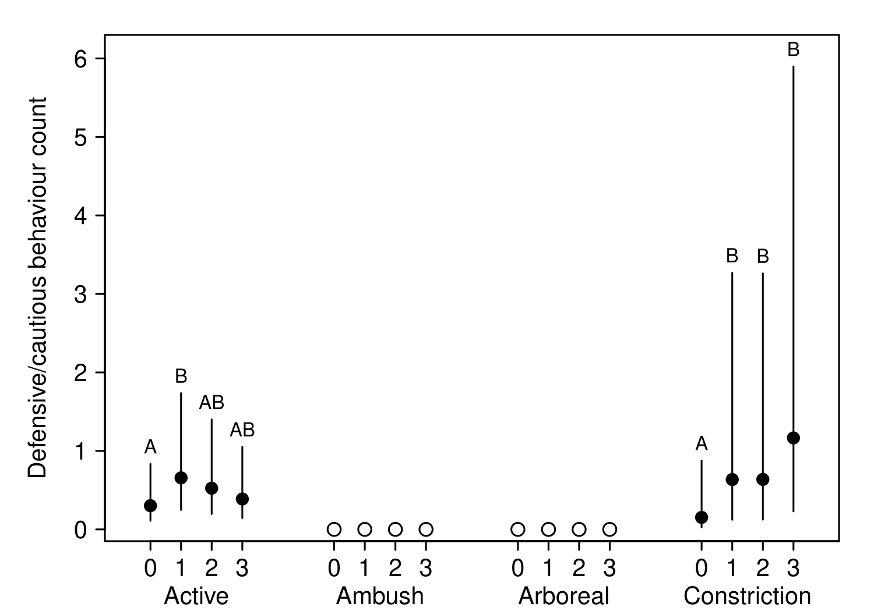

Example plot (quite austere at the moment). Letters are grouped within foraging categories (I didn’t test for significant between group differences between Active 0 and Constriction 0, for instance).

**Tongue Flicks**

Tongue flicks exhibited opposite variance patterns to def/caut behaviours, with nearly 5x as much variation being explained by species compared to individual snakes. So individual age, sex, domestication etc, explained a lot of variation in defensive behaviours, while tongue flicks appear more physiological, with species-specific flick rates that didn’t change much among snakes of a given species. Ignore my lack of snake biology, but could this be a way of separating conscious vs unconscious response to sound. Equivalent of tongue flick in humans might be heart rate or breathing rate?

Great question re whether tongue flicks are conscious or not. I would suspect they are, since it's not crucial to bodily function such as breathing. As snake handlers, we get the 'feeling' that their rate of tongue flicks depends on their mood. e.g. when they're suspicious of food being around, tongue flicks heaps. When they're startled, tongue stops flicking. But of course death adders are the exception b/c they're always in crypsis mode, trying not to be noticed b/c that's how they do. I'd consider excluding death adders from your poisson tongue flick model, and then I imagine it would not be zero-inflated. Even though you somewhat did this by excluding zeros, the trials with very few tongue-flicks would also be death adders.  Anyway, tongue flicks is the most boring behaviour b/c people can't see that, so I'm unphased by it being a dud. But interesting that they didn't change the # of tongue flicks regardless of the sound! It's all cool!

Tongue flicks are quite substantially zero-inflated. This means there were more zeros than we expected under a Poisson model, and because zero is far away from the mean, the variance in our data exceeded Poisson-expectations. When we model as a negative binomial, we have a signal of underdispersion and still have a signal of zero inflation.

So what I did was use the two-step ‘hurdle model’ approach, where I separated out the probability of a snake tongue flicking during the trial, and then the number of tongue flicks in those snakes that flicked at least once. The binary part of the hurdle model was essentially useless, the zero-inflation was all in the ambush group and there was no sound-based effect. So I excluded zeros, modelled the remaining counts and then included the proportion of “at least one” tongue flick as a bar chart above the plot (see below).

Sound did not influence the number of tongue flicks, which I think was the result we got when we were working on this all together. It looks like tongue flicks are a poor indicator of response to airborne sound.

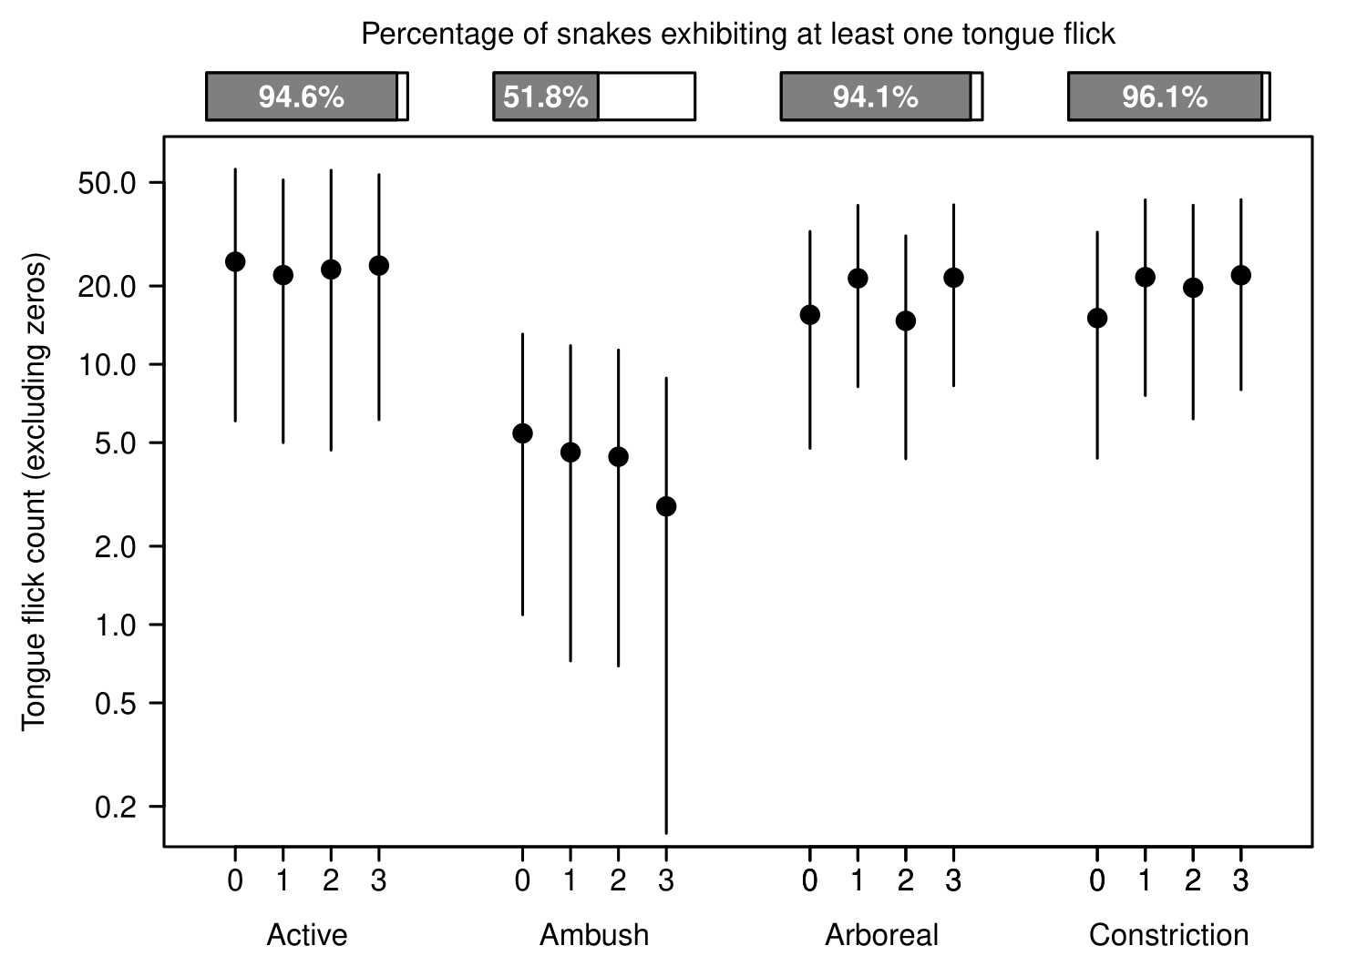

**Movement**

This one has always been the trickiest to analyse. I’ve separated “total additive movement” which represents the snake’s energy output and might be a proxy for agitation in response to the sound. I’ve also pulled out “direction of maximum movement”, looking at whether the snake primarily moved towards, away or orthogonal to the speaker.

For total additive movement, there was no effect of sound treatment. Species and snake explained similar amount of variance, with snake age showing a weak negative trend (older snakes tended to move less).

So instead I looked at whether sound treatment resulted in snakes being more likely to move away from the source of sound, compared with the control. I turned direction of maximum movement into an “away” vs “toward/orthogonal” binary variable.

Sound levels 1 and 2 both resulted in a significant increase in snake movement away from the speaker, which was not linked to foraging mode. Snakes had a 12.7% probability of moving most away from the speaker. In Sound levels 1 and 2, these probabilities were 27.1% and 27.8%, a more than doubling). In terms of raw numbers, 11 snakes moved the most away from the speaker in the controls, with 25 snakes in sounds 1 and 2. Snake species explained no variance in this decision making, likely because I just took the direction with the most distance travelled (so snake species that didn’t travel much might have gone 20cm in one direction, while those that went a long way might have gone 1m, but they were both collapsed into “away” or “toward/orthogonal”.

It’s interesting that only 11 snakes moved towards the speaker out of 77 trials (which is a raw probability of 14.2%). I would have thought we would have seen random movement, with 25% in each direction under the control “null” hypothesis. Instead we saw 14.2% away, 32.4% toward and 53.2% orthogonal (which is left + right). So orthogonal is what we might expect, but there’s a big difference in away vs towards. I thought it might be that the snakes saw toward as a safe space seeing as the speaker was there, but there was also a speaker in the “away” direction, so theoretically the snake should have seen speaker “cover” away vs towards more of the time.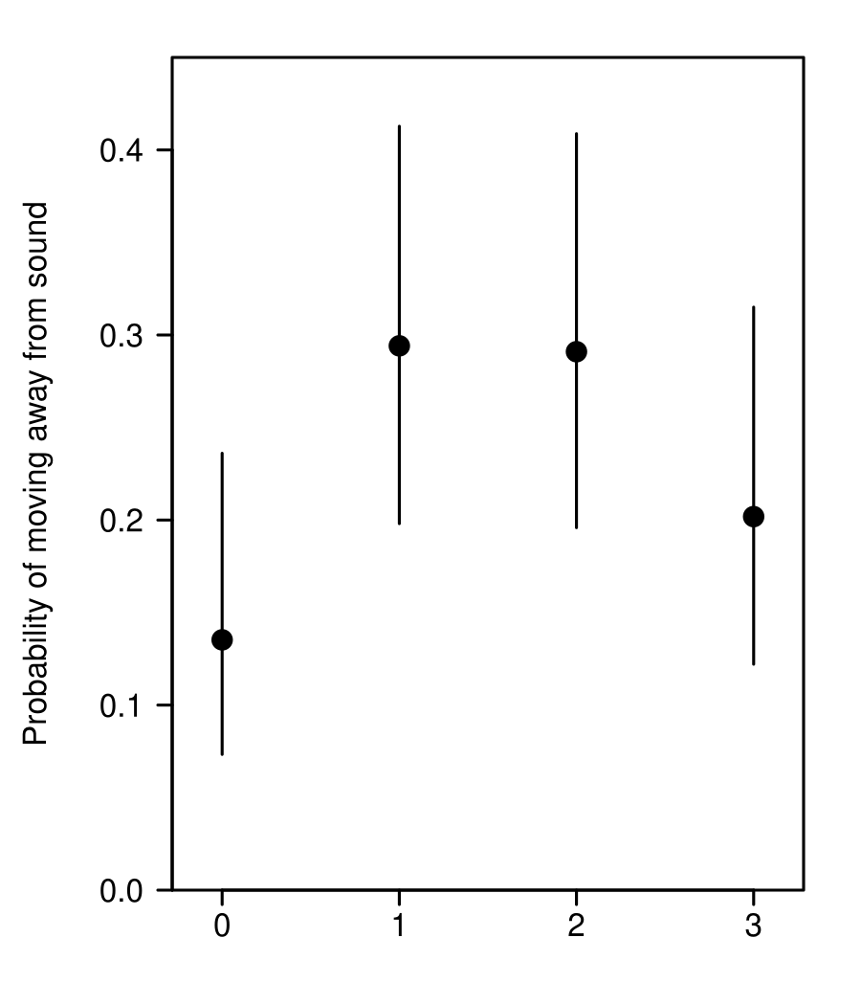 Not sure if you have thoughts about this?

Re away vs toward the speaker movement, it makes sense to me that they would mostly choose to go away, as the sound might be a large predator who might squash them. Or some unknown that they'd rather stay clear of just in case. They're quite cautious scarety cats. I'd certainly be seeing if initial head direction helped to predict the direction they went. B/c it could be that any sound makes them want to bolt and that they don't have good directionality re sound hearing. If we can say the data suggests they have directional hearing capacity, that's a big deal. But we can't say that unless we address the potential that the sound merely stimulated to move in the direction they were facing.