**Q: What is the overlap/correlation of three primary snake behavioural responses in each trial: tongue flicks, defensive and cautious behaviours, and >20cm movement?**

I’ve split this up by genus, with species and snake counts listed, and grouped by forage mode (with space for some lovely snake photos). These bar charts are equivalent to a “tree” style diagram where we break up different combinations of behaviours.

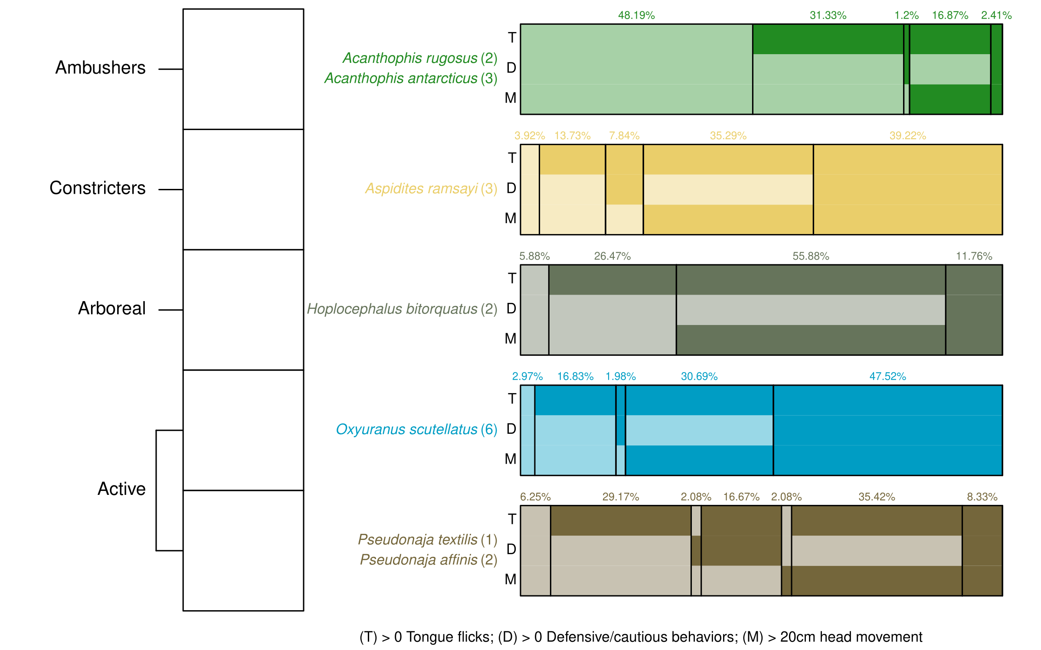

At top right of figure, above the death adders, have a grouping type line above the percentages that shows that all those percentages add up to ‘100% of trials’.

It might be much more easy to compare the columns across all the genera if we separated the rectangle categories out so as to line up the first column together vertically, then the second column together vertically, etc. e.g. the 48.19% Ac would vertically align with the 3.92% of As and 5.88% of H, etc, and then for the vertical column #2, you’d vertically align the 31.33% Ac with the 13.73% As and 26.47% H, et. Hope this makes sense. I can show you on zoom or in person if need be! If we did that, we may need to make this fig landscape and take up a whole page, but it’s the best fig so it’d be worth it, I reckon!

Loving this figure. It’s probably the best quick-view of all the loads of data. Some suggested edits:

* Change Pseudonaja to a red-type colour, as it’s currently too visually close to Hoplocephalus, and Pseudonaja is the biggest killer, so having a colour that jumps out and says ‘danger’ suits this genus well.
* Have all the test bigger font (no smaller than size 10), and defo make the percentages much bigger b/c they felt quite hidden relative to their importance. That is, they’re the *key* to understanding why the subfigures are different for each genus.
* To make the figure more compact and to accommodate larger text, you could stack the genus on top of the species name, and for the genera with multiple spp, you could have the second one written as P. affinis, for example.
* The yellow text is difficult to see. Perhaps a darker yellow might be more contrasty against the white background.
* Perhaps make the thin white lines outlining all the cells/rectangles a bit thicker so more obvious the divisions everywhere.
* To me, it’s not obvious right away what the solid colour means vs the lighter colour. I’m wondering for quick interpretation support, we could put something in the quick legend at the bottom of the figure. I understood the concept only when you gave the example of ‘~50% of death adder trials had 0 out of 3 behaviours, and 31% where there was a tongue flick with no other behaviours’. Ditto for Lachie- it took us both a while to work out the solid vs light colour dealio.
  + Along these lines, I think if you make the lighter colour even lighter/ more transparent, it would be more obvious that it means ‘nothing to see here’ sort of thing. I thought the light colour meant something else besides ‘nothing’.

Proposed groupings of species:

Ambushing Elapidae

Active Elapidae

Arboreal Elapidae

Active/arboreal Pythonidae

I’m hoping this is relatively easy to interpret, such that ~50% of death adder trials had 0 out of 3 behaviours, and 31% where there was a tongue flick with no other behaviours.

This figure accomplishes three things. First, it highlights the sorts of behaviour we observed (taipans are cranky and move a lot, death adders sit around and do nothing etc). It also helps to justify a genus-based nesting rather than foraging-mode, as the two active genera exhibit very different patterns of behaviour (the browns and dugites were far less likely to be defensive/cautious).

I think this fig does well to show this, and I think that’s a very interesting point to reveal re the data.

Finally, it also justifies where we exclude genera from models (so excluding *Acanthophis* and *Hoplocephalus* from the defensive model).

Also important to do.

**Q: Is the probability of defensive/cautious behaviour altered by sound treatments?**

Binomial mixed-effect GLM, modelling genus x sound treatment probability of exhibiting defensive or cautious behaviour, including an effect of ln(snake age) and different predictions for male and female snakes. Included random intercepts for individual snakes (explained a lot of variation), trial block (barely explained anything) and side of room the sound came from (explained zero). Death adders and pale headed snakes were not modeled because they exhibited so few behaviours (as per the previous figure).

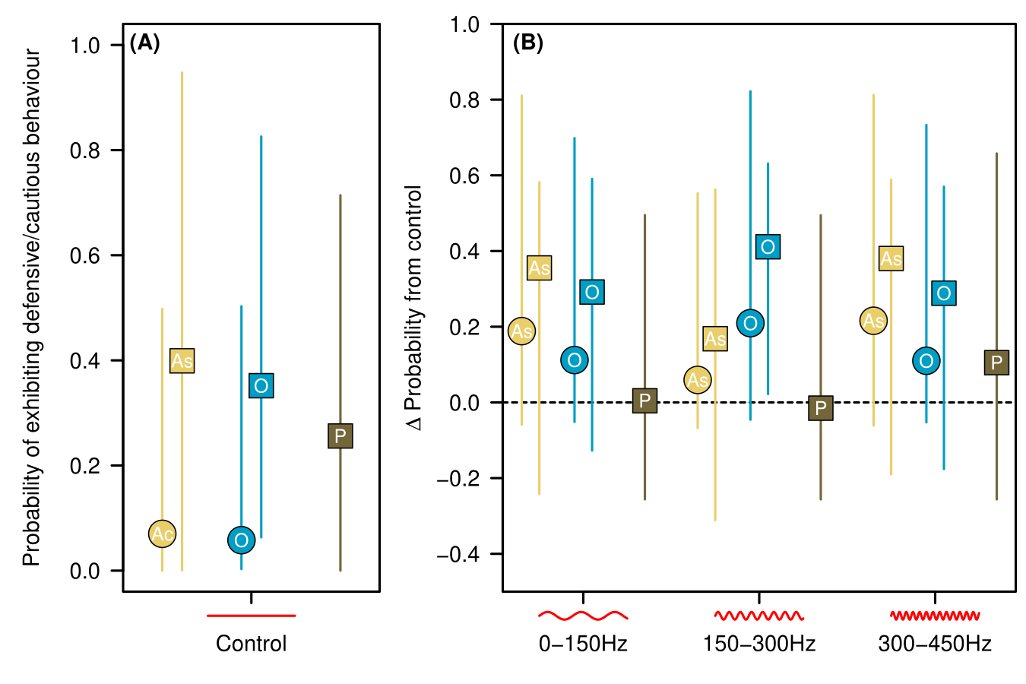

Ac should be As b/c Ac was not modelled. Also, why is there two each of Aspidites and Oxyuranus, but only one Pseudonaja? It appears like the main take-home here is that the sounds make the snakes a bit more defensive/cautious, but it doesn’t matter which sound was played. Just the fact that sound was played.

Love the visual of the sound throughout these figs. Very nice touch!

Confidence intervals are wide in the three modelled genera because there was substantial within-snake variance, even after accounting for sex and age. This limited our ability to detect significant trends.

This is where we, in the paper, call for future research should use wild snakes to reduce the within-snake variability caused by varying years each snake has spent in captivity listening to loud music during weekly cleaning days, thus desensitising some more than others to sound.

We do see some indication that the pythons and taipans increased behaviours with sound treatments, particularly with sound level 2.

This is in line with previous work showing greater sensitivity to lower frequencies. However, we would have expected sound 1 to have the greatest response b/c previous work had 80–160Hz as greatest sensitivity range, which mostly sits within the range of sound 1. So perhaps these snakes have slightly different internal ear morphology resulting in different sensitivity range to sound? We would then say future research should scan their heads to see their morphology and transmitability of sound through the tissue in the head of these snakes. Testing the transmittability of sound through certain parts of the head is something that we may do at QUT if we win a grant. Likewise, we can do as per Poulsen et al (2021) re imaging snake brain responses to different sounds, as per:

Interesting that active and constriction hunters showed such similar response, yet different response from other active genus (with browns and dugites). Ecological reasoning for why that might be?

Yes, I think there is. When eastern browns encounter humans, about half of the time they retreat and half of the time they were found to rely on crypsis (staying still) (Whitaker and Shine, 1999). If the snakes interpret our sound as potential predator or beast that might step on them, then this could explain the staying put, but having said that not any more so than evading the stimulus. Unfortunately, we have no such comparison for any other snake species in the study, including taipans. People’s impressions is that taipans are extremely difficult to catch because always run away so fast, but brown snakes will hold their ground if need be. We will be on unsteady ground discussing this, but it’s still probably worth discussing b/c non-australians and non-herpers will have no clue about this.

Re the constrictors, the species we use does a fair amount of active foraging too, so we may need to include this species in two categories for fig 1: constrictors and active foragers. In a 21mo intensive tracking study published in 2013 by Melissa Bruton, she found that ﻿snake movements indicate an active foraging strategy predominates, but that ambush behaviour also observed. So our fig foraging categories are problematic re the woma python. One solution is we can call womas active, constrictors, and arboreal (in that order), adding commentary that they predominantly are active foragers, then ambush, then arboreal. I considered alternatively switching to a body morphology as a means of breaking up the snakes, but I kept going back to foraging mode words of description.

We can also point out for future work that head size may be of interest to consider with respect to their response to sound, as a larger heads may have a greater capacity to receive or distinguish b/w sound frequencies (I have to dig this out of the literature). That is, they may have greater resolution in differentiating sound frequencies (so can hear more clearely) compared to smaller heads. A direct brain measuring and imaging study may help answer this question.

**Q: Does the type of defensive/cautious behaviour change based on sound treatments?**

Given that we didn’t observe much of a change in the probability of these behaviours, maybe snakes were changing the types of behaviours they exhibited? This is an ordination where each genus x sound combination is a replicate (or “site”), and each defensive/cautious behaviour is a “species”. Counts were relativized to the total # of defensive/cautious behaviours exhibited in the genus x sound combination. Bra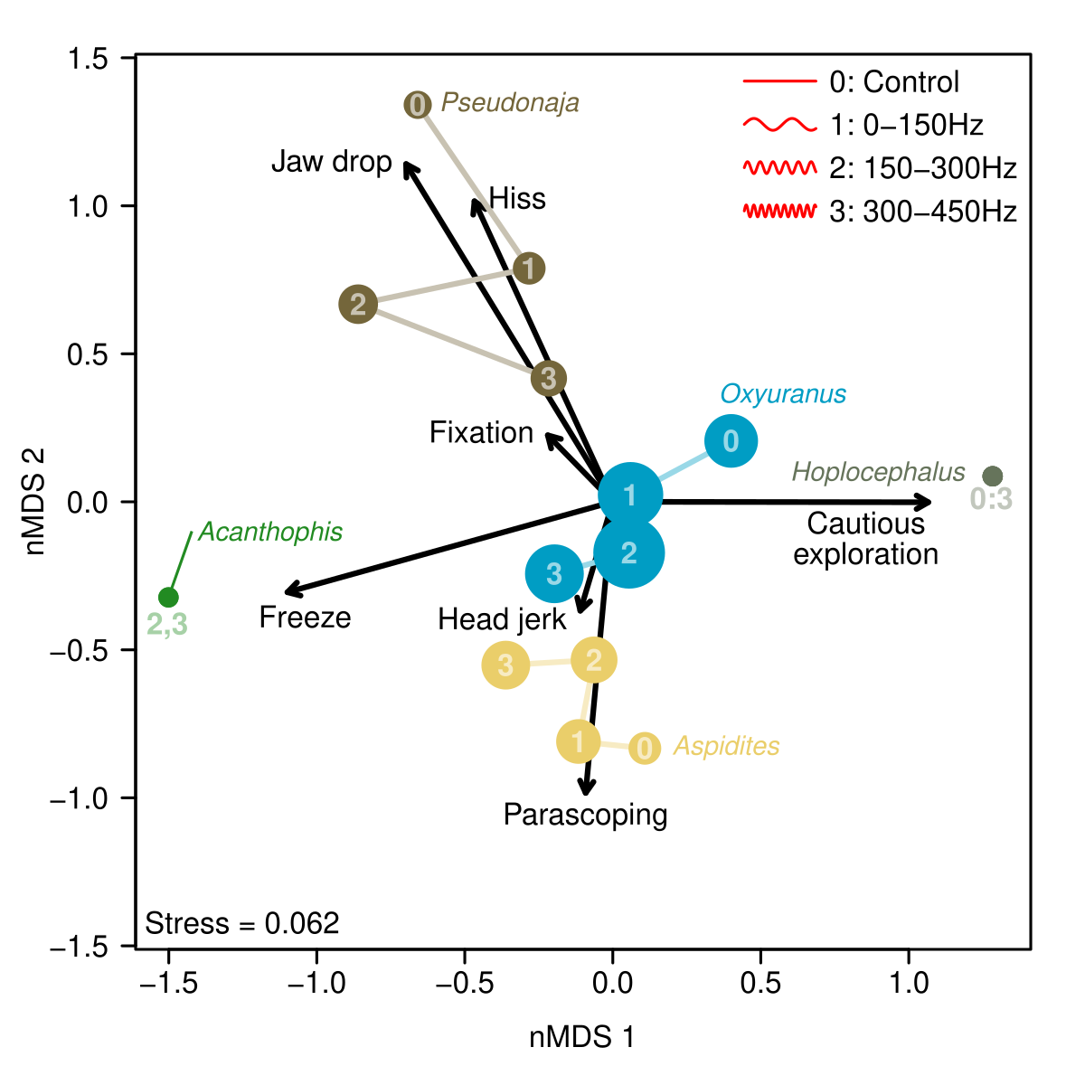y-curtis dissimilarity, very low stress. Point size is relative to the number of behaviours observed.

It’s ‘Periscoping’ not ‘parascoping’, sorry! I probs misled you somewhere in the spreadsheet!

Chris also found this figure quite tricky to work out. He doesn’t understand the length of the arrows. Nor why there are lines connecting the circles within a genus. Also, some things we observed don’t seem to align with the figure (probs b/c the observation is being pulled in ordination space). Such as taipans doing more fixation behaviour than almost any other species, but here it seems that brown snakes do more fixation (or at least in sound 3) b/c it’s closer to the fixation arrow. Maybe it’s not a figure to show specific responses, and fig 1 is better at this? Perhaps if we have a super clear figure caption (to explain to people with zero stats knowledge) and an example of how to interpret the size and location of one of the sounds (dots) of one of the genera, it would be worth including, but it’s quite difficult. I think we need to explain it to people as if they’re a 7-year-old (says Michael Scott from the Office!) I suppose in the least, this fig shows different species respond differently (the colours group together). Eg. How the snakes interpret the sound alters their response to it, and different species interpret the sounds differently.

I think this will be also an important figure re diving down into the data, but Lachy and I found the black arrows confusing re how they relate to the dots with numbers in them (probs b/c we’re not all that used to these types of figs). E.g. the brown #2, does it go left relative to 1 and 3 b/c it represents fixation and not hiss or jaw drop? Maybe there’s a way to pattern-code the behaviour while colour coding the genus? That way you can quickly interpret both and not get confused what behaviours the numbers and circles are referring to. Or maybe I need in-person explaining re this fig. But if I do, then our readers may struggle too. Ah, I read the number in the dots as replicates, but they refer to the sound! Just clicked on that front. It’s not intuitive though re 0:3 for hoplos and 2,3 for acanthophis. Hmmmm. And if we can remove the indicator line from acanthophis, I think that would reduce confusion with arrowed lines. b/c hoplos don’t have the indicator line, so I’m not sure why acanthophis has one.

And I’m guessing that the further the 1,2,and3 are from 0, the greater our confidence is that they’re actually responding to the sound?

Two interesting results. One general one is how clustered genus behaviours are (browns hissed and dropped jaws the most, death adders only froze, etc). This is cool. Patterns to me in this regard sho

Second result is that there appears to be some change in behaviour in the sound treatments. Even though the browns don’t increase in behaviour, their behaviour changes. Jaw drops and hisses don’t decrease, but we see some occurrence of fixation, freezes and head jerks. Taipans increased in head jerks and freezes. Aspitides froze more. Overall this suggests a decrease in “aggressive” behaviours and an increase in “cautious/avoidance” behaviours in these genera. No response from pale-headed snakes, and death adder response might suggest dominant freezing response (at sound levels 2 & 3), but overall defensive/cautious behaviour count was extremely low, so not enough samples to really tell.

It’s important to note that because of the relatively small sample size, these are more ‘indications’ or ‘fingerprints’ of behaviour change rather than really robust results. A single record of a behaviour is enough to move one of these points a decent amount across the plot, because the ‘abundance’ of behaviour is pretty low.

This is a very important point that we need to strongly make. This will also allow us the leverage to point to future work, saying that it is clear there is a response, but due to captivity and low sample sizes, we cannot confidently predict how each species will respond to sound. But that the next step is using wild snakes and more individuals within a species.

I think they’re still interesting though!

**Q: Is the probability of tongue flicks altered by sound treatments?**

The overarching results don’t change no matter whether we use ‘probability of at least one tongue flick’, or look at actual tongue flick count. Overall, tongue flick probability doesn’t change across sound treatments. Only real result is in the behaviour overview (first figure) where death adders only tongue flicked half the time, and every other genus tongue flicked in >90% of trials.

I think this shows that tongue flicks are often used in every situation, revealing the reliance that snakes have on this sensory option.

**Q: Do sound treatments alter the probability of snake movement?**

While movement was recorded in 10cm increments, there was a natural break between snakes that “didn’t move or barely moved” and those that “substantially moved”, which was 20cm. So I split the movement data into two groups and looked at the probability that a snake moved at least 20cm.

Model was a binomial mixed-effect GLM, modelling genus x sound treatment probability of moving >20cm, including an effect of ln(snake age). Included random intercepts for individual snakes (explained a lot of variation), trial block (barely explained anything) and side of room the sound came from (explained zero).

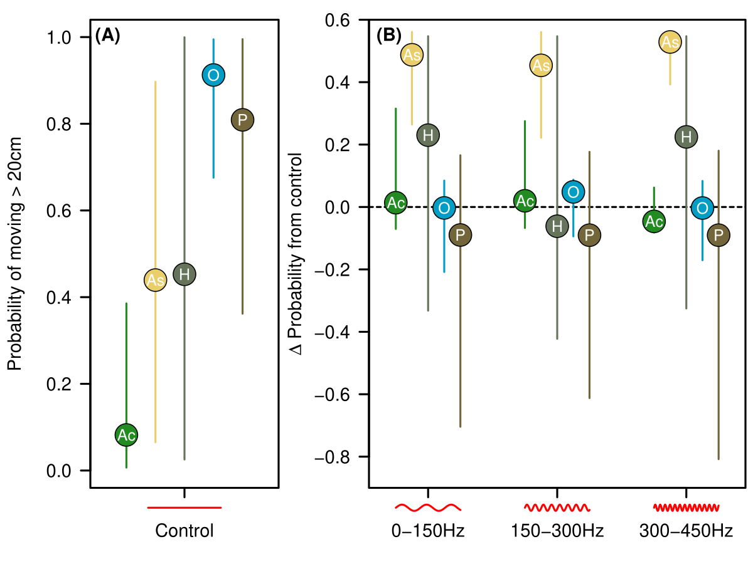Two interesting results. First is the between-genera variation. Death adders rarely moved, taipans and browns were the most active, and the other two genera varied wildly between individual snakes.

This is great to see b/c, when conducting the trials, it was super obvious to us that Elapid Boy was very much responding to the sound. He must have pulled his genus’ data up in subfigure B, I would imagine. But maybe the other two individuals did a fair amount of first-third-of-body movement too.

It’s nice to see in A that As and H stick together and O and P stick together, with Ac down below. I think this will make good sense to people, giving them and us a bit more confidence in our experiments. b/c if the controls are buggered, it’s all buggered. But the controls certainly make sense with everything herpetologists know about these species.

When we considered the effect of sound, the pythons were all much more likely to move compared with controls, with other genera showing no real pattern. What is it about constriction hunters that make them more likely to move? Do they rely less on information from other senses?

Maybe it’s their large body size being able to receive more of the sound stimulus? That is, they were all much bigger and heavier and larger surface area than all other snakes. It could be ecological too, though, in that they’re also a desert snake whereas all the other ones are coastal or woodland/forest. So maybe there’s something about their habitat that makes them more wary of predators/beasts. It’s of course important to think of these species in evolutionary time scales like tens of millions of years and what occurred where they lived back in the day when their species was evolving. I’ll have to think about this and look into what we know about extinct species like megafauna in Australia.

Taipans and browns typically rely on their eyesight to detect prey or predator. In the presence of the sound, they hold still in order to detect movement. Often they raise their heads in response to a stimuli to then look and reinforce what they’re detecting. They prop up their heads in response to potential predators or prey b/c they’re a visual animals. Vs Womas can’t see for shit- very poor vision in comparison.

**Q: Do sound treatments alter the direction of snake movement?**

As with the defensive/cautious behaviours, some of the non-results above might obscure changes in HOW snakes moved in response to sound. This is where we looked at the direction of snake movement, only including snakes that actually moved > 20cm. Simplest way to do this was to divide movement into “away from speaker” versus “everything else”. This hopefully captures snake avoidance mechanisms.

Initial head direction did not explain sufficient variation to warrant inclusion in the model. i.e. these results were not dependent on which way the snake was facing.

That’s excellent. Gives us and the reader confidence in our data. Great we collected that variable, and great it didn’t affect their responses re movement away or toward the speaker. That would make future experiments very difficult otherwise.

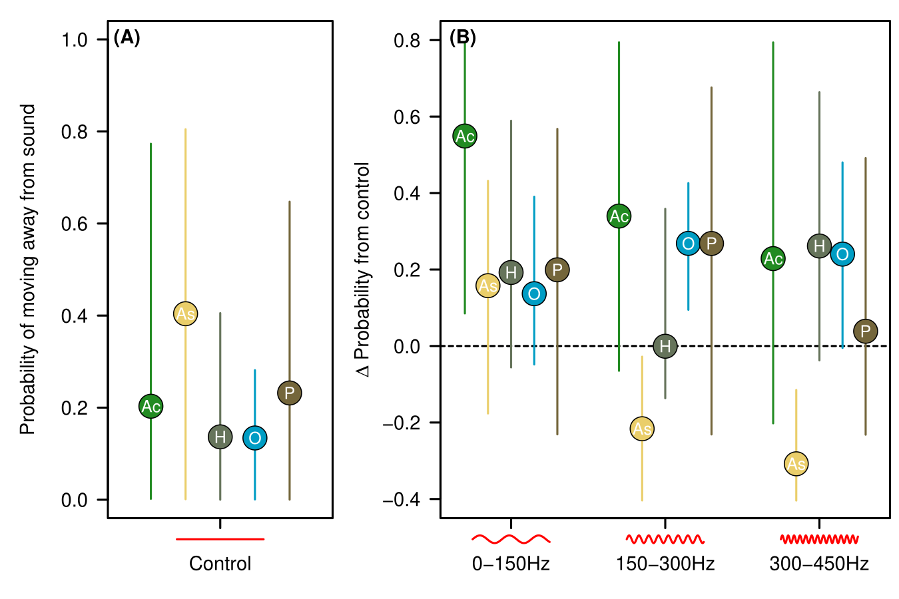

So the probability of moving away varied in the control, with the weird preference for taipans to move towards the sound (hence their low probability of moving away from sound) – to be explored further!

I’d say in A we need to put inverted commas around ‘sound’ in the y-axis b/c sound did not play. So it might be worth saying ‘speakers’ here and then clarifying in methods or even the figure caption that, since there were speakers on both sides of the room, we take ‘speakers’ as to mean the side of the room where sound was planned to play according to our randomisation of where sound was played from.

Why do womas go toward the speaker and taipans go away?

Taipans might be thinking that they’re going away from threat, and womas toward a prey item. But why in this pattern across these two species?

Possibly higher frequencies emitted by smaller prey vs larger prey items and pythons taking larger prey items.

Perhaps Womas more likely to interpret the sound as prey as opposed to predators b/c of fewer predators. Larger pythons would have fewer natural predators than smaller active snakes throughout the day. Reduction in number and types of predators in the night. Birds of prey being biggest predators of snakes, and also monitor lizards, both of which are diurnal. Maybe diurnal snakes are more shit-scared (very timid creatures) of the sound b/c they live in a more dangerous world than nocturnal snakes and so are therefore more likely to interpret the sound as potential predator. Therefore, large pythons such as womas may be more willing to interpret sound as potential prey, not predator.

Important to note that these animals were tested in their active temperatures, so their response here is a response when they’re active with heightened alertness.

In the sound treatments we find some interesting results. Most interesting are the taipan increase in probability of moving away from speaker in sound 2 & 3, and the decrease in python probability suggests they were more likely to move TOWARDS the speaker. This could be an exploratory response, that is investigating a stimulus. Why them and not others I’m not too sure. I’ll see if Chris has an idea. He’s been working night-shift so our overlap awake time has been quite limited lately, making spare time and a meeting with him hard. And we’re also buying a property! So we’ve been dealing with all of that lately : ).

It’s probs also worth specifically commenting on the death adder movement away from the sound in sound 1 b/c that’s quite clear. They’d be the most vulnerable to being trodden on since they’re such slow moving snakes.

Coupled with the increase in python probability of moving at all with sound, this suggests sound might stimulate prey hunting strategies, while in other snakes (like taipans), it stimulates predator avoidance?

This conclusion is tempting, I agree. And maybe being a bigger snake (kilograms rather than grams heavy), they don’t have to avoid beasts as much as the smaller, perhaps more vulnerable snakes.

Maybe? I’m not a snake biologist, but there could be something cool here.

Overall comment: I’m wondering if we have a summary table of genus on the left and likely behavioural responses to sound on the right (perhaps 3 columns, one for each of the sound). That is, taking all these figures and making a bit of a summary table that one can look at and see for, eg, what death adders are likely to do in response to sound 1,2,and 3, and ditto for brown snakes.