## Abstract (currently 286 words)

Although snakes lack an outer and tympanic middle ear, evidence strongly suggests they can still hear. However, no study to date has tested the natural behavioral response of snakes to sound. Using 19 snakes across five Australian snake genera, we conducted a controlled experiment to investigate the effects of airborne sound on snake behaviour and movement. We quantified body movement and six defensive or cautious snake behaviours (e.g. hissing, head-flicks, lower jaw drop), comparing responses to sounds played at three frequencies (0–150Hz (S1) 150–300Hz (S2) and 300–450Hz (S3)) to no sound controls. We found all snake responses were strongly genus-dependent. Only one genus (Woma Pythons) showed an increase in the probability of movement in response to sound, but we observed signs that three other genera (death adders, taipans and brown snakes) were more likely to move away from the source of sound, signaling potential avoidance behavior. Only one genus (taipans) increased their likelihood of displaying defensive or cautious behaviors in response to sound (only to S2), but three of the five genera showed a substantial shift in the types of behaviors. The behavior difference between genera in S3 was *c*. 50% of that in controls, highlighting a potential convergent behavioral response of snakes to airborne noise, across both elapid and python species. The consistency of observed patterns within genera provide insights into both variability and consistency in behavioural responses to sound among different snake genera.

**Methods**

Data analysis

All data processing and statistical analyses were conducted in R version 4.02 (R Development Core Team, 2018)⁠.

Summarizing snake behavioral responses

Defensive and cautious behaviors included six distinct behaviors: freezing, hissing, fixation, head jerks, lower jaw drops, periscoping and cautionary exploration. We converted the sum of these for each trial into a binary variable, whether at least one defensive/cautious behavior occurred. This binary variable was modeled as a response variable in one of the probability models.

Many snakes recorded small head movements during trials. We summed head movement in all directions to reflect the magnitude of movement. We observed a natural division between snakes with < 20cm head movement and those with substantially larger movement. We divided movement into less than and greater than 20 cm binary category for probability modeling.

Movement response does not resolve whether snakes were moving towards or away from the sound, which has different biological implications. As such, we constructed an additional model only for snake trials with >20 cm head movement. We constructed a binary variable, with all trials with the greatest magnitude of head movement occurring away from the speaker as successes, and with all other trials treated as failures. This model estimated the probability that snakes moved away from the speaker. We excluded all trials where we did not observe >20cm head movement from this model.

Sound treatment models

We tested for an effect of sound treatment using Bayesian hierarchical models (brm function, brm package (Bürkner, 2017, 2018)⁠, fit with two interacting fixed effects: sound treatment (four level factor) and snake genus (five level factor). We excluded *Acanthophis* and *Hoplocephalus* trials from the defensive/cautious behavior model due to their lack of non-zero trials.

We specified a Bernoulli likelihood function with vague uninformative priors for intercept and slope terms (normal distribution with μ = 0, σ = 5). We specified random intercept for each snake, each block of trials and the two speaker directions, with cauchy priors (μ = 0, σ = 5). Models were run across four chains for 10,000 iterations each, 5,000 warm-up and 5,000 for sampling, for a total of 20,000 sampling iterations. We set adapt delta to 0.999 and max treedepth to 15 to reduce divergent transitions. Chain convergence in models was evaluated via R-hat scores. Model validation was performed via residual simulation (DHARMa package, (Hartig, 2020)⁠), including model uniformity and dispersion tests, and leave-one-out cross validation (loo function, loo package, (Vehtari et al., 2017)⁠).

We visualized snake response to control conditions as the mean posterior probabilities made at the population scale (i.e. ignoring random effects), with corresponding 95% credible intervals. To estimate the response difference between control and treatments, we subtracted each genus’ control posterior draws from the posterior draws from each respective sound treatment. This put each genus on an equivalent ‘difference from control’ scale. The means of these resulting distributions reflect mean difference from control to treatment; whereby if the 95% credible intervals of these differences do not cross zero, it suggests evidence of a substantial difference in response probability between the control and treatments.

Two models initially included additional variables; the defensive/cautious behavior model initially included snake sex and movement away from speaker model initially included initial head direction. These additional variables did not improve model fit, as determined via comparison of leave-one-out cross-validation information criteria (LOOIC), interpretable as per AIC. Defensive/cautious models with and without snake sex had LOOIC scores of 223.9 and 223.5 respectively, and movement away from speaker models with and without initial head direction had LOOIC scores of 378.8 and 372.9 respectively.

nMDS of defensive/cautious behaviors

We also explored whether the composition of defensive/cautious behaviors changed based on sound treatment and genus identity. We summed all defensive behaviors for all snakes of a given genus for each sound treatment. We converted these to relative abundance measures (dividing by the total sum of behaviors in that genus-sound treatment combination). These formed the rows of a compositional matrix, with behaviors as columns. We visualized differences in composition using non-metric multidimensional scaling (metaMDS function, vegan package (Oksanen et al., 2020)⁠), using Bray-Curtis dissimilarity. We also tested for whether genus or sound treatment significantly affected composition of defensive/cautious behaviors using a PERMANOVA with 999 permutations (adonis2 function, vegan package (Oksanen et al., 2020)⁠).

**Results**

Genus-based responses

In control trials we observed substantial inter-genus differences in our three target behaviors: tongue flicks, defensive and cautious behaviors and head movement (Fig. 1). Trials in all genera except *Acanthophis* contained a close to 100% tongue-flick response. Exhibiting defensive and cautious behaviors was less common, with genera likely to exhibit a target behavior in 20-30% of control trials, with the exception of *Hoplocephalus* (15%) and *Acanthophis* (0%). Substantial head movement was greatest in *Oxyuranus* snakes, although was observed in at least *c.* 50% of trials for all genera except *Acanthophis*.

Defensive/cautious behaviors

We observed substantial variation in the likelihood of defensive and cautious behaviors in different snakes. Bayesian R2 scores were 0.206 (marginal, fixed effects only: 95% CIs 0.084-0.317) and 0.425 (conditional, fixed and random effects: 95% CIs 0.372-0.475), suggesting random effects were equally important as genus and sound treatment factors in explaining the likelihood of defensive or cautious behaviors. Estimates of the standard deviation of random effects were 1.04 for the room the sound was played on, 0.71 for block of trials, and 2.90 for snake identity, suggesting most of the conditional variance was due to between-snake differences in the likelihood of exhibiting a defensive or cautious behavior.

This within-snake variation contributed to results with wide credible intervals (Fig. 2A-B). Even so, we observed an increase in the likelihood of defensive or cautious behaviors in *Oxyuranus* in all three sound treatments (relative to control), and a lesser effect with *Aspidites* in the S1 and S3 treatment.

While the probability of observing these behaviors was not strongly linked to sound treatment, especially in *Pseudonaja*, we observed differences in the composition of these behaviors across each genus, and between sound treatments (Fig. 2C). We found that genus identity explained 88.913% of the variation in behavior composition (F4,17 = 36.279, *P* = 0.001), with sound treatment contributing an additional 3.605% (F1,17 = 5.884, *P* = 0.001), and no significant variation explained by their interaction (2.580%: F4,17 = 1.053, *P* = 0.421). All three genera in the probability model (*Aspidites*, *Oxyuranus* and *Pseudonaja*) were defined by different sets of behaviors in the control trials, and behaviors changed across the three sound treatments. *Aspidites* became more likely to freeze and less likely to periscope, *Oxyuranus* increased in freezing, head jerks and was less likely to hiss and cautiously explore, and *Pseudonaja* became less likely to hiss and more likely to freeze, head jerk and periscope (Fig. 2C). Behavior composition between genera became more similar as sound frequency increased; Bray-Curtis dissimilarities between control trials for these three genera were *c.* 2x larger than behavior composition in the S3 sound treatment (*Aspidites-Oxyuranus*, 0.657 vs 0.298; *Aspidites – Pseudonaja*, 0.786 vs 0.444; *Oxyuranus-Pseudonaja*, 1.000 vs 0.576).

Snake movement

Snake movement patterns varied by genus. *Acanthophis* was the least likely to move and *Hoplocephalus*, while quite likely to move, rarely moved more than 50cm from starting position (Fig. 3A). The other three genera exhibited a range of movement, with *Aspidites* showing uniform patterns of movement between 0cm and 1m, and *Oxyuranus* and especially *Pseudonaja* likely to either stay still or move a substantial distance (Fig. 3A).

The probability of head movement greater than 20cm also varied by genera. *Acanthophis* was the least likely to move in control trials, *Oxyuranus* the most, and the other three genera varied strongly based on snake identity (Fig. 3B). Marginal and conditional R2 values were 0.365 (95% CIs = 0.256-0.454) and 0.504 (CIs = 0.469-0.538) respectively. Most random variation was explained by differences between individual snakes (SD = 2.04), compared with trial blocks (SD = 0.23) and speaker sides (SD = 0.92).

In the three sound treatments, we observed a consistent increase in the probability that *Aspidites* moved compared with controls, especially in S3, where almost all trials resulted in movement (Fig. 3A, C). Other genera showed no response in the probability of movement.

When considering the direction of movement, all genera showed a low likelihood of movement away from the speaker, consistent with random choice of direction (*c.* 25%). We found *Acanthophis* was more likely to move away from the sound in S1 and S2 treatments, and *Oxyuranus* was more likely to move away in S2, with slightly lower probabilities in S1 and S3 (Fig. 3D). *Pseudonaja* showed a weak propensity towards greater probability of movement away from the sound source in treatment S2, but not in S1 and S3. While no *Aspidites* differences were likely to be non-zero, we observed a trend from movement away from the sound source in treatment S1 to a trend to move towards the sound source in treatment S3.

**Reference List**

Bürkner, P.-C. (2017). {brms}: An {R} Package for {Bayesian} Multilevel Models Using {Stan}. *Journal of Statistical Software*, *80*(1), 1–28. https://doi.org/10.18637/jss.v080.i01

Bürkner, P.-C. (2018). Advanced {Bayesian} Multilevel Modeling with the {R} Package {brms}. *The R Journal*, *10*(1), 395–411. https://doi.org/10.32614/RJ-2018-017

Hartig, F. (2020). DHARMa: Residual Diagnostics for Hierarchical (Multi-Level / Mixed) Regression Models. R package version 0.3.3.0. In *https://CRAN.R-project.org/package=DHARMa*. https://cran.r-project.org/package=DHARMa

Oksanen, J., Blanchet, F. G., Friendly, M., Kindt, R., Legendre, P., McGlinn, D., Minchin, P. R., O’Hara, R. B., Simpson, G. L., Solymos, P., Stevens, M. H. H., Szoecs, E., & Wagner, H. (2020). *vegan: Community Ecology Package*. https://cran.r-project.org/package=vegan

R Development Core Team. (2018). A Language and Environment for Statistical Computing. In *R Foundation for Statistical Computing* (Vol. 2, p. https://www.R-project.org). http://www.r-project.org

Vehtari, A., Gelman, A., & Gabry, J. (2017). Practical Bayesian model evaluation using leave-one-out cross-validation and WAIC. *Statistics and Computing*, *27*(5), 1413–1432. https://doi.org/10.1007/s11222-016-9696-4

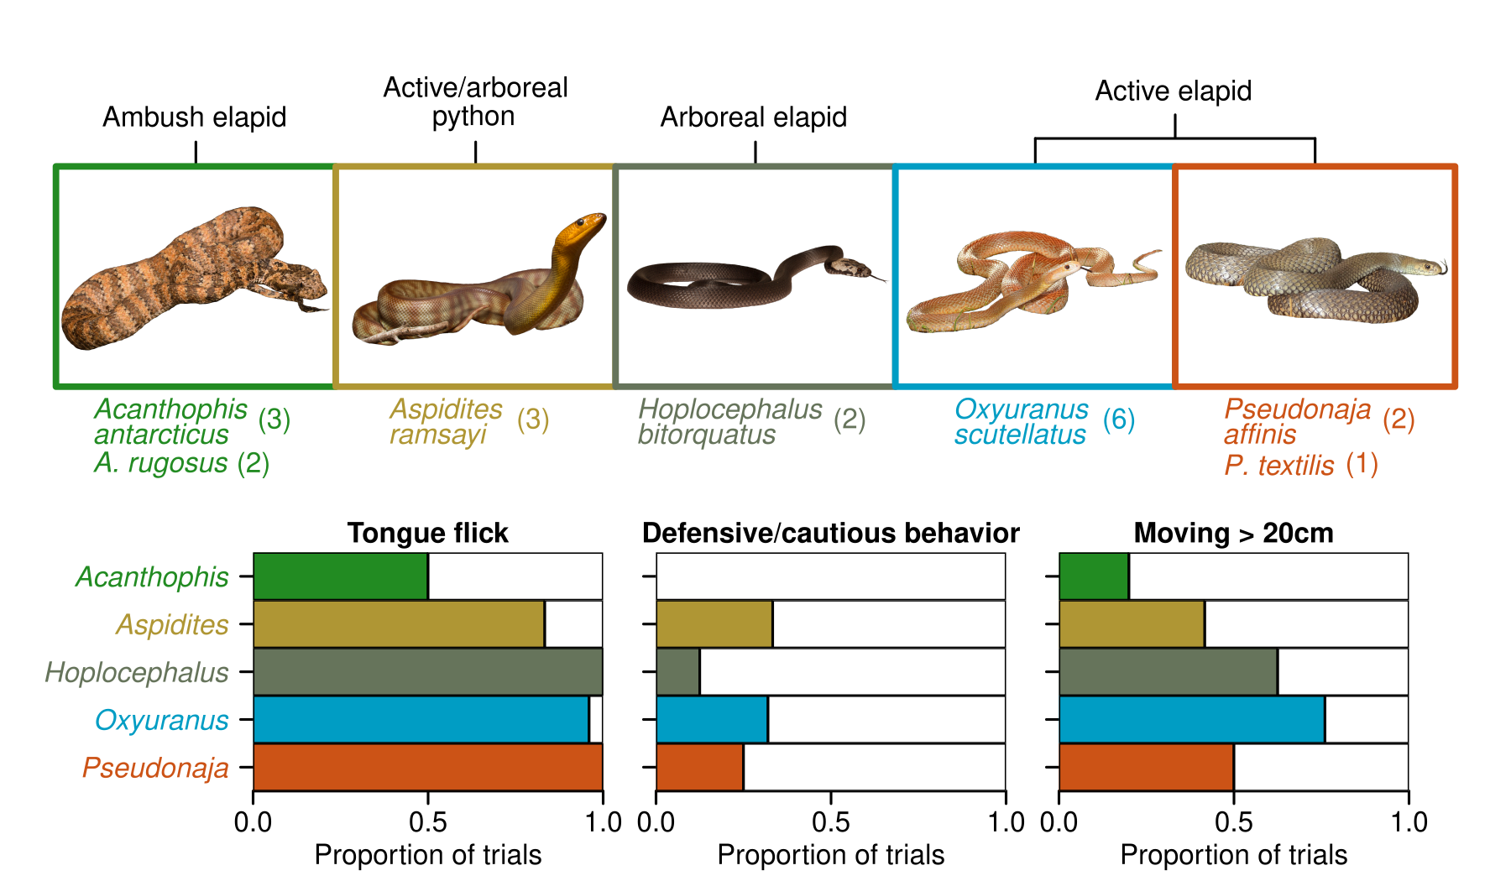

**Figure 1:** Genus groupings of snakes, snake count per species and presence of three dominant behaviors (tongue flicks, defensive/cautious behaviors and >20cm movement) as a proportion of control trials. Defensive/cautious behaviors included cautious exploration, fixation, freezing, hisses, head jerks, jaw drops and periscoping. Snake images are not to relative scale. Image credits to CNZ: *Acanthophis*, *Aspidites*, *Hoplocephalus*; to CJH: *Oxyuranus*, *Pseudonaja.*

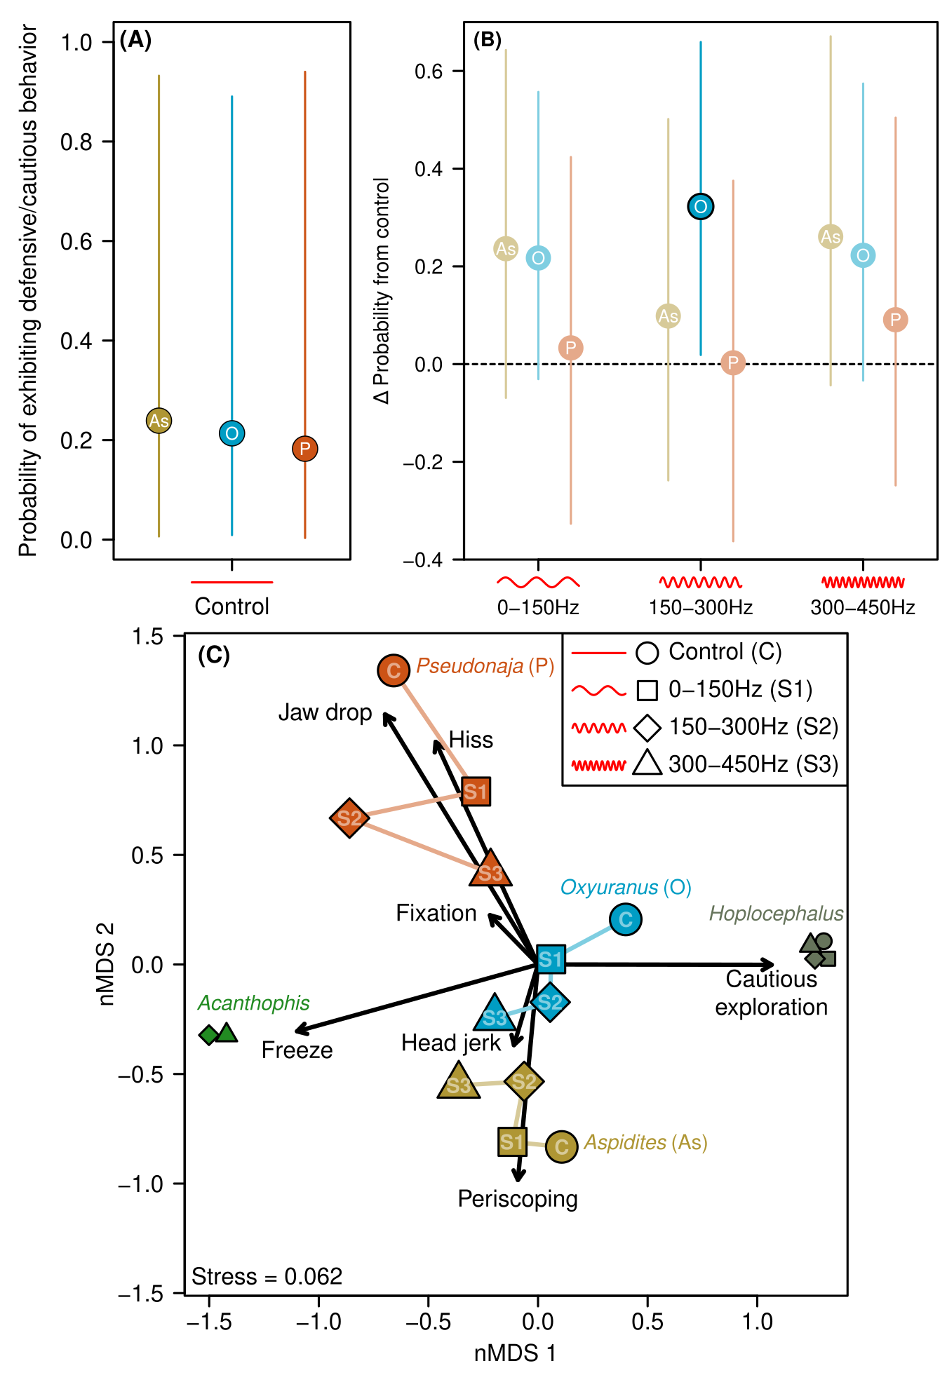**Figure 2: (A)** Mean probability of exhibiting defensive or cautious behavior in control trials for three snake genera with sufficient response (Fig. 1). Behaviors included cautious exploration, fixation, freezing, hisses, head jerks, jaw drops and periscoping. Lines represent 95% credible intervals.**(B)** Change in probability of exhibiting defensive or cautious behaviors from the control to each of three sound treatments. Values above one indicate increase in probability, and vice versa. Faded points had credible intervals crossing zero, suggesting no change in probability from control. **(C)** Non-metric multidimensional scaling of defensive/cautious behaviour composition for each genus-sound treatment combination. Points with similar behavior composition are clustered on the plot. Arrows reflect weighted behavior centroids, where points in the same direction as arrows exhibited more of those behaviors, with arrow length proportional to strength of influence. Differences between control (“C”) and treatment points (“S1”, “S2” and “S3”) suggest the type of exhibited defensive behaviors changed in response to sound treatments. Symbols for the control and sound 1 are omitted for *Acanthophis* due to no behaviors being exhibited in those trials. Numbers are omitted from *Acanthophis* and *Hoplocephalus* symbols due to space constraints.

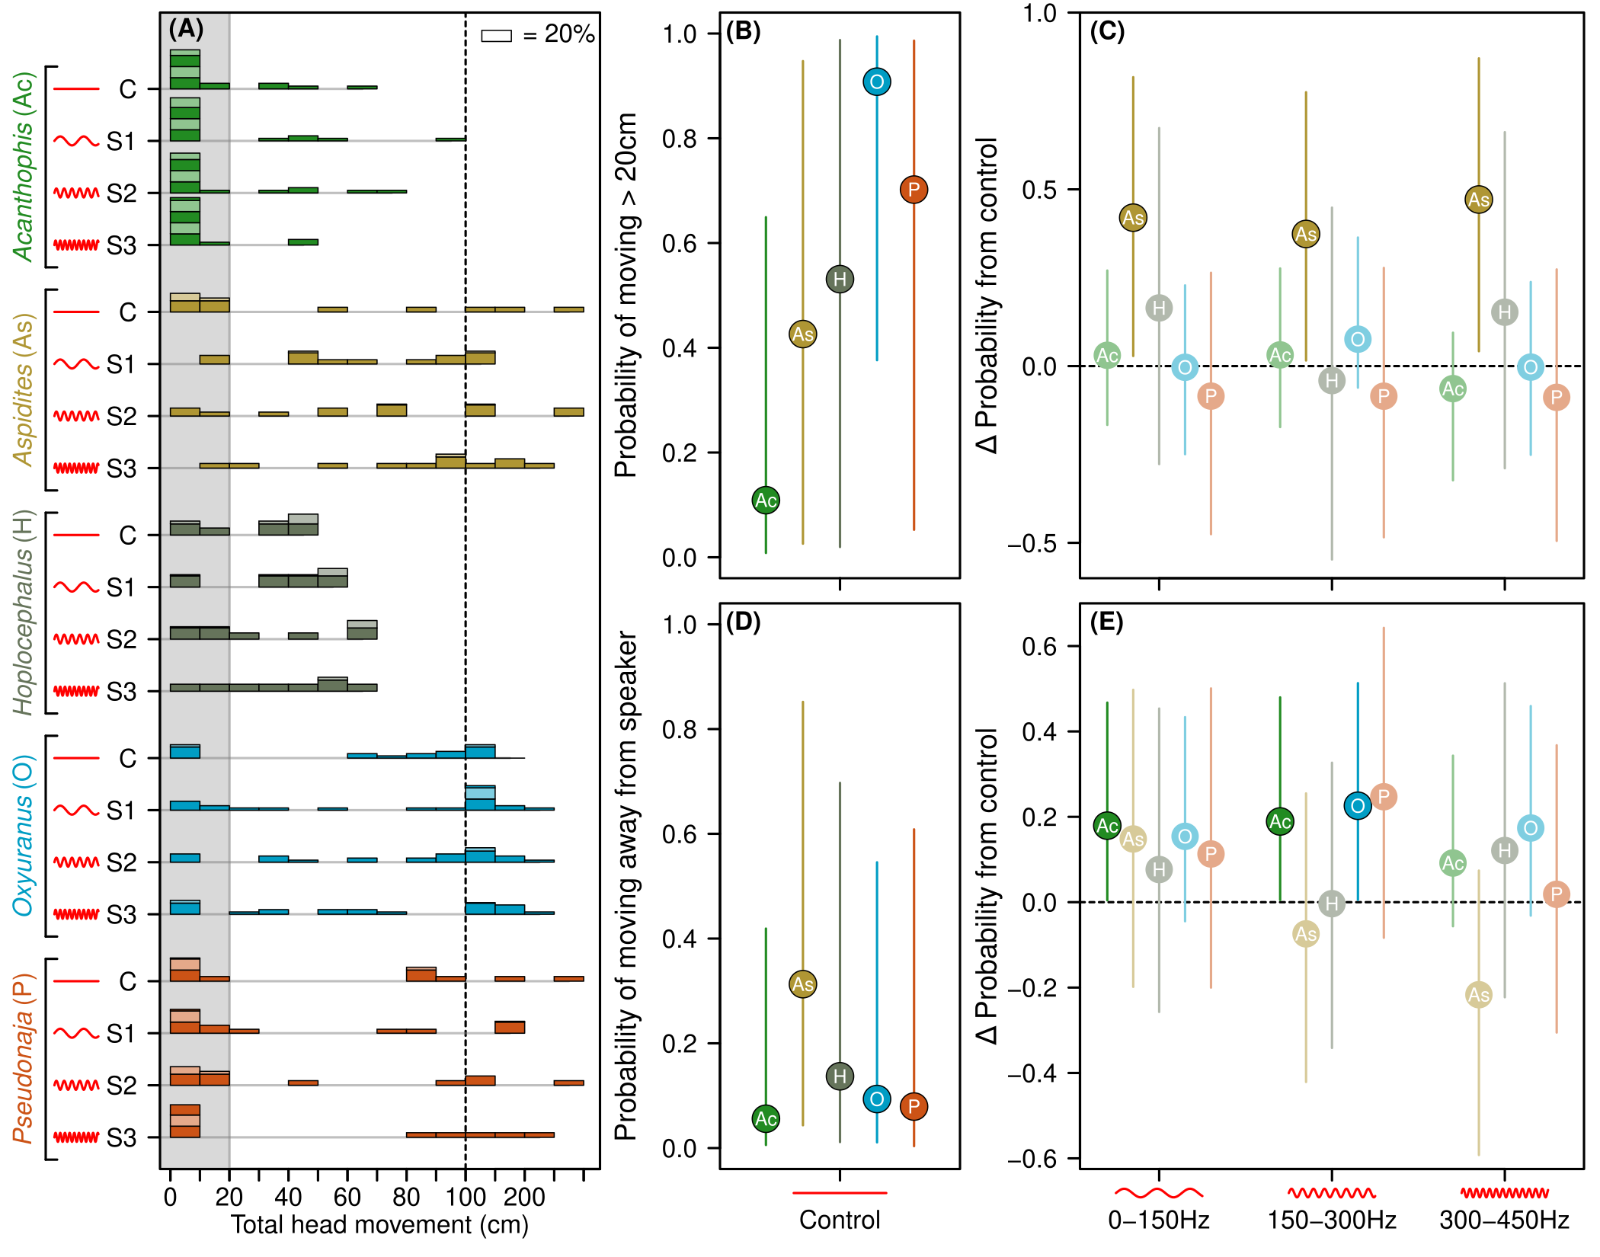**Figure 3:** **(A)** Histogram of snake movement by genus (colored groupings) and sound treatment (0 to 3). Histogram bars are grouped in units of 10cm, except above 100cm (right of dashed line) where they are grouped in units of 50cm. Alternating colors on bars represent blocks of up to 20% of trials. Grey shading indicates the cut-off used to distinguish 20cm threshold for binary movement response used in probability model. **(B**) Mean probability of >20cm snake movement in control. **(C)** Change in probability of movement from the control to each of three sound treatments. Values above one (dashed line) indicate increase in probability, and vice versa. **(D)** Mean probability of movement away from speaker for each genus in control trials, using only snakes with >20cm of movement. **(E)** Change in probability of movement away from speaker compared to control means for each of three sound treatments, as per (B). Lines in (B-E) represent 95% credible intervals from Bayesian hierarchical models. Points in C and E with 95% credible intervals that do not cross zero are highlighted as significant effects.

**Supplementary Tables**

Table S1: PERMANOVA summary table testing whether dissimilarity of composition of defensive/cautious behaviors is clustered by genus, sound treatment, or their interaction.

|  |  |  |  |  |  |
| --- | --- | --- | --- | --- | --- |
|  | **DF** | **Sum of squares** | **R2** | **F** | **P** |
| Genus | 4 | 4.028 | 0.889 | 36.279 | 0.001 |
| Sound Factor | 1 | 0.163 | 0.036 | 5.884 | 0.001 |
| Genus: sound factor | 4 | 0.117 | 0.026 | 1.052 | 0.446 |
| Residual | 8 | 0.222 | 0.049 |  |  |
| Total | 17 | 4.530 | 1.000 |  |  |

Table S2-4 are Bayesian hierarchical model summary tables, along with additional model validation tests via residual simulation and leave-one-out cross validation (LOO). Each model is fit with the control treatment and the first genus alphabetically (*Aspidites* in Table S2 and *Acanthophis* is Tables S3-S4) as the global intercept. Estimates are means from Bayesian posteriors, along with standard errors (SE) and credible intervals (CI). Ȓ is a metric of model convergence, where 1 equals perfect convergence (REF). ESS = effective sample size, a measure of the number of reliable samples obtained from the model markov chains. ELPD = theoretical expected log pointwise predictive density, a measure of model fit (can be read as per log-likelihood in frequentist models), P LOO = effective number of parameters, LOOIC = LOO information criterion. Pareto K is a measure of importance sampling reliability (where values < 0.5 are ideal).

**Table S2:** Probability of defensive/cautious behavior model summary table

|  |  |  |  |  |  |  |  |
| --- | --- | --- | --- | --- | --- | --- | --- |
| Fixed effects | Estimate | SE | Lower 95% CI | Upper 95% CI | Ȓ | Bulk ESS | Tail ESS |
| Intercept | 1.064 | 4.502 | -8.045 | 10.078 | 1.001 | 8145 | 10980 |
| soundFact1 | 1.537 | 1.039 | -0.451 | 3.638 | 1.000 | 8168 | 11984 |
| soundFact2 | 0.654 | 1.058 | -1.376 | 2.773 | 1.000 | 8446 | 12004 |
| soundFact3 | 1.696 | 1.064 | -0.324 | 3.859 | 1.000 | 7789 | 11268 |
| genusOxyuranus | -0.145 | 2.029 | -4.077 | 3.885 | 1.001 | 7853 | 11146 |
| genusPseudonaja | -0.341 | 2.355 | -5.002 | 4.317 | 1.000 | 7828 | 11639 |
| logAge | -0.960 | 1.801 | -4.577 | 2.675 | 1.001 | 7917 | 10736 |
| soundFact1:genusOxyuranus | -0.213 | 1.276 | -2.733 | 2.268 | 1.000 | 9087 | 12753 |
| soundFact2:genusOxyuranus | 1.281 | 1.292 | -1.229 | 3.815 | 1.000 | 9107 | 12791 |
| soundFact3:genusOxyuranus | -0.341 | 1.316 | -2.906 | 2.212 | 1.000 | 8600 | 13063 |
| soundFact1:genusPseudonaja | -1.279 | 1.493 | -4.263 | 1.650 | 1.000 | 10254 | 13393 |
| soundFact2:genusPseudonaja | -0.638 | 1.505 | -3.611 | 2.277 | 1.000 | 9731 | 13134 |
| soundFact3:genusPseudonaja | -1.024 | 1.510 | -3.957 | 1.908 | 1.000 | 9447 | 12556 |
|  |  |  |  |  |  |  |  |
| Random effects | Estimate | SE | Lower 95% CI | Upper 95% CI | Ȓ | Bulk ESS | Tail ESS |
| Speaker Side | 1.038 | 1.384 | 0.022 | 4.528 | 1.000 | 8431 | 10258 |
| Snake | 2.898 | 1.012 | 1.501 | 5.373 | 1.000 | 6950 | 11461 |
| Trial | 0.706 | 0.367 | 0.067 | 1.497 | 1.001 | 5559 | 5622 |
|  |  |  |  |  |  |  |  |
| Dispersion test | Obs:Sim | p-value |  |  |  |  |  |
|  | 0.935 | 0.408 |  |  |  |  |  |
|  |  |  |  |  |  |  |  |
| Uniformity test | D | p-value |  |  |  |  |  |
| One-sample Komogorov-Smirnov test | 0.039 | 0.918 |  |  |  |  |  |
|  |  |  |  |  |  |  |  |
| Leave-one-out cross validation | Estimate | SE |  |  |  |  |  |
| ELPD LOO | -112 | 8.7 |  |  |  |  |  |
| P LOO | 30.2 | 3.0 |  |  |  |  |  |
| LOOIC | 223.9 | 17.4 |  |  |  |  |  |
| Pareto K | 99.5% < 0.5 |  |  |  |  |  |  |

**Table S3:** Binary movement probability model summary

|  |  |  |  |  |  |  |  |
| --- | --- | --- | --- | --- | --- | --- | --- |
| Fixed effects | Estimate | SE | Lower 95% CI | Upper 95% CI | Ȓ | Bulk ESS | Tail ESS |
| Intercept | 4.601 | 3.194 | -1.607 | 11.021 | 1.000 | 8809 | 11155 |
| soundFact1 | 0.238 | 0.744 | -1.249 | 1.687 | 1.000 | 9090 | 13335 |
| soundFact2 | 0.246 | 0.746 | -1.228 | 1.703 | 1.000 | 9534 | 13815 |
| soundFact3 | -0.814 | 0.885 | -2.597 | 0.875 | 1.001 | 9240 | 12237 |
| genusAspidites | 1.778 | 1.683 | -1.592 | 5.056 | 1.000 | 8280 | 11625 |
| genusHoplocephalus | 2.226 | 1.968 | -1.635 | 6.152 | 1.000 | 10480 | 13554 |
| genusOxyuranus | 4.381 | 1.552 | 1.306 | 7.470 | 1.000 | 7726 | 11544 |
| genusPseudonaja | 2.965 | 1.936 | -1.087 | 6.622 | 1.000 | 7517 | 10972 |
| logAge | -3.120 | 1.472 | -6.060 | -0.222 | 1.000 | 9062 | 11803 |
| soundFact1:genusAspidites | 2.804 | 1.424 | 0.172 | 5.766 | 1.000 | 13036 | 14100 |
| soundFact2:genusAspidites | 2.276 | 1.343 | -0.285 | 4.983 | 1.000 | 12682 | 15313 |
| soundFact3:genusAspidites | 4.765 | 1.673 | 1.681 | 8.234 | 1.000 | 13673 | 14838 |
| soundFact1:genusHoplocephalus | 0.930 | 1.599 | -2.122 | 4.144 | 1.000 | 14270 | 15215 |
| soundFact2:genusHoplocephalus | -0.517 | 1.564 | -3.607 | 2.529 | 1.000 | 13501 | 14085 |
| soundFact3:genusHoplocephalus | 1.875 | 1.651 | -1.292 | 5.242 | 1.000 | 13246 | 14617 |
| soundFact1:genusOxyuranus | -0.243 | 1.156 | -2.523 | 2.053 | 1.000 | 12222 | 15156 |
| soundFact2:genusOxyuranus | 0.826 | 1.206 | -1.477 | 3.277 | 1.000 | 12353 | 13886 |
| soundFact3:genusOxyuranus | 0.806 | 1.253 | -1.601 | 3.311 | 1.001 | 11073 | 13058 |
| soundFact1:genusPseudonaja | -0.757 | 1.234 | -3.168 | 1.689 | 1.000 | 12400 | 14833 |
| soundFact2:genusPseudonaja | -0.755 | 1.286 | -3.296 | 1.749 | 1.000 | 12918 | 14222 |
| soundFact3:genusPseudonaja | 0.285 | 1.349 | -2.347 | 2.926 | 1.000 | 11746 | 14912 |
|  |  |  |  |  |  |  |  |
| Random effects | Estimate | SE | Lower 95% CI | Upper 95% CI | Ȓ | Bulk ESS | Tail ESS |
| Speaker Side | 0.913 | 1.312 | 0.018 | 4.278 | 1.000 | 7276 | 8774 |
| Snake | 2.026 | 0.577 | 1.146 | 3.373 | 1.001 | 7859 | 12714 |
| Trial | 0.226 | 0.176 | 0.008 | 0.649 | 1.000 | 10289 | 7965 |
|  |  |  |  |  |  |  |  |
| Dispersion test | Obs:Sim | p-value |  |  |  |  |  |
|  | 0.969 | 0.696 |  |  |  |  |  |
|  |  |  |  |  |  |  |  |
| Uniformity test | D | p-value |  |  |  |  |  |
| One-sample Komogorov-Smirnov test | 0.052 | 0.354 |  |  |  |  |  |
|  |  |  |  |  |  |  |  |
| Leave-one-out cross validation | Estimate | SE |  |  |  |  |  |
| Elpd LOO | -153.8 | 12.6 |  |  |  |  |  |
| P LOO | 37.7 | 4.2 |  |  |  |  |  |
| LOOIC | 307.7 | 25.1 |  |  |  |  |  |
| Pareto K | 97.5% <0.5 |  |  |  |  |  |  |

**Table S4:** Probability of movement towards speaker model summary

|  |  |  |  |  |  |  |  |
| --- | --- | --- | --- | --- | --- | --- | --- |
| Fixed effects | Estimate | SE | Lower 95% CI | Upper 95% CI | Ȓ | Bulk ESS | Tail ESS |
| Intercept | -0.170 | 1.626 | -3.225 | 2.938 | 1.001 | 6233 | 4587 |
| soundFact1 | 1.654 | 0.820 | 0.098 | 3.330 | 1.000 | 6224 | 9111 |
| soundFact2 | 1.708 | 0.823 | 0.140 | 3.394 | 1.000 | 6122 | 8898 |
| soundFact3 | 1.025 | 0.880 | -0.671 | 2.808 | 1.000 | 6845 | 10060 |
| genusAspidites | 2.034 | 0.996 | 0.116 | 4.014 | 1.000 | 6787 | 10889 |
| genusHoplocephalus | 0.984 | 1.142 | -1.298 | 3.223 | 1.000 | 7606 | 11205 |
| genusOxyuranus | 0.564 | 0.980 | -1.383 | 2.497 | 1.000 | 6434 | 9128 |
| genusPseudonaja | 0.383 | 1.351 | -2.479 | 2.875 | 1.000 | 7669 | 9554 |
| logAge | -1.242 | 0.500 | -2.261 | -0.287 | 1.001 | 13219 | 11028 |
| soundFact1:genusAspidites | -0.891 | 1.154 | -3.149 | 1.362 | 1.000 | 8313 | 11172 |
| soundFact2:genusAspidites | -2.145 | 1.225 | -4.591 | 0.215 | 1.000 | 8392 | 11890 |
| soundFact3:genusAspidites | -2.840 | 1.573 | -6.232 | -0.032 | 1.000 | 11231 | 13246 |
| soundFact1:genusHoplocephalus | -1.060 | 1.365 | -3.691 | 1.635 | 1.000 | 9342 | 12356 |
| soundFact2:genusHoplocephalus | -1.742 | 1.430 | -4.603 | 1.002 | 1.000 | 9184 | 13150 |
| soundFact3:genusHoplocephalus | -0.164 | 1.404 | -2.885 | 2.602 | 1.000 | 9091 | 12574 |
| soundFact1:genusOxyuranus | -0.451 | 1.137 | -2.706 | 1.807 | 1.000 | 7566 | 11388 |
| soundFact2:genusOxyuranus | -0.109 | 1.110 | -2.291 | 2.073 | 1.000 | 6975 | 9831 |
| soundFact3:genusOxyuranus | 0.295 | 1.173 | -1.989 | 2.617 | 1.000 | 7873 | 11060 |
| soundFact1:genusPseudonaja | -0.609 | 1.555 | -3.535 | 2.571 | 1.000 | 9342 | 10563 |
| soundFact2:genusPseudonaja | 0.166 | 1.507 | -2.699 | 3.224 | 1.000 | 8906 | 10827 |
| soundFact3:genusPseudonaja | -0.893 | 1.791 | -4.480 | 2.542 | 1.000 | 10036 | 12216 |
|  |  |  |  |  |  |  |  |
| Random effects | Estimate | SE | Lower 95% CI | Upper 95% CI | Ȓ | Bulk ESS | Tail ESS |
| Speaker Side | 1.008 | 1.415 | 0.023 | 4.695 | 1.001 | 5738 | 5104 |
| Snake | 0.406 | 0.286 | 0.018 | 1.073 | 1.001 | 5838 | 8223 |
| Trial | 0.335 | 0.231 | 0.016 | 0.869 | 1.000 | 6750 | 8732 |
|  |  |  |  |  |  |  |  |
| Dispersion test | Obs:Sim | p-value |  |  |  |  |  |
|  | 1.008 | 0.912 |  |  |  |  |  |
|  |  |  |  |  |  |  |  |
| Uniformity test | D | p-value |  |  |  |  |  |
| One-sample Komogorov-Smirnov test | 0.029 | 0.955 |  |  |  |  |  |
|  |  |  |  |  |  |  |  |
| Leave-one-out cross validation | Estimate | SE |  |  |  |  |  |
| Elpd LOO | -186.5 | 11.7 |  |  |  |  |  |
| P LOO | 33.9 | 3.2 |  |  |  |  |  |
| LOOIC | 372.9 | 23.4 |  |  |  |  |  |
| Pareto K | 99.1% <0.5 |  |  |  |  |  |  |