**Q: What is the overlap/correlation of three primary snake behavioural responses in each trial: tongue flicks, defensive and cautious behaviours, and >20cm movement?**

I’ve split this up by genus, with species and snake counts listed, and grouped by forage mode (with space for some lovely snake photos). These bar charts are equivalent to a “tree” style diagram where we break up different combinations of behaviours.

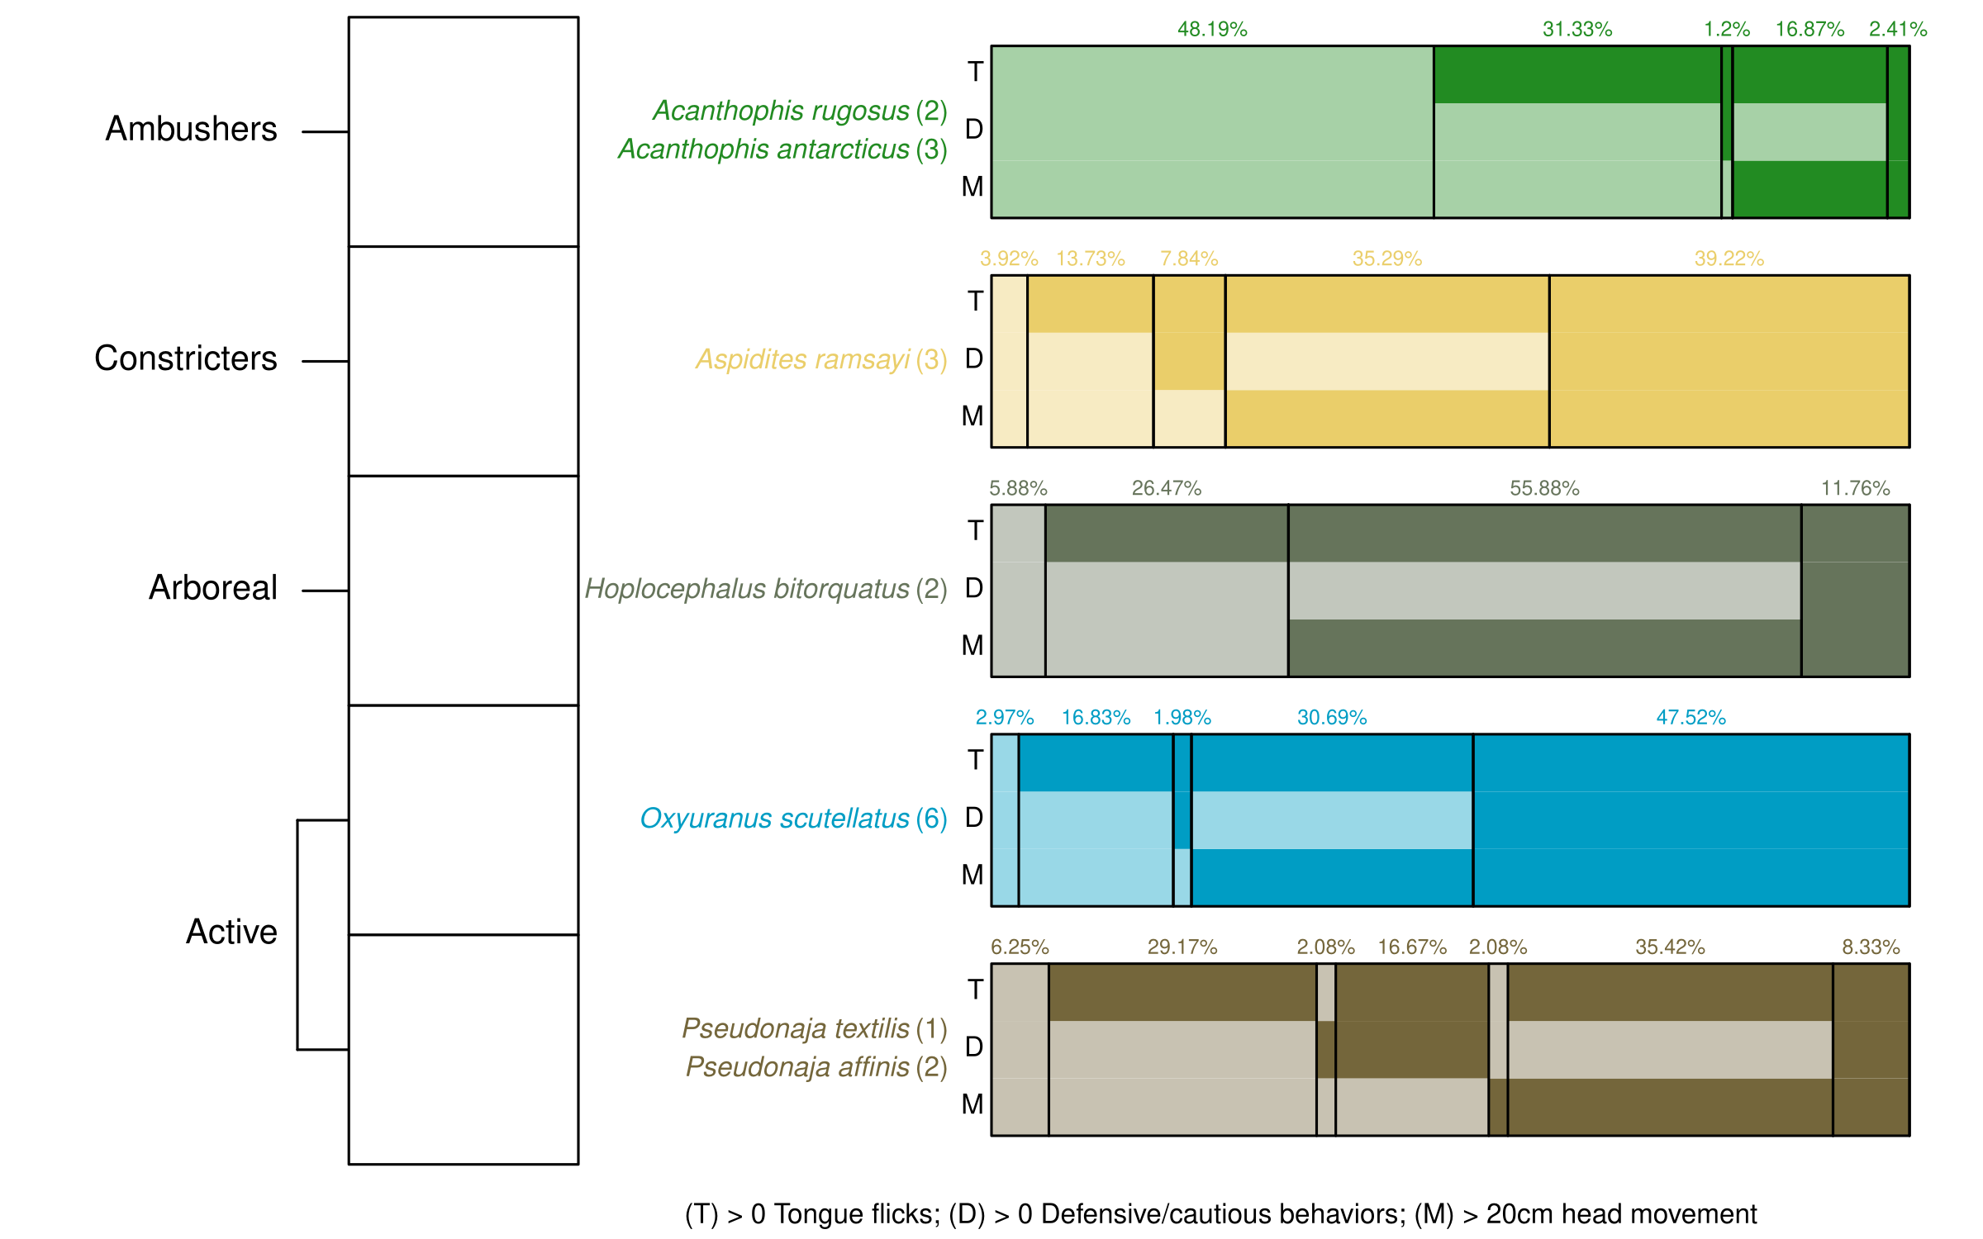

I’m hoping this is relatively easy to interpret, such that ~50% of death adder trials had 0 out of 3 behaviours, and 31% where there was a tongue flick with no other behaviours.

This figure accomplishes three things. First, it highlights the sorts of behaviour we observed (taipans are cranky and move a lot, death adders sit around and do nothing etc). It also helps to justify a genus-based nesting rather than foraging-mode, as the two active genera exhibit very different patterns of behaviour (the browns and dugites were far less likely to be defensive/cautious). Finally, it also justifies where we exclude genera from models (so excluding *Acanthopsis* and *Hoplocephalus* from the defensive model).

**Q: Is the probability of defensive/cautious behaviour altered by sound treatments?**

Binomial mixed-effect GLM, modelling genus x sound treatment probability of exhibiting defensive or cautious behaviour, including an effect of ln(snake age) and different predictions for male and female snakes. Included random intercepts for individual snakes (explained a lot of variation), trial block (barely explained anything) and side of room the sound came from (explained zero). Death adders and pale headed snakes were not modeled because they exhibited so few behaviours (as per the previous figure).

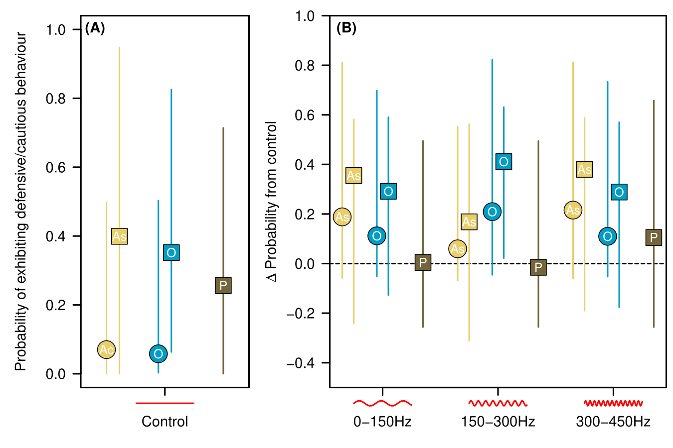

Confidence intervals are wide in the three modelled genera because there was substantial within-snake variance, even after accounting for sex and age. This limited our ability to detect significant trends. We do see some indication that the pythons and taipans increased behaviours with sound treatments, particularly with sound level 2. Interesting that active and constriction hunters showed such similar response, yet different response from other active genus (with browns and dugites). Ecological reasoning for why that might be?

**Q: Does the type of defensive/cautious behaviour change based on sound treatments?**

Given that we didn’t observe much of a change in the probability of these behaviours, maybe snakes were changing the types of behaviours they exhibited? This is an ordination where each genus x sound combination is a replicate (or “site”), and each defensive/cautious behaviour is a “species”. Counts were relativized to the total # of defensive/cautious behaviours exhibited in the genus x sound combination. Bra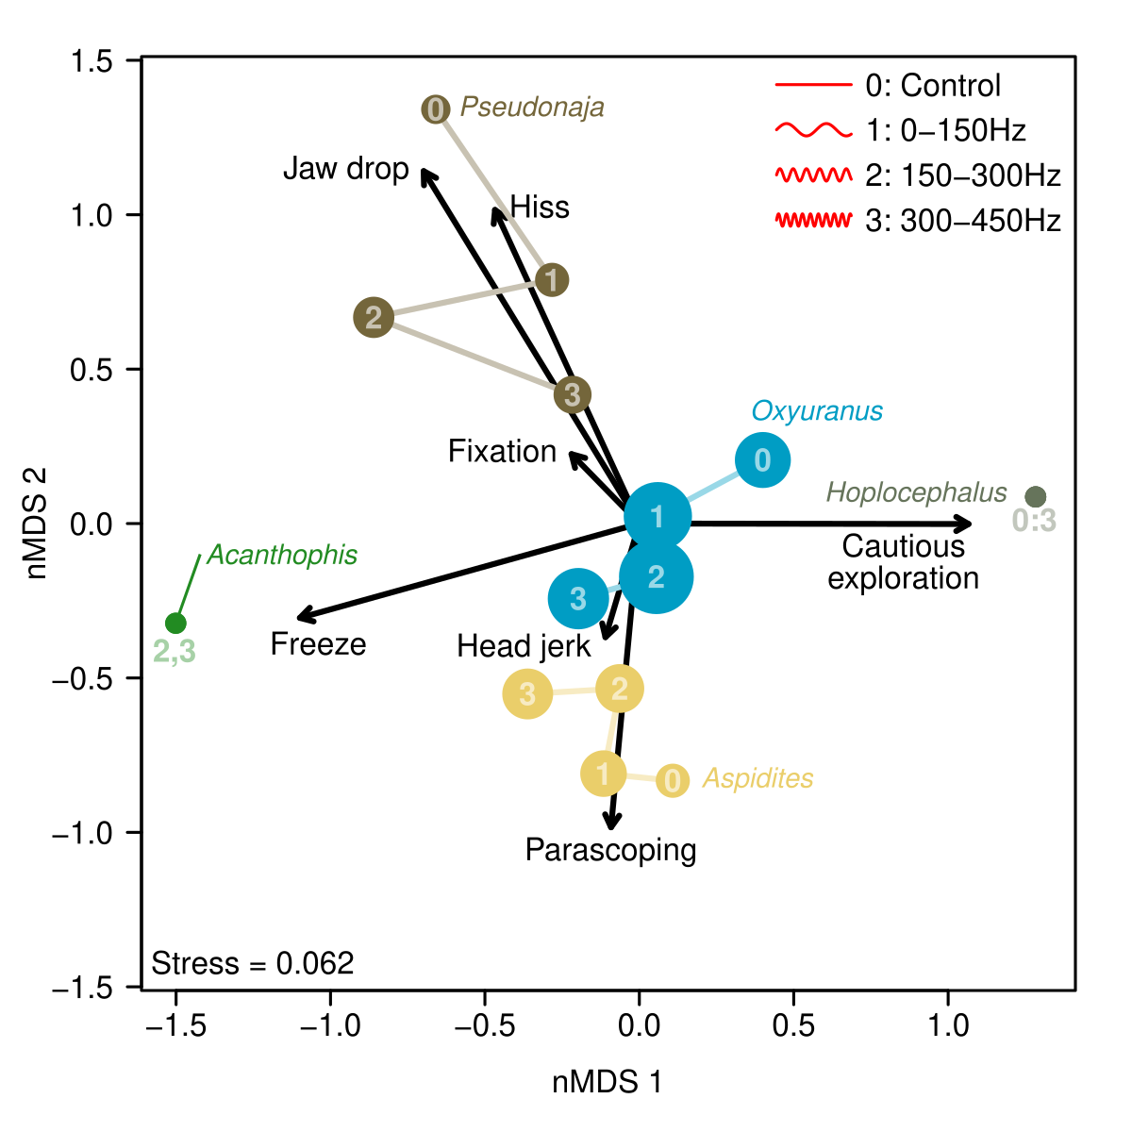y-curtis dissimilarity, very low stress. Point size is relative to the number of behaviours observed.

Two interesting results. One general one is how clustered genus behaviours are (browns hissed and dropped jaws the most, death adders only froze, etc).

Second result is that there appears to be some change in behaviour in the sound treatments. Even though the browns don’t increase in behaviour, their behaviour changes. Jaw drops and hisses don’t decrease, but we see some occurrence of fixation, freezes and head jerks. Taipans increased in head jerks and freezes. Aspitides froze more. Overall this suggests a decrease in “aggressive” behaviours and an increase in “cautious/avoidance” behaviours in these genera. No response from pale-headed snakes, and death adder response might suggest dominant freezing response (at sound levels 2 & 3), but overall defensive/cautious behaviour count was extremely low, so not enough samples to really tell.

It’s important to note that because of the relatively small sample size, these are more ‘indications’ or ‘fingerprints’ of behaviour change rather than really robust results. A single record of a behaviour is enough to move one of these points a decent amount across the plot, because the ‘abundance’ of behaviour is pretty low. I think they’re still interesting though!

**Q: Is the probability of tongue flicks altered by sound treatments?**

The overarching results don’t change no matter whether we use ‘probability of at least one tongue flick’, or look at actual tongue flick count. Overall, tongue flick probability doesn’t change across sound treatments. Only real result is in the behaviour overview (first figure) where death adders only tongue flicked half the time, and every other genus tongue flicked in >90% of trials.

**Q: Do sound treatments alter the probability of snake movement?**

While movement was recorded in 10cm increments, there was a natural break between snakes that “didn’t move or barely moved” and those that “substantially moved”, which was 20cm. So I split the movement data into two groups and looked at the probability that a snake moved at least 20cm.

Model was a binomial mixed-effect GLM, modelling genus x sound treatment probability of moving >20cm, including an effect of ln(snake age). Included random intercepts for individual snakes (explained a lot of variation), trial block (barely explained anything) and side of room the sound came from (explained zero).

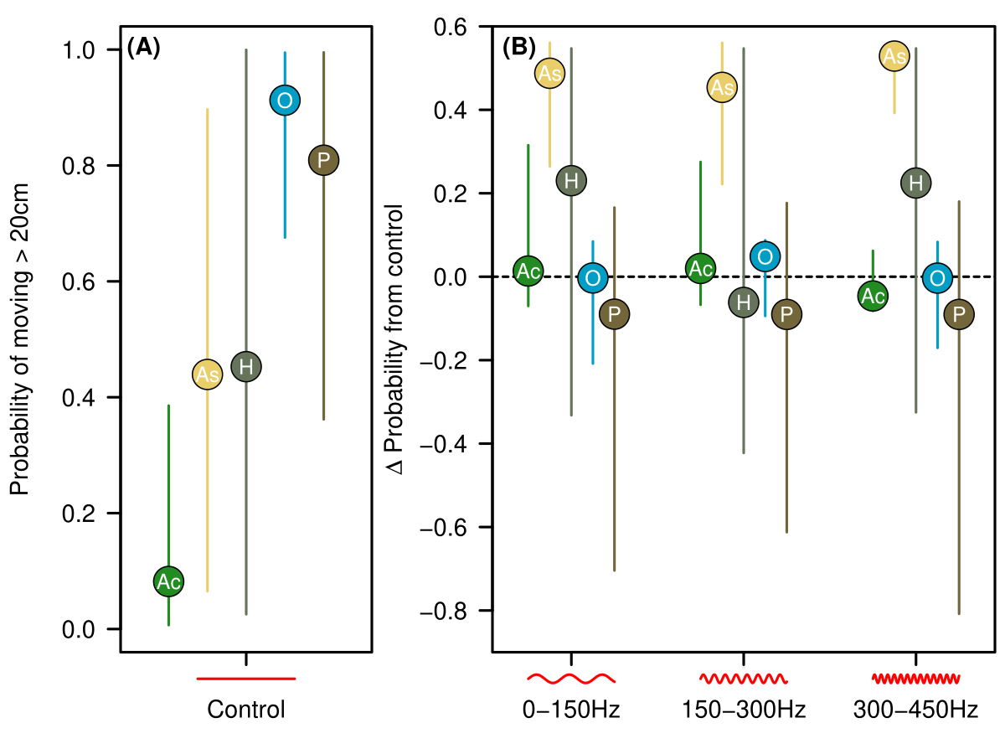Two interesting results. First is the between-genera variation. Death adders rarely moved, taipans and browns were the most active, and the other two genera varied wildly between individual snakes.

When we considered the effect of sound, the pythons were all much more likely to move compared with controls, with other genera showing no real pattern. What is it about constriction hunters that make them more likely to move? Do they rely less on information from other senses?

**Q: Do sound treatments alter the direction of snake movement?**

As with the defensive/cautious behaviours, some of the non-results above might obscure changes in HOW snakes moved in response to sound. This is where we looked at the direction of snake movement, only including snakes that actually moved > 20cm. Simplest way to do this was to divide movement into “away from speaker” versus “everything else”. This hopefully captures snake avoidance mechanisms.

Initial head direction did not explain sufficient variation to warrant inclusion in the model. i.e. these results were not dependent on which way the snake was facing.

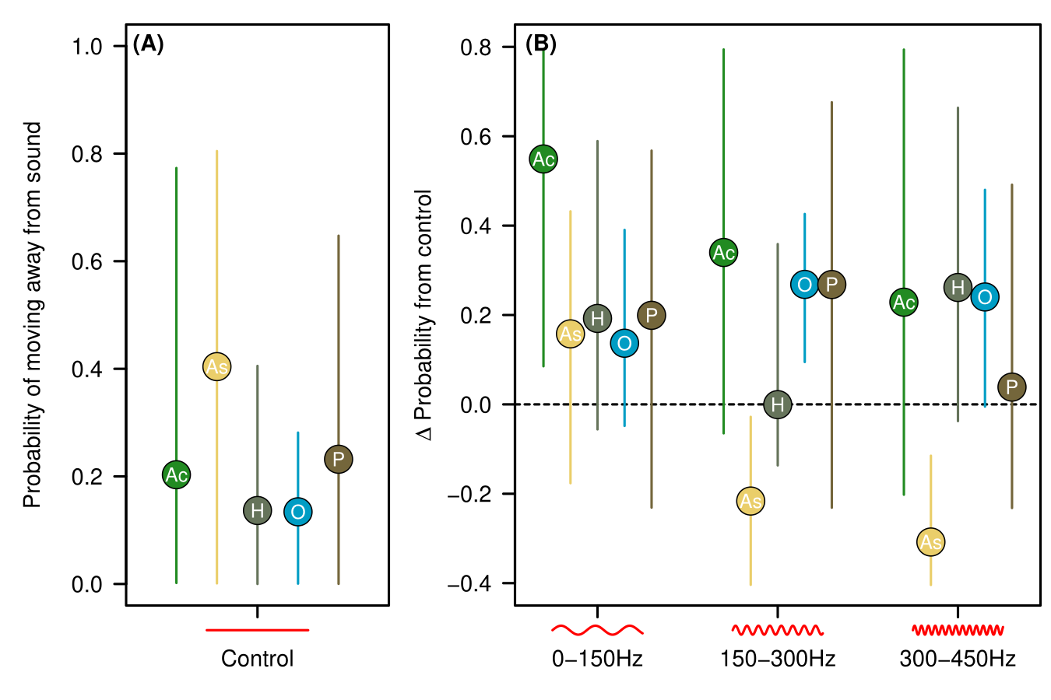

So the probability of moving away varied in the control, with the weird preference for taipans to move towards the sound (hence their low probability of moving away from sound) – to be explored further!

In the sound treatments we find some interesting results. Most interesting are the taipan increase in probability of moving away from speaker in sound 2 & 3, and the decrease in python probability suggests they were more likely to move TOWARDS the speaker. Coupled with the increase in python probability of moving at all with sound, this suggests sound might stimulate prey hunting strategies, while in other snakes (like taipans), it stimulates predator avoidance? Maybe? I’m not a snake biologist, but there could be something cool here.