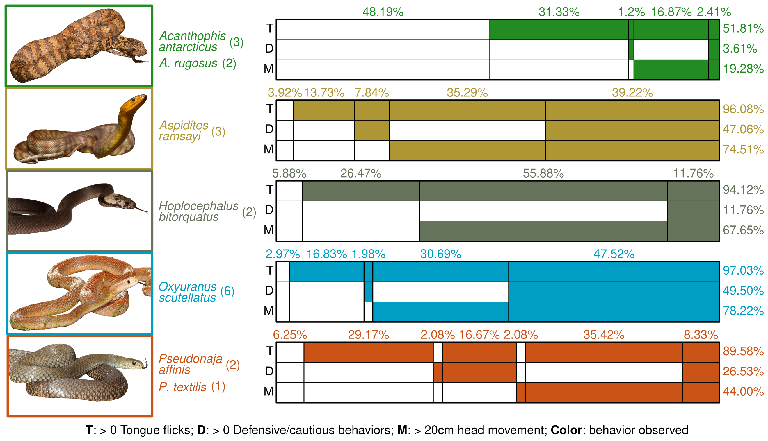**Figure 1:** Genus groupings of snakes, snake count per species and co-occurrence patterns of three dominant behaviours (“T”, “D” and “M”) across controls and all three sound treatments. Row percentages reflect proportion of trials where snakes of each genus exhibited a given behavior. Column percentages reflect the proportion of trials where particular combination of behaviors were absent or present (i.e. *Acanthophis* snakes exhibited none of the three behaviours in 48.19% of trials, and all three behaviors in 2.41% of trials). Defensive/cautious behaviors included cautious exploration, fixation, freezing, hisses, head jerks, jaw drops and periscoping.

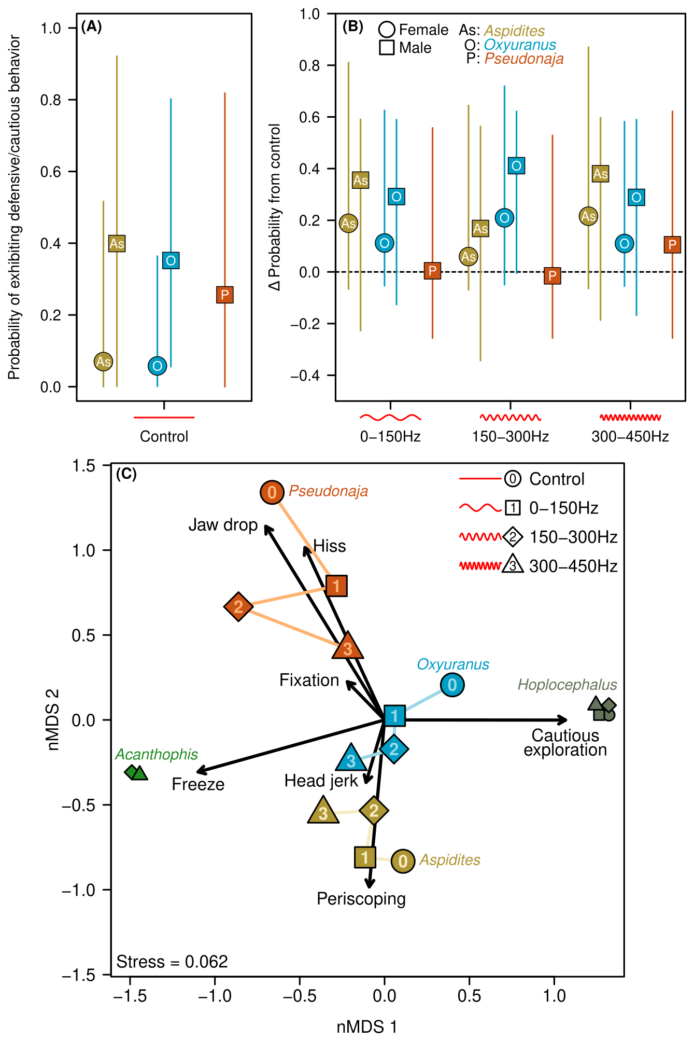

**Figure 2: (A)** Mean probability of exhibiting defensive or cautious behavior in control trials for three snake genera with sufficient response (Fig. 1): *Aspidites* (“As”), *Oxyuranus* (“O”) and *Pseudonaja* (“P”). Defensive/cautious behaviors included cautious exploration, fixation, freezing, hisses, head jerks, jaw drops and periscoping. Probabilities were modelled separately for male and female snakes (*Pseudonaja* snakes were all male). Lines represent 95% confidence intervals.**(B)** Change in probability of defensive or cautious behaviours from the control to each of three sound treatments. Values above one indicate increase in probability, and vice versa. **(C)** Non-metric multidimensional scaling of defensive/cautious behaviour composition for each genus-sound treatment combination. Points with similar behavior composition are clustered on the plot. Arrows reflect weighted behavior centroids, where points in the same direction as arrows exhibited more of those behaviors. These can be interpreted similar to PCA loading vectors (i.e. longer arrows more strongly influenced point position in a given direction). Differences between control (“0”) and treatment points (“1”, “2” and “3”) suggest the type of exhibited defensive behaviors changed in response to sound treatments.

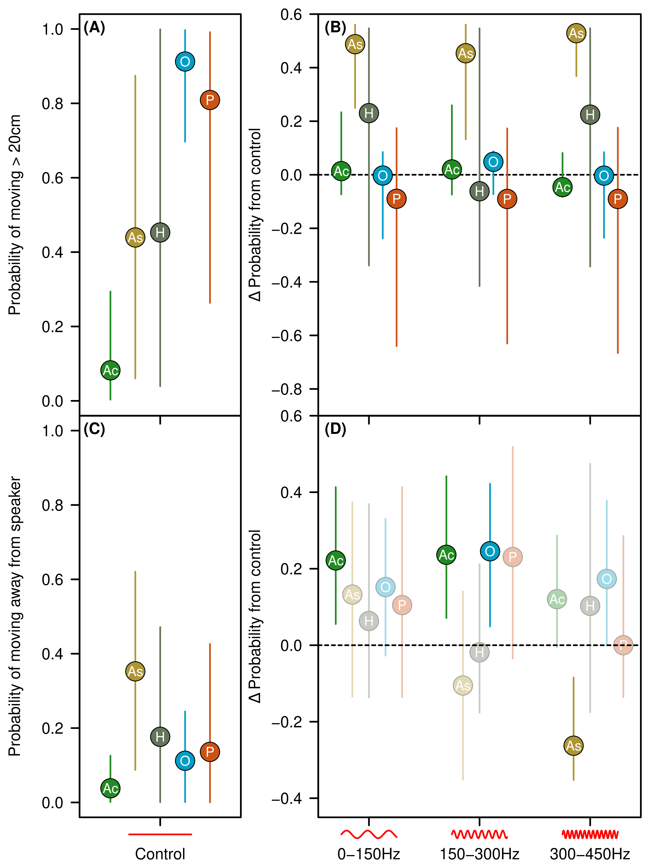

**Figure 3:** **(A**) Mean probability of snake movement in control trials. Movement was classified as head movement of more than 20cm, with separate estimates per genus. **(B)** Change in probability of movement from the control to each of three sound treatments. Values above one indicate increase in probability, and vice versa. **(C)** Mean probability of movement away from speaker for each genus in control trials, using only snakes with >20cm of movement. **(D)** Change in probability of movement away from speaker compared to control means for each of three sound treatments, as per (B). Lines in all four panels represent 95% confidence intervals.

**Response to some comments:**

**CJH (on Fig 1)**

At top right of figure, above the death adders, have a grouping type line above the percentages that shows that all those percentages add up to ‘100% of trials’.

It might be much more easy to compare the columns across all the genera if we separated the rectangle categories out so as to line up the first column together vertically, then the second column together vertically, etc. e.g. the 48.19% Ac would vertically align with the 3.92% of As and 5.88% of H, etc, and then for the vertical column #2, you’d vertically align the 31.33% Ac with the 13.73% As and 26.47% H, et. Hope this makes sense. I can show you on zoom or in person if need be! If we did that, we may need to make this fig landscape and take up a whole page, but it’s the best fig so it’d be worth it, I reckon!

I like these ideas, and happy to implement if you think they are still necessary after my other revisions.

Proposed groupings of species:

Ambushing Elapidae

Active Elapidae

Arboreal Elapidae

Active/arboreal Pythonidae

I got rid of this section in the revised figure, and thought these could be explored in text. But I’m happy to add them back in, and I like the grouping terms.

**CJH (on Fig 2A-B)**

Ac should be As b/c Ac was not modelled. Also, why is there two each of Aspidites and Oxyuranus, but only one Pseudonaja? It appears like the main take-home here is that the sounds make the snakes a bit more defensive/cautious, but it doesn’t matter which sound was played. Just the fact that sound was played.

Yep changed the wrong acronym, and added a legend to clarify that male vs female was an important predictor of responses (males more likely to exhibit defensive/cautious behaviours.

**Both on Fig 2C**

It’s ‘Periscoping’ not ‘parascoping’, sorry! I probs misled you somewhere in the spreadsheet!

Chris also found this figure quite tricky to work out. He doesn’t understand the length of the arrows. Nor why there are lines connecting the circles within a genus. Also, some things we observed don’t seem to align with the figure (probs b/c the observation is being pulled in ordination space). Such as taipans doing more fixation behaviour than almost any other species, but here it seems that brown snakes do more fixation (or at least in sound 3) b/c it’s closer to the fixation arrow. Maybe it’s not a figure to show specific responses, and fig 1 is better at this? Perhaps if we have a super clear figure caption (to explain to people with zero stats knowledge) and an example of how to interpret the size and location of one of the sounds (dots) of one of the genera, it would be worth including, but it’s quite difficult. I think we need to explain it to people as if they’re a 7-year-old (says Michael Scott from the Office!) I suppose in the least, this fig shows different species respond differently (the colours group together). Eg. How the snakes interpret the sound alters their response to it, and different species interpret the sounds differently.

So I’ve added a figure caption which highlights how to read this figure, but I’m hoping that most potential readers would be familiar with ordinations/nMDS – I thought they were a pretty common biological/ecological analysis! Maybe we can also pull it apart a bit in the results, because I think there’s a lot of interesting information here.

I also removed some of the confusing parts, like the line from Acanthophis, and adding more detail via different shapes to points based on sound treatment. A lot of changes were based on initial CZ comments.

The way to read this figure is almost like a PCA, except it’s constrained to 2 dimensions and there’s no direct mathematical link between position on the nMDS axes and the raw data (it’s designed to replicate dissimilarities as close as possible, with some lost information (that’s the “stress” in the new version)). Points with similar composition of behaviours are close together, and arrows define the behaviours that distinguish certain points. Examples are how Acanthophis were dominated by freeeze responses, and Pseudonaja was dominated by jaw drops and hisses. The arrow lengths are a reflection of how strong those behaviours were driving differences. So when you say taipans had the most fixation, you’re right. That’s why the fixation and head jerk arrows were small (i.e. they didn’t push points away from the origin) and why the taipan points were close to the center.

Here’s how I read this plot.

Taipans exhibited some of all behaviours except for jaw dropping and periscoping, but also the most fixation and head jerking. So they occupy the plot center, with the behaviours most associated with them having small arrows. The control exhibited more cautious exploration than the treatments, which were all very similar (and exhibited more freezing, head jerking and periscoping, because they moved in the direction of those arrows).

Acanthophis and Hoplocephalus were dominated by freeze and cautious exploration responses respectively with essentially no other behaviours exhibited. In some control + sound 1 Acanthophis cases, there were no defensive/cautious behaviours observed.

Pseudonaja were dominated by jaw drops and hisses, with a drop in these behaviours and increases in head jerks and fixation in sound treatments (with some variation, like more freezing in treatment 2).

Aspidites were the most periscope-y genus, with a lot of head jerks too. In treatments they exhibited more freeze behaviours, especially treatment 3, and less periscoping in treatments 2 and 3.

The two points to this plot are: (1) the genus-clustering, each genus had a unique signal of behaviours, and (2) the movement in behaviour composition from 0 to 1:3, suggesting that while the probability of exhibiting any of these behaviours might not change much (Fig 2A-B), the types of behaviours seems to.

**CZ on Fig 3A-B**

This is great to see b/c, when conducting the trials, it was super obvious to us that Elapid Boy was very much responding to the sound. He must have pulled his genus’ data up in subfigure B, I would imagine. But maybe the other two individuals did a fair amount of first-third-of-body movement too.

It’s nice to see in A that As and H stick together and O and P stick together, with Ac down below. I think this will make good sense to people, giving them and us a bit more confidence in our experiments. b/c if the controls are buggered, it’s all buggered. But the controls certainly make sense with everything herpetologists know about these species.

Actually, Elapid Boy by itself does nothing, because all of these models have snake-level random effects. That means if the other two Aspidites snakes did not have a movement response, we wouldn’t see an effect, it would all get pushed to Elapid Boy’s random effect. We actually see Dorsal Girl moved in almost all treatment trials (bar one), and Bitey Boy went from not moving at all in control trials to 50% movement in treatment 1, 60% movement in trial 2 and 75% movement in trial 3. It’s that we saw movement in all three Aspidites snakes that gave us the genus-level results we see in Fig 3A-B.