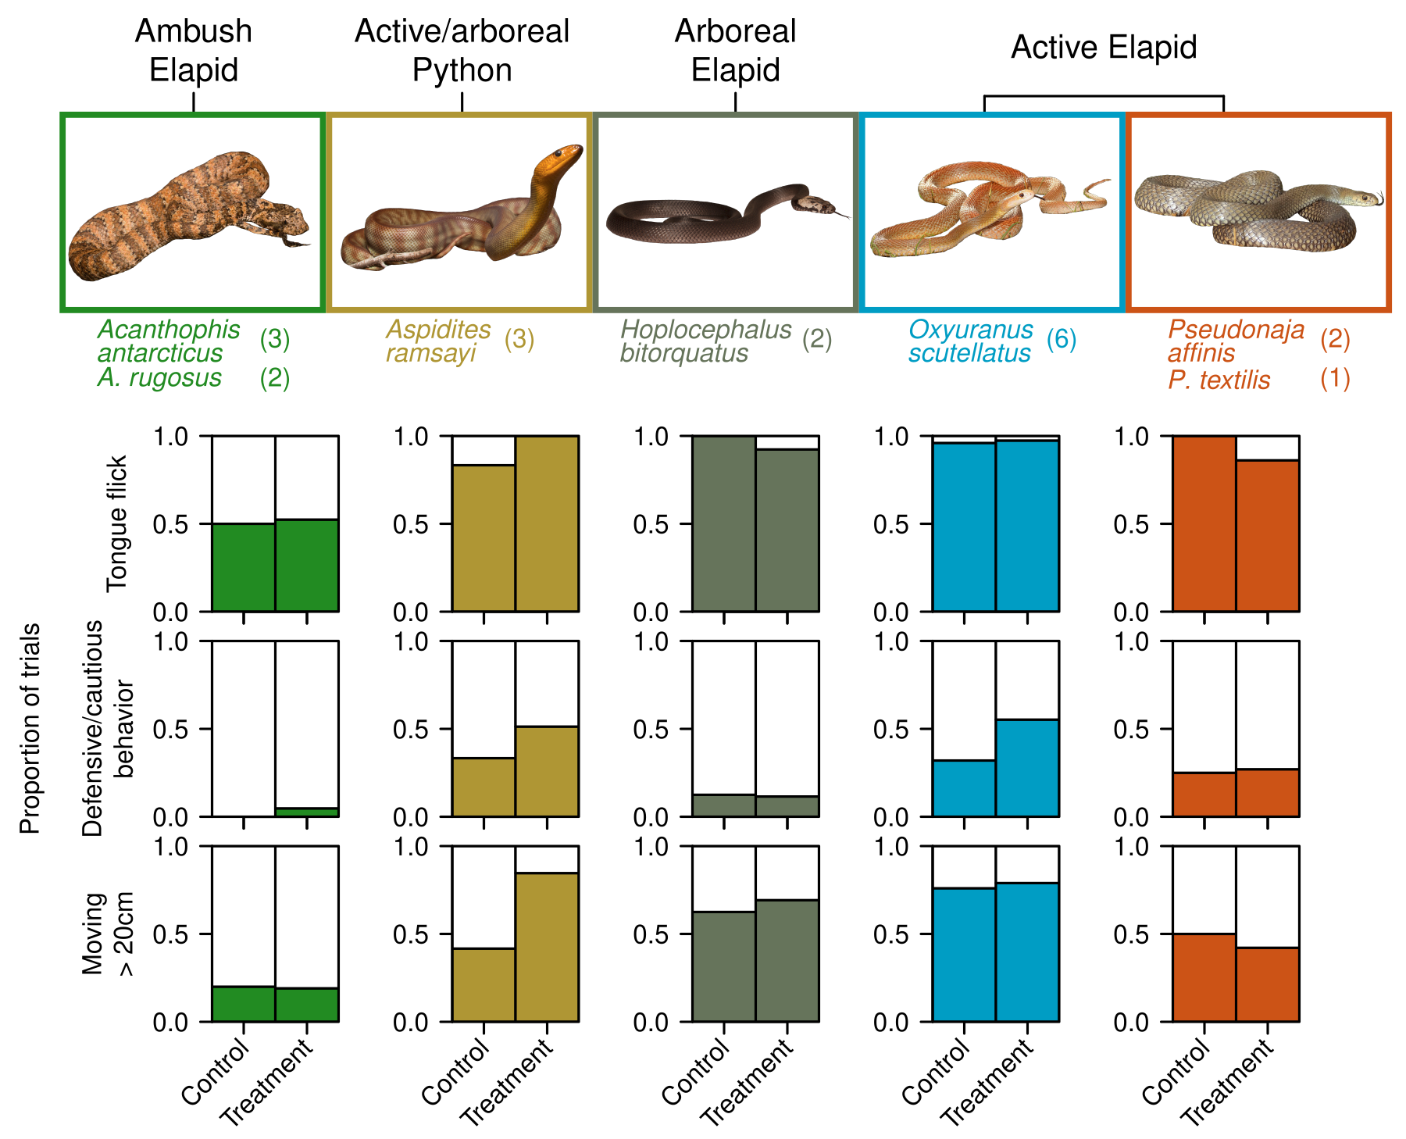

**Figure 1:** Genus groupings of snakes, snake count per species and patterns of three dominant behaviours (tongue flicks, defensive/cautious behaviors and >20cm movement) across controls and all three sound treatments combined. Defensive/cautious behaviors included cautious exploration, fixation, freezing, hisses, head jerks, jaw drops and periscoping.

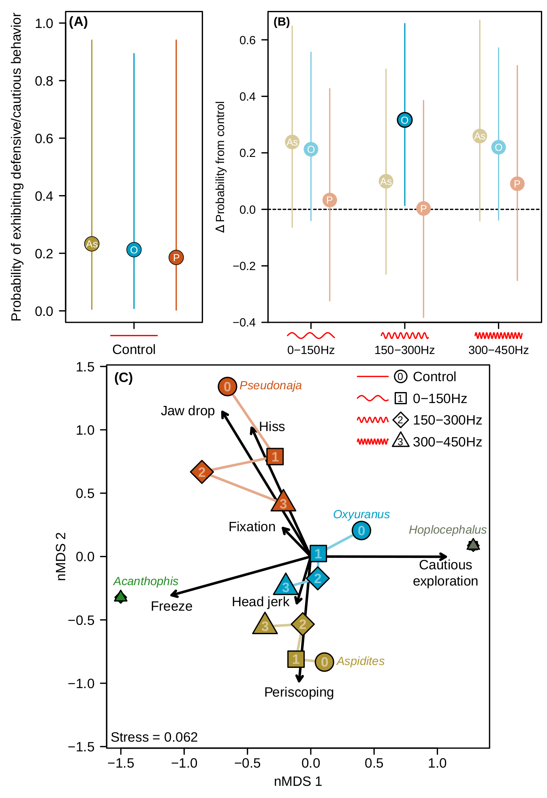

**Figure 2: (A)** Mean probability of exhibiting defensive or cautious behavior in control trials for three snake genera with sufficient response (Fig. 1). Behaviors included cautious exploration, fixation, freezing, hisses, head jerks, jaw drops and periscoping. Lines represent 95% credible intervals.**(B)** Change in probability of exhibiting defensive or cautious behaviours from the control to each of three sound treatments. Values above one indicate increase in probability, and vice versa. Light points had credible intervals crossing zero, suggesting no change in probability from control. **(C)** Non-metric multidimensional scaling of defensive/cautious behaviour composition for each genus-sound treatment combination. Points with similar behavior composition are clustered on the plot. Arrows reflect weighted behavior centroids, where points in the same direction as arrows exhibited more of those behaviors, with arrow length proportional to strength of influence. Differences between control (“0”) and treatment points (“1”, “2” and “3”) suggest the type of exhibited defensive behaviors changed in response to sound treatments. Symbols for the control and sound 1 are omitted for *Acanthophis* due to no behaviours being exhibited in those trials. Numbers are omitted from *Acanthophis* and *Hoplocephalus* symbols due to space constraints.

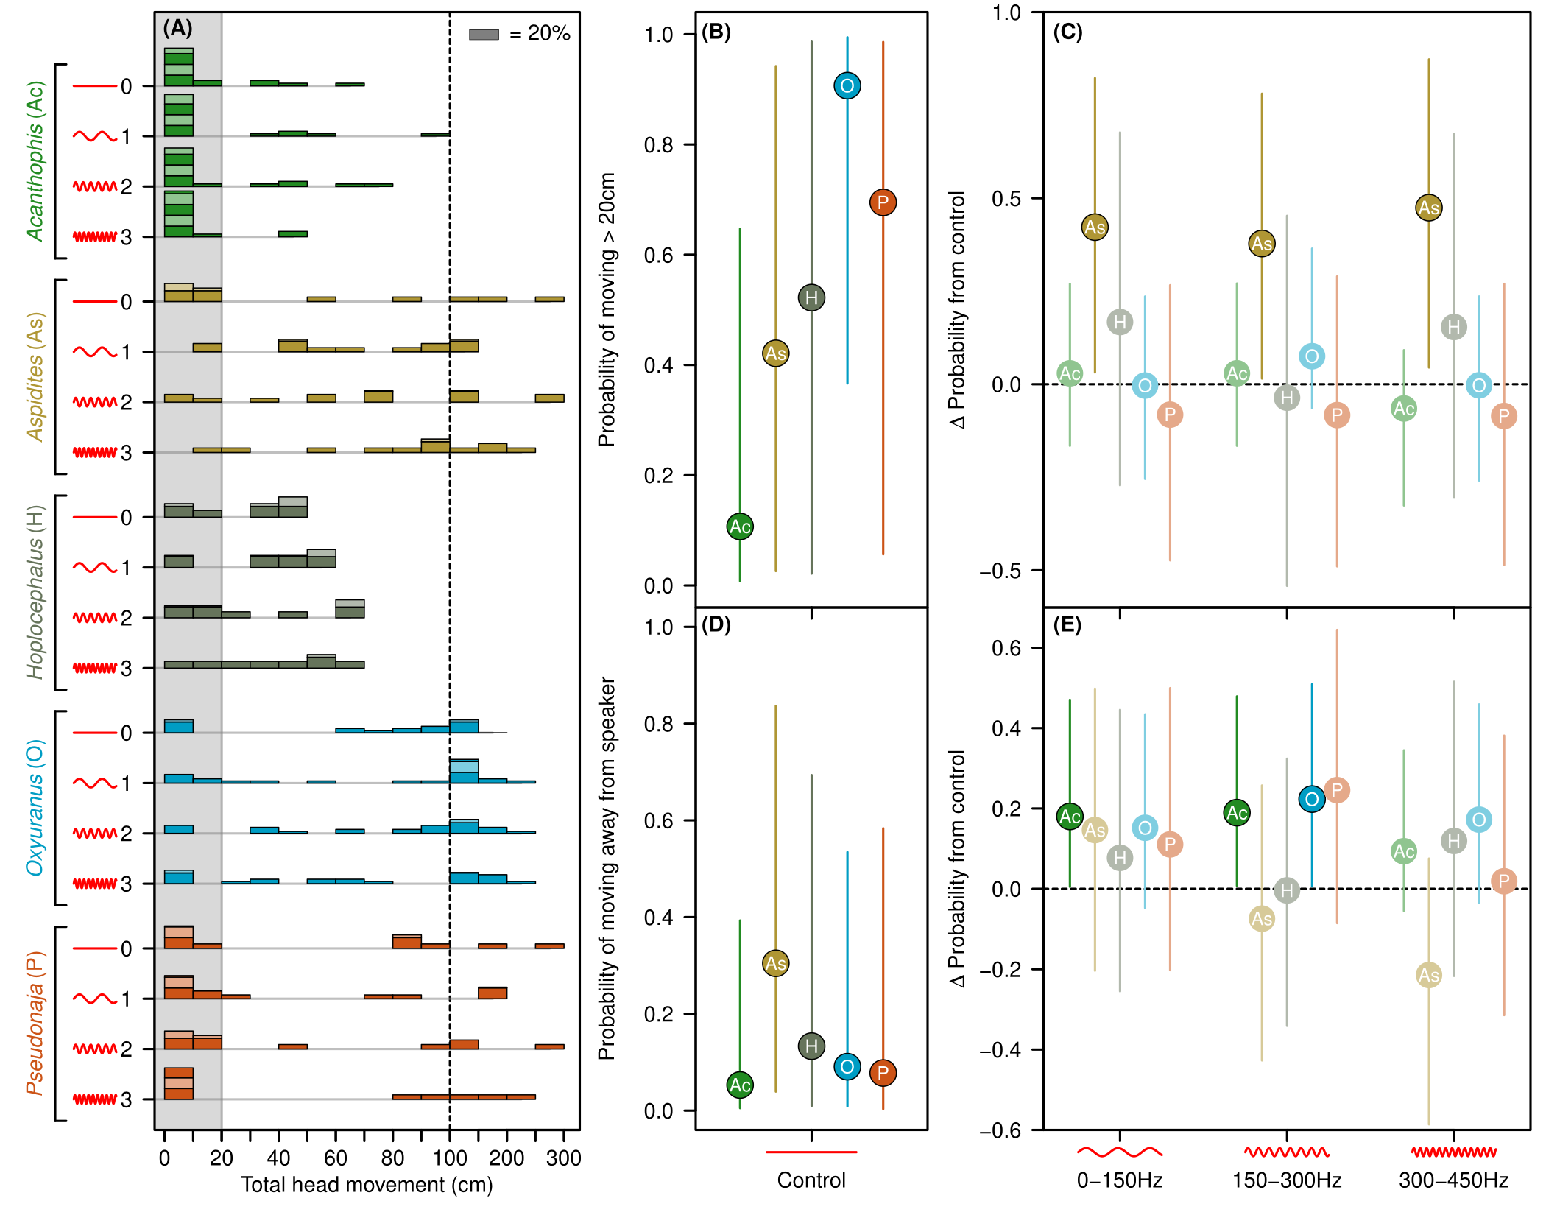**Figure 3:** **(A)** Histogram of snake movement by genus (coloured groupings) and sound treatment (0 to 3). Histogram bars are grouped in units of 10cm, except above 100cm (right of dashed line) where they are grouped in units of 50cm. Alternating colours on bars represent blocks of up to 20% of trials. Grey shading indicates the cut-off used to distinguish 20cm threshold for binary movement response used in probability model. **(B**) Mean probability of >20cm snake movement in control. **(C)** Change in probability of movement from the control to each of three sound treatments. Values above one indicate increase in probability, and vice versa. **(D)** Mean probability of movement away from speaker for each genus in control trials, using only snakes with >20cm of movement. **(A)** Change in probability of movement away from speaker compared to control means for each of three sound treatments, as per (B). Lines in (B-E) represent 95% credible intervals from Bayesian heirarchical models. Points in C and E with 95% credible intervals that do not cross zero are highlighted as significant effects.

**Model process (this will become Methods text and I will make it more detailed and readable, include citations etc)**

Summarizing snake behavioral response

Defensive and cautious behaviors included freezing, hissing, fixation, head jerks, lower jaw drops, periscoping and cautionary exploration. We converted the sum of these for each snake trial into a binary variable, whether at least one defensive/cautious behavior occurred. These were modelled as one of the probability models below.

Snake head movement and direction

Many snakes recorded small head movements during trials. There was a natural division between snakes with < 20cm head movement and those with substantially larger movement. We divided movement into less than and greater than 20cm binary category for probability modelling.

Movement response does not resolve whether snakes were moving towards or away from the sound, which has different biological implications. We constructed an additional model only for snake trials with >20 cm head movement, modelling the probability that snakes moved away from the speaker. We constructed a binary variable, with all trials with head movement away from the speaker as successes and with all other trials treated as failures.

***Staistical analyses***

nMDS of defensive/cautious behaviors

We also explored whether the composition of defensive/cautious behaviors changed based on sound treatment. For this, we summed all defensive behaviours for all snakes of a given genus for a given sound treatment. We converted these to relative abundance measures (dividing by the total behaviors in that genus-sound treatment combination). These formed the rows of a compositional matrix, with behaviors as columns. We visualized differences in composition using non-metric multidimensional scaling (metaMDS function, vegan packge), using Bray-Curtis dissimilarity.

We also tested for whether genus or sound treatment significantly affected composition of defensive/cautious behaviorrs using a PERMANOVA (adonis2 function, vegan package).

Probability models

Bayesian heirarchical models, fit via brms. Bernoulli likelihood, vague uninformative priors for intercept and slope terms (normal distribution with 0 mean, 5 sd). Random intercepts set for each snake, each set of trials and the two speaker directions, with Half-normal cauchy priors for standard deviation (0 mean, 2 sd).

All models had genus, sound factor, their interaction, and ln(snake age) as fixed effects.

Our defensive/cautious behavior model initially included snake sex and movement away from speaker model initially included initial head direction. These additional variables did not improve model fit, as determined via comparison of leave-one-out cross-validation information criteria (LOOIC), interpretable as per AIC. Defensive/cautious models with and without snake sex had LOOIC scores of 223.9 and 223.5 respectively, and movement away from speaker models with and without initial head direction had LOOIC scores of 378.8 and 372.9 respectively.

We set adapt delta to 0.999 and max treedepth to 15 to reduce divergent transitions. Models ran across four chains for 10,000 iterations each, 5,000 warm-up and 5,000 for sampling, for a total of 20,000 sampling iterations. Chain convergence in models was evaluated via R-hat scores. Model validation was performed via residual simulation in DHARMa package (Hartig 2019) and leave-one-out cross validation (loo function, loo package).

Control plots have points at the mean posterior probability. Bars are 95% credible intervals, the 2.5% and 97.5% quantiles of posterior distribution. To get the difference from control plots, which puts each genus on an equivalent scale (“difference from control”), we subtracted response-scale each genus’ control posterior draws from the respective sound factor treatment posterior draws for each genus. The points of these resulting distributions are the mean difference from control to treatment, with 95% credible intervals of the differences. Where credible intervals do not cross zero, it is evidence of a difference in response probability between the control and treatments.

In some cases, even with snake-level random effects, population-level predictions had wide credible intervals, reduce confidence in some potential trends (such as *Aspidites* reduction in probability of movement away from speaker).

Specific model details

We tested for whether initial head direciton significantly influenced probability of snake movement direction, but this model was a poorer fit than the model with this effect absent

**Results**

Basic results

*Summarize Fig 1*

Defensive/cautious behaviors

*Talk through Fig 2A-B*

Permanova of defensive/cautious behaviour shows significant variation in composition is explained by both genus and by sound treatment. Genus identity explained 89% of the variation, with sound contributing an additional 3.6%, with no significant interaction between the two sets of factors.

*Talk through Fig 2C*

Snake movement

*Talk through Fig 3A*

*Probability model summary*

*Direction model summary*

**Supplementary Tables**

Permanova summary table testing whether dissimilarity of composition of defensive/cautious behaviors is clustered by genus, sound treatment, or their interaction.

|  |  |  |  |  |  |
| --- | --- | --- | --- | --- | --- |
|  | **DF** | **Sum of squares** | **R2** | **F** | **P** |
| Genus | 4 | 4.028 | 0.889 | 36.279 | 0.001 |
| Sound Factor | 1 | 0.163 | 0.036 | 5.884 | 0.003 |
| Genus: sound factor | 4 | 0.117 | 0.026 | 1.052 | 0.437 |
| Residual | 8 | 0.222 | 0.049 |  |  |
| Total | 17 | 4.530 | 1.000 |  |  |

Table S2-4 are model summary tables from brms, along with additional model validation tests via residual simulation and leave-one-out cross validation. Estimates are means from Bayesian posteriors, along with standard errors and confidence intervals. Ȓ is a metric of model convergence, where 1 equals perfect convergence (REF). ESS = effective sample size, a measure of the number of reliable samples obtained from the model markov chains. ELPD = theoretical expected log pointwise predictive density, P LOO = effective number of parameters, LOOIC = LOO information criterion. Pareto K is a measure of importance sampling reliability.

**Table S2:** Probability of defensive/cautious behavior model summary table

|  |  |  |  |  |  |  |  |
| --- | --- | --- | --- | --- | --- | --- | --- |
| **Fixed effects** | Estimate | SE | Lower 95% CI | Upper 95% CI | Ȓ | Bulk ESS | Tail ESS |
| Intercept | 0.365 | 4.526 | -8.836 | 9.279 | 1.000 | 9513 | 11344 |
| soundFact1 | 1.582 | 1.058 | -0.448 | 3.727 | 1.000 | 8602 | 10792 |
| soundFact2 | 0.647 | 1.061 | -1.407 | 2.772 | 1.000 | 8526 | 11364 |
| soundFact3 | 1.703 | 1.078 | -0.349 | 3.868 | 1.001 | 9107 | 11932 |
| genusOxyuranus | -0.220 | 2.021 | -4.189 | 3.800 | 1.000 | 8797 | 10633 |
| genusPseudonaja | -0.882 | 2.382 | -5.592 | 3.855 | 1.000 | 9464 | 11538 |
| ln(Age) | -1.377 | 1.835 | -5.030 | 2.312 | 1.000 | 9403 | 11516 |
| SexMale | 2.394 | 2.019 | -1.538 | 6.549 | 1.000 | 10250 | 11884 |
| soundFact1:genusOxyuranus | -0.228 | 1.294 | -2.785 | 2.320 | 1.000 | 9191 | 12070 |
| soundFact2:genusOxyuranus | 1.314 | 1.306 | -1.214 | 3.877 | 1.000 | 8883 | 12049 |
| soundFact3:genusOxyuranus | -0.329 | 1.326 | -2.958 | 2.258 | 1.001 | 9772 | 13051 |
| soundFact1:genusPseudonaja | -1.328 | 1.490 | -4.277 | 1.536 | 1.000 | 10188 | 14013 |
| soundFact2:genusPseudonaja | -0.637 | 1.523 | -3.644 | 2.315 | 1.000 | 10235 | 13633 |
| soundFact3:genusPseudonaja | -1.026 | 1.512 | -4.015 | 1.909 | 1.001 | 10673 | 13543 |
|  |  |  |  |  |  |  |  |
| **Random effects** | Estimate | SE | Lower 95% CI | Upper 95% CI | Ȓ | Bulk ESS | Tail ESS |
| Speaker Side | 1.032 | 1.368 | 0.025 | 4.522 | 1.000 | 8699 | 9811 |
| Snake | 2.856 | 1.027 | 1.454 | 5.395 | 1.000 | 7872 | 10978 |
| Trial | 0.730 | 0.371 | 0.077 | 1.543 | 1.000 | 5094 | 5395 |
|  |  |  |  |  |  |  |  |
| **Dispersion test** | Obs:Sim | P-value |  |  |  |  |  |
|  | 0.875 | 0.096 |  |  |  |  |  |
|  |  |  |  |  |  |  |  |
| **Uniformity test** | D | p-value |  |  |  |  |  |
| One-sample Komogorov-Smirnov test | 0.039 | 0.925 |  |  |  |  |  |
|  |  |  |  |  |  |  |  |
| **Leave-one-out cross validation** | Estimate | SE |  |  |  |  |  |
| Elpd LOO | -111.8 | 8.8 |  |  |  |  |  |
| P LOO | 30.4 | 3.0 |  |  |  |  |  |
| LOOIC | 223.5 | 17.5 |  |  |  |  |  |
| Pareto K | 99% < 0.5 |  |  |  |  |  |  |

**Table S3:** Binary movement probability model summary

|  |  |  |  |  |  |  |  |
| --- | --- | --- | --- | --- | --- | --- | --- |
| **Fixed effects** | Estimate | SE | Lower 95% CI | Upper 95% CI | Ȓ | Bulk ESS | Tail ESS |
| Intercept | 4.601 | 3.194 | -1.607 | 11.021 | 1.000 | 8809 | 11155 |
| soundFact1 | 0.238 | 0.744 | -1.249 | 1.687 | 1.000 | 9090 | 13335 |
| soundFact2 | 0.246 | 0.746 | -1.228 | 1.703 | 1.000 | 9534 | 13815 |
| soundFact3 | -0.814 | 0.885 | -2.597 | 0.875 | 1.001 | 9240 | 12237 |
| genusAspidites | 1.778 | 1.683 | -1.592 | 5.056 | 1.000 | 8280 | 11625 |
| genusHoplocephalus | 2.226 | 1.968 | -1.635 | 6.152 | 1.000 | 10480 | 13554 |
| genusOxyuranus | 4.381 | 1.552 | 1.306 | 7.470 | 1.000 | 7726 | 11544 |
| genusPseudonaja | 2.965 | 1.936 | -1.087 | 6.622 | 1.000 | 7517 | 10972 |
| logAge | -3.120 | 1.472 | -6.060 | -0.222 | 1.000 | 9062 | 11803 |
| soundFact1:genusAspidites | 2.804 | 1.424 | 0.172 | 5.766 | 1.000 | 13036 | 14100 |
| soundFact2:genusAspidites | 2.276 | 1.343 | -0.285 | 4.983 | 1.000 | 12682 | 15313 |
| soundFact3:genusAspidites | 4.765 | 1.673 | 1.681 | 8.234 | 1.000 | 13673 | 14838 |
| soundFact1:genusHoplocephalus | 0.930 | 1.599 | -2.122 | 4.144 | 1.000 | 14270 | 15215 |
| soundFact2:genusHoplocephalus | -0.517 | 1.564 | -3.607 | 2.529 | 1.000 | 13501 | 14085 |
| soundFact3:genusHoplocephalus | 1.875 | 1.651 | -1.292 | 5.242 | 1.000 | 13246 | 14617 |
| soundFact1:genusOxyuranus | -0.243 | 1.156 | -2.523 | 2.053 | 1.000 | 12222 | 15156 |
| soundFact2:genusOxyuranus | 0.826 | 1.206 | -1.477 | 3.277 | 1.000 | 12353 | 13886 |
| soundFact3:genusOxyuranus | 0.806 | 1.253 | -1.601 | 3.311 | 1.001 | 11073 | 13058 |
| soundFact1:genusPseudonaja | -0.757 | 1.234 | -3.168 | 1.689 | 1.000 | 12400 | 14833 |
| soundFact2:genusPseudonaja | -0.755 | 1.286 | -3.296 | 1.749 | 1.000 | 12918 | 14222 |
| soundFact3:genusPseudonaja | 0.285 | 1.349 | -2.347 | 2.926 | 1.000 | 11746 | 14912 |
|  |  |  |  |  |  |  |  |
| **Random effects** | Estimate | SE | Lower 95% CI | Upper 95% CI | Ȓ | Bulk ESS | Tail ESS |
| Speaker Side | 0.913 | 1.312 | 0.018 | 4.278 | 1.000 | 7276 | 8774 |
| Snake | 2.026 | 0.577 | 1.146 | 3.373 | 1.001 | 7859 | 12714 |
| Trial | 0.226 | 0.176 | 0.008 | 0.649 | 1.000 | 10289 | 7965 |
|  |  |  |  |  |  |  |  |
| **Dispersion test** | Obs:Sim | P-value |  |  |  |  |  |
|  | 0.969 | 0.696 |  |  |  |  |  |
|  |  |  |  |  |  |  |  |
| **Uniformity test** | D | p-value |  |  |  |  |  |
| One-sample Komogorov-Smirnov test | 0.052 | 0.354 |  |  |  |  |  |
|  |  |  |  |  |  |  |  |
| **Leave-one-out cross validation** | Estimate | SE |  |  |  |  |  |
| Elpd LOO | -153.8 | 12.6 |  |  |  |  |  |
| P LOO | 37.7 | 4.2 |  |  |  |  |  |
| LOOIC | 307.7 | 25.1 |  |  |  |  |  |
| Pareto K | 97.5% <0.5 |  |  |  |  |  |  |

**Table S4:** Probability of movement towards speaker model summary

|  |  |  |  |  |  |  |  |
| --- | --- | --- | --- | --- | --- | --- | --- |
| **Fixed effects** | Estimate | SE | Lower 95% CI | Upper 95% CI | Ȓ | Bulk ESS | Tail ESS |
| Intercept | -0.170 | 1.626 | -3.225 | 2.938 | 1.001 | 6233 | 4587 |
| soundFact1 | 1.654 | 0.820 | 0.098 | 3.330 | 1.000 | 6224 | 9111 |
| soundFact2 | 1.708 | 0.823 | 0.140 | 3.394 | 1.000 | 6122 | 8898 |
| soundFact3 | 1.025 | 0.880 | -0.671 | 2.808 | 1.000 | 6845 | 10060 |
| genusAspidites | 2.034 | 0.996 | 0.116 | 4.014 | 1.000 | 6787 | 10889 |
| genusHoplocephalus | 0.984 | 1.142 | -1.298 | 3.223 | 1.000 | 7606 | 11205 |
| genusOxyuranus | 0.564 | 0.980 | -1.383 | 2.497 | 1.000 | 6434 | 9128 |
| genusPseudonaja | 0.383 | 1.351 | -2.479 | 2.875 | 1.000 | 7669 | 9554 |
| logAge | -1.242 | 0.500 | -2.261 | -0.287 | 1.001 | 13219 | 11028 |
| soundFact1:genusAspidites | -0.891 | 1.154 | -3.149 | 1.362 | 1.000 | 8313 | 11172 |
| soundFact2:genusAspidites | -2.145 | 1.225 | -4.591 | 0.215 | 1.000 | 8392 | 11890 |
| soundFact3:genusAspidites | -2.840 | 1.573 | -6.232 | -0.032 | 1.000 | 11231 | 13246 |
| soundFact1:genusHoplocephalus | -1.060 | 1.365 | -3.691 | 1.635 | 1.000 | 9342 | 12356 |
| soundFact2:genusHoplocephalus | -1.742 | 1.430 | -4.603 | 1.002 | 1.000 | 9184 | 13150 |
| soundFact3:genusHoplocephalus | -0.164 | 1.404 | -2.885 | 2.602 | 1.000 | 9091 | 12574 |
| soundFact1:genusOxyuranus | -0.451 | 1.137 | -2.706 | 1.807 | 1.000 | 7566 | 11388 |
| soundFact2:genusOxyuranus | -0.109 | 1.110 | -2.291 | 2.073 | 1.000 | 6975 | 9831 |
| soundFact3:genusOxyuranus | 0.295 | 1.173 | -1.989 | 2.617 | 1.000 | 7873 | 11060 |
| soundFact1:genusPseudonaja | -0.609 | 1.555 | -3.535 | 2.571 | 1.000 | 9342 | 10563 |
| soundFact2:genusPseudonaja | 0.166 | 1.507 | -2.699 | 3.224 | 1.000 | 8906 | 10827 |
| soundFact3:genusPseudonaja | -0.893 | 1.791 | -4.480 | 2.542 | 1.000 | 10036 | 12216 |
|  |  |  |  |  |  |  |  |
| **Random effects** | Estimate | SE | Lower 95% CI | Upper 95% CI | Ȓ | Bulk ESS | Tail ESS |
| Speaker Side | 1.008 | 1.415 | 0.023 | 4.695 | 1.001 | 5738 | 5104 |
| Snake | 0.406 | 0.286 | 0.018 | 1.073 | 1.001 | 5838 | 8223 |
| Trial | 0.335 | 0.231 | 0.016 | 0.869 | 1.000 | 6750 | 8732 |
|  |  |  |  |  |  |  |  |
| **Dispersion test** | Obs:Sim | P-value |  |  |  |  |  |
|  | 1.008 | 0.912 |  |  |  |  |  |
|  |  |  |  |  |  |  |  |
| **Uniformity test** | D | p-value |  |  |  |  |  |
| One-sample Komogorov-Smirnov test | 0.029 | 0.955 |  |  |  |  |  |
|  |  |  |  |  |  |  |  |
| **Leave-one-out cross validation** | Estimate | SE |  |  |  |  |  |
| Elpd LOO | -186.5 | 11.7 |  |  |  |  |  |
| P LOO | 33.9 | 3.2 |  |  |  |  |  |
| LOOIC | 372.9 | 23.4 |  |  |  |  |  |
| Pareto k | 99.1% <0.5 |  |  |  |  |  |  |