

Event: Tree Planting – “10,000 Trees for the Rouge Valley”

Website: www.10000trees.com
Date: Sunday April 28, 2013
Time: 10:00am – 12:30pm
Drop off/ Pick up: WalMart at Hwy 407 and Donald Cousens Parkway (Shuttle buses to Rouge Valley will be arranged the organizer)
Dress code: Casual wear with 8th Markham neckerchief
What to bring: A shovel and bucket, work gloves, waterproof boots, water bottle
Contact Person: (Group) Richard Yiu (416) 904-0733
(Beaver) Karen Kam (647) 504-8177
(Cub) Joycelyn Suen (647) 688-9808
(Troop) Danny Cheng (647) 208-9168
(Venture) Desmond Wong (416) 892-2332

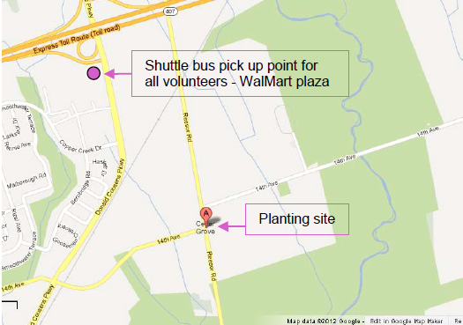

To parents/ Guardians:

This is to inform you that our scout group will be joining a tree-planting event on the date and time mentioned above. Please fill in the slip below and return it along with the donation envelope to the contact leader in your section by April 25, 2013.

I do/ do not (please circle one) permit _________________ in the ____________ section to go to join the Tree planting event on April 28, 2013.
I understand that there is an inherent risk in this or any activity and in signing this form gives permission to the leader(s) in charge to obtain medical assistance as stipulated on his/her Health Form if required.

Emergency Contact Person and Phone number: ____________________

Parent/ Guardian’s Signature: ________________

