

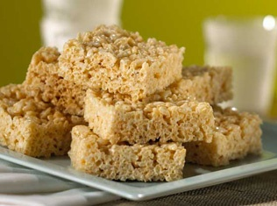On Thursday, April 2, 2015, the 8th Markham Venturers will be hosting an Easter Bake Sale Fundraiser! Make sure to come by and support us. We have lots of yummy baked goods and sweet treats to sell including:

* Chocolate Chip Cookies $1
* Chocolate Dipped Strawberries $0.75
* Chocolate Dipped Pretzels $0.50
* Brownies $1
* Cupcakes $1.25
* Rice Krispies $0.50



