Your friend, who loves to use and play different apps, just found out you know how to program. They decide to ask you to create a Horoscopes app so that they can know their fortune for the year. You agree to make this program as it will be good practice for you. Little does your friend know that you also have control over what each fortune says!

To create this program, you should first ask the user when their date of birth is, and allow them to input a birth month and day separately **(Hint: there should be 2 variables)**. Based on their inputs, you should use if and else if statements to determine what **horoscope sign and fortune** to **output** (there should be a different fortune for each horoscope).

|  |  |
| --- | --- |
| **Horoscope Sign** | **Date Range** |
| **Aries** | March 21 - April 19 |
| **Taurus** | April 20 - May 20 |
| **Gemini** | May 21 - June 20 |
| **Cancer** | June 21 - July 22 |
| **Leo** | July 23 - August 22 |
| **Virgo** | August 23 - September 22 |
| **Libra** | September 23 - October 22 |
| **Scorpio** | October 23 - November 21 |
| **Sagittarius** | November 22 - December 21 |
| **Capricorn** | December 22 - January 19 |
| **Aquarius** | January 20 - February 18 |
| **Pisces** | February 19 - March 20 |

Please follow the date ranges in the following table for your conditional statements.

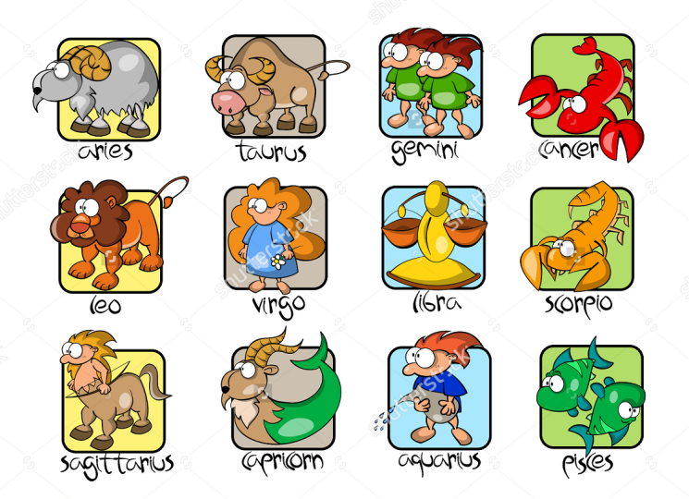

Be creative and have fun making up fortunes! Name your program YournameHmwk2 (e.g. CarmenHmwk2)

**Your completed program should output and display something like this:**

**(note: *italicized* words are user input)**

Welcome to the Horoscopes App!

Please enter your birth month as a number (e.g. January = 1, February = 2, etc.):

*7*

Please enter your birth day (e.g. 1, 2, etc.):

*23*

You are a LEO!

This year you will discover that your friend knows how to make programs. You’re actually using one of their programs right now!