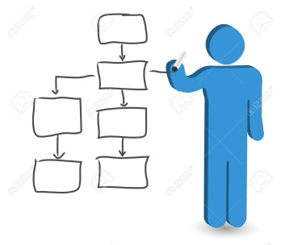It’s the weekend, and you are bored out of your mind! You feel like watching something, but you can’t decide on what to watch. Your friend suggests that you make a TV/Movie database program that contains all your favourite TV shows/programs and movies, in order to help narrow down your choices. Since this database can potentially be useful in the future, you decide to go ahead and make this program. You decide that you want to **narrow down the TV and Movie options by different types**. You decide on the following types for each option:

|  |  |
| --- | --- |
| **TV program types:**   * News * Sports * Sitcoms/Series * Cartoons/Anime | **Movie types:**   * Live action * Animated |

To create this program, you should first **ask the user if they want to watch TV or a movie**. Depending on what the user chooses, you will **then output the types for the user to choose from**. Depending on the type, you will then **output a list of programs (or movies) that the user can watch, corresponding to that type**. Be sure to include a **failsafe** in case the user types/chooses an option not on the list.

Since there are different decisions to make based on the first decision, you should be using if statements and nested if statements to create this program. These are the minimum requirements for the program. However, there is a lot you can add to this to make it better, and to potentially get bonus marks. Name your program YournameHmwk3 (e.g. CarmenHmwk3)

**Your completed program should output and display something like this:**

**(note: *italicized* words are user input)**

Welcome to the Television/Movie Database Program!

What would you like to watch (please enter TV or Movie)?

*Movie*

You have chosen to watch a movie. Please select one of the following types of movies (input 1 or 2):

1) live action

2) animated

*2*

You have chosen animated movies. The following is a list of your favourite animated movies:

- Big Hero 6

- How to Train Your Dragon

- Kung Fu Panda