

8th Markham, Scouts Canada

(2014 – 2015)

#### WINTER CAMP 2015

## Date of Camp: January 30 (Friday) to February 1(Sunday), 2015

## Camp Location: Camp Samac, Kitchie Lodge

### Cost: $40.00/person

Time: Arrival : 7:00 – 8:00 pm January 30, 2015 – All campers are required to check in with the section leader upon arrival

# Departure: 12:00 pm February 1, 2015 – Please pick up your children at this time at the camp site

Every member and his or her family member are welcome to join this camp. Beavers must be accompanied by their parents or guardians. You do not need to wear uniform except neckerchief and baseball cap (if available).

Please note that we WILL NOT provide transportation to the camp, please make car pool arrangement for your youth if necessary. Beaver, Cub and most troop members will be sleeping in the cabin; some senior troops and venturers might be sleeping outdoor if conditions permitted, so be prepared and pack accordingly. Please see a suggested packing list at the end of this memo. Please return the bottom half of the form along with a cheque on or before January 22, 2015.

Enjoy the camp!

NOTE: On site contact persons for emergency:

Richard Yiu --------- (416) 904-0733 (Group)

Karen Kam --------- (647) 504-8177 (Beaver)

Kate Lee --------- (647) 462-2678 (Cub)

Arthur Wu --------- (416) 723-0909 (Troop)

Desmond Wong --------- (416) 892-2332 (Venturer)

********************************************Cut here and Return*************************************

### I do/do not *(cross out one)* permit _________________________ to go to the fall camp on January 30 – February 1, 2015 at Camp Samac, Kitchie Lodge. I understand that there is an inherent risk in this or any activity and in signing this form gives permission for the Leader(s) in charge to obtain medical assistance as stipulated on his/her Health Form if required.

Number of Persons: Adult Youth

If the youth is not attending, please state reason: _______________________________________________________

## Parent/Guardian Signature: _________________________________ Date: _________________________________

### Phone Number: _____________________

*(IN CASE OF EMERGENCY)*

Please list any allergies, dietary restrictions or medications being taken that the Leader(s) should be aware of:

_________________________________________________________________________________________________________________________________________________________________________________________________________________________

**Map / Directions**

Access to Camping is through the NORTH entrance at **Conlin Road ONLY**

Look for Kitchie Lodge while inside the campsite



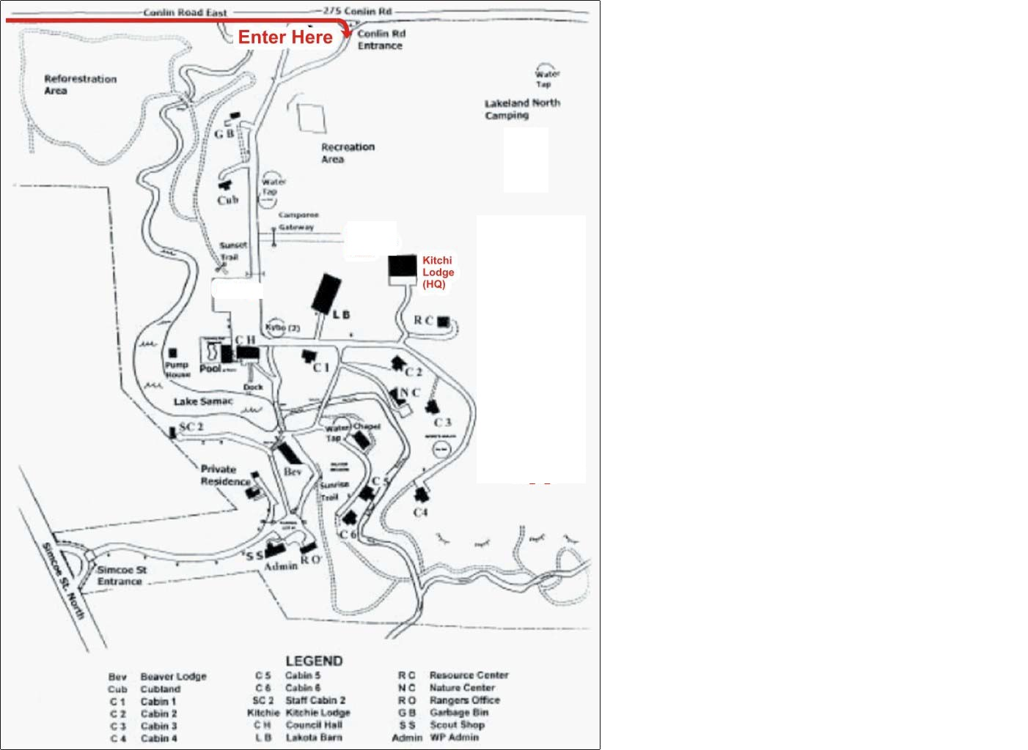

# 

**8th Markham WINTER CAMP Checklist**

**All Scouts and Leaders MUST arrive and depart with neckerchief.**

**All personal belongings MUST be labeled with your name.**

**Use hiking pack for packing. DO NOT use garbage bag or heavy bags.**

**Parents: - Please let your child do the packing (with your help if needed)**

**THINGS THAT SHOULD NOT BRING:**

All electronic games, glass containers, knife (except permitted for Scout & Venture Section), candy or snack. If found, these items will be kept by leaders until end of the camp.

**The following checklist helps your child to pack enough for a comfortable and enjoyable fall camp:**

**IN OUT**

**1) Sleeping Bag (-25º C or Better)………………….. ________ _________**

**2) Camp Fire Blanket (If available)………………… ________ _________**

**3) 8th Markham Cap……………………….............. ________ _________**

**4) Sun Screen with high SPF and lip balm ..……….. ________ _________**

**5) Extra Socks………………………………………… ________ _________**

**6) Rain Coat or poncho ……………………………... ________ _________**

**7) Sunglasses ……………………..………………….. ________ _________**

**8) Long sleeved shirt and pants …………………….. ________ _________**

**9) Winter boots……………….…….…….…….……. ________ _________**

**10) Flashlight (with extra battery if possible).……….. ________ _________**

**11) Mess kit (UNBREAKABLE cup/bowl/plate/utensil) ________ _________**

**12) Wash kit (Use a small Ziploc Bag), tooth brush etc.) ________ _________**

**13) Empty pillowcase to make a pillow ………..……... ________ _________**

**14) Compass & emergency kit (if required)……….….. ________ _________**

**15) Plastic grocery bags for dirty & wet clothes …….. ________ _________**

**16) Few extra grocery bags ……………………………. ________ _________**

**17) Air mattress ………………………………………... ________ _________**

**18) Clothes for both indoor and outdoor activities…... ________ _________**

**19) Gloves & mittens (in case of cold night) .…………. ________ _________**

**19) Hats .…………. .…………. .…………. .…………. . ________ _________**

**20) Extra underwear.…………. .…………. .…………. . ________ _________**

**21) Survival kit .…………. .…………. .…………. . ________ _________**

**22) Campfire Chair ……………………………………. ________ _________**

**23)Wallet with photocopy of your OHIP card………. ________ _________**