MINDANAO STATE UNIVERSITY AT NAAWAN
College of Business and Information Technology
Bachelor of Science in Information Technology

PROJECT PROPOSAL
CESS DocuFlow: A Web-Based Document Management and Tracking System for the College of Education and Social Sciences, MSU at Naawan

ITE183 - Web Systems and Technologies
IT4-A

Barrientos, Kaye Junio, Vale Sayniel
Cardoza, Quinick Rosan Lantape, Aivan
Catayong, Derek Marvie Mapula, Hazel Anne
Chio, Louren Mar Mendoza, Mildred
Cuteron, Enelrad Molina, Al Christian
Estenzo, Kian Christian Nabong, James Christian
Graciano, Ivan Carl Remiscal, Jay
Jamaca, Anthony Sacay, Pya Sue

Submitted to: Niña Bonita Brilleta

October 14, 2026

1. Introduction

1.1 Background of the Project
Document processing is an essential activity in the College of Education and Social Sciences (CESS) of Mindanao State University at Naawan. Students and faculty regularly submit requests and requirements, such as thesis forms, leave and travel documents, INC forms, requests for Special Order (SO), and endorsement letters for promotion, hiring, or training. The College Secretary serves as the college's document controller: she receives, records, routes, releases, and files every type of document. Depending on the document, it passes through the Department Chairperson and the College Dean, and may continue to the office of the Vice Chancellor for Academic Affairs (OVCAA), the Office of the Chancellor, and other offices such as the Human Resource Management Office (HRMO), the Registrar, the Budget and Accounting. Documents from the faculty of Mindanao State of University at Naawan - Integrated Development School (MSUN-IDS), a school connected to CESS, follow a different route: the documents is submitted to the College Secretary, and after the Department Chairperson’s review they return to the IDS Principal before reaching the College Dean. Each office plays a role in reviewing, endorsing, approving, or processing the documents before they reach their intended destination.
However, the current process relies heavily on physical documents, manual recordkeeping, and coordination between offices. The document controller records submissions in a logbook, Excel sheets, and Google Drive, and keeps hard copies in a filing cabinet. These practices make document tracking difficult, especially when documents are delayed, misplaced, or awaiting approval, and the extra IDS hand-offs make it harder to know where an IDS document currently is. Students and faculty may also need to visit the college office repeatedly to inquire about their requests. These challenges show the need for a centralized system that can improve and support document monitoring, record management, and communication among the involved offices.

1.2 Problem Statement
The current document processing workflow faces several challenges that affect the CESS College Secretary, students, faculty, and other personnel involved in document handling. Based on the identified problems in the existing process, document requirements may be incomplete or unclear, records of received documents are not centralized, and physical transfers between offices can result in delays, misplaced documents, or lost records. Furthermore, the absence of priority indicators and reminders can create bottlenecks, while retrieving information from paper files and following up on pending documents require additional time and effort.
Tracking also becomes difficult when documents are forwarded to higher offices, such as the OVCAA and Office of the Chancellor, or when IDS documents pass between the IDS Principal, the College Secretary, and the Department Chairpersons, because their current status and waiting time are not readily visible. Additionally, separate recordkeeping practices among offices can lead to repeated data entry and inconsistent information. These problems indicate the need for an improved document management and tracking process that provides centralized records, clearer status monitoring, and more efficient coordination among stakeholders.
Interviews with the College Dean (October 2, 2026) and the College Secretary (October 7 and 8, 2026) support these problems. The College handles documents such as endorsement, notices, minutes of meetings, forms, syllabus, INC forms, and other documents. Their approval status is tracked manually and through email, and scanned copies are kept in Google Drive. The College Secretary named storing, retrieval, tracking, and communication as the main challenges. The College Dean added that after a document is endorsed, staff must wait for its status, follow up, and sometimes submit the document again.

1.3 Project Objectives
General Objective
To develop a centralized document management and tracking system that improves the monitoring,
recording, and retrieval of documents processed by the college.

Specific Objectives
- To provide a centralized repository for recording and retrieving document information, including submission details and processing history, for every document received by the College Secretary.
- To enable users to monitor document status and track its movement between the offices involved in the approval and processing workflow.
- To improve document processing by providing visibility into pending requests and identifying documents that require follow-up through priority flags and reminders for pending items.
- To reduce repetitive manual recordkeeping and incomplete submissions, and improve the consistency of document information across participating offices, by showing the required forms and attachments for each document type.
- To provide students and faculty with a way to check the progress of their submitted documents and receive email alerts when a document is returned or ready, reducing the need for repeated in-person follow-ups.
- To support the different routing paths of CESS and IDS documents, so that each document follows the correct sequence of offices and its location is visible at every hand-off.

1.4 Scope and Limitations
Scope
The proposed system will focus on improving the recording, monitoring, and tracking of documents within the college's existing processing workflow. The CESS College Secretary, as document controller, will be the primary user, and the system will also accommodate the needs of students, faculty, IDS faculty, Department Chairpersons, the IDS Principal, the College Dean, and other offices involved in document processing.
The system will cover the following functions:
- Online submission: Allow students and faculty, including IDS faculty, to submit document requests and upload digital copies of the required forms and attachments.
- Requirements and completeness checking: Show the required forms and attachments for each document type, and record the College Secretary's completeness check of each submission.
- Document recording: Store and organize document information, including submission details and relevant processing records.
- Document status tracking: Monitor the current status of documents as they move through the designated offices.
- Workflow monitoring: Provide visibility into document progress, pending actions, and delays during processing.
- Centralized record management: Maintain accessible records to make document retrieval easier and reduce dependence on separate manual records.
- Requester monitoring: Allow students and faculty, including IDS faculty, to check the progress of their submitted documents.
- Office coordination: Support the recording and monitoring of document transfers, endorsements, and approvals within the defined workflow.
- Origin-based routing: Apply the correct approval path based on the document type and where it came from (CESS or IDS), including the IDS Principal's first and second review of IDS documents.
- External office transfers: Allow the College Secretary to record documents sent to and returned from HRMO, the Registrar, Budget, and Accounting, so a document's location stays visible while it is outside the reviewing offices.
- Priority flags and notifications: Allow requests to be marked by priority, send email alerts when a document is returned or ready, and send reminders for pending items.
- User accounts and roles: Provide role-based access for requesters, the IDS Principal, the College Secretary, and the reviewing offices.

Limitations
The system's effectiveness will depend on the accuracy and timeliness of the information entered by authorized users. Documents that are not recorded or whose statuses are not updated may not be accurately reflected in the system. The system will also depend on the participation of the reviewing offices (Department Chairpersons, the IDS Principal, the College Dean, OVCAA, and the Office of the Chancellor).
Furthermore, the project will focus on document recording and tracking rather than replacing all existing institutional approval procedures. Final decisions and approvals will remain the responsibility of the designated personnel and offices. Direct access and integration with systems used by HRMO, the Registrar, Budget, and Accounting are outside the scope of this version; the College Secretary records transfers to and from these offices on their behalf. The project will also be limited by the development period, available resources, and the requirements established during consultation with the intended users.

2. Current Process Flow (As-Is)

2.1 Stakeholders
Stakeholder | Classification | Role in the Current Process
College Secretary | Primary User and System Admin | Serves as the document controller by receiving submissions (directly from CESS requesters or forwarded by the IDS Principal), checking document completeness, recording document details, routing documents to the appropriate offices, and releasing completed documents to requesters.
Student, CESS Faculty, IDS Faculty | Secondary Users (requesters) | Prepare and submit physical documents, provide the required attachments, follow up on document status, and receive completed documents.
IDS Principal | Secondary User (requesters) | Receives and reviews documents from IDS Faculty, forwards them to their respective office responsibilities.
Department Chairpersons, College Dean, OVCAA, Office of the Chancellor | Secondary Users (reviewing offices) | Review and evaluate submitted documents, provide endorsements or approvals when required, and handle further processing according to their respective office responsibilities.
HRMO, Registrar, Budget and Accounting | External Offices (not system user) | Receive documents forwarded by the College Secretary or other offices and process them according to their respective office responsibilities. In the proposed system, the College Secretary records these transfers on their behalf.
College of Education and Social Sciences: College Dean and College Secretary | Client | Owns the document workflow that the system will support, and provides the requirements and process details.

2.2 Current Process Flow Diagram
Figure 1 shows the current process as one continuous flow, from submission to release.

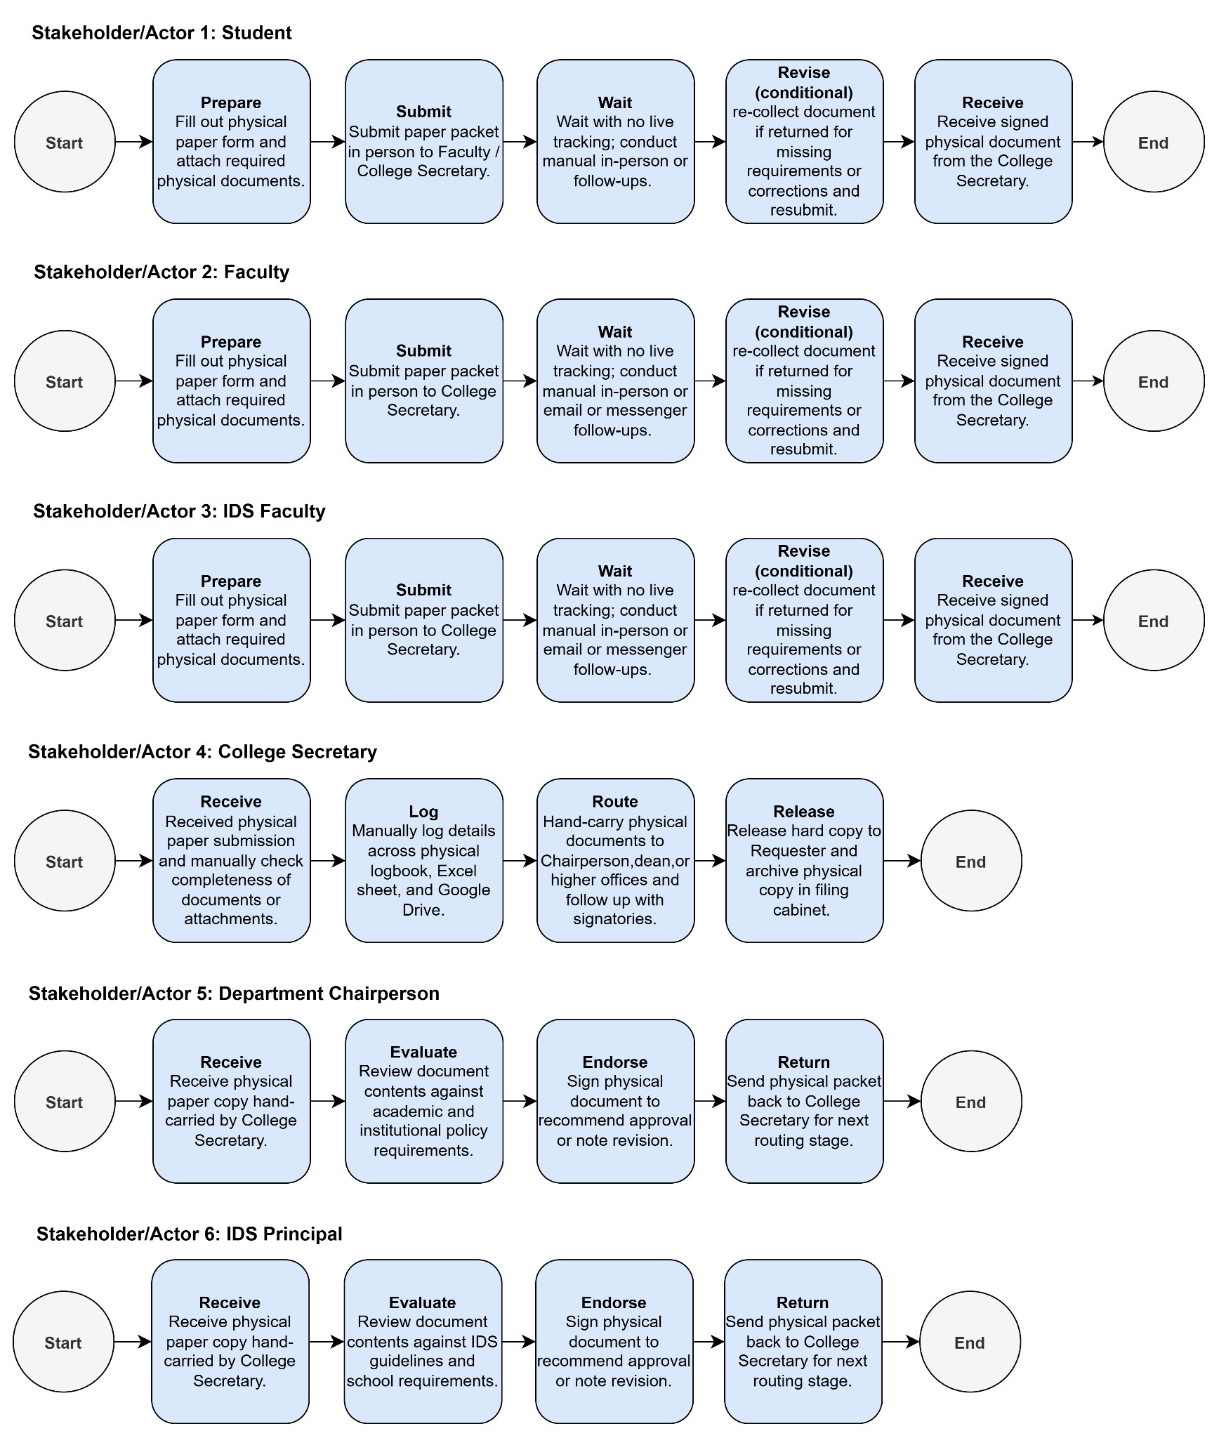
Figure 1. Current (As-Is) Document Processing Flow

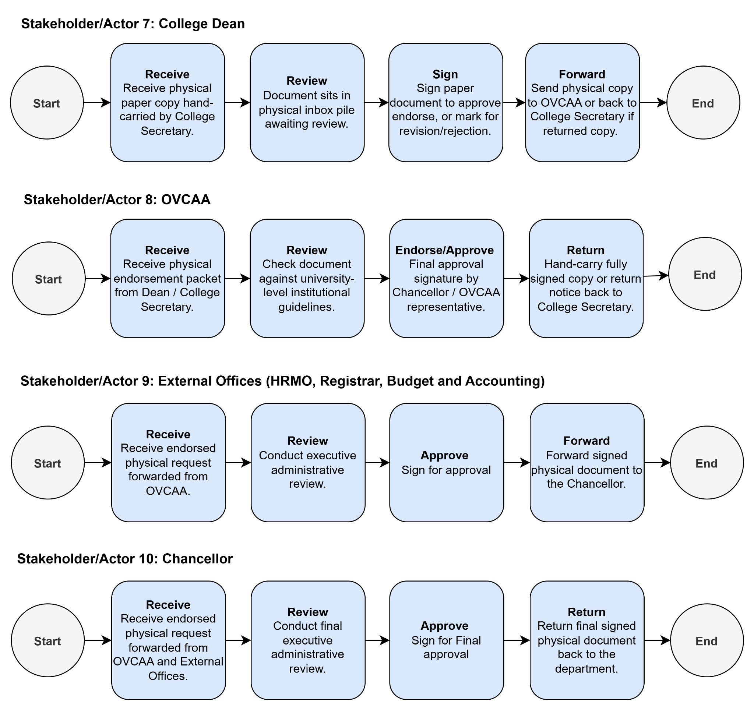
Cont. Figure 1. Current (As-Is) Document Processing Flow

2.3 Problems and Gaps Identified
Based on the current process flow, several problems and gaps were identified in the existing document processing workflow:
- Manual Document Tracking: Document submissions and movements are recorded manually using logbooks, Excel sheets, and Google Drive, making it difficult to maintain centralized and consistent records.
- Lack of Real-Time Status Monitoring: Students and faculty have no direct way to monitor the progress of their documents and must follow up in person, through email, or through a messenger.
- Difficulty in Locating Documents: With document transactions recorded across multiple logbooks and files, staff may have difficulty determining a document’s current location or identifying which office last handled it, delaying retrieval and follow-up.
- Delays in Document Processing: Documents may remain in physical inboxes or wait for signatures and approvals without clear visibility into their current status, resulting in delays and bottlenecks.
- Risk of Incomplete, Misplaced, or Lost Documents: Physical document handling and transfers between offices increase the possibility of missing requirements, misplaced papers, and documents being returned for corrections or resubmission.
- Limited Coordination Between Offices: Once documents are forwarded to another office, tracking their location and processing progress becomes difficult, particularly when documents are returned for revision or require further approval. IDS documents add further hand-offs between the offices, which makes their location harder to follow.
- Unclear Document Requirements: Requesters are not always sure which forms and attachments each document type needs, so submissions may arrive incomplete and be returned for correction or resubmission.
- No Priority Indicators or Reminders: Without priority flags or reminders for pending documents, urgent requests can sit unnoticed in physical inboxes and create bottlenecks.

3. Proposed Solution

3.1 Project Description
CESS DocuFlow is a web-based system that lets students and faculty submit document requests, upload the required attachments, and follow their progress without repeated visits to the college office. Each document type shows its required forms and attachments, and requests can be marked by priority. The College Secretary checks each submission for completeness, logs it, and routes it to the Department Chairperson, the College Dean, and, when required, the OVCAA and the Office of the Chancellor. When a document must also go to HRMO, the Registrar, Budget, or Accounting, the College Secretary records the hand-off and the return on behalf of those offices, which do not need accounts, so the document stays visible in the system. Each office records its action (endorsed, approved, or returned with reasons), so the document's current status and its movement between offices are visible to the people involved. Requesters are notified when a document is returned or ready, reminders are sent for pending items, and all records are kept in one central repository, so each document is entered once and every office works from the same record. The system supports and tracks the existing process; final decisions and approvals remain with the designated offices. IDS faculty submit through the same system. Their request will be forwarded to the Department Chairpersons for review, the document will be passed to the IDS Principal, then proceeds to the College Dean, and continues to any other required offices. The College Secretary will check the completeness of the requirements and route the document to the designated offices. The system applies the correct route based on the document's origin and type, so staff do not have to set it by hand each time.

The system addresses the gaps identified in the following ways:
- Manual Document Tracking: A central repository replaces the logbooks, Excel sheets, and scattered files, so document submissions and movements are recorded and tracked in one system instead of manually.
- Lack of Real-Time Status Monitoring: Requesters check the status of their documents online and receive email alerts, so they no longer need to follow up in person, through email, or through messenger.
- Difficulty in Locating Documents: The office currently holding each document and its processing history are visible in the system, so staff can find a document's current location and see which office last handled it.
- Delays in Document Processing: Pending requests and the office currently holding each document are visible, so documents waiting in an office or for approval can be identified and followed up.
- Risk of Incomplete, Misplaced, or Lost Documents: Completeness is checked at submission, attachments are stored digitally, and every transfer between offices is recorded.
- Limited Coordination Between Offices: A processing history shows where a document is and what action is pending, including returns for revision and the hand-offs of IDS documents between the offices.
- Unclear Document Requirements: Each document type shows its required forms and attachments at submission, so requesters know what to submit.
- No Priority Indicators or Reminders: Requests can be marked by priority, and reminders are sent for pending items, so urgent requests are not overlooked.

3.2 Proposed Process Flow (Flowchart)
Figure 2 shows the new process with the system in place. Each lane belongs to one stakeholder, and each diamond is a decision.
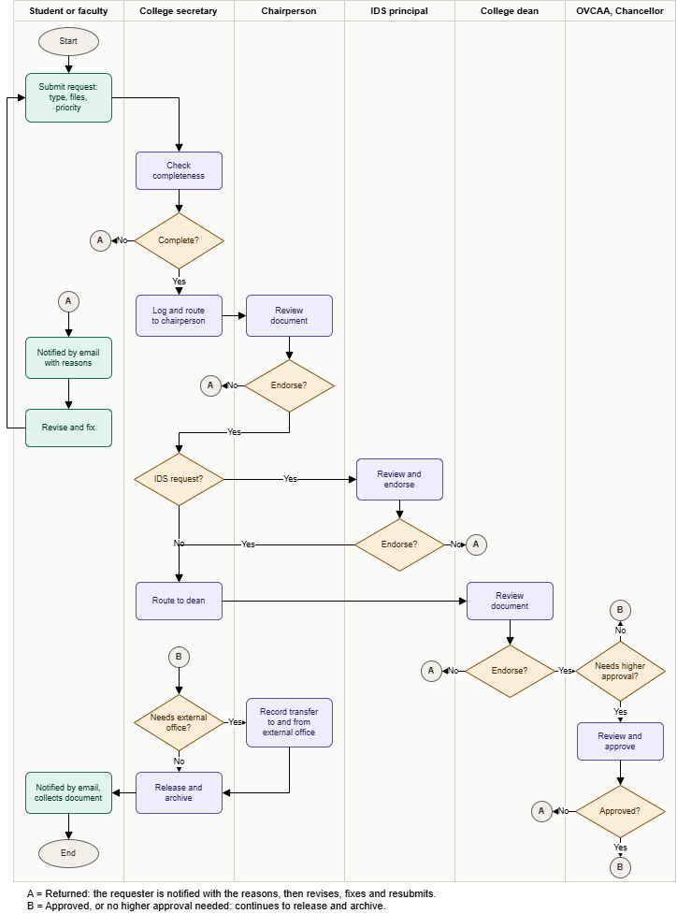
Figure 2. Propose process flow (Swimlane flowchart)

3.3 System Architecture Diagram
Figure 3 shows the main components and how data flows between them. Users work through the
web client, which exchanges JSON with the API server over HTTPS. The API server reads and writes the Supabase database, authentication, and file storage, and sends email alerts. Code is kept on GitHub and deployed automatically to Vercel.

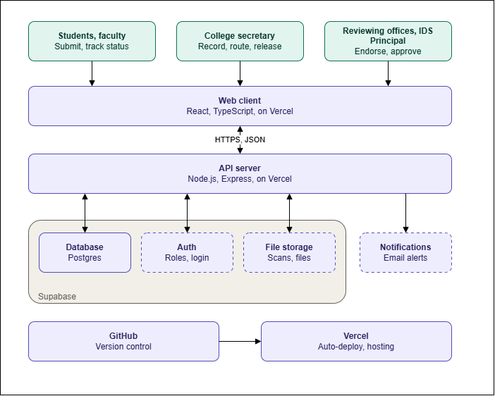
Figure 3. System architecture diagram

3.4 Related Systems
Web-based document tracking has been studied and deployed in several Philippine institutions as a response to paper logbooks, misplaced documents, and repeated follow-ups. Three of these systems are reviewed here because their settings and features are closest to CESS DocuFlow.
Payumo-Mabulay and Calades (2026) developed Intelligence-Track, a real-time college document tracking system for faculty-related documents at Samar State University, where manual logbooks and paper-based tracking caused delayed approvals, misplaced records, and limited visibility over document status. The system was developed using the Agile model and evaluated by 133 faculty members and five unit document controllers against ISO/IEC 25010 quality criteria, with mean ratings from 4.49 to 4.70 on a 5-point scale across all criteria. The authors recommended adding electronic signatures and SMS notifications in future versions. Like CESS DocuFlow, the system is college-level, follows Agile, and relies on document controllers. However, it was designed for faculty-related documents, whereas CESS DocuFlow also serves students and follows each request through the College Secretary, Department Chairperson, College Dean, OVCAA, and Chancellor, with requesters submitting online and receiving the reasons when a document is returned.
Castro et al. (2022) built DocTrack for the University of Northern Philippines after staff and faculty had to make repeated trips or phone calls to follow up on documents sent to the Office of the President. The system, developed with the Modified Waterfall Model, PHP CodeIgniter, and MySQL, supports document uploading, status tracking, SMS notifications for declined documents, and archiving. Faculty, non-teaching personnel, and students rated it highly acceptable, with overall weighted means of 4.56, 4.41, and 4.47, respectively. CESS DocuFlow shares this study’s goal of sparing requesters from physical follow-ups, but it is a separate system despite the similar name. It is built for a single college with the College Secretary as document controller, sends email alerts when a document is returned or ready, provides priority flags and reminders for pending items, and follows an Agile rather than a Modified Waterfall approach.
Jaca (2022) developed the Electronic Document Management and Tracking System (EDMTS) for the PhilHealth Regional Office of the National Capital Region, where paper-based routing, manual logbooks, and spreadsheets led to lost or misfiled documents and poor tracking. The web-based system digitizes, centralizes, routes, tracks, and publishes official documents across departments and regional offices. It obtained an average System Usability Scale score of 84.5, and vulnerability testing with OWASP ZAP found no high-priority alerts. The study recommends integrating digital signatures to allow fully paperless approvals. In contrast, CESS DocuFlow serves an academic unit and records and tracks requests without replacing the signatures of the designated offices, and it includes online submission with a completeness check by the College Secretary.
Taken together, these studies show that web-based tracking has been well received in Philippine institutions, with high acceptability or usability scores in all three, which supports the feasibility of this project. They also point to needs that CESS DocuFlow addresses through email alerts and role-based access, and they show that quality criteria and usability scales are common ways to evaluate such systems. CESS DocuFlow builds on this work but is scoped to one college: it centers on the College Secretary as document controller and combines online submission, completeness checking, status tracking across the IDS Principal, the Chairperson, Dean, OVCAA, and Chancellor, notifications with reasons for returns, and reminders in a single system.

4. Technical Approach

4.1 Tools and Technologies
Category | Tool / Technology | Reason
Development Methodology | - Agile Framework (Kanban) | - It lets the team adapt to changing client requirements, deliver working features in short iterations, and gather continuous feedback. Its early testing and regular collaboration also reduce project risks and keep the system aligned with what users actually need.
Frontend | - React  - Typescript (.tsx)  - Tailwind CSS | - Using React as the core frontend frameworks provides the system with a component-based architecture, an efficient virtual DOM, and Hooks for managing state, making dynamic document tracking workflows smooth, organized, and simple to maintain ( Ollila et al., 2022; React Team, 2024; Sianandar & Manuaba, 2022).  - Typescript builds on this by adding strict type safety to Javascript, which prevents runtime bugs when handling crucial document metadata,user roles, and system statuses, while also enhancing developer productivity through auto-completion and better error detection (Bogner & Merkel, 2022; Gao et al., 2017).  - For presentation and styling, Tailwind CSS enables rapid layout design using utility-first classes, enforcing a consistent visual hierarchy with minimal CSS bundle sizes (Biradar, 2025; Wathan, 2021).
Backend | - Node.js  - Express.js | - Node.js provides a high-performance, asynchronous, non-blocking I/O event-driven runtime environment that allows the system to process concurrent document-tracking API requests efficiently without performance degradation (OpenJS Foundation, n.d.).  - Express.js serves as a minimalist web framework for Node.js, streamlining the design of modular RESTful API endpoints, request routing, and backend middleware to ensure scalable client-server data exchange (OpenJS Foundation, n.d.).
Database | - Postgres(Supabase) | - Supabase serves as an open-source Backend-as-a-Service (BaaS) platform powered by PostgreSQL, delivering enterprise-grade relational data storage, ACID compliance, auto-generated REST APIs, secure user authentication, and real-time database synchronization for tracking document statuses dynamically (Supabase, n.d.).
Version Control | - Git  - GitHub | - Git is a free, open-source distributed version control system whose strength is its branching model, which lets people work on independent lines of development and merge them back (Git, n.d.), so teammates can work on separate features in parallel without overwriting each other.  - GitHub hosts the shared repository and lets teammates propose and review changes through pull requests (GitHub, n.d.), so code is checked before it goes into the main project.

4.2 Development Approach
The team will follow an Agile approach that combines Kanban with short iterations (Beck et al., 2001). Work is broken into small tasks such as interface design, frontend development, backend development, database setup, testing, and documentation. These are tracked on a Kanban board in GitHub Projects with the columns Backlog, To Do, In Progress, For Review, Testing, and Done. A limit on how many tasks can be In Progress at once keeps work from piling up and makes blockers visible early (Kanban Guides, 2025). Development is organized into three two-week iterations (October 26 to December 4, 2026), each ending with a working, tested set of features, so progress can be reviewed regularly and the system can adapt to changing requirements.
The team will use Git and GitHub for version control. The main branch is protected and holds only reviewed, working code, while each feature or fix gets its own branch. Every change goes through a pull request that needs at least one teammate’s review before it is merged (GitHub, n.d.-b). Vercel builds a preview for each pull request and deploys the main branch, so reviewers can try changes before they go live.
The team will meet weekly, face-to-face or on Google Meet (Google, n.d.), to plan the next iteration, review completed work, discuss bugs and technical problems, and adjust tasks. Short daily updates in the group chat replace daily meetings, and each iteration ends with a brief retrospective on what worked and what to improve. Extra meetings are called when an important decision can’t wait.
Testing is done throughout development instead of only at the end. Developers write unit and API tests for their own work, testers run manual test cases against the requirements, and the team gathers feedback from the intended users so problems are found while there is still time to fix them. This approach supports the Agile principles of collaboration, responding to change, and regular review of progress (Beck et al., 2001).

5. Project Plan

5.1 Team Roles and Responsibilities
Role | Name | Responsibilities
Project Manager | Hazel Anne P. Mapula | Plans, schedules,and oversees the project from the start to finish, managing scope, budget, timeline, risks, and stakeholder communication so the work is delivered on time.
Product Owner | Quinick Rosan Cardoza | Represents the client or users need, defines and prioritizes the product backlog, and decides which features deliver the most value to the business.
Team Leader | Kian Christian Estenzo | Guides and supports the development team day to day, assigns tasks, removes blockers,resolves conflicts, and makes sure the team stays productive and aligned with project goals.
Frontend Developers | Jay Remiscal  Pya Sue Sacay  Louren Mar Chio  Ivan Carl Graciano | Build the user-facing part of the application (pages, buttons, forms, layouts) using any frameworks and make sure it is responsive and works well across devices.
Backend Developers | Anthony Jamaca  James Christian Nabong  Vale Sayniel Junio | Build and maintain the server-side logic, databases, and APIs that process data, handle authentication, and power the Frontend behind the scenes.
UI/UX Designer | Aivan Lantape  Enelrad Cuteron | Researches user needs and designs the look, feel, and flow of the product through wire frames, mockups, and prototypes so it is both attractive and easy to use.
QA / Tester | Mildred Mendoza  Kaye Barrientos  Derek Marvie Catayong | Test the system through manual and automated checks to find bugs, verify that requirements are met, and report issues so quality is ensured before release.
DevOps | Al Christian Molina | Manages deployment, servers, CI/CD pipelines, and monitoring, so that code moves smoothly from development to production and the system stays reliable and scalable.

5.2 Work Plan and Timeline
Phase | Task / Deliverable | Owner | Target Date
Planning and Requirements | -Requirements gathering  -SRS | Hazel Anne Mapula  Quinick Rosan Cardoza | 10/19/2026
Design | Wireframes / UI design and System Architecture & Database Design | Enelrad Cuteron  Aivan Lantape | 10/23/2026
Development | Working application, source code, database, and basic technical documentation | Kian Christian Estenzo  Jay Remiscal  Pya Sue Sacay  Louren Mar Chio  Ivan Carl Graciano  Anthony Jamaca  James Christian Nabong  Vale Sayniel Junio | 12/04/2026
Testing & Delivery | Test plan/cases, testing results,bug fixing, user manual and Go Live | Mildred Mendoza  Kaye Barrientos  Derek Marvie Catayong  Al Christian Molina | 12/04/2026

5.3 Risks and Mitigation
Risk | Likelihood | Mitigation
Unauthorized access to documents or records | Medium | Role-based access for requesters, secretary, and reviewing offices; Supabase row-level security; test every role’s permissions before release.
Leaked credentials or API keys | Medium | Keep secrets in Vercel environment variables, never in GitHub; rotate keys if exposed; add a secrets check to code review.
Data loss or corruption in the database | Low | Regular Supabase backups, a tested restore, and a status history log so records can be traced and recovered.
Serverless Express issues on Vercel | Medium | Use Supabase connection pooling, keep the API stateless, and test deployment early instead of at the end.
Inaccurate or outdated statuses because offices don’t update them in the system | Medium | Make status updates one or two clicks, send notifications for pending items, and show the last-updated time on every record.
Notifications fail or get ignored, so requesters don’t know a document was returned | Medium | Show the return reason in the system as well as by email, log every notification sent, and allow retry on failure.
Invalid or incomplete uploads | Low | Validate file type and size on upload, limit file size, and show clear error messages.
Poor usability or low adoption by staff and students | Medium | Test with the College Secretary early, keep the interface simple, and provide a short user guide.

6. References
Beck, K., Beedle, M., van Bennekum, A., Cockburn, A., Cunningham, W., Fowler, M., Grenning, J., Highsmith, J., Hunt, A., Jeffries, R., Kern, J., Marick, B., Martin, R. C., Mellor, S., Schwaber, K., Sutherland, J., & Thomas, D. (2001). Manifesto for Agile software development. https://agilemanifesto.org
Biradar, V. M. (2025). Tailwind CSS. Zenodo. https://doi.org/10.5281/zenodo.15194897
Bogner, J., & Merkel, M. (2022). To type or not to type? A systematic comparison of the software quality of JavaScript and TypeScript applications on GitHub (arXiv:2203.11115). arXiv. https://doi.org/10.48550/arXiv.2203.11115
Castro, F. V., Quilon, E. R. C., & Arruejo, A. C. (2022). DocTrack: A dynamic document tracking system for the University of Northern Philippines. Journal of Innovative Technology Convergence, 4(2), 23–34. https://doi.org/10.69478/JITC2022v4n2a03
Gao, Z., Bird, C., & Barr, E. T. (2017). To type or not to type: Quantifying detectable bugs in JavaScript. In Proceedings of the 39th International Conference on Software Engineering (pp. 758–769). IEEE. https://doi.org/10.1109/ICSE.2017.75
Git. (n.d.). About. https://git-scm.com/about
GitHub. (n.d.-a). Collaborating with pull requests. https://docs.github.com/en/pull-requests/collaborating-with-pull-requests
GitHub. (n.d.-b). Writing code for a project. https://docs.github.com/en/pull-requests/concepts/writing-code-for-a-project
Google. (n.d.). Google Meet Help. Google Support. https://support.google.com/meet/answer/12389066?hl=en
Jaca, V. M., Jr. (2022). Electronic Document Management and Tracking System [Master's capstone project, University of the Philippines Open University]. UP Open University Institutional Repository. https://doi.org/10.5281/zenodo.7478530
Kanban Guides. (2025). The Kanban guide. https://kanbanguides.org/the-kanban-guide/history/
Ollila, R., Mäkitalo, N., & Mikkonen, T. (2022). Modern web frameworks: A comparison of rendering performance. Journal of Web Engineering, 21(3). https://doi.org/10.13052/jwe1540-9589.21311
OpenJS Foundation. (n.d.-a). Node.js. Retrieved October 10, 2026, from https://nodejs.org/
OpenJS Foundation. (n.d.-b). Express. Retrieved October 10, 2026, from https://expressjs.com/
Payumo-Mabulay, J., & Calades, M. G. (2026). Intelligence-Track: A real-time automated college document tracking system. International Journal of Information and Communication Technology, Artificial Intelligence, and Digital Innovation, 1(1), 1–12. https://doi.org/10.63498/ijictaidi1
React Team. (2024). React v19. React Blog. https://react.dev/blog/2024/12/05/react-19
Sianandar, J., & Manuaba, I. B. K. (2022). Performance analysis of hooks functionality in React and Vue frameworks. In 2022 International Conference on Information Management and Technology (ICIMTech). IEEE. https://doi.org/10.1109/ICIMTech55957.2022.9915183
Supabase. (n.d.). Supabase documentation. Retrieved October 10, 2026, from https://supabase.com/docs
Tailwind Labs. (n.d.-a). Optimizing for production. Tailwind CSS. https://v3.tailwindcss.com/docs/optimizing-for-production
Tailwind Labs. (n.d.-b). Styling with utility classes. Tailwind CSS. https://tailwindcss.com/docs/styling-with-utility-classes
Wathan, A. (2021). Tailwind CSS v3.0. Tailwind CSS Blog. https://tailwindcss.com/blog/tailwindcss-v3

Appendix
Appendix A. Client Interview
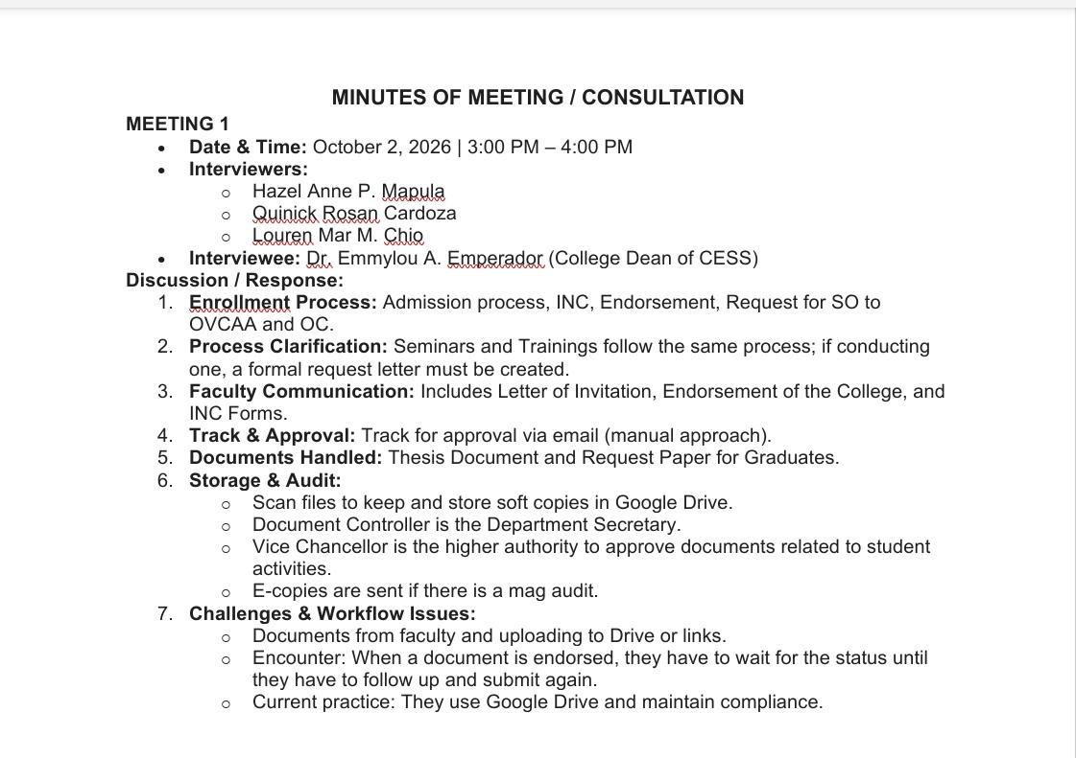
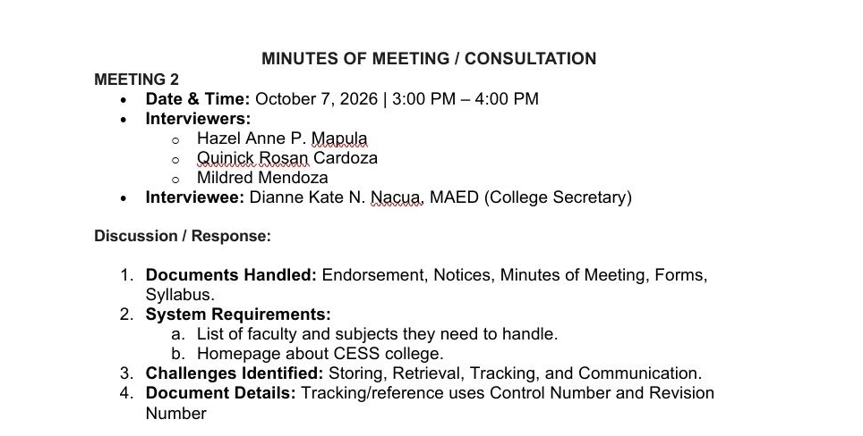
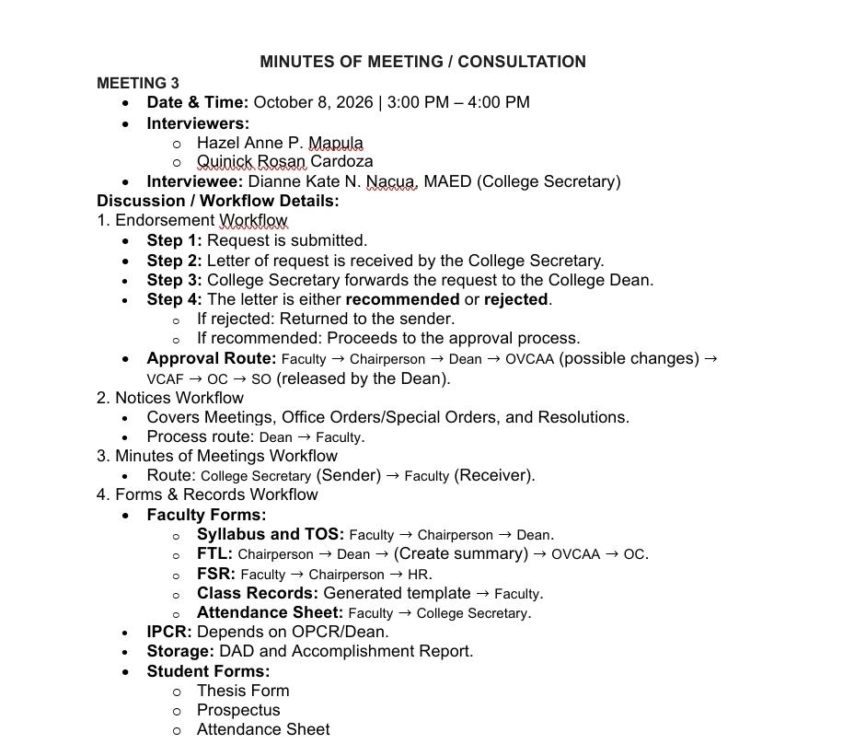

Appendix B. Sample forms and records



