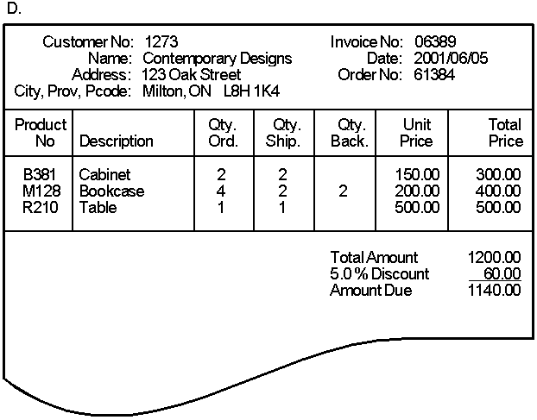

0NF

Order (Customer No, Name, Address ,city, prov, pcode, invoiceNo, date, orderNo, [ProductNo, ProdDescription, Qty Orde,qty shipped, qty back, unit price ,total price], Total amount, Disc, Amount Due)

1NF

Order (Customer No, Name, Address ,city, prov, pcode, invoiceNo, date, orderNo, Total amount, Disc, Amount Due)

OrderProduct (orderNo ,ProductNo, ProdDescription, Qty Orde,qty shipped, qty back, unit price ,total price)

2NF:Remove partial dependency

Order (Customer No, Name, Address ,city, prov, pcode, invoiceNo, date, orderNo, Total amount, Disc, Amount Due)

OrderProduct (orderNo, ProductNo,

Qty Orderd,qty shipped, qty back, ,total price)

Product(ProductNo, ProdDescription, unit price)

3NF:remove transitive dependency

Order (orderNo, date, FKCustomer No,FKinvoiceno)

OrderProduct (orderNo, ProductNo,

Qty Orderd,qty shipped, qty back, ,total price)

Product(ProductNo, ProdDescription, unit price)

Customer(Customer No, Name, Address ,city, prov, pcode)

Invoice(Invoiceno, Total amount, Disc, Amount Due)