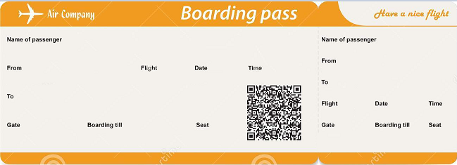

BA2490 02/10/2002 14:30

3B 14:20 8A

John Doe

Tokyo HND

Schiphol airport AMS

BA2490 02/10/2002 14:30

Danny Ocean

Tokyo HND

Schiphol airport AMS

3B 14:20 8A



BA2490 02/10/2002 14:30

12C 23:00 32D

John Doe

South Africa JNB

Tokyo HND

CF7592 30/10/2002 23:15

Miguel Diaz

South Africa JNB

Tokyo HND

12C 23:00 32D Tokyo HND



IU4738 3/12/2002 10:50

2A 10:30 10C

John Doe

Morocco RAK

South Africa JNB

IU4738 3/12/2002 10:50

Mr. Eisenhower

Morocco RAK

South Africa JNB

2A 10:30 10C

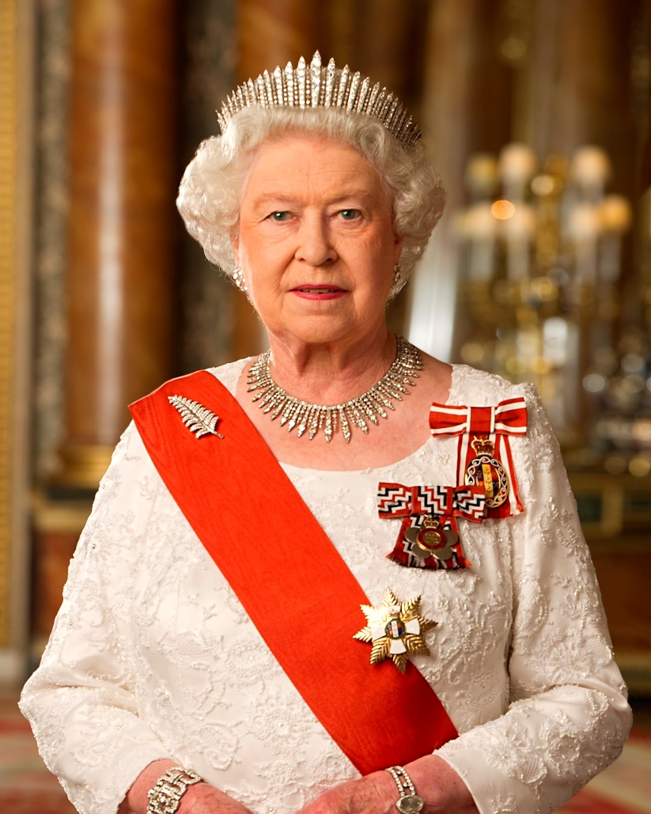 

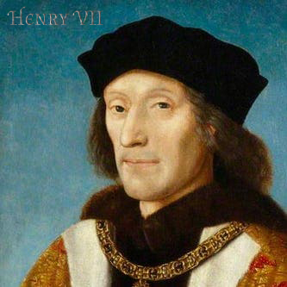 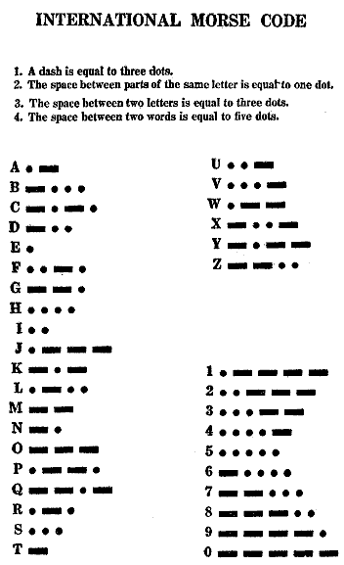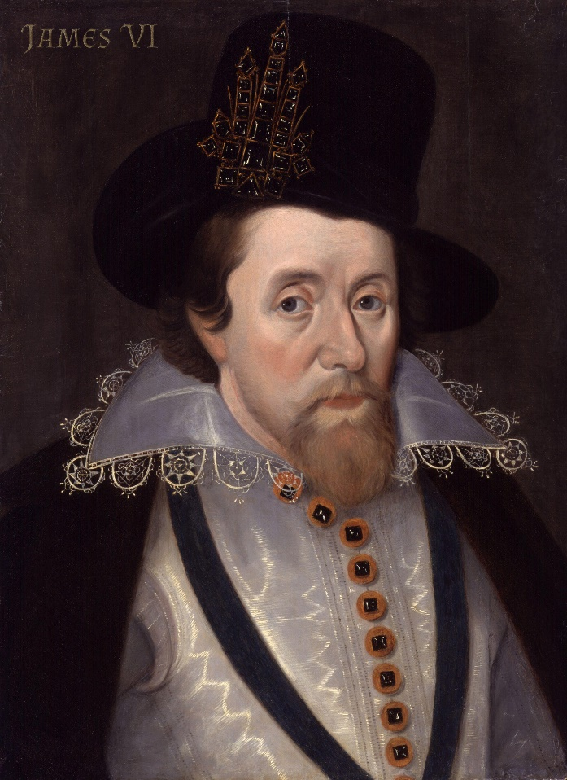 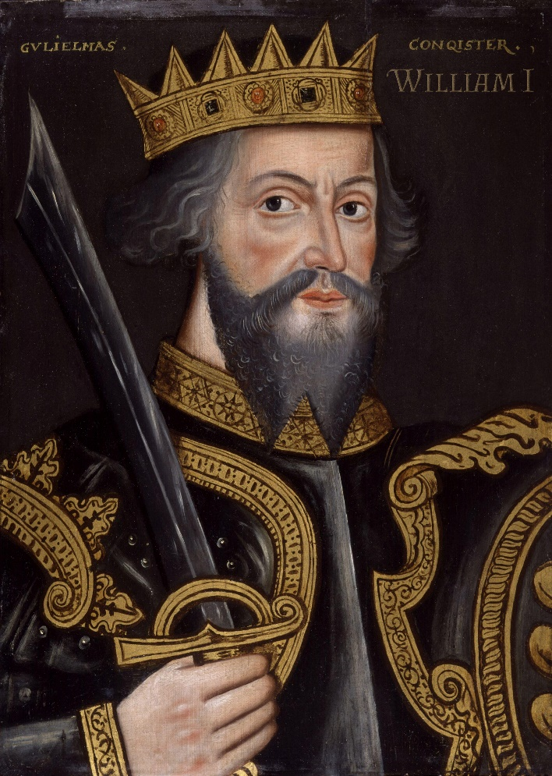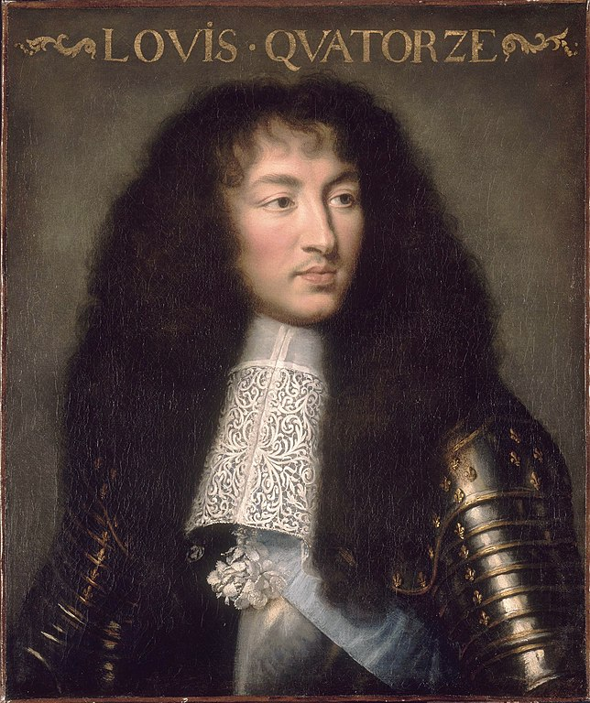 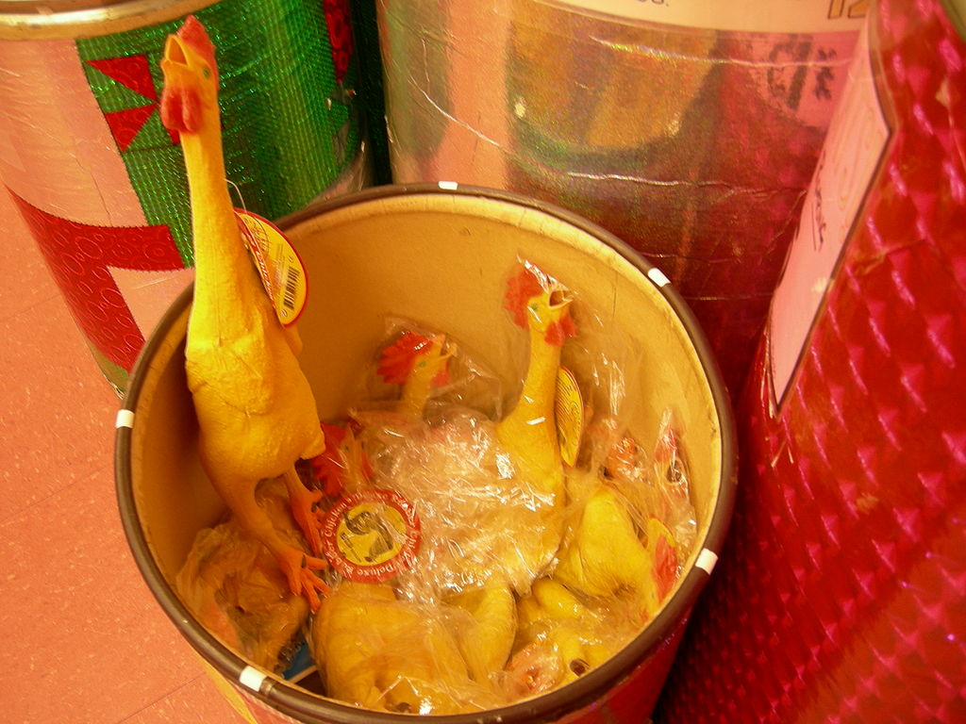 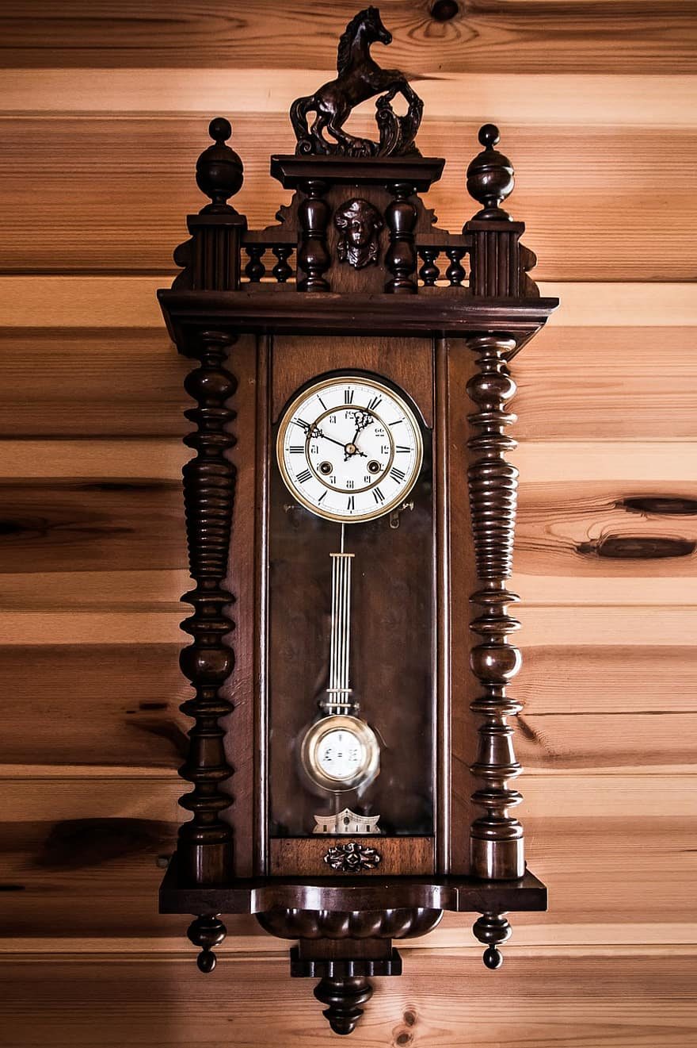

Hvs xoqy kog igwbu vwg gdors wb hvs twszr  
Kvwzs hvs eissb uojs vsf vsofh hc obchvsf aob  
Obr hvs ywbu kog wb zcjs kwhv vwg rwoacbrg

LOOK WITHIN! …THE SECRET IS INSIDE YOU.

Monarch intro

You enter a room where you see a lot of paintings of monarchs on the walls.

Under the paintings you find names **James VI**, **Elizabeth II**, **Louis XIV**, **Henry VII** and **William I**.

In front of each painting there is also a short description about that person’s life.

**James VI**

James VI and I (James Charles Stuart; 19 June 1566 – 27 March 1625) was King of Scotland as James VI from 24 July 1567 and King of England and Ireland as James I from the union of the Scottish and English crowns on 24 March 1603 until his death in 1625. The kingdoms of Scotland and England were individual sovereign states, with their own parliaments, judiciaries, and laws, though both were ruled by James in personal union.

James was the son of Mary, Queen of Scots, and a great-great-grandson of Henry VII, King of England and Lord of Ireland, and thus a potential successor to all three thrones. James succeeded to the Scottish throne at the age of thirteen months, after his mother was compelled to abdicate in his favour.

James's sexuality is a matter of dispute. Throughout his life James had close relationships with male courtiers, which has caused debate among historians about their exact nature In Scotland Anne Murray was known as the king's mistress. James's wife Anne gave birth to seven live children, as well as suffering two stillbirths and at least three other miscarriages.

**Henry VII**

Henry VII (Welsh: Harri Tudur; 28 January 1457 – 21 April 1509) was the King of England and Lord of Ireland from his seizure of the crown on 22 August 1485 to his death. He was the first monarch of the House of Tudor.

Henry is credited with a number of administrative, economic and diplomatic initiatives. His supportive policy toward England's wool industry and his standoff with the Low Countries had long-lasting benefits to the whole English economy. He paid very close attention to detail, and instead of spending lavishly he concentrated on raising new revenues. New taxes stabilised the government's finances. After his death, a commission found widespread abuses in the tax collection process. Henry reigned for nearly 24 years and was peacefully succeeded by his son, Henry VIII.

Henry’s wife was Elizabeth of York. They had 7 children of whom most died at a young age. Elizabeth died during the birth of the last child, who was named Katherine. It is widely believed that Henry also had one illegitimate son with a woman from Breton. The son was named Velville and was knighted in 1497.

**William I**

William I (c. 1028 – 9 September 1087), usually known as William the Conqueror and sometimes William the Bastard, was the first Norman King of England, reigning from 1066 until his death in 1087. He was a descendant of Rollo and was Duke of Normandy from 1035 onward. His hold was secure on Normandy by 1060, following a long struggle to establish his throne, and he launched the Norman conquest of England six years later. The rest of his life was marked by struggles to consolidate his hold over England and his continental lands, and by difficulties with his eldest son, Robert Curthose.

He died in September 1087 while leading a campaign in northern France, and was buried in Caen. His reign in England was marked by the construction of castles, settling a new Norman nobility on the land, and change in the composition of the English clergy. He did not try to integrate his various domains into one empire but continued to administer each part separately. His lands were divided after his death: Normandy went to Robert, and England went to his second surviving son, William.

William’s marriage in the 1050s to Matilda of Flanders provided him with a powerful ally in the neighbouring county of Flanders. They had at least nine children. The birth order of the sons is clear, but no source gives the relative order of birth of the daughters. There is no evidence of any illegitimate children born to William.

**Elizabeth II**

Elizabeth II (Elizabeth Alexandra Mary, born 21 April 1926) is Queen of the United Kingdom and 15 other Commonwealth realms. Elizabeth was born in Mayfair, London, as the first child of the Duke and Duchess of York (later King George VI and Queen Elizabeth). Her father ascended the throne on the abdication of his brother King Edward VIII in 1936, from which time she was the heir presumptive. She was educated privately at home and began to undertake public duties during the Second World War, serving in the Auxiliary Territorial Service.

Significant events have included her coronation in 1953 and the celebrations of her Silver, Golden, and Diamond Jubilees in 1977, 2002, and 2012, respectively. In 2017, she became the first British monarch to reach a Sapphire Jubilee. She is the longest-lived and longest-reigning British monarch. She is the longest-serving female head of state in world history, and the world's oldest living monarch, longest-reigning current monarch, and oldest and longest-serving current head of state.

In 1947 she married Philip, Duke of Edinburgh, a former prince of Greece and Denmark, with whom she has four children: Charles, Prince of Wales; Anne, Princess Royal; Prince Andrew, Duke of York; and Prince Edward, Earl of Wessex. Charles, (Charles Philip Arthur George; born 14 November 1948) is the heir apparent to the British throne.

**Louis XIV**

Louis XIV (Louis Dieudonné; 5 September 1638 – 1 September 1715), known as Louis the Great (Louis le Grand) or the Sun King (le Roi Soleil), was King of France from 14 May 1643 until his death in 1715. His reign of 72 years and 110 days is the longest recorded of any monarch of a sovereign country in European history. Louis XIV's France was emblematic of the age of absolutism in Europe.

Louis began his personal rule of France in 1661, after the death of his chief minister, the Italian Cardinal Mazarin. An adherent of the concept of the divine right of kings, Louis continued his predecessors' work of creating a centralised state governed from the capital. He sought to eliminate the remnants of feudalism persisting in parts of France and, by compelling many members of the nobility to inhabit his lavish Palace of Versailles, succeeded in pacifying the aristocracy, many members of which had participated in the Fronde rebellion during his minority. By these means he became one of the most powerful French monarchs and consolidated a system of absolute monarchy in France that endured until the French Revolution.

Louis and his wife Maria Theresa of Spain had six children from the marriage contracted for them in 1660. Despite evidence of affection early on in their marriage, Louis was never faithful to Maria Theresa. He took a series of mistresses, both official and unofficial. Among the better documented are Louise de La Vallière (with whom he had five children; 1661–67), Bonne de Pons d'Heudicourt (1665), Catherine Charlotte de Gramont (1665), Françoise-Athénaïs, Marquise de Montespan (with whom he had seven children; 1667–80), Anne de Rohan-Chabot (1669–75), Claude de Vin des Œillets (one child born in 1676), Isabelle de Ludres (1675–78), and Marie Angélique de Scorailles (1679–81).

 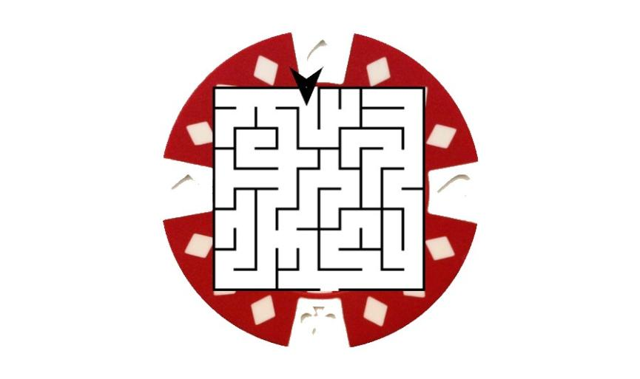

Intro text

You recently got a letter that a far flung relative has died and you are his sole heir!

But that is not the only shocking news of the day, he apparently was a famous bank robber still sought by the police.

Hidden among his inheritance is the location of his never found stash of gold, but hurry!

You are not the only one on the trail, the police also got a sniff of the hidden treasure and are on your tail. You immediately flew to the Netherlands, where the gold is supposed to be located. Unfortunately, one of the border guards recognized you and notified the local police. You entered an old workshop where upon showing the letter an old lady let you through to the back room. You noticed a clock on the wall, a bucket full of chicken toys lying and a cookie jar on the table. On the wall you notice a framed motivational quote above a ringing telephone. You have 60 minutes to find the gold and escape with it before the police catches you.

The Face always speaks the truth

Follow the money

Order by treasure The richest is the key