Building ReWear, a Pre-Owned Fashion Marketplace for the UAE — Market Validation Report
Nov 10, 2026 · @Sanidhya

Summary
The idea can work, but only if ReWear starts narrow and gets the money flow right. Second-hand fashion is growing fast worldwide, the UAE buys a lot of fashion online, and about half the people surveyed would use a pre-owned marketplace. But a typical second-hand item sells for little, so the commission on each order is small, and delivery in the UAE costs more than that commission. A mass-market app that pays for delivery loses money on every order.
Tthe Streamlit dashboard in the project folder (run streamlit run app.py).
The five main findings, in plain words:
- About half the people (54%) say they would use ReWear. But only 23% say "definitely". People always say "yes" more often than they actually buy, so the real figure will be lower.
- Experience decides, not age or emirate alone. People who already buy second-hand are three times as likely to use ReWear as people who never have (88% against 28%). Young people and people who shop on resale apps and social media are the keenest.
- Buyers, money and stock come from different people. Young value seekers are the keenest buyers, premium brand hunters pay the most (about AED 172 for an item that costs AED 300 new), and busy declutterers are the most willing to sell. One in ten people rejects pre-owned clothes completely.
- Trust is the product. People worried about fakes want an authenticity check and certificate; people with no time to sell want doorstep pickup. These needs come together, so they should be sold together.
- Break-even needs the right model. Paying for delivery never breaks even. Targeting likely buyers, focusing on premium items and adding a small buyer-protection fee breaks even in month 17 and needs about AED 74,000 on top of the AED 220,000 start-up budget.

The business idea
ReWear is an online marketplace, first in Dubai and then across the UAE, where people buy and sell pre-owned clothes, shoes, bags and accessories. ReWear does not own any stock. It earns a commission when an item sells, like eBay, Vinted or The Luxury Closet.
The platform would offer five things:
What ReWear offers | What it is, simply
A marketplace | An app and website where sellers list items and buyers browse, pay and arrange delivery
Trust services | Verified sellers, condition grading, secure payment held until the item arrives, and returns
Authentication | Expert checks and a certificate for designer items and bags, so buyers know they are real
Seller help | Doorstep pickup, a listing service, and AI price suggestions for people who do not know what to charge
Delivery | Courier pickup and delivery across the emirates, paid by the buyer
Who would use it: UAE residents who shop for fashion, both as buyers looking for value or designer pieces, and as sellers with unused clothes at home.
The goal: a trusted UAE marketplace that makes buying pre-owned feel as safe as buying new, and competes with local players such as The Luxury Closet, Yalla BB, Bazaara and Dubizzle, and with Instagram sellers.

The market: what real industry numbers say
The market is large and growing, but there is no reliable figure for UAE second-hand fashion specifically.
What | Number | Source
UAE e-commerce | AED 42.2 billion (2025), forecast AED 67.2 billion by 2030, about 10% growth a year | EZDubai / Euromonitor via WAM & Zawya (2026)
UAE fashion e-commerce | AED 11.4 billion (2025), the largest online shopping category | WAM (2026)
Global second-hand apparel | About USD 257 billion (2025), about 10% of all clothing spend, growing about 9% a year to 2030 | ThredUp / GlobalData Resale Report 2026
Shoppers buying second-hand | 59% of people worldwide bought second-hand clothes in 2025 | ThredUp Resale Report 2026
UAE resale market | No official figure. Estimates range from about USD 341 million to USD 5.2 billion | Khaleej Times (2025); Mobility Foresights (2025)
UAE textile waste | About 220,000 tonnes a year; national Naseej circularity programme launched June 2026 | The National / WAM (2026)
Benchmark company | Vinted: €10.8 billion of sales in 2025, about 10% take rate, profitable only since 2023 | Vinted 2025 results via Retail Insight Network
Competition | Yalla BB, Bazaara, Luved, Taggy, REVYN, The Luxury Closet, Gemaee, Dubizzle, Thrift for Good | Gulf News, Images RetailME, Entrepreneur ME (2025–26)
What this means. UAE shoppers already buy a lot of fashion online, and second-hand is moving into the mainstream worldwide. The government is also pushing to cut textile waste, which helps a resale platform's story.
The catch. The two UAE resale estimates differ by more than 15 times, so nobody really knows how big the local market is. Vinted, the biggest European player, took years to make a profit even with billions in sales. And the UAE already has several resale apps. So the numbers show the direction of the market, not proof that ReWear will succeed.

How the study was done
The study followed four steps: design a survey, create realistic data, clean it, then analyse it on a dashboard.
1. The survey. A 20-question survey was designed for UAE fashion shoppers. Every question was chosen because one of the four analysis techniques needs it:
- Who they are: age, emirate, occupation.
- How they shop: monthly fashion spend, how often they shop, where they shop, and whether they have bought second-hand before.
- What gets in the way: tick-lists of shopping problems (Q9) and barriers to selling (Q11).
- What they want: tick-lists of categories (Q12), platform features (Q13) and things that build trust (Q14).
- Supply: what they do with unused clothes, and whether they would sell on ReWear.
- Price: what they would pay for delivery, a membership, the most they would spend on one item, and what they would pay for an item that costs AED 300 new (Q19).
- The outcome question: "Would you use ReWear?" (Q20, five answers from "definitely not" to "definitely yes").
2. Synthetic data. Because a real survey of 5,000 people was not possible, a computer program created the answers. It was built so that answers follow real shopping logic. For example, people who worry about fakes are more likely to want an authenticity check, and people who spend more on fashion will pay more for a pre-owned item. The program also hid five customer types inside the data, so the analysis could test whether it finds them.
T5,045 responses.
3. Cleaning. The mistakes were fixed in a clear, logged way (next section).
4. Analysis on a dashboard. The cleaned data was analysed in Python and shown on an interactive Streamlit dashboard with nine tabs. Every chart has a short written explanation that updates automatically when filters change. The screenshots in this report come from that dashboard.

Cleaning the data
C4,980 clean rows with no missing values
Problem found | What was done | How many
Same person submitted twice | Removed the repeat | 45 rows
Careless answers (ticked all 52 options, even contradictory ones) | Removed | 20 rows
Emirate, age and other labels typed many ways (DXB, dubai, DUBAI) | Rewritten to one standard answer | 626 answers
Yes/No text in tick-list columns | Converted to 1/0 | 495 answers
Impossible values (negative spend, a "99999" price code) | Treated as unknown, then re-worked from the band the person chose | 14 answers
Spending far above any answer band | Kept the person, capped the value at the top band | 40 answers
Skipped questions | Filled with the most common answer; prices filled with the median of people who spend the same | 539 answers
Why fill price gaps from people who spend the same? Someone who spends AED 100 a month on fashion and someone who spends AED 2,500 will not pay the same for a pre-owned item. Filling a missing price with the overall median would give the low spender a big spender's answer. Using the median of their own spend band keeps the guess realistic.
Why cap big numbers instead of deleting them? Some people really do spend a lot on fashion. Only values that match no answer band were pulled back, so genuine big spenders stayed in the data.
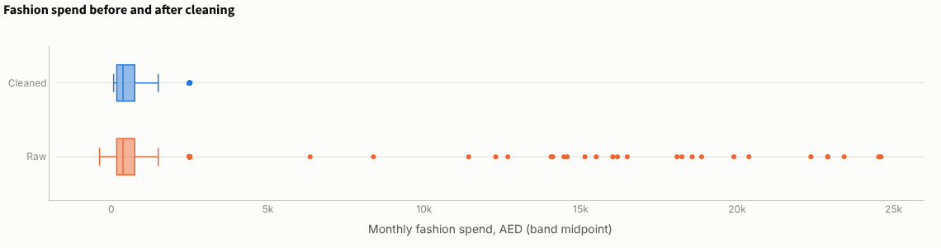
Figure 1. Monthly fashion spend before cleaning (bottom) and after (top). The scattered dots on the right are data-entry errors; after cleaning, the largest value is the top answer band.
Finally, new helper columns were created for the analysis. Examples are a "would use ReWear" yes/no flag, a log of spending (which tames very large values), a "willing to sell" flag, the price a person would pay as a share of the new price, and a count of ticks in each tick-list.

Descriptive analysis: who the customers are
What descriptive analysis means. It simply describes the data: how many, how much, how often. It answers "what is happening?" before any attempt to explain why. The dashboard's Descriptive EDA tab has 14 charts (D1–D11 plus Q19 and Q20). The most important ones are below.
The headline numbers from the dashboard's overview tab:
Figure 2. Key numbers from the dashboard overview: 4,980 people, 54% would use ReWear, 48% would sell, a typical price of AED 113 for an item that costs AED 300 new, and break-even in month 17 on the recommended plan.
Interest is real but soft. 54% say they would use ReWear (31% "probably", 23% "definitely"), 7% are not sure and 39% say no. The 23% who say "definitely" are the realistic early-adopter pool.
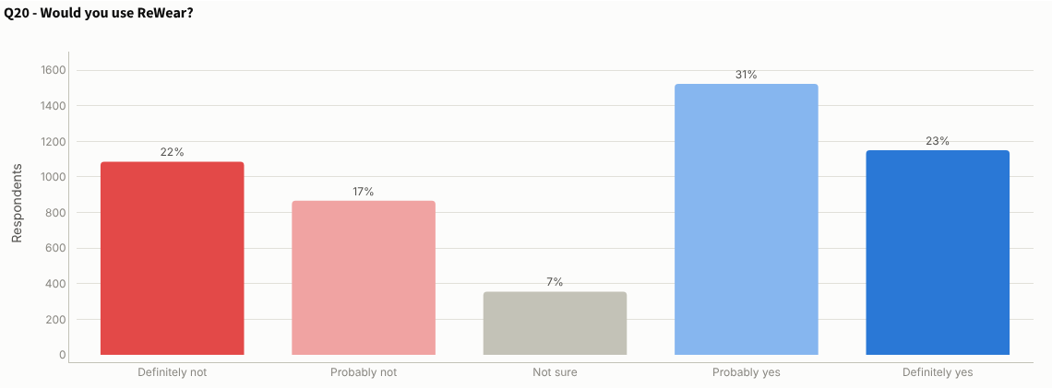
Figure 3. Q20, would you use ReWear? Red bars are "no", blue bars are "yes".
Many people have never bought second-hand. Ages 25–40 make up more than half of the people surveyed. But 36% have never bought second-hand clothes and only 11% do so often. ReWear will have to win first-time buyers, which is harder than serving people who already buy pre-owned.
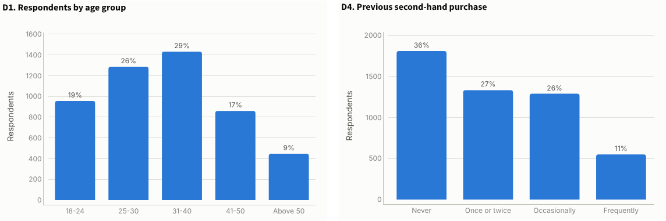
Figure 4. D1, age group (left), and D4, previous second-hand buying (right).
Stock is sitting in wardrobes, but selling is a hassle. The most common thing people do with unused clothes is keep them (29%), then donate them (22%). Only 24% already sell them. The biggest barriers to selling are a complicated process (34%), no time (33%) and not knowing what price to ask (32%). A pickup-and-list service and AI price suggestions answer all three.
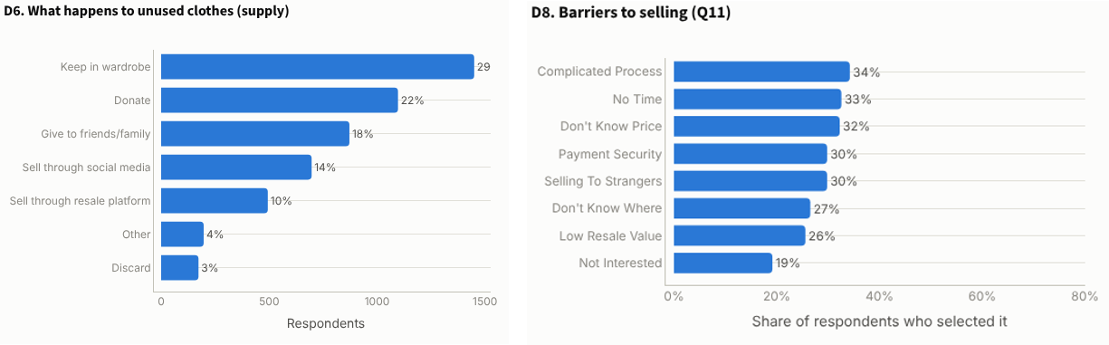
Figure 5. D6, what happens to unused clothes (left), and D8, barriers to selling (right).
Price and trust are the main worries. Affordability and high branded prices (41% each) are the top shopping problems, followed by trust in online sellers (38%). Reviews, detailed photos and condition ratings are what build trust.
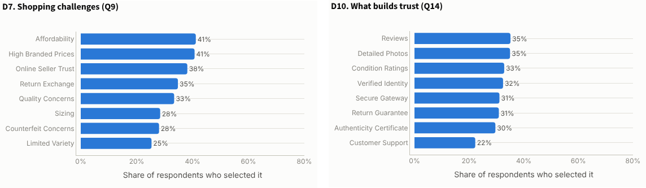
Figure 6. D7, shopping challenges (left), and D10, what builds trust (right).
People want convenience and safety, and expect low prices. The most wanted features are home delivery (42%), verified sellers (41%) and secure payments (39%). For an item that costs AED 300 new in excellent condition, the typical person would pay about AED 113, which is 38% of the new price. 8% would not buy it at all. The median person would pay only AED 3 for delivery and AED 7.50 a month for a membership.
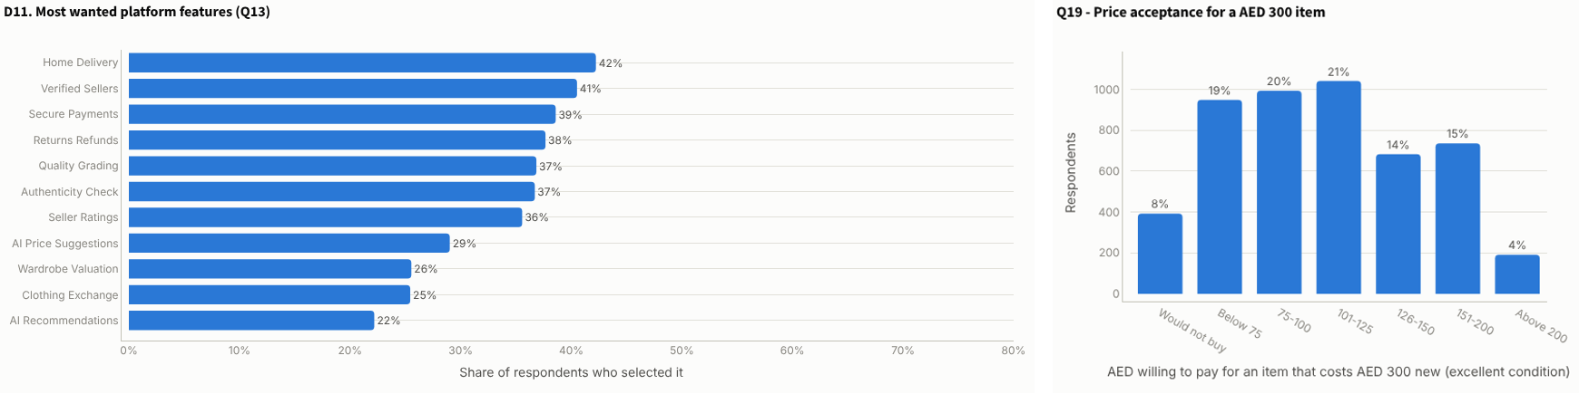
Figure 7. D11, most wanted platform features (left), and Q19, the price people would pay for an item that costs AED 300 new (right).

Diagnostic analysis: why people would use ReWear
What diagnostic analysis means. It looks for the reasons behind what was described: which answers move together with "would use ReWear". The main tools are correlation, a number between −1 and +1, and Cramér's V, a number from 0 (no link) to 1 (perfect link) for answers that are categories rather than numbers. Both show a link, not proof of cause.
The correlation map. Each square shows how strongly two questions move together. Red is a positive link and blue a negative one, and darker means stronger. Reading the "intent to use ReWear" row: previous second-hand buying and interest in selling have the strongest positive links; age and needing a big discount pull the other way.
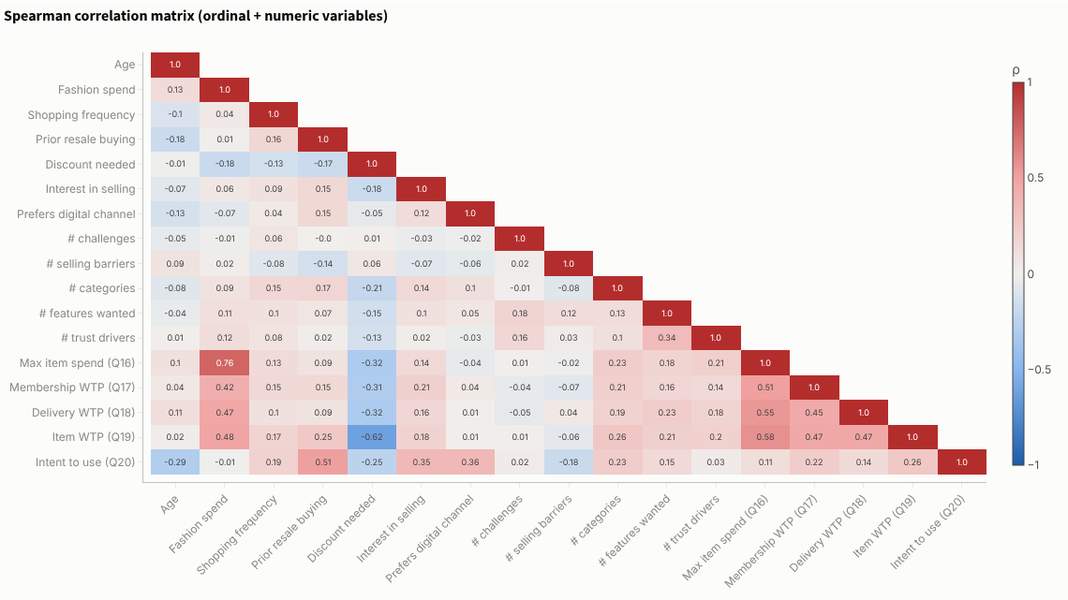
Figure 8. G1, correlation map of the main survey questions (Spearman). Red means a positive link and blue a negative one.
The strongest drivers. Ranking every question by its link with intent, previous second-hand buying is far ahead (Cramér's V 0.45), followed by preferred shopping channel (0.35), the discount needed (0.33), interest in selling (0.31) and age (0.27). Emirate barely matters.
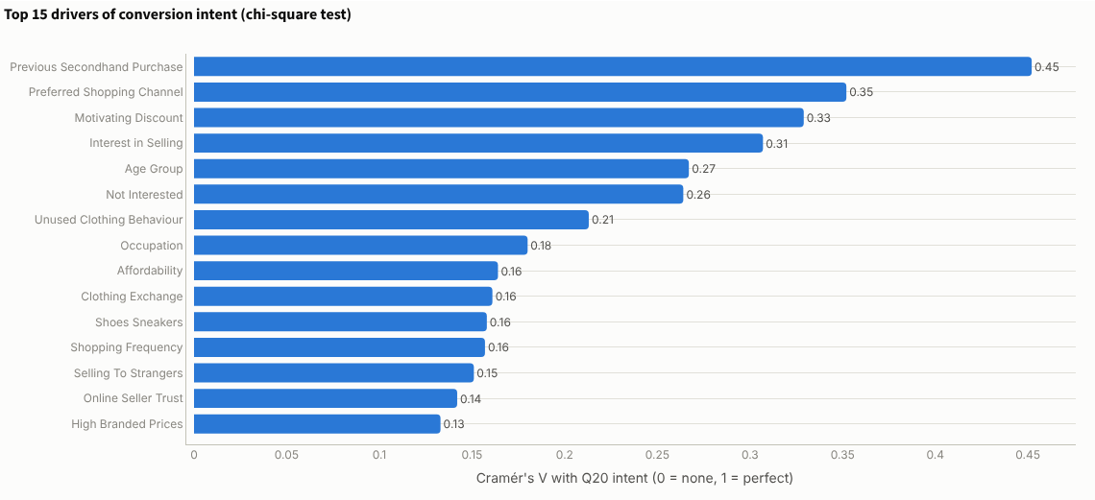
Figure 9. G2, the 15 questions most strongly linked to intent (Cramér's V).
Experienced resale shoppers and app shoppers are the warmest leads. Intent rises from 28% among people who have never bought second-hand to 88% among frequent buyers. By channel, 81% of people who already use resale platforms and 68% of social-media shoppers would use ReWear, against 29% of mall shoppers. The first customers should be found where second-hand already happens: resale apps, Instagram and TikTok.
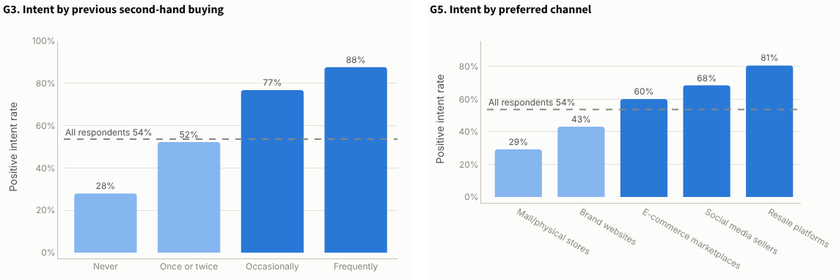
Figure 10. G3, intent by previous second-hand buying (left), and G5, intent by preferred channel (right). The dashed line is the 54% average.
Bigger spenders and luxury fans pay more. The price people would pay rises steadily with their monthly fashion budget. At every level of resale experience, people who want designer or luxury items would pay AED 40–60 more for the same item. That is the margin ReWear needs.
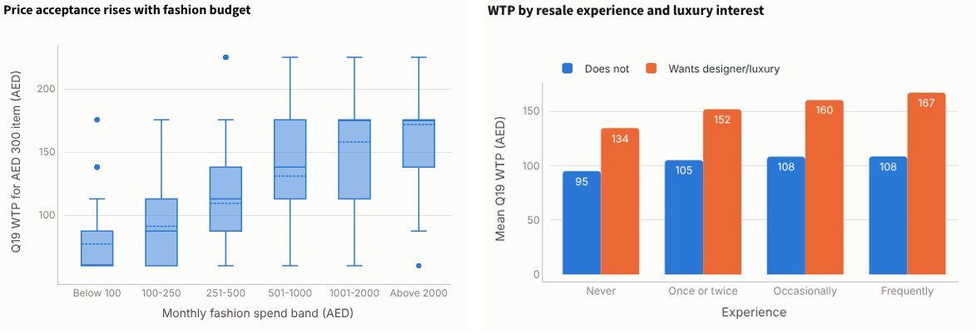
Figure 11. Price people would pay by monthly fashion budget (left), and by resale experience and luxury interest (right).
Other diagnostic charts on the dashboard show that 18–24 year-olds (70%) and 25–30 year-olds (65%) are the most receptive and people over 50 the least (27%). Emirates sit within a narrow band (44–55%). Almost nobody who "would not buy pre-owned" would use ReWear (4%), which confirms that this group should not be targeted.

Classification: who will use ReWear?
What classification means. Classification teaches a computer to sort things into groups, here "will use ReWear" or "won't". The model studies answers where the outcome is known and learns which patterns lead to "yes". It can then score new people it has never seen. It works like an experienced shop assistant who can tell from a few answers who is a serious customer, except that it learns from almost 5,000 examples.
How it was tested. The data was split into two parts. The models learned from 75% of people and were then tested on the other 25%, which they had never seen. This shows whether they really learned patterns or just memorised answers. Seven models were compared:
- Logistic regression: adds up the effect of each answer to give a probability of using ReWear.
- Decision tree: asks a chain of yes/no questions, like a flowchart.
- Random forest: builds hundreds of decision trees and lets them vote.
- Gradient boosting: builds trees one after another, each fixing the mistakes of the last.
- Support vector machine, k-nearest neighbours and naive Bayes: three other common methods, included for comparison.
The outcome question (Q20) was never shown to the models as an input.
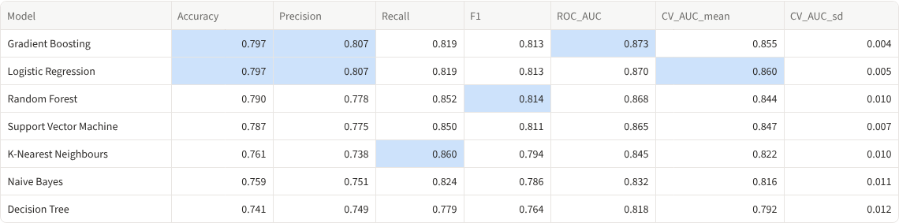
Figure 12. Classification results for the seven models on the test group.
How to read the scores. Accuracy is the share of people sorted correctly. Precision is how often a "will use" prediction is right, and recall is how many real users the model finds. ROC-AUC measures how well the model ranks people: 0.5 is a coin toss and 1.0 is perfect. CV AUC is the same score averaged over five different splits, which shows how stable the model is.
Result. Gradient boosting has the highest test score (ROC-AUC 0.873), but logistic regression is almost the same (0.870), has the best five-split score (0.860) and is much easier to explain, so it is the practical choice. It sorts 80% of people correctly. In plain words, if you pick one real user and one non-user at random, the model ranks the user higher about 9 times out of 10. The confusion matrix (right) shows it correctly found 438 of 535 users and 356 of 461 non-users in the test group. That is good enough to score a waitlist so ad money goes to the most promising people first.
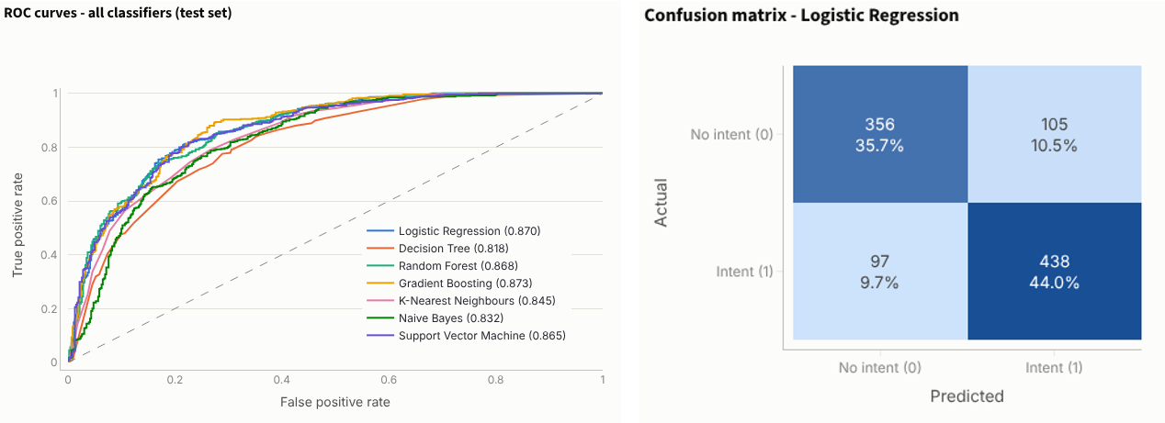
Figure 13. C1, ROC curves for the seven models (left). The further a curve bends towards the top-left, the better. C2, confusion matrix for logistic regression (right).
What drives a "yes". The chart ranks answers by how much the random forest relied on them. Never having bought second-hand is by far the most important (it lowers the chance), followed by refusing pre-owned, preferring malls, resale experience and the price a person would pay. These are the screening questions to put on a real sign-up form.
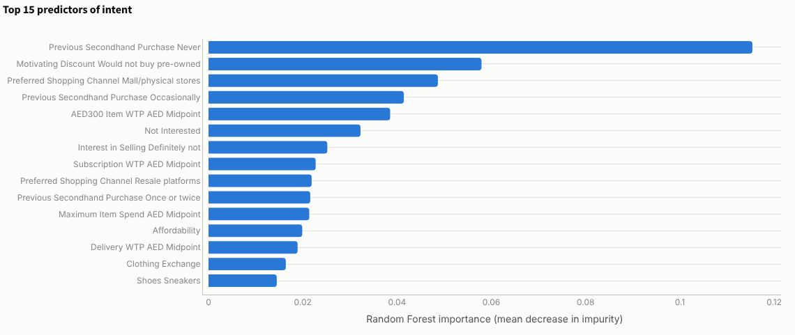
Figure 14. C3, the 15 most important answers for predicting intent (random forest).

Regression: how much will they pay?
What regression means. Classification predicts a category (yes or no). Regression predicts a number, here how many dirhams a person would pay for an item that costs AED 300 new (Q19). It finds the best-fitting relationship between that number and the person's other answers, such as fashion budget, luxury interest and resale experience. A simple example is "every extra step in monthly budget adds about AED X to the price", but the models handle many answers at once.
Four models were compared: plain linear regression, ridge and lasso regression (linear models that are protected against answers that overlap, and lasso can drop weak answers entirely), and a random forest.
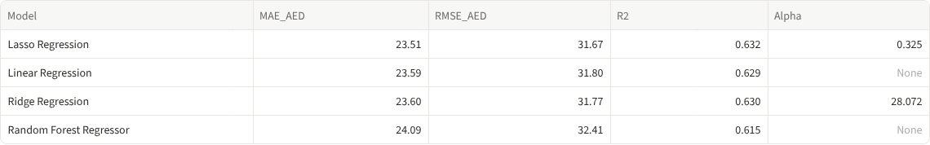
Figure 15. Regression results for the four models on the test group.
How to read the scores. R² is the share of the differences between people that the model explains: 0 means nothing and 1 means everything. MAE is the typical size of the error in dirhams.
Result. Lasso regression did best. It explains about 63% of the differences in price, with a typical error of about AED 24 per person. Ridge and lasso barely beat plain linear regression, and the random forest is no better, so the relationships are mostly simple and straight-line. In the left chart, each dot is a test person; the closer the dots sit to the dashed line, the better. The column of dots on the far left are people who would not buy at all, which the classification model handles better.
The right chart shows what drives the price. Refusing pre-owned and needing a discount above 40% cut it the most; a bigger fashion budget and interest in designer items raise it.
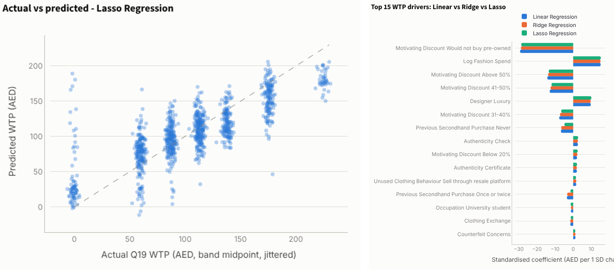
Figure 16. R1, predicted vs actual price (left), and R2, what raises or lowers the price people would pay (right).
How to use it. Use the two models together. Classification gives the chance that a person uses ReWear, and regression gives the price they would accept. This works as a pricing assistant for sellers, and tells ReWear which shoppers to show premium stock to.

Clustering: the five kinds of customer
What clustering means. Clustering puts similar people into groups without being told what the groups are. Imagine spreading 5,000 shopper profiles on a table and pushing together the ones that look alike. The method used here, K-means, does exactly that. It compares people on their age, fashion budget, how often they shop, resale experience, the discount they need, what they want to buy and what worries them.
Choosing the number of groups. K-means needs to be told how many groups to make, so 2 to 8 groups were tried. The elbow chart (left) shows how much tighter the groups get with each extra group; it bends around 4–5. The silhouette score (right) measures how clearly the groups are separated and peaks at 5 groups (0.098). That is low, but normal for survey answers, where people sit on a range rather than in tight clumps. So five groups were chosen.
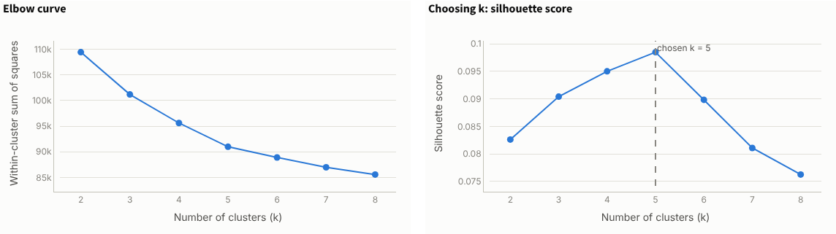
Figure 17. K1, elbow chart (left), and K2, silhouette score (right), for 2 to 8 groups.
The groups on a map. The chart below squeezes all the measures into two dimensions so the groups can be seen. Each dot is a person, and each colour is one group. The groups are distinct, with overlap at the edges.
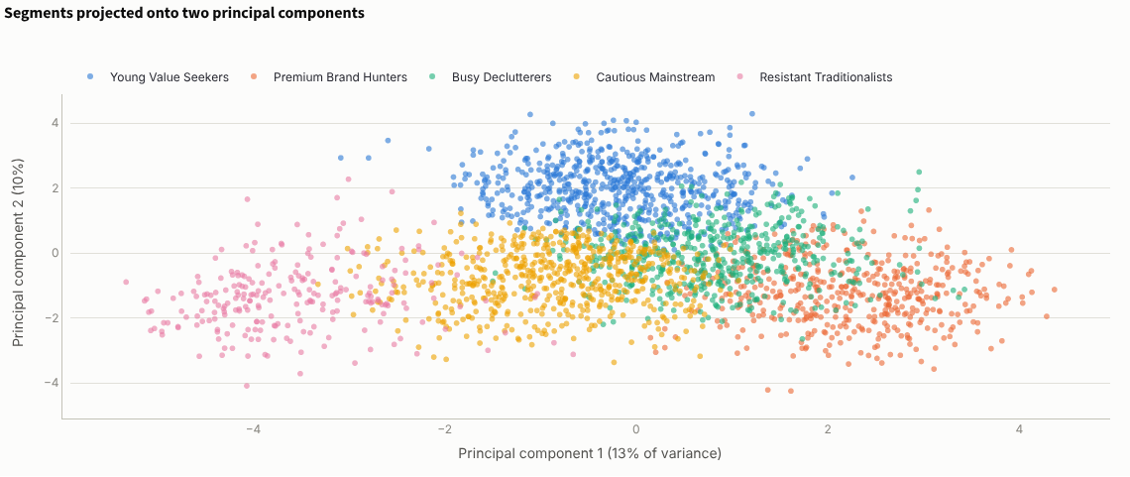
Figure 18. K3, the five customer groups shown on a two-dimensional map.
Who the five groups are. Each group was named after what makes it different from the others (see the group profiles and heatmap below).
- Young Value Seekers (1,365 people, 27%): the keenest buyers. 82% would use ReWear and 58% would sell, but they would pay only about AED 90 for an AED 300 item. Reach them on social media with sneakers and casual wear.
- Premium Brand Hunters (932, 19%): the profit pool. They spend about AED 1,115 a month on fashion, 80% want designer items, 69% would use ReWear, and they would pay about AED 172. They need authentication and certificates.
- Busy Declutterers (1,010, 20%): the supply engine. 70% would sell, the highest of any group, but 70% say they have no time. A doorstep pickup service unlocks their wardrobes.
- Cautious Mainstream (1,205, 24%): a large group with a trust problem. Only 25% would use ReWear. Win them later, once reviews and guarantees exist.
- Resistant Traditionalists (468, 9%): all of them reject pre-owned and only 3% would use ReWear. Do not spend money on them.
Because the data was generated with five hidden customer types, it is possible to check the result. The groups matched the hidden types well (adjusted Rand index 0.52, where 1.0 would be a perfect match and 0 would be random). Value seekers and declutterers were recovered almost perfectly; the cautious and premium types overlap more, as real shoppers do.
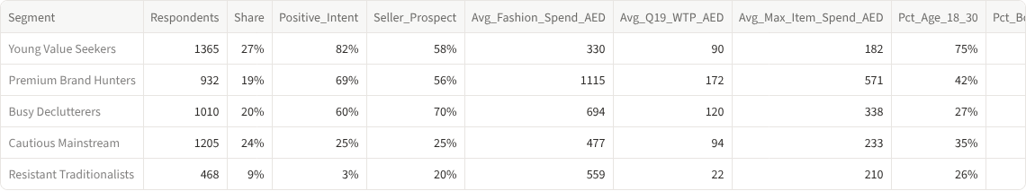
Figure 19. Group profiles from the dashboard.
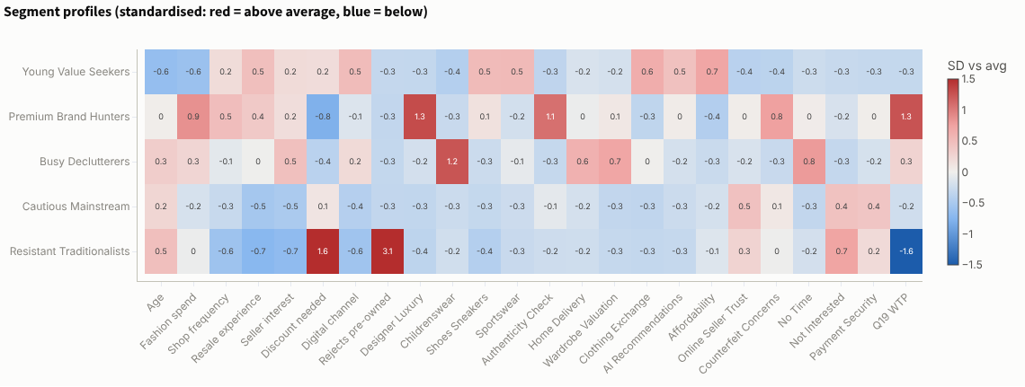
Figure 20. What makes each group different, in standard units (red = above average, blue = below).

Association rules: what goes together
What association rules mean. This is the method supermarkets use to find that people who buy bread often buy butter too ("market basket analysis"). Here, each person's ticks across the five tick-list questions (problems, selling barriers, categories, features and trust) form a basket. The Apriori method searches all the baskets for answers that appear together more often than chance would suggest. Each rule reads "if a person ticks A, they also tick B" and has three scores:
- Support: how common the combination is. A support of 0.13 means 13% of all people ticked both.
- Confidence: how often the rule is true. A confidence of 0.92 means 92% of people who tick A also tick B.
- Lift: how much more likely B becomes when A is ticked. A lift of 1 means no link, and 2.5 means two and a half times more likely than normal.
With minimum support 5%, confidence 50% and lift 1.3, the method found 1,199 rules.
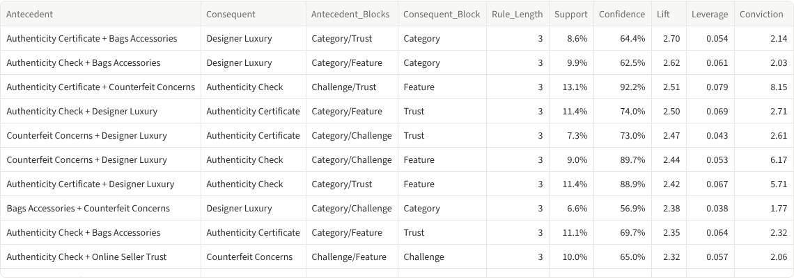
Figure 21. The strongest rules, sorted by lift.
Result: three natural bundles.
- Trust bundle: people who worry about fakes and want an authenticity certificate also want an authenticity check 92% of the time, 2.5 times more often than normal.
- Luxury entry bundle: people who want bags and accessories and an authenticity certificate also want designer items 64% of the time (lift 2.7). Bags are the way into luxury.
- Seller convenience bundle: people with no time and a complicated process want doorstep pickup; people who do not know what to charge want AI price suggestions (lift about 2).
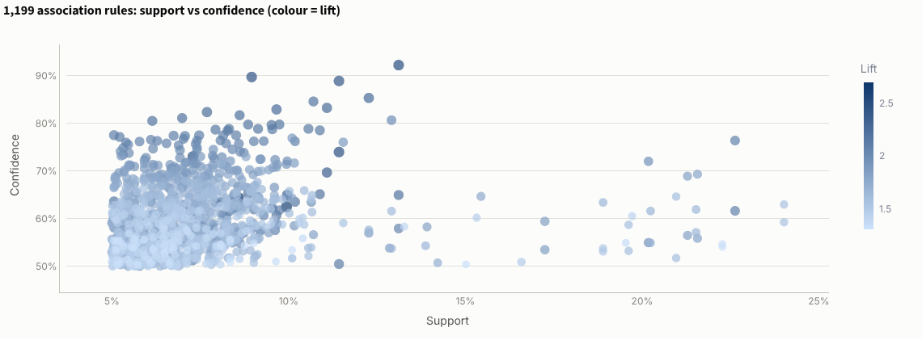
Figure 22. A1, all 1,199 rules by support (how common) and confidence (how reliable). Darker dots have higher lift.
How to use it. Sell these combinations as packages: an "Authenticated Luxury" section with checks and certificates built in, and a "Sell for me" service with pickup, listing and price suggestions. The dashboard also turns the rules into a cross-sell table for each customer group (for example, offer quality grading to premium hunters who pick authenticity checks).

Is the business sustainable?
Yes, but only with a focused, premium-led start and the right fees. The dashboard's last tab turns the survey results into a unit-economics check and a 36-month cash projection. Break-even is the point at which income covers all costs.
Step 1: the profit on one order. At the typical price of AED 113 and a 15% commission, ReWear earns about AED 17 per order. After payment fees and support costs, and if ReWear pays most of an AED 18 courier because buyers will only pay about AED 3, each order loses about AED 3. More orders would mean more losses.
Figure 23. Unit economics with the starting assumptions: a loss of AED 3.33 per order, so break-even never comes.
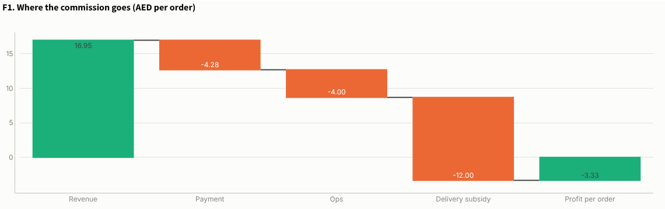
Figure 24. F1, where the commission goes on one order: revenue, payment fees, operations, delivery subsidy and profit.
Making the buyer pay full delivery turns the order positive (about AED 8.67), but then ReWear needs about 2,600 orders a month to break even, and each customer brings in only 65% of what it costs to acquire them. Premium items (about AED 350, 20% commission) earn about AED 50 an order, so only about 450 orders a month are needed. A 70/30 mix of everyday and premium items needs about 1,070 orders a month.
Step 2: who to target. Combining the models gives every person a group (clustering), a chance of using ReWear (classification) and a likely price (regression). People were split into High (70% or more), Medium (40–70%) and Low (under 40%) chance. 2,040 people should be targeted now, and 85% of them actually said yes. 1,840 people (37%), everyone in the Low tier plus the Resistant group, should not be targeted.
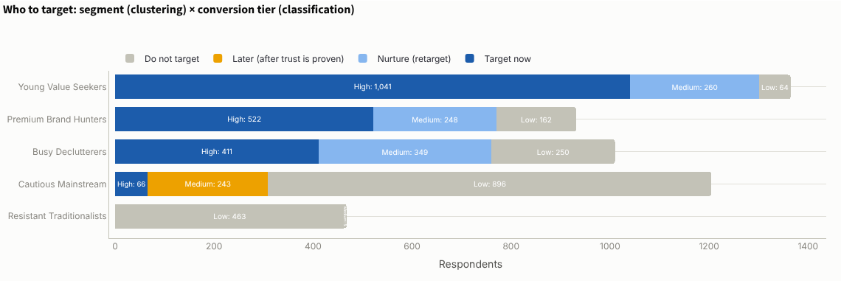
Figure 25. Who to target: each group split by chance of buying, coloured by action (target now, nurture, later, do not target).
Step 3: price by group. The regression model predicts what each group would pay for an AED 300 item: Premium Brand Hunters about AED 162 (54% of the new price), Busy Declutterers AED 119 (40%), Cautious Mainstream AED 98, Young Value Seekers AED 93 (31%) and Resistant Traditionalists AED 23. A cheap membership cannot carry the business: most people would pay only AED 5–14 a month.
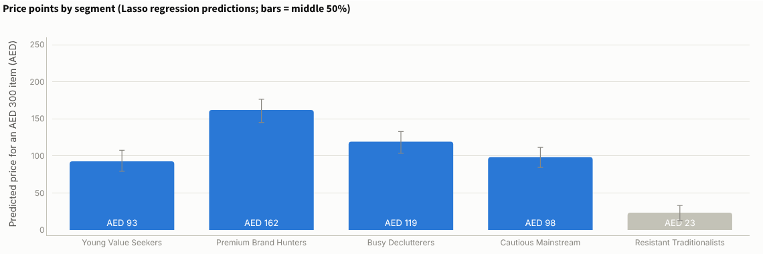
Figure 26. Predicted price for an AED 300 item by customer group (bars show the middle 50% of people).
Step 4: when ReWear breaks even. Three strategies were projected month by month over three years, starting with AED 105,000 left after set-up costs from the AED 220,000 budget:
Strategy | Break-even | Cash outcome
Advertise to everyone, ReWear pays delivery | Never | Burns about AED 1.48 million by month 36
Target likely buyers only, buyer pays delivery | Not within 3 years | Needs about AED 608,000 extra
Recommended: target likely buyers, 40% of ad spend on premium buyers, buyer pays delivery, 5% + AED 2 buyer-protection fee | Month 17 | About 3,800 customers in year 1; needs about AED 74,000 extra
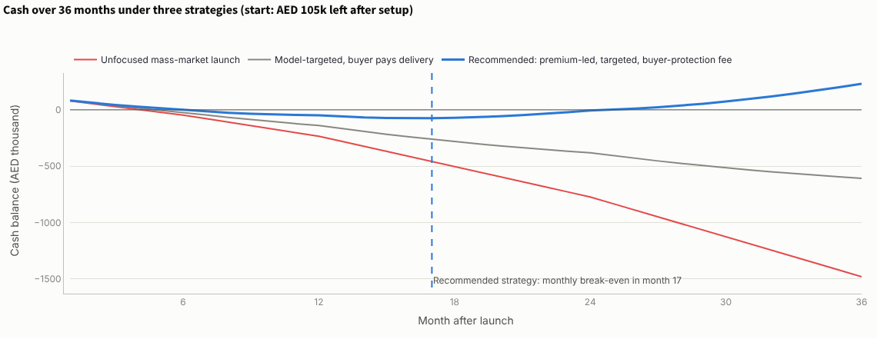
Figure 27. Cash balance over 36 months for the three strategies. The recommended strategy (blue) breaks even in month 17.
What this means. The business is not sustainable as a mass-market app that pays for delivery. It becomes sustainable if it wins premium buyers, charges buyers for delivery and protection, and spends acquisition money only on people the model scores highly. The result depends heavily on the protection fee: without it, break-even slips to month 34. Acquisition cost matters too: if it is 25% higher, break-even moves to month 22. The costs, acquisition cost and churn are assumptions, not quotes, and can be changed on the dashboard.
Recommendations
- Start with a Dubai concierge pilot, not a full app. Spend AED 40–60k on three months of pickup-and-list service and a simple web shop. Move on only if it reaches 300 orders, more than AED 10 profit per order and 25% repeat buyers.
- Lead with premium and authentication. Build an authenticated designer and bags section with checks and certificates, at a 20% commission. Premium buyers carry the profit.
- Make the buyer pay delivery and a small protection fee. Add 5% + AED 2 per order for secure payment and returns, as Vinted does. Never subsidise delivery.
- Solve supply with a "Sell for me" service. Doorstep pickup, a listing service and AI price suggestions for Busy Declutterers, starting with childrenswear.
- Target with the model. Score sign-ups with the classification model and spend ads only on the High tier, mainly on resale apps, Instagram and TikTok, with 40% of the budget on premium buyers.
- Win the Cautious Mainstream later. Once reviews, verified sellers and a return guarantee exist, retarget them.
- Skip the Resistant Traditionalists. Offer a donation or recycling partner instead of advertising to them.

Limitations and sources
Limitations
- The survey data is synthetic. It was generated to follow realistic shopping logic, so the models partly rediscover patterns that were built in. It shows how the analysis would work, not proof that real demand exists. The next step is a real waitlist and survey of 200–300 UAE shoppers, and real courier and payment quotes.
- Stated intent overstates real buying. Only 23% said "definitely", and even those will not all buy.
- Costs are placeholders. Courier costs, fixed costs, acquisition cost and churn are planning assumptions and should be replaced with real quotes.
- Market estimates disagree. UAE resale estimates differ by more than 15 times, so they show direction, not precise size.
Dashboard and code: the rewear_project folder (app.py, analysis.py, clean_data.py, generate_data.py, data/). Run streamlit run app.py.
Sources: EZDubai / Euromonitor via WAM & Zawya (2026) – UAE e-commerce · WAM (2026) – UAE fashion e-commerce · ThredUp / GlobalData Resale Report 2026 · Khaleej Times (2025) citing KD Market Insights; Mobility Foresights (2025) – UAE resale estimates · The National / WAM (2026) – UAE textile waste and Naseej · Vinted 2025 results via Retail Insight Network / Sharecast (2026) · Gulf News, Images RetailME, MENA Startup Digest, Entrepreneur ME (2025–26) – local competition

