2803ICT – Assignment 1
By Tiam Adnum

Table of Contents
2803ICT – Assignment 1 1
Problem Statement 1
User Requirements 2
Software Requirements 2
Software Design 3
High Level Design – Logical Block Diagram 3
Structure Chart 3
List of all functions in the software. 4
List of all data structures in the software. (eg linked lists, trees, arrays etc) 5
Detailed Design – Pseudocode for all non-standard and non-trivial algorithms that operate on datastructures 7
Requirement Acceptance Tests 10
Detailed Software Testing 13
User Instructions 14

Problem Statement

The goal of Assignment 1: Part 2 was to develop two independent programs, a Game Server and a Game Client that would be used to for a multiplayer game called “Numbers”. The programs must communicate over a network, letting players join, play and verse on separate clients.
The game follows a simple set of rules. It’s a turn-based game where you start with a score of 25. Each player takes turns making a move from 1-9, which will be subtracted from the total score. The first player that gets the score to 0 or below will win the game.

User Requirements

The following outlines the user requirements for the program:

- The server must be started from customisable command-line arguments as shown: game_server <Port Number> <Game Type> <Game arguments>
- The server will listen for incoming connections on the specified port, accepting all connections up to the specified number of players for the game.
- The server shall wait till the required number of players have connected to the server before starting the game.
- The server shall handle player turns, sending a TEXT message with the current score each turn and a GO message indicating the next players move. If the client doesn’t respond to the GO message within 20 seconds, the player will be removed from the game and an END message will be sent the client.
- The server shall send a TEXT message to each client at the end of the game indicating if they won or lost the game. As well as, a END message to terminate all client connections to the server.
- The server shall send a TEXT ERROR message for invalid inputs or commands from the client. If an invalid input or command has been entered 5 times in a row by a client, the client will be removed from the game and send a END message to terminate client connection.
- To join the server, the client must input command-line arguments matching the server as shown: game_client <Game Type> <Server Name> <Port Number>
- The client must display all messages received from the server such as game prompts and results.
- When it is the clients turn, the client must send a move in the format: MOVE <move> or the command QUIT if they would like to exit the game.
- When the client recieves a TEXT ERROR message from the server, the client should display the error message and send a prompt indicating the user to try again.
- The client shall be terminated if it recieves invalid messages from the server or encounters connection issues.

Software Requirements

The following outlines the software requirements for the program:

- The server and client programs should be implemented in the programming language C.
- The server shall be capable of managing multiple clients simultaneously.
- Comprehensive error handling shall be implemented to manage and report any issues like connection failures, invalid inputs and protocol volilations.
- There shall be game logic implemented to handle game states, player turns, active players, and the winners and losers of the game.
- A README file with instructions for compling and running the server and connecting to the server shall be included.

Software Design

High Level Design – Logical Block Diagram
This diagram is an example excusion of the Numbers game on a local host server with two client connections.

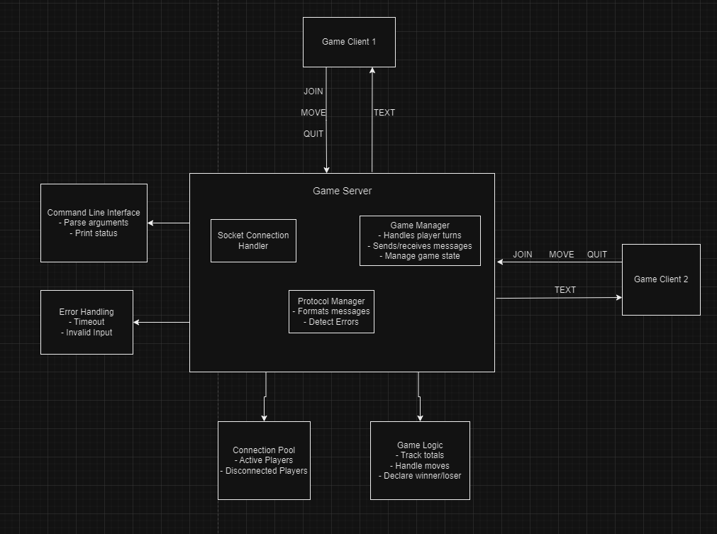

Structure Chart
UML diagram for game server and client programs for the “Numbers” game:
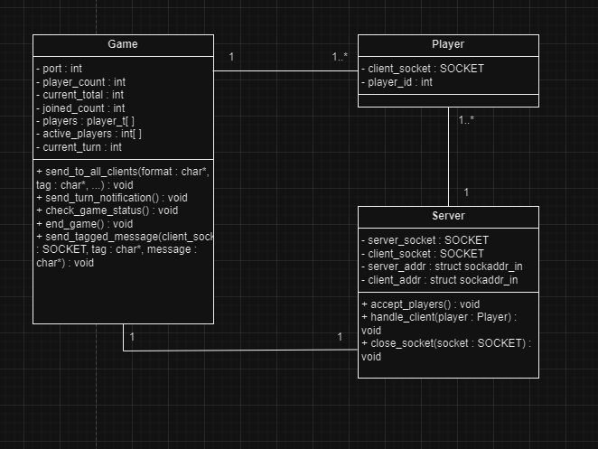

List of all functions in the software.
main()
- Description: The main loop for the server, setting up game, handling player connections and launching game threads.
- Input parameters:
  - argc (int): Amount of command-line arguments.
  - argc (char *[]): Array of command-line arguments, port number, game type, number of players.
- Side Effects:
  - Initializes game_t
  - Allocates memory for players and active players.
  - Creates threads for every player.
- Return: int

handle_client(void *arg)
- Description: Handles player gameplay, such as moves, timeouts and disconnections.
- Input parameters:
  - argc (void): pointer to player_t
- Side Effects:
  - Updates game_t.active_players on timeouts or disconnects.
  - Updates game.current_total based on player moves.
- Return: void *

send_to_all_clients(const char *format, const char *tag, ...)
- Description: Sends formatted message to all players.
- Input parameters:
  - format (const char*): Format string of message.
  - tag (const char *): Tag for prefix log to server.
  - … (variable): Variable amount of arguments to format message.
- Side Effects:
  - Sends message to all active players using send_tagged_message function.
- Return: void

send_tagged_message(SOCKET client_socket, const char *tag, const char *message)
- Description: Sends message to specified client and also to server with tag prefix for logging.
- Input parameters:
  - client_socket (SOCKET): Players socket to send message to.
  - tag (const char *): Tag for prefix log to server.
  - message (const char *): message to be sent to client.
- Side Effects:
  - Sends message to specific player.
  - Logs message send to server with prefix.
- Return: void

send_turn_notification()
- Description: Sends message indicating to client that its their turn.
- Input parameters: None
- Side Effects:
  - Sends message to player whose turn it is.
  - Sends waiting message to other players.
  - Logs to server.
- Return: void

check_game_status()
- Description: Checks if game should continue or end based on the current active players.
- Input parameters: None
- Side Effects:
  - Sends winner and losers messages if game ends.
  - Calls end_game() if game is over.
  - Updates game.current_turn to move to next active player if game continues.
- Return: void

end_game()
- Description: Terminates connections and server and sends END messages to all clients.
- Input parameters: None
- Side Effects:
  - Sends “END” messages to all active clients.
  - Terminates server.
  - Closes all player sockets.
- Return: void

List of all data structures in the software. (eg linked lists, trees, arrays etc)

game_t
- Type: Structure
- Description: Holds the game state data, and its used through the game to track and manage the game. Including total score, player count and player turns.
- Data members:
  - int port : port which server listens on
  - int player_count : total number of player connections.
  - int current_total : the current total score of the game.
  - int joined_count : the number of players who have connected to the server.
  - player_t *players : array of player structures, for each player in the game.
  - int *active_players : an array of integers showing which players are active (1 for active, 0 for disconnected).
  - int current_turn : index of the current players turn.
- Functions that use it: main(), send_to_all_clients(), send_turn_notification(), check_game_status(), end_game().
player_t
- Type: Structure
- Description: Represents a player within the game. Storing inportant information such as a unique ID, socket and other game-related data.
- Data members:
  - SOCKET client_socket : network socket used for communication with player.
  - int player_id : ID for each player.
- Functions that use it: handle_client(), send_tagged_message(), send_turn_notification(), check_game_status().

fd_set
- Type: File descripter set
- Description: Used to manage socket connections.
- Data members:
  - Contains a set of file descripters (sockets) to be monitored.
- Functions that use it: handle_client().

va_list
- Type: Variable agrument list
- Description: Used to handle functions with variable arguments used mainly to format and send messages to players.
- Data members:
  - A list of arguments in variable-length format.
- Functions that use it: send_to_all_clients()

struct sockaddr_in
- Type: Structure
- Description: Standard structure used in network programming.
- Data members:
  - sin_family : specifies address family
  - sin_addr.s_addr : stores IP address
  - sin_port : stores port number
- Functions that use it: main(), handle_client().

pthread_t
- Type: Structure
- Description: Used to create and manage threads for each player in game.
- Data members:
  - Thread identifier for each thread for client communication.
- Functions that use it: main(), handle_client().

player_t *players
- Type: Array
- Description: List of players connected to the game.
- Functions that use it: send_to_all_clients(), check_game_status(), end_game().

int *active_players
- Type: Array of integers
- Description: Tracks which players are still in game.
- Functions that use it: send_to_all_clients(), check_game_status(), send_turn_notifications().

Detailed Design – Pseudocode for all non-standard and non-trivial algorithms that operate on datastructures

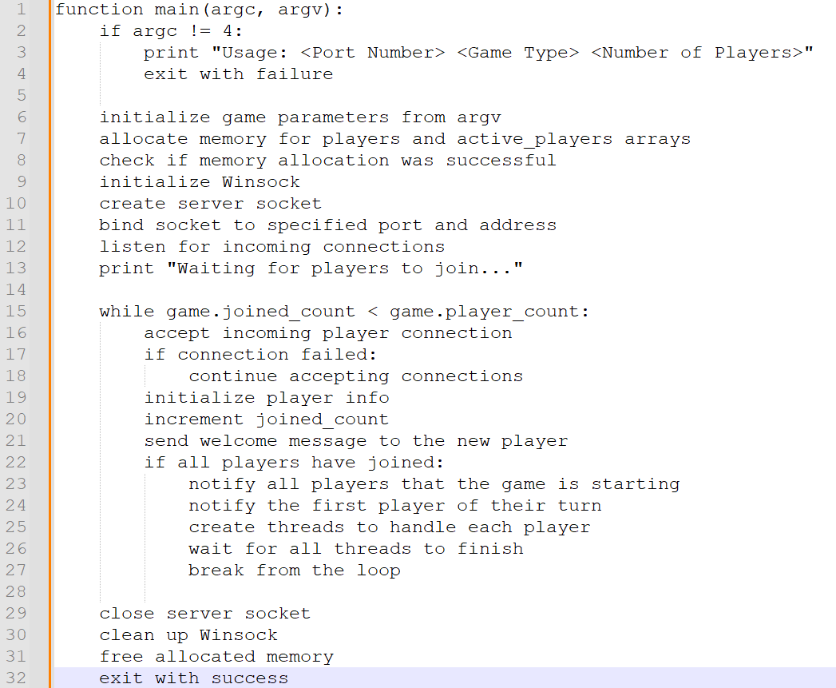

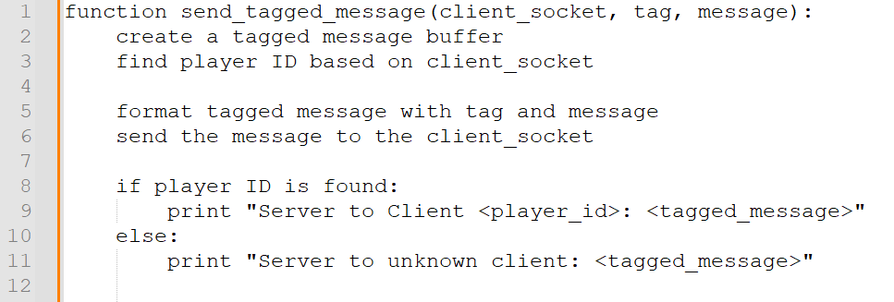

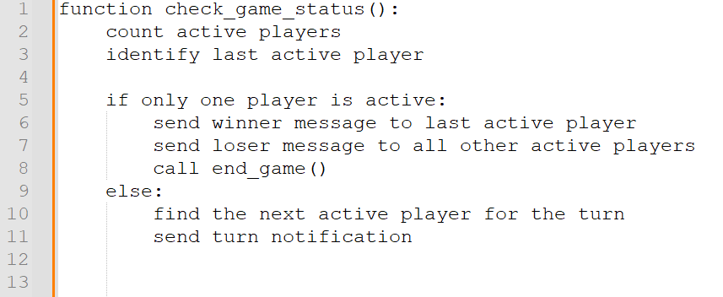

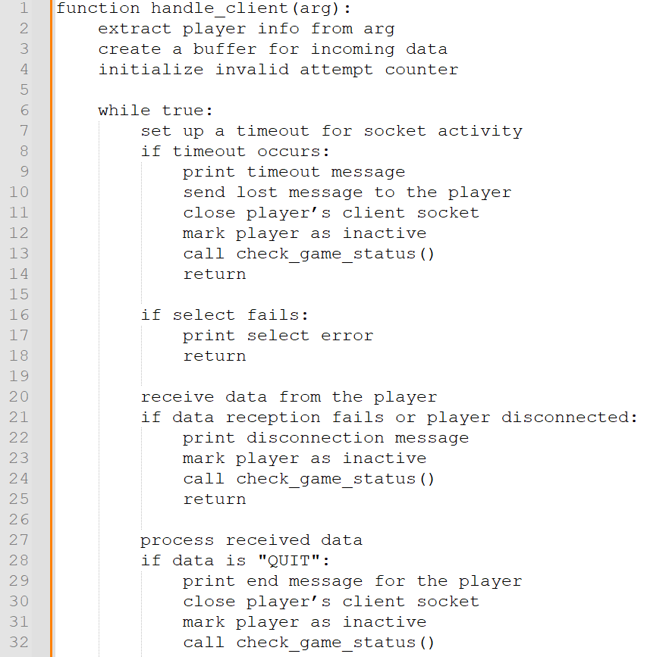

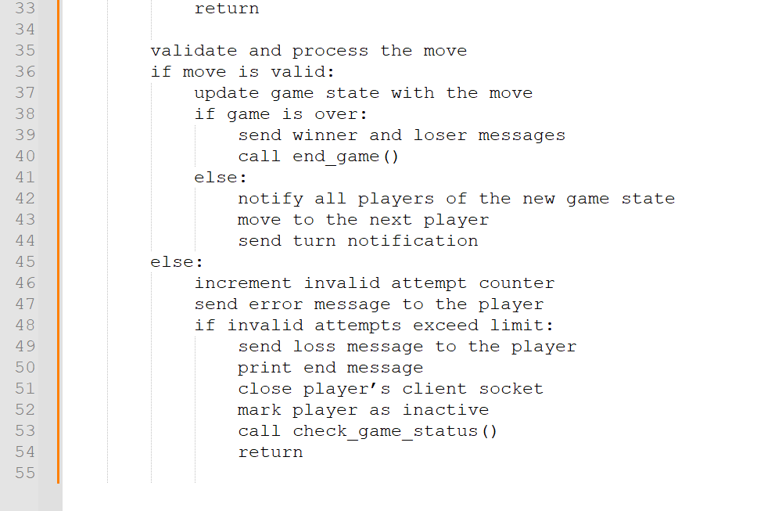

Requirement Acceptance Tests

User  Requirement No | Test | Implemented (Full /Partial/ None) | Test Results (Pass/ Fail) | Comments (for partial implementation or failed test results)
1 | The server must be started from customisable command-line arguments as shown: game_server <Port Number> <Game Type> <Game arguments> | Full | Pass
2 | The server will listen for incoming connections on the specified port, accepting all connections up to the specified number of players for the game. | Full | Pass
3 | The server shall wait till the required number of players have connected to the server before starting the game. | Full | Pass
4 | The server shall handle player turns, sending a TEXT message with the current score each turn and a GO message indicating the next players move. If the client doesn’t respond to the GO message within 20 seconds, the player will be removed from the game and an END message will be sent the client. | Full | Pass
5 | The server shall send a TEXT message to each client at the end of the game indicating if they won or lost the game. As well as, a END message to terminate all client connections to the server. | Full | Pass
6 | The server shall send a TEXT ERROR message for invalid inputs or commands from the client. If an invalid input or command has been entered 5 times in a row by a client, the client will be removed from the game and send a END message to terminate client connection. | Full | Pass
7 | To join the server, the client must input command-line arguments matching the server as shown: game_client <Game Type> <Server Name> <Port Number> | Full | Pass
8 | The client must display all messages received from the server such as game prompts and results. | Full | Pass
9 | When it is the clients turn, the client must send a move in the format: MOVE <move> or the command QUIT if they would like to exit the game. | Full | Pass
10 | When the client recieves a TEXT ERROR message from the server, the client should display the error message and send a prompt indicating the user to try again. | Full | Pass
11 | The client shall be terminated if it recieves invalid messages from the server or encounters connection issues. | Full | Pass

Software  Requirement No | Test | Implemented (Full /Partial/ None) | Test Results (Pass/ Fail) | Comments (for partial implementation or failed test results)
1 | The server and client programs should be implemented in the programming language C. | Full | Pass
2 | The server shall be capable of managing multiple clients simultaneously. | Full | Pass
3 | Comprehensive error handling shall be implemented to manage and report any issues like connection failures, invalid inputs and protocol volilations. | Full | Pass
4 | There shall be game logic implemented to handle game states, player turns, active players, and the winners and losers of the game. | Full | Pass
5 | A README file with instructions for compling and running the server and connecting to the server shall be included. | Full | Pass

Detailed Software Testing

No | Test | Expected Results | Actual Results
1.0 | Connection tests
1.1  1.2  1.3  1.4 | Client connecting to server with:  - incorrect port  - incorrect name  - incorrect IP address  - too many arguments | - Connect failed: 10061  - Connected Anyways  - Connect failed: 10060  - Usage: C:\cygwin64\home\tiama\A1P2\game-client.exe <Game Type> <Server IP> <Port Number> | As expected except 1.2 which should not connect despite having the wrong game-name.
1.5  1.6 | Starting Server with too many or not enough arguments. | 1.5) Usage: C:\cygwin64\home\tiama\A1P2\game-server.exe <Port Number> <Game Type> <Number of Players>  1.6) Usage: C:\cygwin64\home\tiama\A1P2\game-server.exe <Port Number> <Game Type> <Number of Players> | As expected
2.0 | Input tests
2.1  2.2  2.3  2.4 | Client inputs:  - non integer  - too many argument  - 5 incorrect inputs  - quit with no uppercase letters | 2.1) ERROR Invalid move or command. Try again!  2.2) ERROR Invalid move or command. Try again!  2.3) Removes socket connection of player disconnecting from game with You Lost message.  2.4) Still quits game | As expected

User Instructions

- Open the A1P2 folder in your prefered code manager.
- Run the command in the terminal “gcc game-server.c -o game-server -lws2_32 -lpthread” to compile game-server.exe
- Run the command in the terminal “gcc game-client.c -o game-client -lws2_32” to compile game-client.exe
- Run the command in the terminal “./game-server <port-number> <game-name> <player-number>
- Open the the same number of cygwin tabs as players selected on the same network.
- Navigate to the A1P2 folder.
- Run the command “./game-client <game-name> <server-ip-address> <port-number>” on each tab making sure that they match the inputs you used to start up the server.
- Make sure you connect all the players to the server, then it will start and you can play the game.

