Cross-Dataset Transfer and Subject Adaptation for sEMG-Based Isolated Digit Recognition
Experiments 06 • 07 • 08 - Transfer Grid | Session-Aware Adaptation | Low-Budget Adaptation

1. Introduction
Surface electromyography (sEMG) enables non-invasive measurement of muscle activity and is widely used in human–computer interaction, prosthetics, and assistive technologies. One promising application is handwriting recognition, where muscle signals are decoded into text, enabling silent input systems and new interaction modalities (Akinshin et al., 2026).
However, this task is challenging because handwriting occurs in a sequence and EMG signals vary greatly between users. This variation leads to significant performance drops when applied to different subjects (Zhang et al., 2023).
Recent research has shown that deep learning models can learn representations directly from raw EMG signals. In particular, Transformer-based models have shown strong results by capturing both spatial and temporal relationships in high-density EMG data, achieving about 92% accuracy on large gesture sets (Rani et al., 2023).
Despite these improvements, generalizing to unseen users is still a major issue. Large-scale studies reveal a significant gap between generic and personalized models. For example, in continuous EMG-based text input, performance improves dramatically after user-specific fine-tuning.. Domain adaptation methods partially address this issue by reducing the amount of calibration data required, but robust cross-user performance is still not fully solved (Zhang et al., 2023).
In this work, we focus on improving cross-user generalization for EMG-based handwriting recognition. We evaluate three strategies using a CNN-Transformer architecture: (1) pretraining on multiple datasets, (2) leave-one-subject-out training, and (3) fine-tuning with a small amount (10%) of data from a new user. All experiments are evaluated on unseen data using the macro-F1 score.

2. Common Setup

2.1 Datasets
Three sEMG datasets are used, all filtered to digit classes 0-9 before any processing.
Dataset | Subjects | Samples | Channels | Length median | Length range
old | 11 | 5,534 | 8 | 1,875 ts | 328-9,203 ts
nm | 91 | 7,018 | 16 | 1,411 ts | 740-23,360 ts
hcmyo | 3 | 30,000 | 8 | 940 ts | 510-1,590 ts
Table 1. Dataset characteristics. ts = timesteps.
The old dataset is an 8-channel sEMG collection for handwritten digit recognition with 11 subjects and highly variable trial lengths. The nm dataset has 91 subjects and 16 channels, requiring a channel-selection step (see §2.2). The hcmyo dataset is the digit subset of HCMYO-A (Ruiz-Pinales et al., 2020), with three subjects and ~10,000 trials each at 200 Hz.

2.2 Preprocessing
Channel selection (nm only)
The nm dataset's 16 channels are reduced to 8 by PCA (for Experiment 6 only) importance scoring on the training split. The top-8 channels are selected (channels 0, 4, 5, 7, 8, 9, 10, 12 in Experiment 6). Figure 1 shows the PCA scores and selected channels.
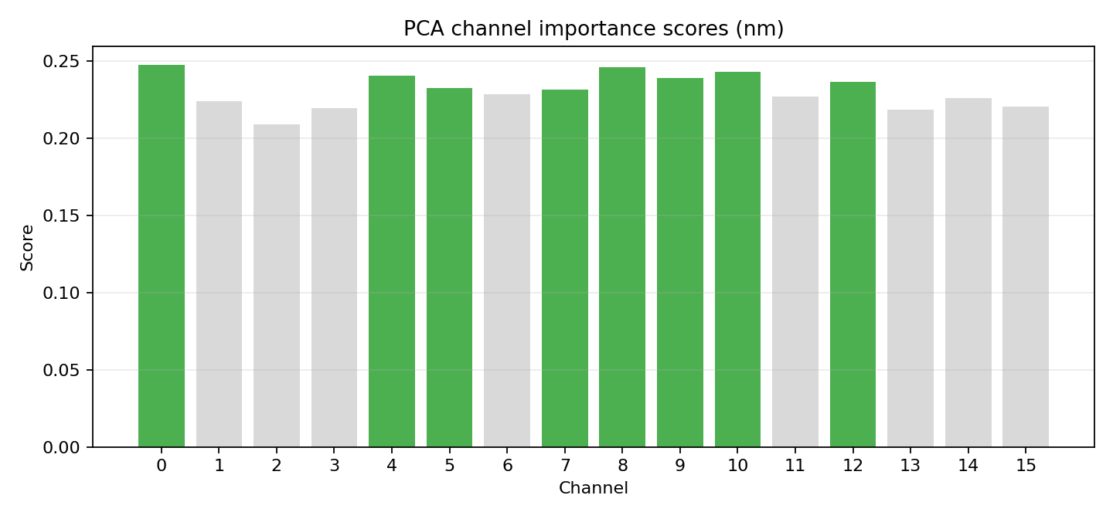
Figure 1. PCA channel importance scores for the nm dataset (Experiment 06). Green bars = selected channels.
Normalization and padding
Robust per-channel normalization:
$μ = median(x), σ = 1.4826·median(|x-μ|), clipped to ±6σ, ε = 1e-6.$
Statistics are estimated on the training portion only. Variable-length trials are handled by within-batch zero-padding to the maximum length in each mini-batch. In Experiments 07/08, normalization is computed per subject to prevent amplitude leakage from the test subject into the normalization scale.

2.3 Model Architecture
All experiments use the same CNN-Transformer backbone (cnn_transformer_loso_v2): a strided CNN (kernel = 21, stride = 8) extracts local temporal features from the 8-channel input (except Experiment 7 – original data 16-channel input), followed by a 2-layer Transformer encoder (d_model = 64, 4 heads, FF = 256, dropout = 0.2). The encoder output is mean-pooled and passed to a 10-class linear head. The model handles variable-length inputs via batch padding and masking.

2.4 Training Protocol
Stage A - Cross-Entropy Supervised Training
Experiment 06
Two CE phases are used in the transfer branch (pretrain -> finetune) and one CE phase in the scratch branch (random init -> finetune).
weight_decay = 1e-2, grad_clip = 1.0, batch_size = 64.
Early stopping patience: 10 epochs (pretrain), 6 epochs (transfer finetune), 6 epochs (scratch finetune).
Monitoring metric: validation macro-F1 of the corresponding CE phase.

Experiment 07
CE training on train subjects with weight_decay = 1e-4, grad_clip = 1.0, batch_size = 64, patience = 15, up to 70 epochs.
Monitored metric: val_adapt_monitor_f1, computed after each epoch via prototypical validation monitor (monitor_adapt_episodes = 50) on validation subjects.
This selects checkpoints by adaptation readiness, not only plain validation CE accuracy.
This experiment use all 16 data channels.

Experiment 08
Same Stage A principle as Exp.07, with weight_decay = 1e-4, grad_clip = 1.0, batch_size = 64, patience = 12, up to 70 epochs.
Monitored metric: val_adapt_monitor_f1 on source-only validation subjects with monitor_adapt_episodes = 40.

Stage B - Prototypical Meta-Adaptation (Experiments 07/08)
The Stage A checkpoint is adapted on the target subject adapt split using episodic prototypical training.
• Episode setup: 5-way, 6-shot, 6-query
• Prototypes: class mean in embedding space
• Query logits: negative squared Euclidean distance to prototypes
• Loss: CE over query logits
• Training config: 80 episodes, lr = 2.5e-4, weight_decay = 1e-4, grad_clip = 1.0, L2-normalized embeddings
Adaptation is skipped if:
• fewer than 10 adapt samples are available
• fewer than 2 query samples can be formed (q_query < 2 effective condition).
Evaluation modes
• Zero-shot: Stage A model directly on target test/eval split
• Pre-adapt proto: prototype inference from adapt split without gradient updates
• Adapted: full Stage B optimization
• Primary metric: macro-F1
For Experiment 06, transfer (pretrain -> finetune) is compared against scratch (random init -> finetune) on the same target split and on the unseen third dataset.
All experiments use the AdamW optimizer.

2.5 Protocol Dictionary
Stage A: supervised CE training checkpoint stage (used in Exp06/07/08 for model initialization before target adaptation).
Stage B: episodic prototypical adaptation on target-adapt data after Stage A checkpoint selection (Exp07/08).
n_way: number of classes sampled per adaptation episode (Exp07/08 Stage B).
k_shot: support samples per class in each adaptation episode (Exp07/08 Stage B).
q_query: query samples per class per adaptation episode; if effective `q_query < 2`, Stage B is skipped because episode supervision becomes unstable.
adapt_applied: flag showing whether Stage B optimization actually ran for a fold/run.
valid_adapt: adapted result included in valid-only aggregates (`adapt_applied=1` and valid proto evaluation).
zero-shot: Stage A model evaluated directly on target eval/test split without Stage B updates.
pre-adapt proto: prototype inference from target adapt split without gradient updates.
adapted: full Stage B optimization followed by prototype-based evaluation on target eval/test split. N

3. Experiment 06 - Cross-Dataset Transfer Grid

3.1 Protocol and Data Partitioning
Exp06 dataset-centric narrative: each dataset is split once (train/validation/test) and then receives a per-run role as pretrain_ds, finetune_ds, or unseen_ds.
- Dataset old split: train=3320, validation=1107, test=1107 (seed=42)
- Dataset nm split: train=4209, validation=1400, test=1409 (seed=1042)
- Dataset hcmyo split: train=18000, validation=5997, test=6003 (seed=2042)
Exp06 fine-tune protocol (applies to whichever dataset is finetune_ds in a run):
- start from that dataset fixed split train/validation/test;
- transfer branch updates weights only on finetune_ds.train after pretraining;
- scratch branch updates weights only on the same finetune_ds.train from random init;
- finetune_ds.validation is used only for checkpoint selection/early stopping in both branches;
- finetune_ds.test is never used for optimization or selection and is used only for final target reporting.
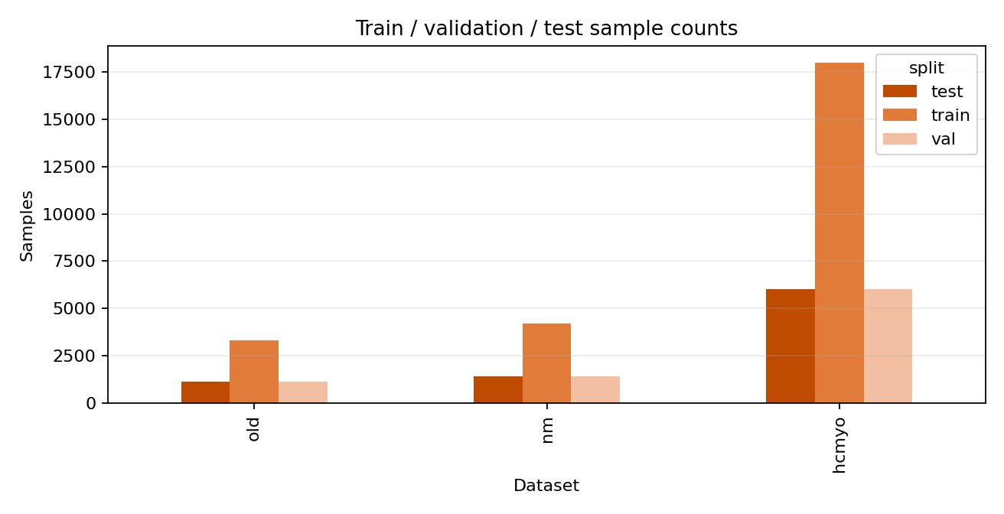
Figure 2. Train / validation / test sample counts per dataset in Experiment 06.

3.2 Training Parameters
Parameter | Value
Stage A pretrain epochs | 45
Stage A lr | 0.00025
Stage A patience | 10
Stage B transfer epochs | 45
Stage B transfer lr | 0.00015
Stage B transfer patience | 6
Stage B scratch epochs | 40
Stage B scratch lr | 0.00018
Stage B scratch patience | 6
batch_size | 64
weight_decay | 0.01
grad_clip | 1.0
optimizer | AdamW

3.3 Aggregate Results
Metric | Value
transfer_target_f1 mean±std | 0.6391 ± 0.2068
scratch_target_f1 mean±std | 0.5617 ± 0.2015
transfer_unseen_f1 mean±std | 0.0598 ± 0.0254
scratch_unseen_f1 mean±std | 0.0587 ± 0.0234
delta_target(transfer-scratch) mean±std | 0.0774 ± 0.0445

3.4 Run-Level Results
Run | Pretrain | Finetune | Unseen | Transfer target F1 | Scratch target F1 | Delta target | Transfer unseen F1 | Scratch unseen F1
1 | old | nm | hcmyo | 0.3216 | 0.2693 | 0.0522 | 0.0356 | 0.0385
2 | old | hcmyo | nm | 0.8075 | 0.7611 | 0.0464 | 0.0471 | 0.0549
3 | nm | old | hcmyo | 0.7288 | 0.6327 | 0.0961 | 0.0395 | 0.0304
4 | nm | hcmyo | old | 0.7997 | 0.7681 | 0.0316 | 0.0463 | 0.0495
5 | hcmyo | old | nm | 0.7990 | 0.6334 | 0.1657 | 0.0974 | 0.0959
6 | hcmyo | nm | old | 0.3782 | 0.3056 | 0.0725 | 0.0930 | 0.0829

Transfer pretraining improved target F1 across all six runs (mean delta +0.077). The largest gain is Run 5 (hcmyo->old, +0.166): a large, densely-sampled source pre-trains strong temporal representations that transfer effectively to a smaller target. The weakest gain is Run 4 (nm->hcmyo, +0.032), where both source and target achieve high absolute F1, leaving little margin for transfer to add. Unseen-dataset F1 remains near chance across all configurations (mean 0.060 ± 0.025), confirming that pure zero-shot cross-dataset generalization is not achievable with the current architecture regardless of pretraining source.

4. Experiment 07 - NM Session-Aware Subject Adaptation

4.1 Protocol and Data Partitioning
NM dataset split has two levels:
- subject-level outer folds
- session-level adapt/eval split inside validation and test subjects.
Level 1 (subjects): per fold, train-subject pool is used for Stage A optimization, validation-subject pool is used for Stage A monitor episodes, and one held-out test subject is reserved for Stage B + final reporting.
Level 2 (sessions): for each validation/test subject, sessions are split ~50/50 into adapt and eval; adapt side is used for prototype construction / Stage B updates, eval side is used for reporting only.
Reporting rule: folds with effective q_query<2 are marked as skipped (adapt_applied=0) and will be separated from valid-adapt aggregates.
Outer subject-level fold split (n_folds=10, n_val_subjects=2, min_eval_sessions=2) with inner session-level adapt/eval split (~50/50 by sessions) for validation/test subjects.
4.1.1 Per-Fold Stage Map (Concrete Pools)
Fold | Train pool | Validation monitor pool | Test adaptation pool | Test reporting pool | Stage B status
1 | 88 subjects, 6768 trials | 2 subjects, 130 trials | sub-005 adapt: 6 sessions / 60 trials | sub-005 eval: 6 sessions / 60 trials | applied
2 | 88 subjects, 6828 trials | 2 subjects, 100 trials | sub-040 adapt: 4 sessions / 40 trials | sub-040 eval: 5 sessions / 50 trials | applied
3 | 88 subjects, 6779 trials | 2 subjects, 150 trials | sub-003 adapt: 4 sessions / 40 trials | sub-003 eval: 5 sessions / 49 trials | applied
4 | 88 subjects, 6829 trials | 2 subjects, 130 trials | sub-068 adapt: 3 sessions / 30 trials | sub-068 eval: 3 sessions / 29 trials | applied
5 | 88 subjects, 6848 trials | 2 subjects, 130 trials | sub-074 adapt: 2 sessions / 20 trials | sub-074 eval: 2 sessions / 20 trials | skipped (q_query<2)
6 | 88 subjects, 6788 trials | 2 subjects, 140 trials | sub-029 adapt: 4 sessions / 40 trials | sub-029 eval: 5 sessions / 50 trials | applied
7 | 88 subjects, 6748 trials | 2 subjects, 180 trials | sub-047 adapt: 4 sessions / 40 trials | sub-047 eval: 5 sessions / 50 trials | applied
8 | 88 subjects, 6758 trials | 2 subjects, 210 trials | sub-042 adapt: 2 sessions / 20 trials | sub-042 eval: 3 sessions / 30 trials | skipped (q_query<2)
9 | 88 subjects, 6809 trials | 2 subjects, 139 trials | sub-090 adapt: 4 sessions / 40 trials | sub-090 eval: 3 sessions / 30 trials | applied
10 | 88 subjects, 6798 trials | 2 subjects, 140 trials | sub-028 adapt: 4 sessions / 40 trials | sub-028 eval: 4 sessions / 40 trials | applied

4.2 Training Parameters
Parameter | Value
Stage A epochs | 70
Stage A lr | 0.0007
Stage A patience | 15
Stage A monitor_adapt_episodes | 50
Stage B episodes | 80
Stage B lr | 0.00025
Stage B n_way | 5
Stage B k_shot | 6
Stage B q_query | 6
Stage B min_adapt_samples_for_train | 10
Stage B min_q_query_for_train | 2
optimizer | AdamW

4.3 Aggregate Results
Metric | Value
test_zero_shot_f1_mean (all folds) | 0.5118
test_pre_adapt_proto_f1_mean (all folds) | 0.5779
test_adapt_f1_mean (all folds) | 0.5933
test_adapt_f1_mean (valid-adapt folds only) | 0.6183
val_adapt_monitor_f1_mean (all folds) | 0.6652
n_valid_test_adapt_folds / n_folds | 8/10

4.4 Fold-Level Results
Fold | Test subject | Best Stage A epoch | Zero-shot F1 | Pre-adapt proto F1 | Adapted F1 | Adapt applied | Skip reason
1 | sub-005 | 47 | 0.2217 | 0.5521 | 0.6300 | 1 | -
2 | sub-040 | 35 | 0.7050 | 0.7435 | 0.6948 | 1 | -
3 | sub-003 | 24 | 0.6700 | 0.8078 | 0.7767 | 1 | -
4 | sub-068 | 33 | 0.4066 | 0.4114 | 0.4190 | 1 | -
5 | sub-074 | 20 | 0.3433 | 0.2819 | 0.2819 | 0 | q_query<2
6 | sub-029 | 54 | 0.5077 | 0.7101 | 0.7409 | 1 | -
7 | sub-047 | 59 | 0.5166 | 0.6033 | 0.6157 | 1 | -
8 | sub-042 | 29 | 0.8262 | 0.7050 | 0.7050 | 0 | q_query<2
9 | sub-090 | 55 | 0.4002 | 0.4883 | 0.5814 | 1 | -
10 | sub-028 | 32 | 0.5207 | 0.4754 | 0.4874 | 1 | -

Across 10 folds, Stage B adaptation was feasible in 8 folds and skipped in 2 folds (both q_query<2). On valid folds, mean test Macro-F1 moved from 0.599 (pre-adapt proto) to 0.618 (adapted), a +0.019 gain; versus pure zero-shot, the gain was +0.125. Results remain heterogeneous: strong improvements appear in folds 1 and 6, while folds 2 and 3 show mild regression versus pre-adapt proto, and fold 10 shows near-parity. This behavior is expected under low-query episodic adaptation (q_query mostly 2-3) and confirms that feasibility and stability must be reported separately from aggregate means.

5. Experiment 08 - HCMYO-A Low-Budget Target Adaptation

5.1 Protocol and Data Partitioning
HCMYO dataset split is run-centric LOSO: each run selects one target subject and uses the other two as source subjects.
Stage A uses only source subjects (train + source-only monitor) with no target peeking.
Target subject is split class-stratified into adapt/eval at 10/90: Stage B updates use only target adapt; final run metrics use only target eval.
Three run leave-one-subject-out rotation. For each run, target subject trials are class-stratified into adapt/eval with target ratio 10/90.
Run | Source train subjects | Source monitor pool | Target adapt pool | Target eval pool | Stage B status
1 | S02,S03 | 4000 trials (source-only) | S01: 999 trials | S01: 9001 trials | applied
2 | S01,S03 | 4000 trials (source-only) | S02: 1000 trials | S02: 9000 trials | applied
3 | S01,S02 | 4000 trials (source-only) | S03: 1000 trials | S03: 9000 trials | applied

5.2 Training Parameters
Parameter | Value
Stage A epochs | 70
Stage A lr | 0.0008
Stage A patience | 12
Stage A monitor_adapt_episodes | 40
Stage B episodes | 80
Stage B lr | 0.00025
Stage B n_way | 5
Stage B k_shot | 6
Stage B q_query | 6
optimizer | AdamW

5.3 Aggregate Results
Metric | Value
test_zero_shot_f1_mean (all runs) | 0.1748
test_pre_adapt_proto_f1_mean (all runs) | 0.4404
test_adapt_f1_mean (all runs) | 0.5430
val_adapt_monitor_f1_mean (all runs) | 0.8716

5.4 Run-Level Results
Run | Target subject | Best StageA epoch | Zero-shot F1 | Pre-adapt proto F1 | Adapted F1
1 | S01 | 70 | 0.1151 | 0.3682 | 0.4454
2 | S02 | 68 | 0.1835 | 0.4892 | 0.6432
3 | S03 | 63 | 0.2256 | 0.4639 | 0.5403

All three runs completed with valid adaptation. Stage B improved F1 over both pure zero-shot and pre-adapt proto in every run (S01: 0.445, S02: 0.643, S03: 0.540). Mean gains were +0.266 for pre-adapt proto over zero-shot and an additional +0.103 for full Stage B over pre-adapt proto, resulting in +0.368 versus pure zero-shot overall. Run-level variance remains substantial and is still dominated by target-subject identity, which is expected when the Stage A prior is learned from only two source subjects.

6. Cross-Experiment Summary
Denominator policy for all gains in this report: every gain must explicitly state its cohort denominator (all folds, valid-adapt folds only, or runs). Exp06 gains are run-level over all 6 runs; Exp07 gains are reported as both all-fold and valid-adapt-only where applicable; Exp08 gains are run-level over 3 runs.
Auxiliary note: detailed stage-flow traces are preserved in tables 3.1.2, 4.1.2, and 5.1.2; primary interpretation should follow dataset-centric split descriptions.
Experiment | Setting | Baseline F1 | Adapted/Transfer F1 | Gain
06 | transfer-vs-scratch grid (6 runs) | 0.5617 (scratch target, all runs) | 0.6391 (transfer target, all runs) | 0.0774 (all runs)
07 | NM session-aware 10 folds (8 valid adapt, 2 skipped) | 0.5990 (pre-adapt proto, valid-adapt folds) | 0.6183 (adapted, valid-adapt folds) | 0.0193 (valid-adapt folds)
08 | HCMYO-A 3 runs (10% adapt) | 0.4404 (pre-adapt proto, all runs) | 0.5430 (adapted, all runs) | 0.1026 (all runs)

7. Conclusion
Reader-traceability check: from sections 3.1.1/4.1.1/5.1.1 and companion maps, each reported metric can be traced to an explicit stage row with its exact input subset and split rule.
This study evaluated three strategies for cross-subject and cross-dataset generalization in sEMG handwriting recognition using a shared CNN-Transformer backbone. Cross-dataset transfer pretraining (Experiment 06) provided a consistent mean improvement of +0.077 macro-F1 over scratch training, with outcomes strongly dependent on the source-target pairing - pretraining helps most when the source and target share similar temporal structure (Run 5: hcmyo->old, +0.166), while gains are smaller when source and target populations differ substantially. Notably, all six transfer runs yielded a positive delta.
Session-aware prototypical adaptation on NM (Experiment 07) now covers 10 folds, with 8 valid adapted folds and 2 skipped folds due to q_query<2. On valid folds, Stage B adds +0.019 mean Macro-F1 over pre-adapt proto (0.599 -> 0.618), but fold-level behavior is mixed and includes mild regressions, so per-fold reporting is required. Low-budget trial-level adaptation on HCMYO-A (Experiment 08) remains consistently positive across all three runs, adding +0.103 over pre-adapt proto on average (0.440 -> 0.543), with strong target-subject variance (S01: 0.445, S02: 0.643, S03: 0.540).
Overall, the results support a qualified practical guideline: when labeled target-user data is available, prototypical adaptation generally improves performance - but its benefit is not guaranteed when adaptation data is very scarce. Cross-dataset transfer pretraining is a reliable baseline when no target data exists, and consistently outperformed scratch training across all configurations. Future work should address: (1) repeated-seed evaluation to separate performance from initialization variance; (2) a softer fallback for the adaptation feasibility gate rather than a hard skip; (3) domain-invariant pre-training (e.g., adversarial or contrastive objectives) to close the near-chance pure zero-shot cross-dataset gap; and (4) scaling HCMYO-A experiments to more subjects to assess how run-level variance evolves with training population size.

8. References
- Akinshin, R., Lopatina, E., Bogatikov, K., Kiz, N., Makarova, A. V., Lebedev, M., Cabrera, M. A., Tsetserukou, D., & Kangler, V. (2026). Prosthetic hand manipulation system based on EMG and eye tracking powered by the neuromorphic processor ALTAI. ACM Digital Library, 778–782. https://doi.org/10.1145/3776734.3794501
- Rani, G. J., Hashmi, M. F., & Gupta, A. (2023). Surface Electromyography and Artificial Intelligence for Human Activity Recognition—A systematic review on methods, emerging trends applications, challenges, and future implementation. IEEE Access, 11, 105140–105169. https://doi.org/10.1109/access.2023.3316509
- Zhang, X., et al. (2023). Multi-source domain generalization and adaptation toward cross-subject myoelectric pattern recognition. Journal of Neural Engineering, 20(3), 036012. https://doi.org/10.1088/1741-2552/acb7a0
- Loshchilov, I., & Hutter, F. (2019). Decoupled weight decay regularization. In International Conference on Learning Representations. https://openreview.net/forum?id=Bkg6RiCqY7
- Ruiz-Pinales, J., Beltran-Hernandez, J. G., Avina-Cervantes, J. G., Lopez-Rodriguez, P., & Lopez-Ramirez, J. L. (2020). HCMYO-A dataset (V1) [Data set]. Mendeley Data. https://doi.org/10.17632/ms3sbpbrgp.1
- Snell, J., Swersky, K., & Zemel, R. (2017). Prototypical networks for few-shot learning. Advances in Neural Information Processing Systems, 30. https://arxiv.org/abs/1703.05175
- Vaswani, A., Shazeer, N., Parmar, N., Uszkoreit, J., Jones, L., Gomez, A. N., Kaiser, L., & Polosukhin, I. (2017). Attention is all you need. Advances in Neural Information Processing Systems, 30. https://arxiv.org/abs/1706.03762

Appendix A — Supplementary Figures
Cross-Dataset Transfer and Subject Adaptation for sEMG Handwriting Recognition
This appendix contains all 28 supplementary figures exported from notebooks 06, 07, and 08. Figures are referenced in the main text as "Appendix A, Figure A.x".

A.1 Experiment 06 — Cross-Dataset Transfer Grid
Figures A.1–A.16.
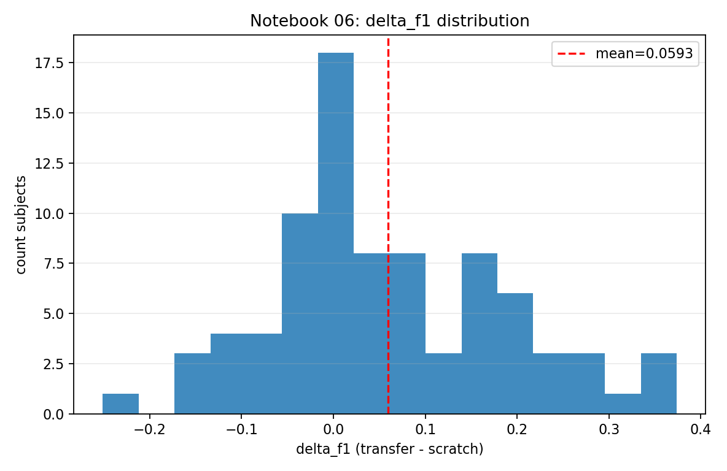
Figure A.1. Distribution of ΔF1 (transfer − scratch) across all six source→target run pairs.
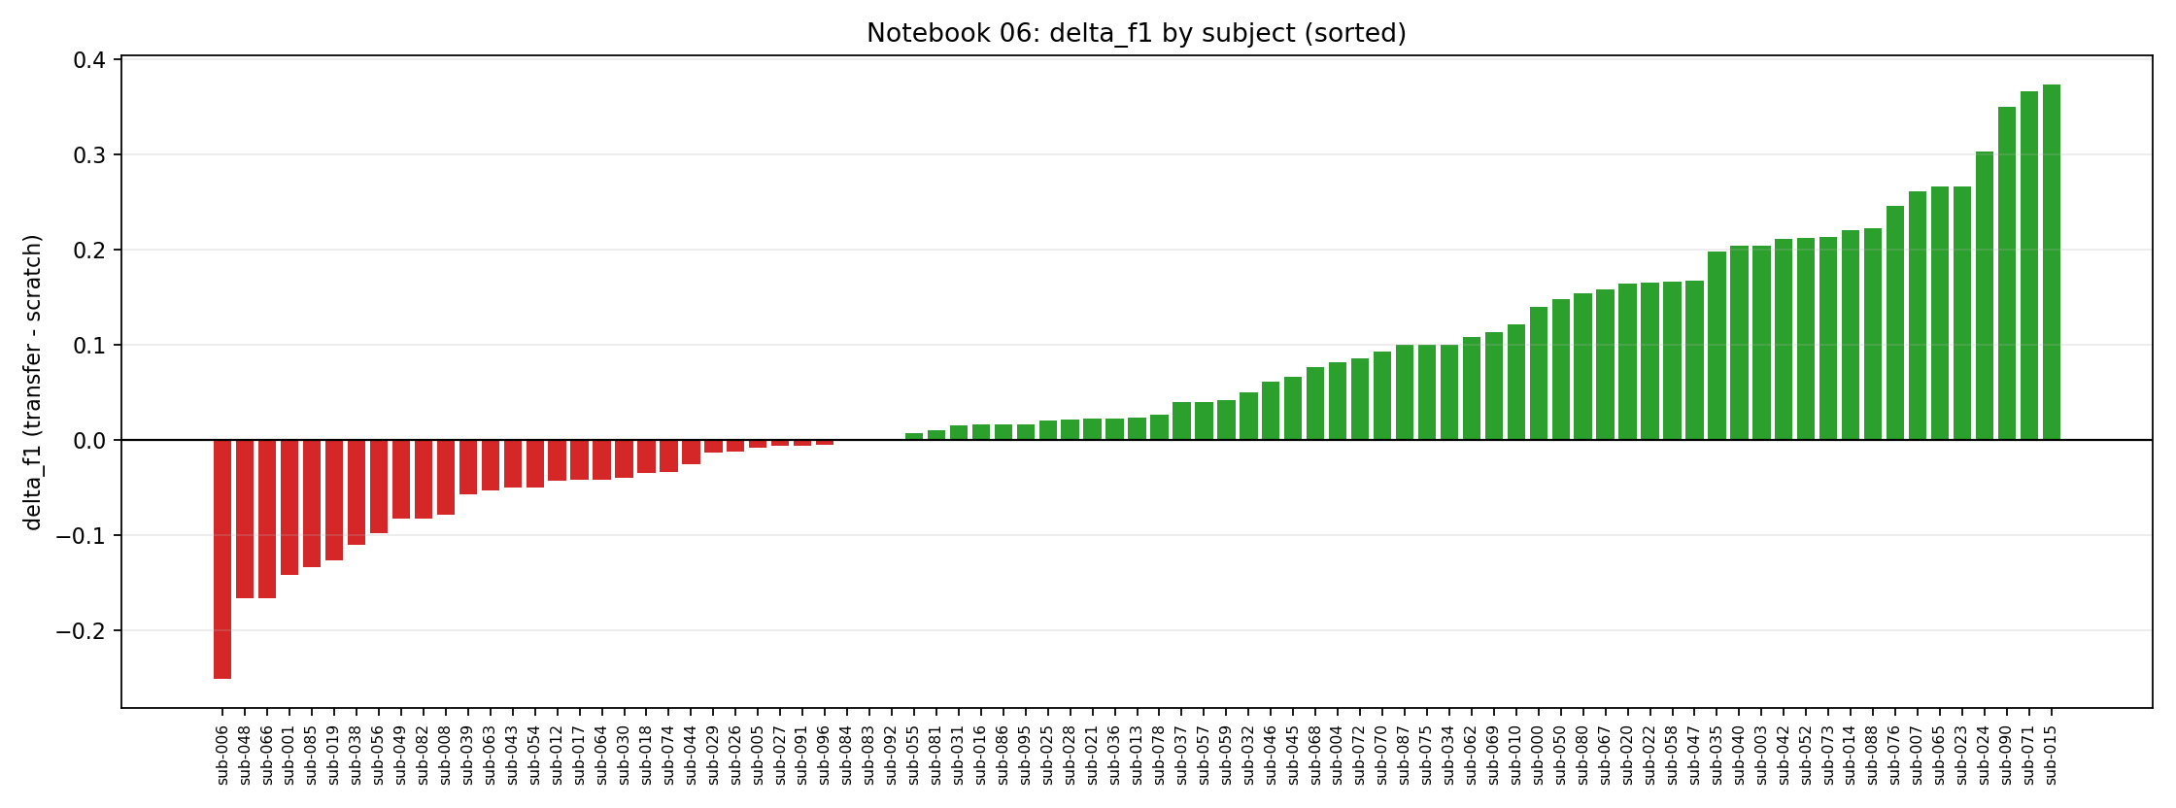
Figure A.2. ΔF1 per subject, sorted by magnitude. Positive bars indicate transfer benefit.
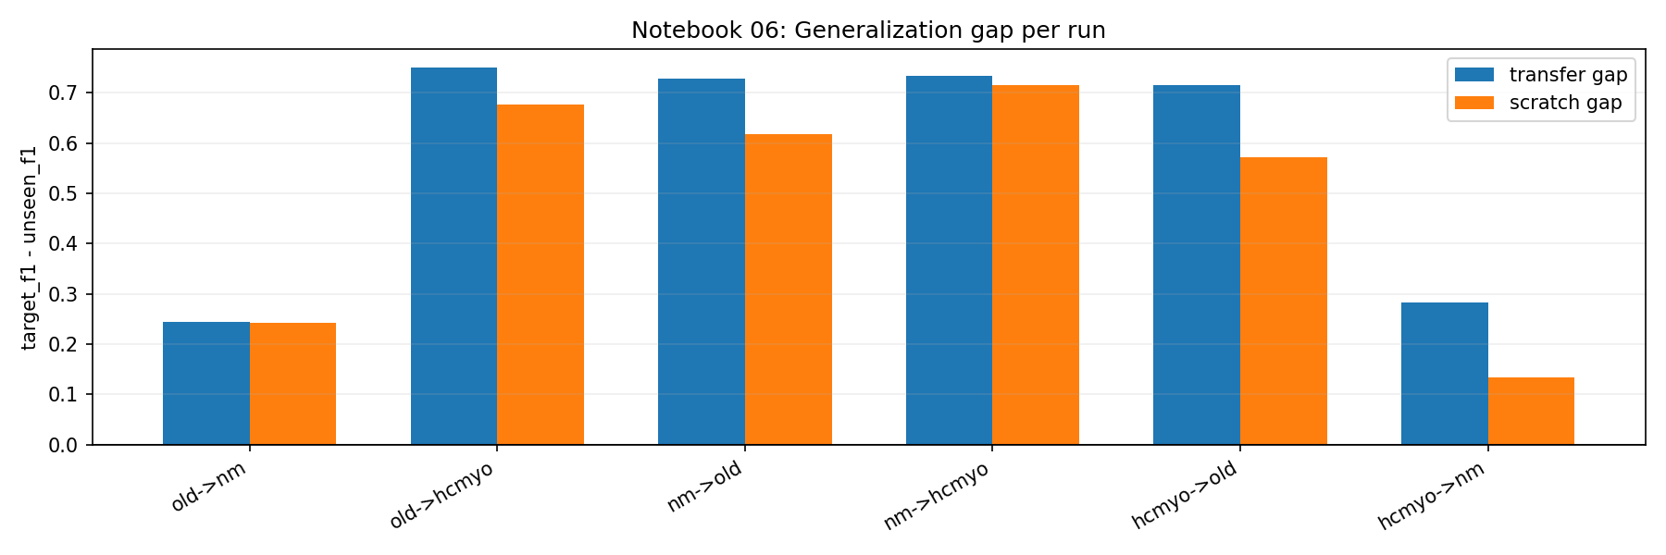
Figure A.3. Generalization gap: transfer vs. scratch on the target dataset per run.
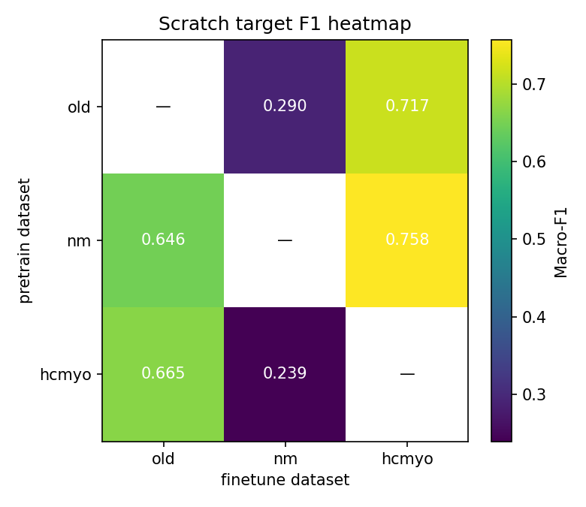
Figure A.4. Heatmap of scratch target F1 across all source / target dataset pairs.
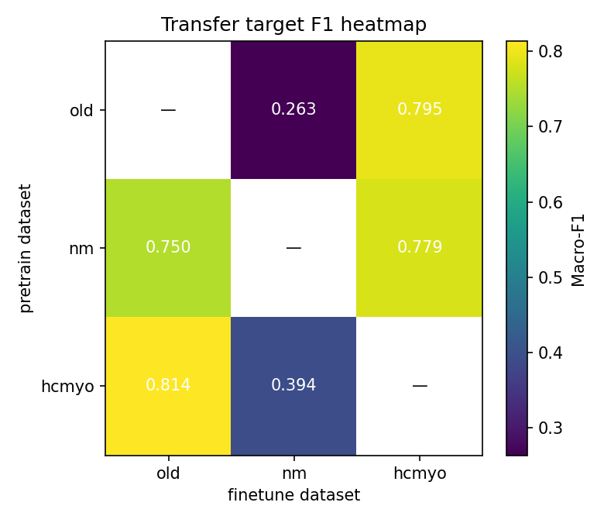
Figure A.5. Heatmap of transfer target F1 across all source / target dataset pairs.
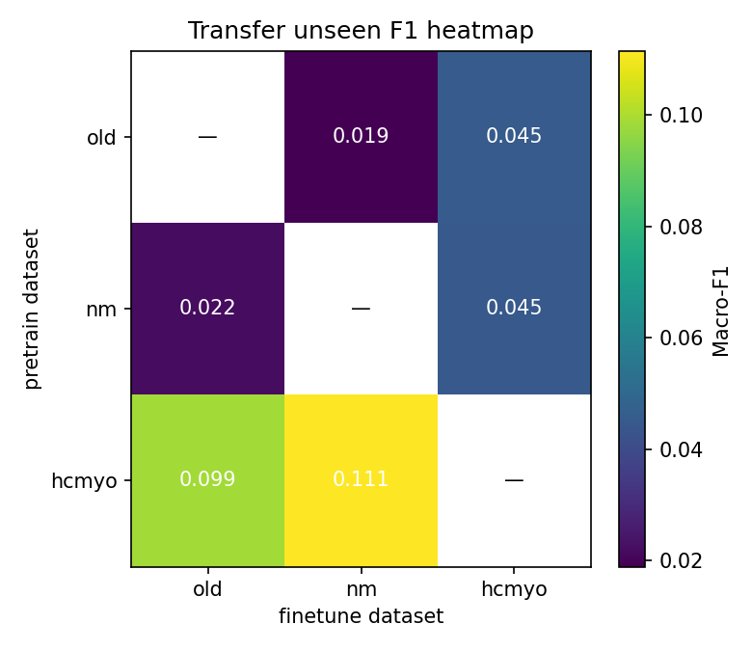
Figure A.6. Heatmap of transfer unseen F1 across all source / target dataset pairs.
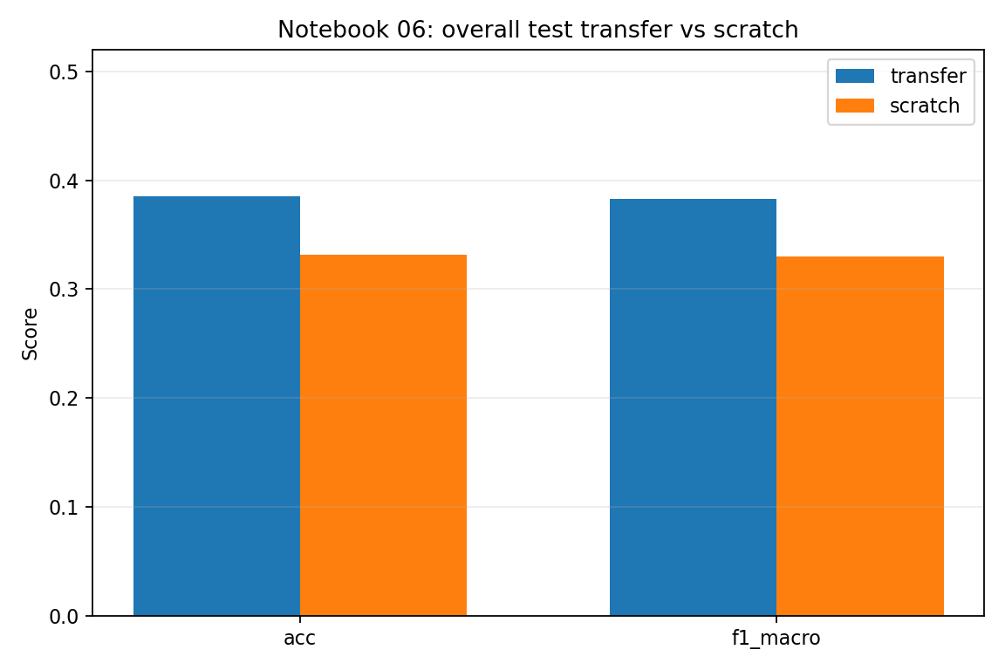
Figure A.7. Overall transfer vs. scratch F1 for every run (paired bar chart).
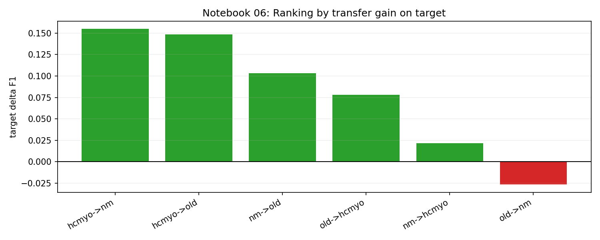
Figure A.8. Runs ranked by target ΔF1 in descending order.
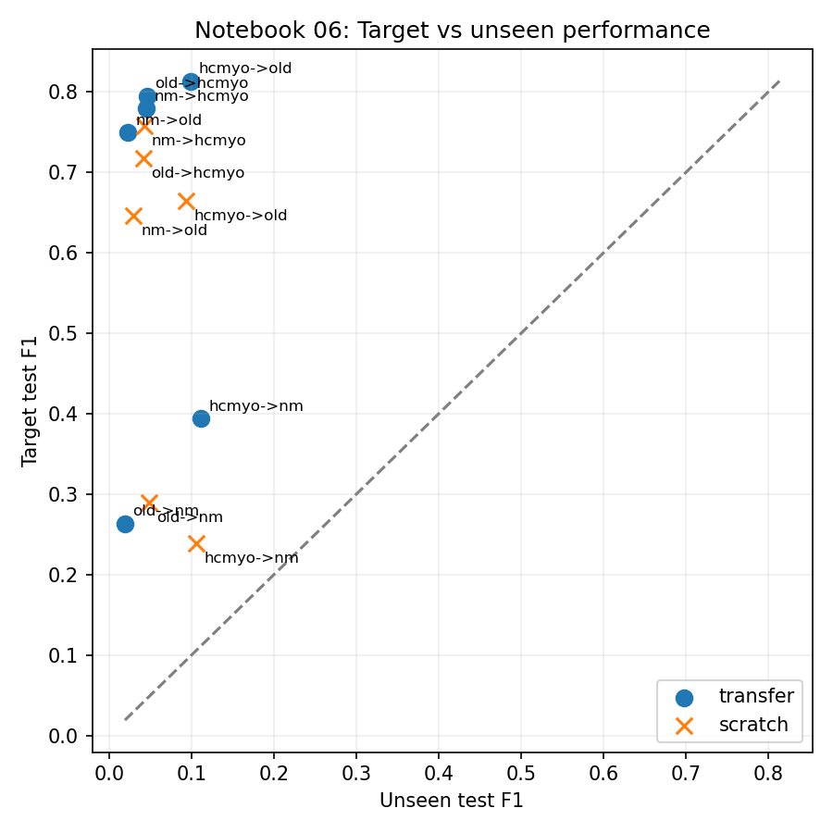
Figure A.9. Scatter of target F1 vs. unseen F1 under the transfer condition.
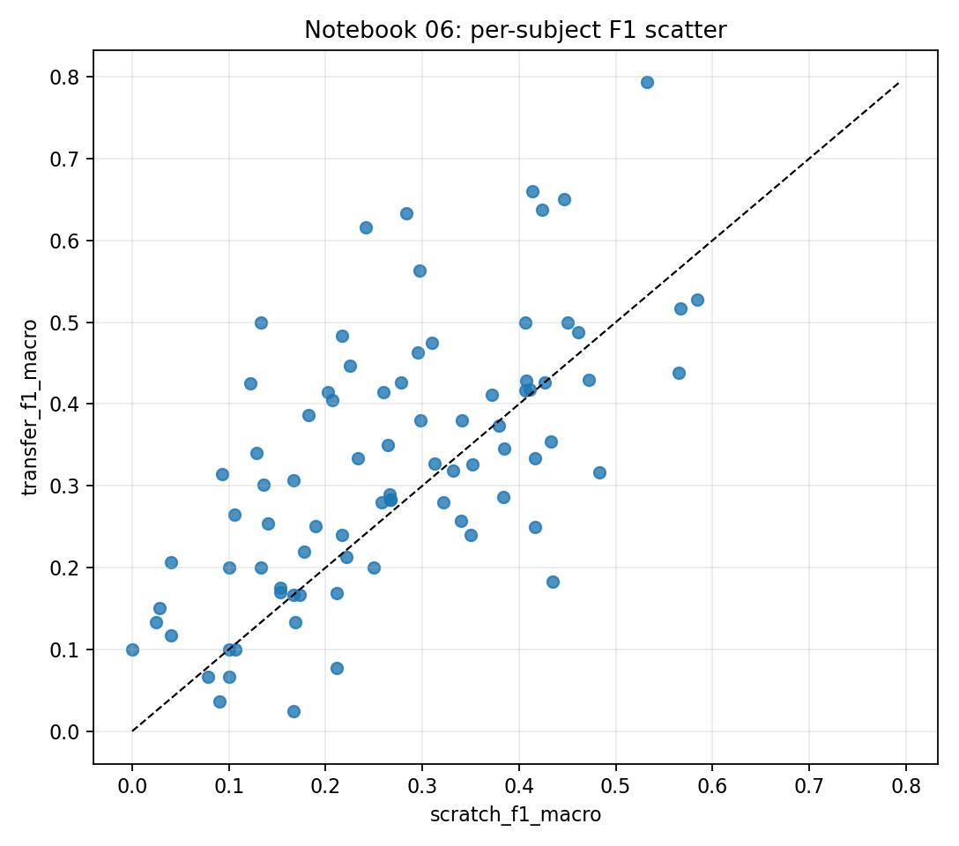
Figure A.10. Scatter of transfer F1 vs. scratch F1 per run; points above the diagonal mark transfer gains.
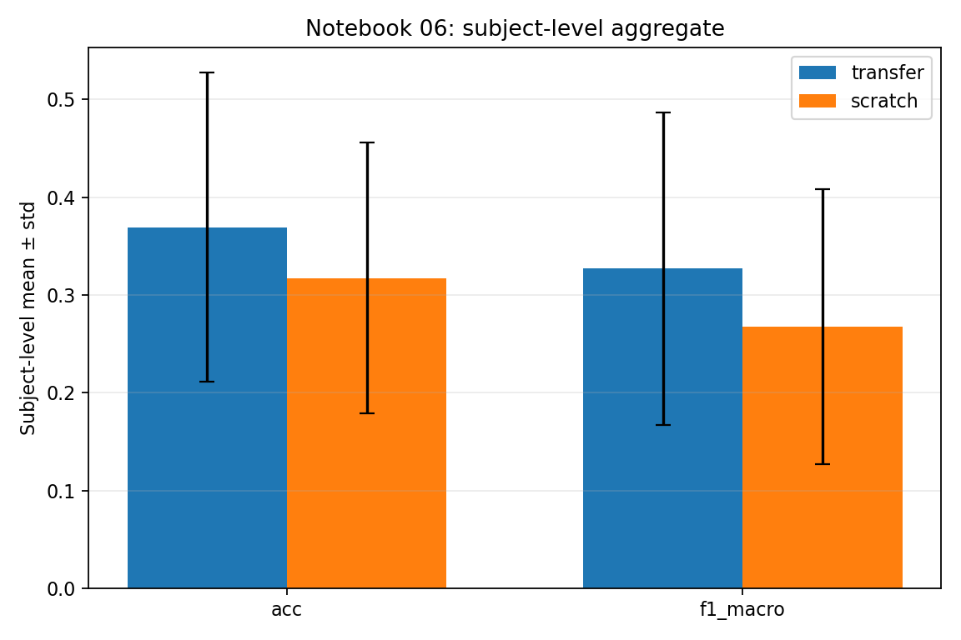
Figure A.11. Subject-level mean ± std of F1 aggregated across all runs.
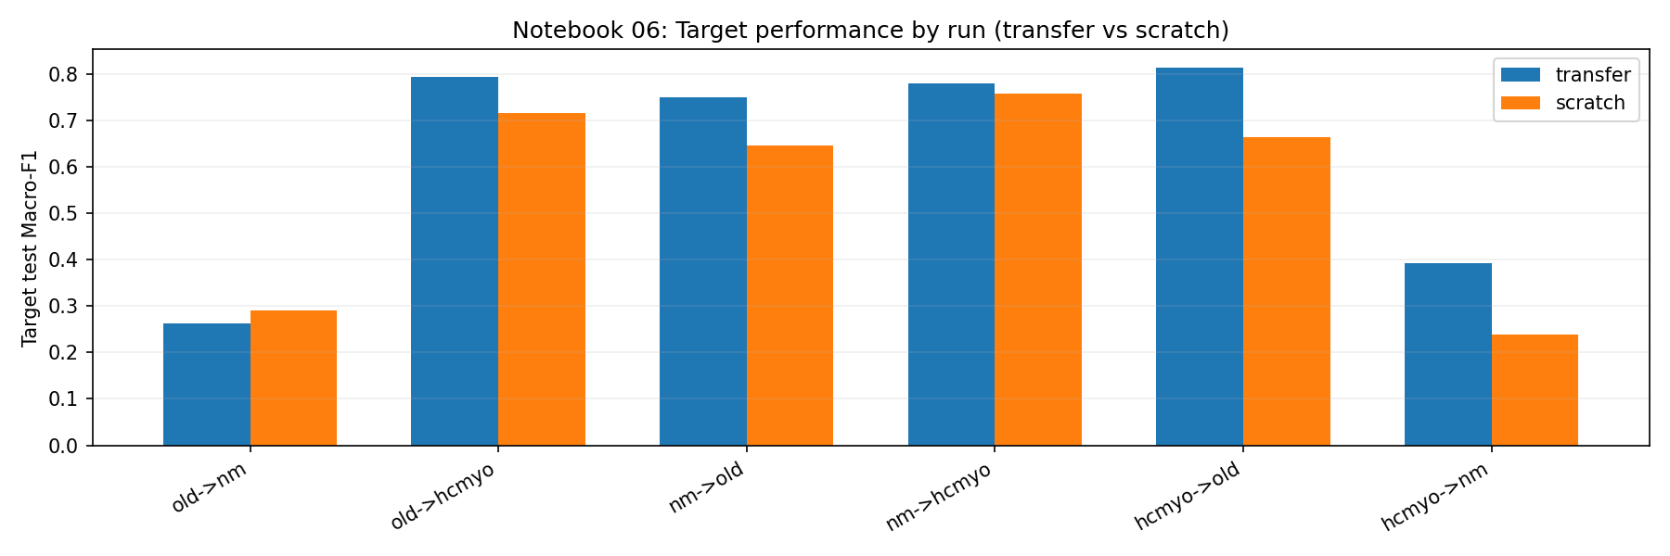
Figure A.12. Target F1 comparison (transfer vs. scratch) broken down per run and per subject.
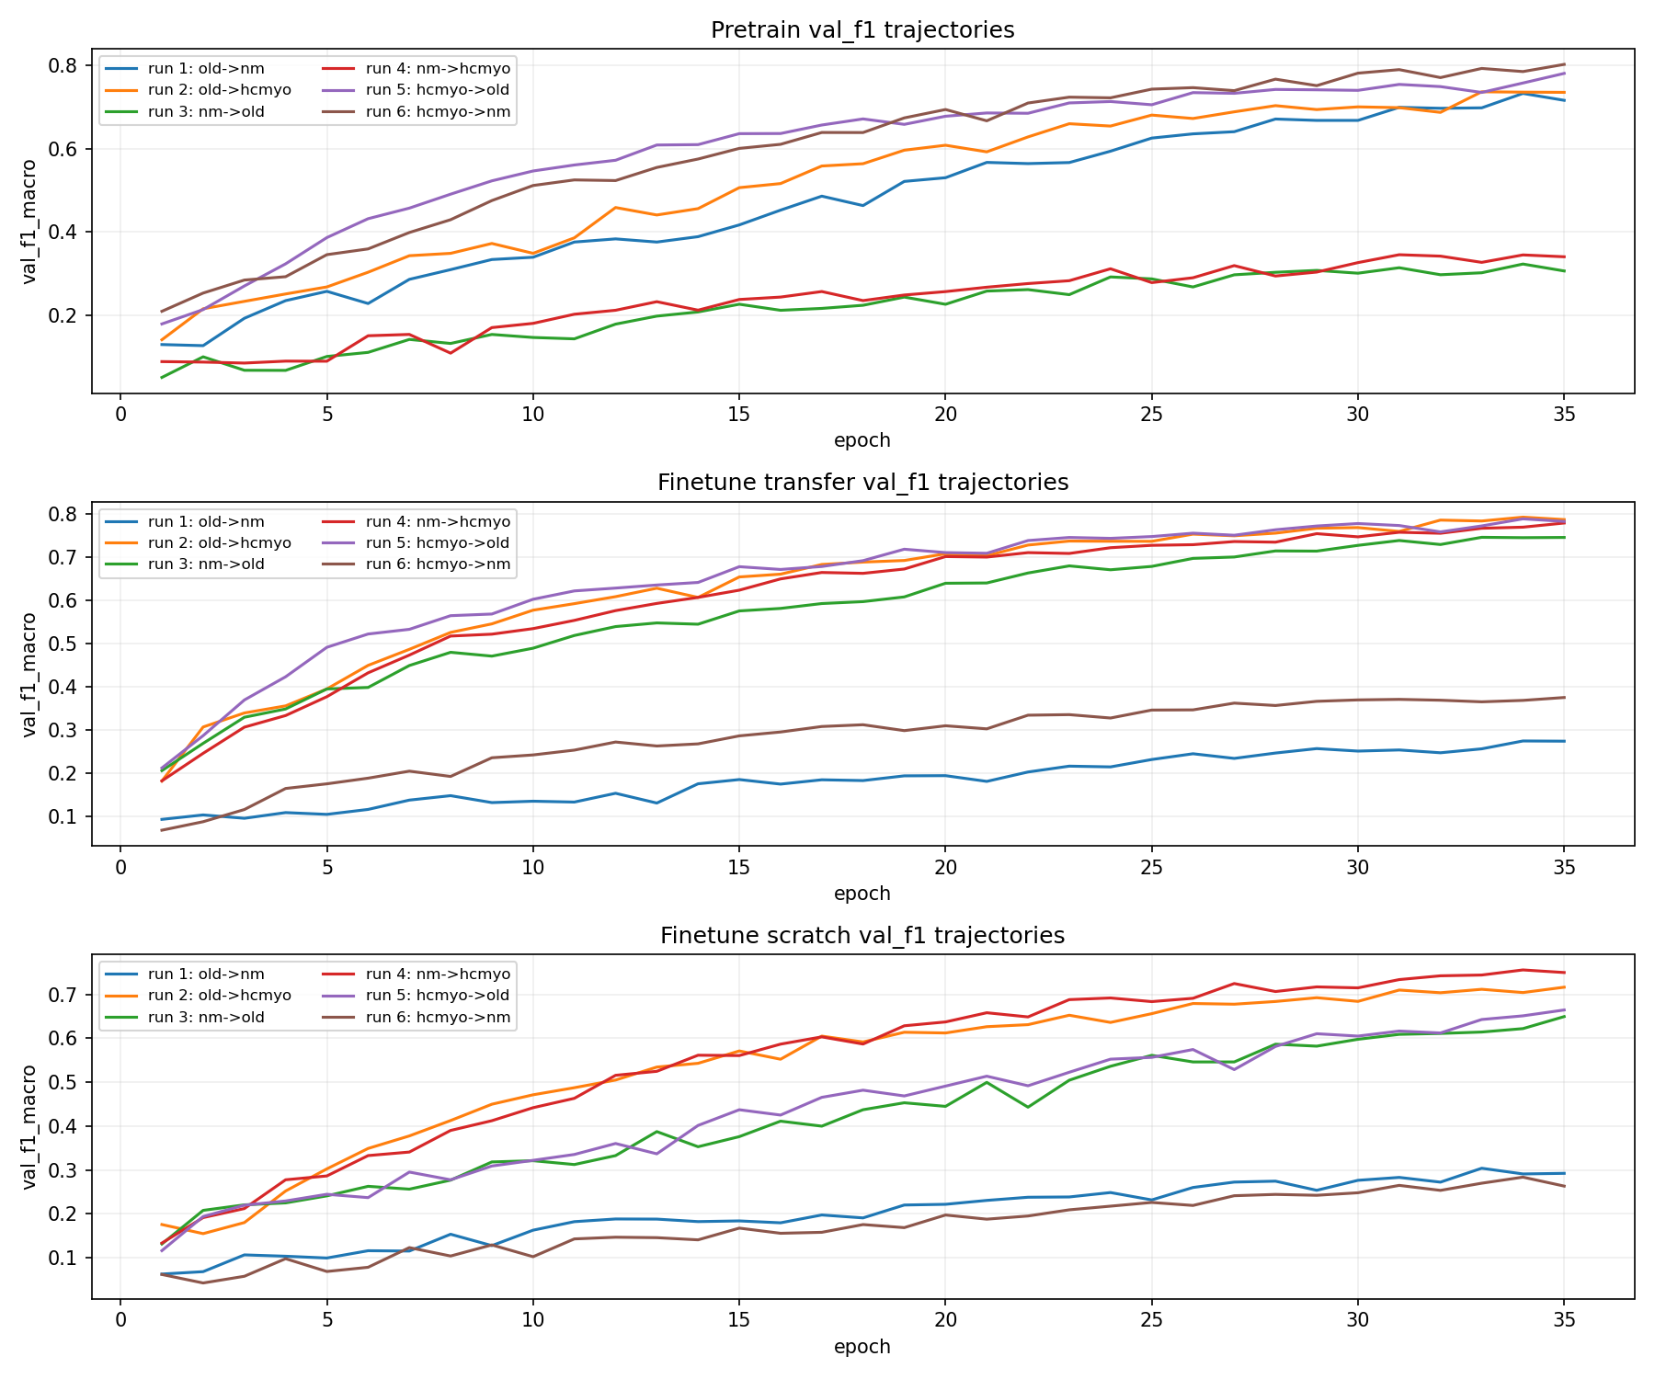
Figure A.13. Training curves — all phases (Stage A pretraining loss and F1).
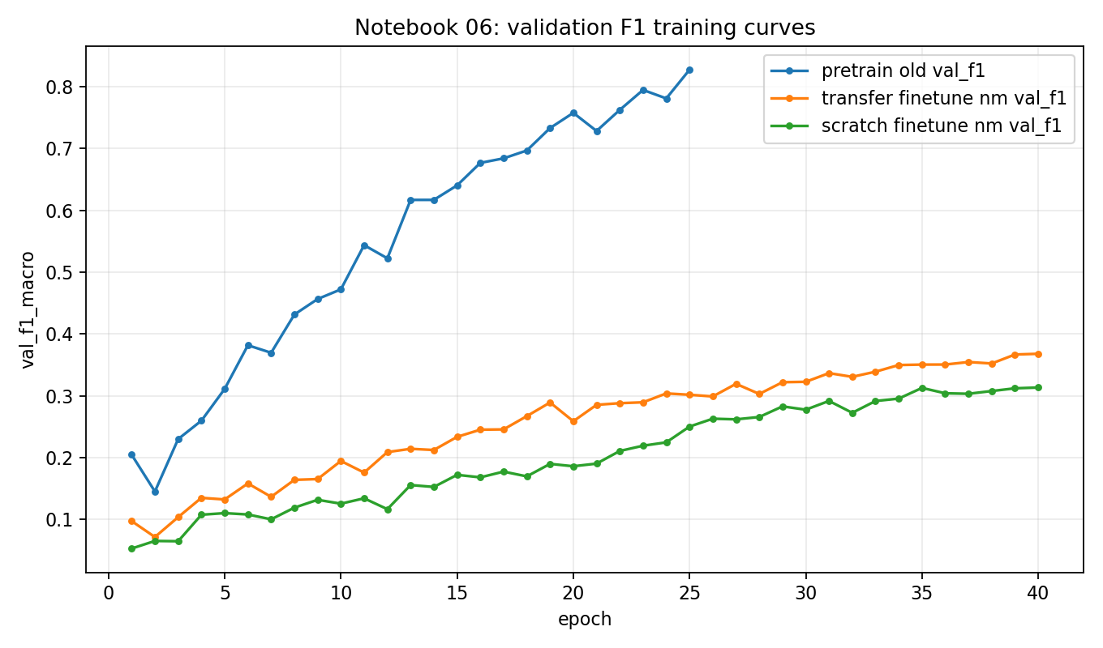
Figure A.14. Training curves — validation F1 over epochs for all runs.
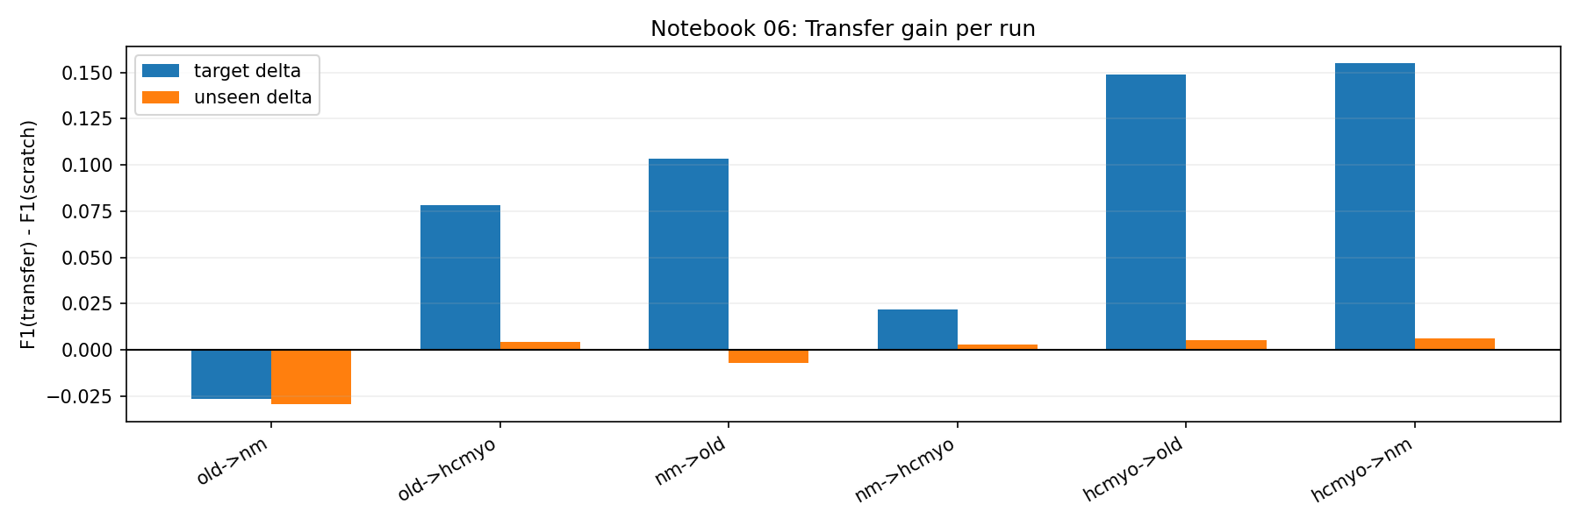
Figure A.15. Transfer gain on target vs. unseen datasets (paired by run).
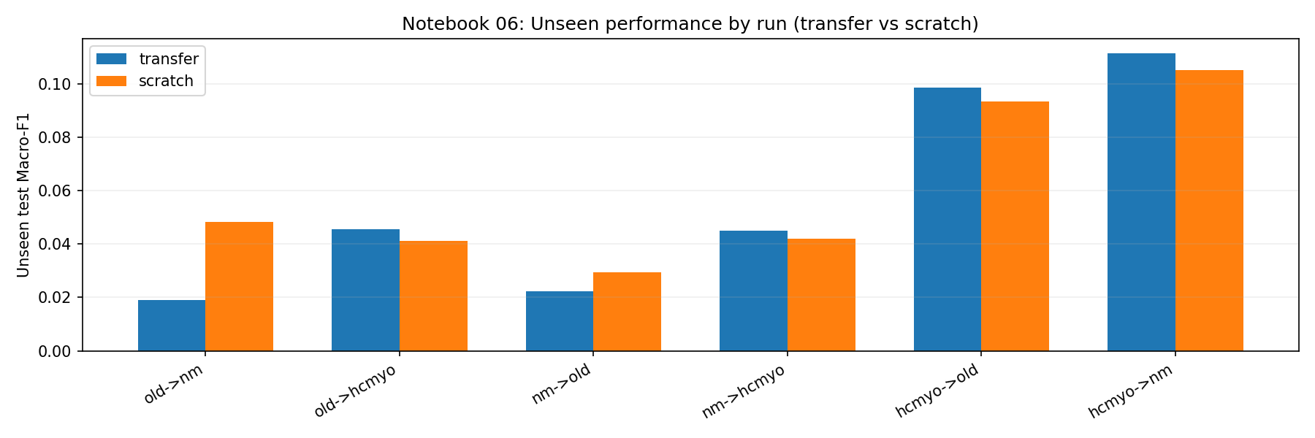
Figure A.16. Unseen F1 comparison (transfer vs. scratch) per run; confirms near-chance performance regardless of source.

A.2 Experiment 07 — NM Session-Aware Subject Adaptation
Figures A.17–A.22.
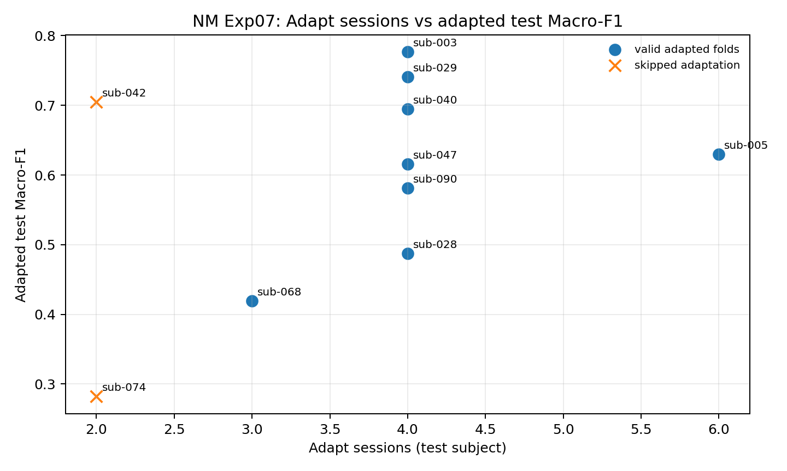
Figure A.17. Number of adaptation sessions available vs. adapted test F1 per fold.
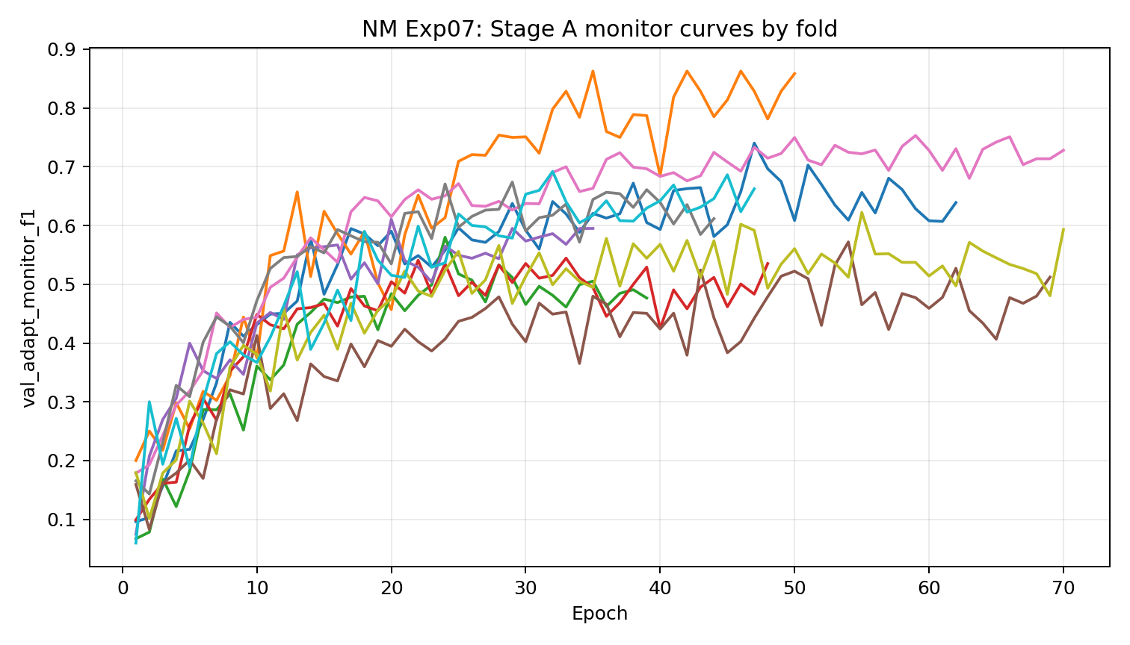
Figure A.18. Figure A.18. Stage A monitor curves (val_adapt_monitor_f1) used for early stopping in Stage A checkpoint selection; Stage B adaptation runs with a fixed number of episodes.

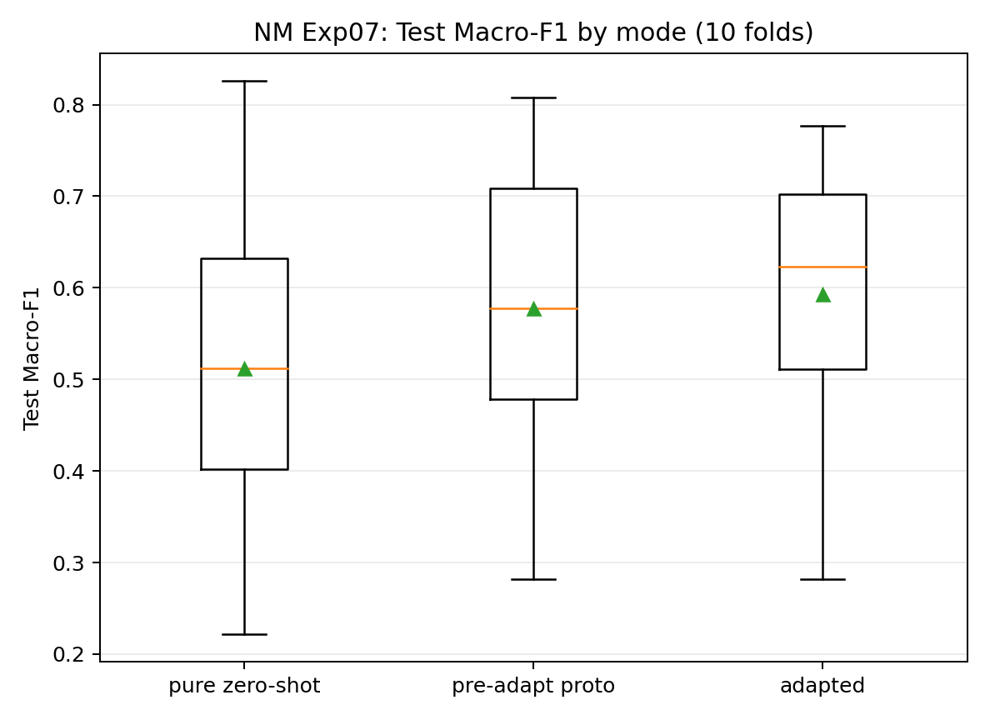
Figure A.19. Boxplot of test F1 across pure zero-shot, pre-adapt proto, and adapted evaluation modes.
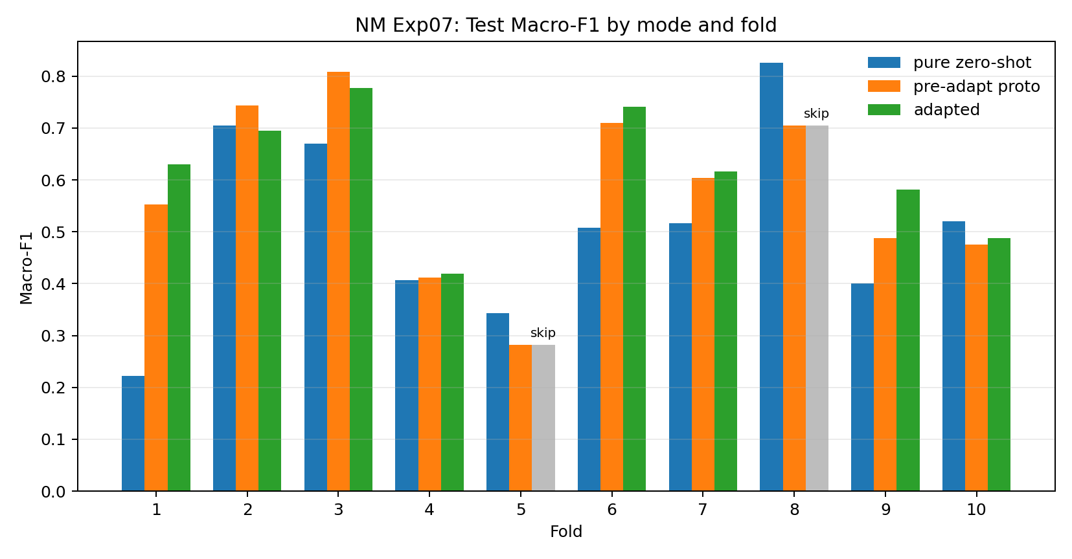
Figure A.20. Test F1 by evaluation mode for each fold (10 folds total). Folds 5 and 8 are skipped (q_query<2); valid adapted folds include both gains and mild regressions.
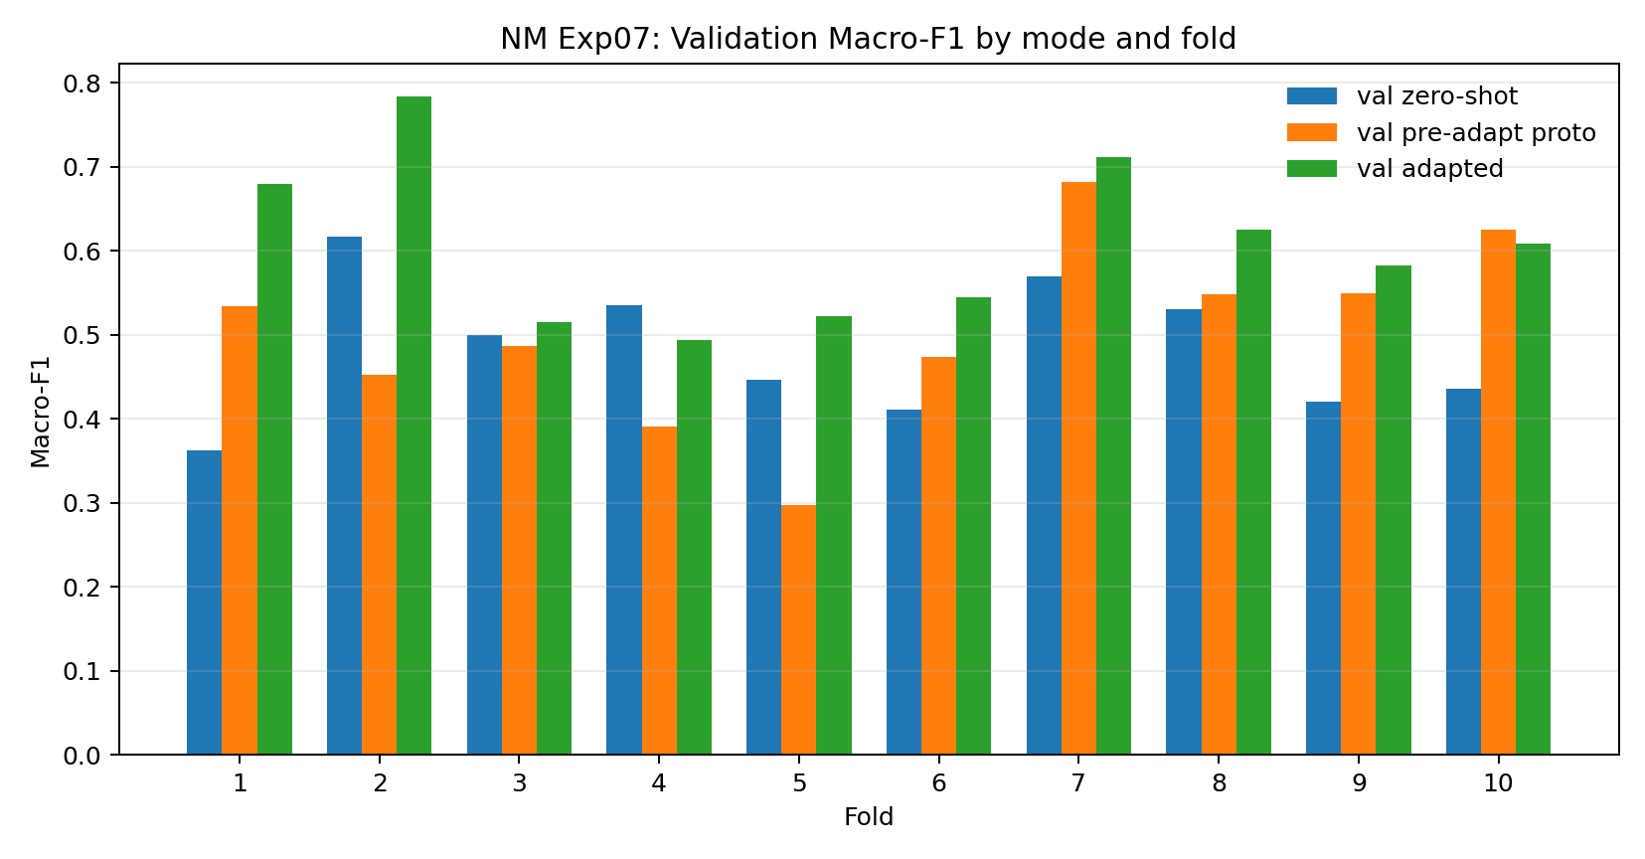
Figure A.21. Validation F1 by evaluation mode for each fold.
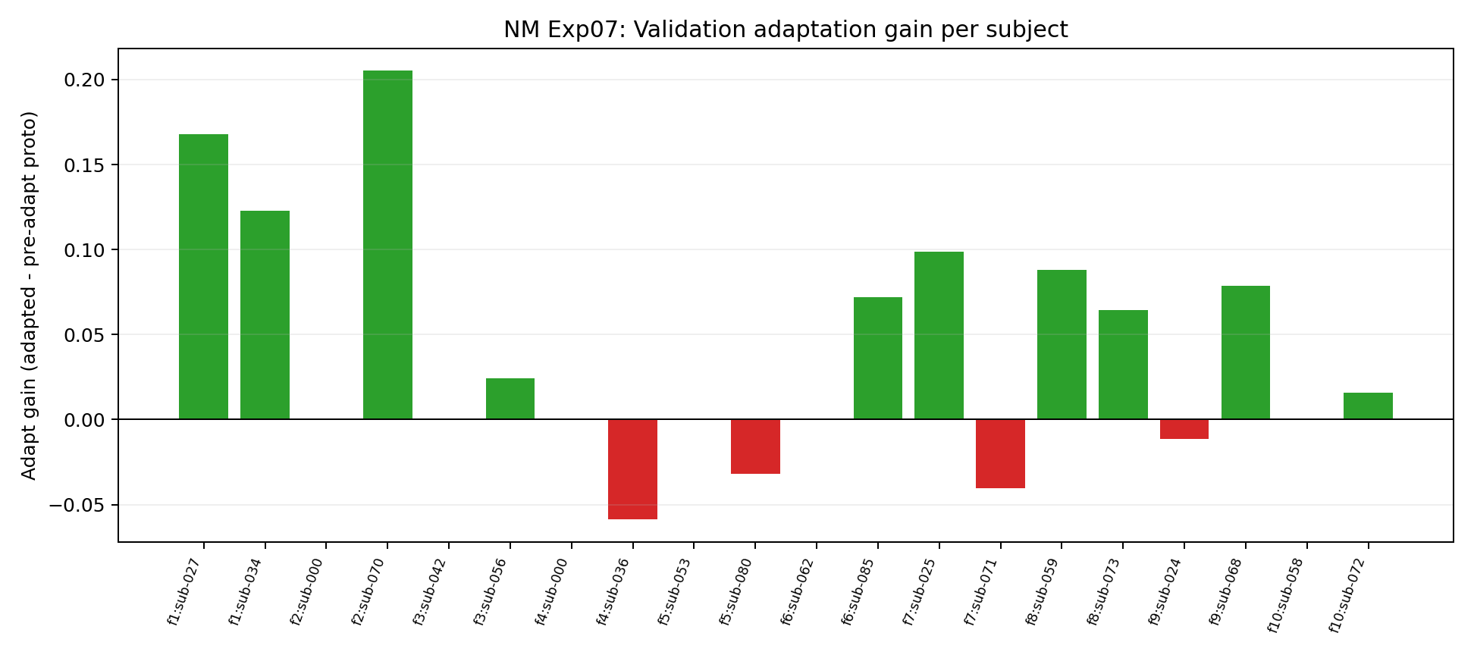
Figure A.22. Per-subject validation adaptation gain (adapted − pre-adapt proto).

A.3 Experiment 08 — HCMYO-A Low-Budget Target Adaptation
Figures A.23–A.28.
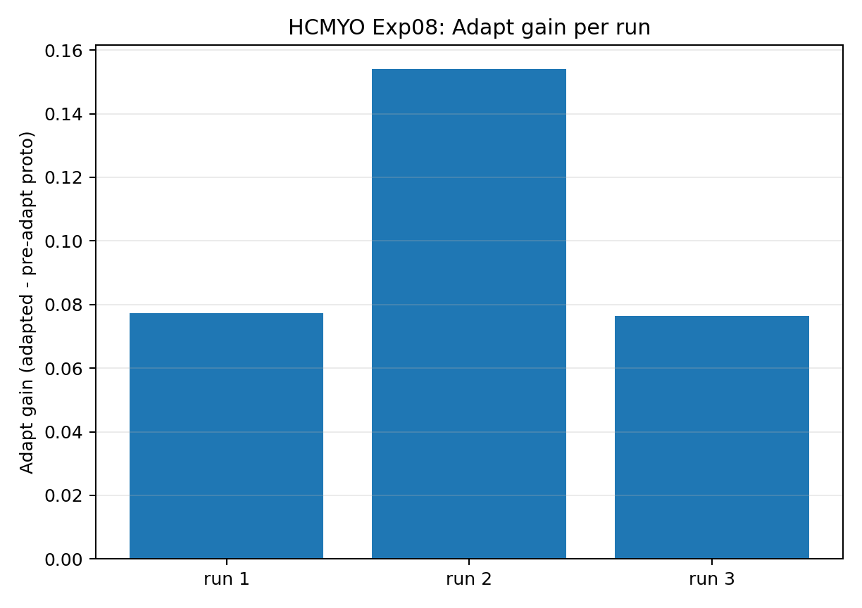
Figure A.23. Adaptation gain (adapted − pre-adapt proto) per run for the low-budget HCMYO-A setup.
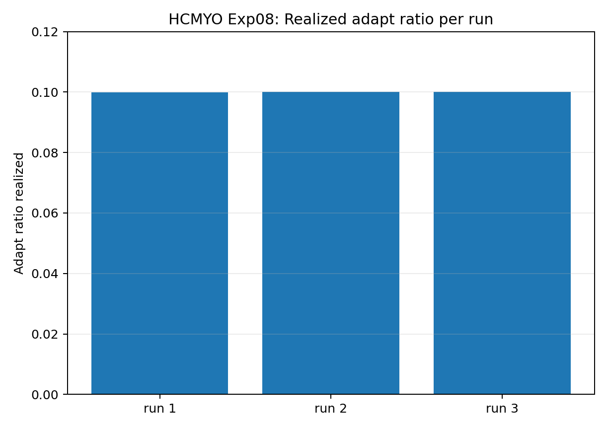
Figure A.24. Realized adapt sample ratio: fraction of the 10% budget actually used per run.
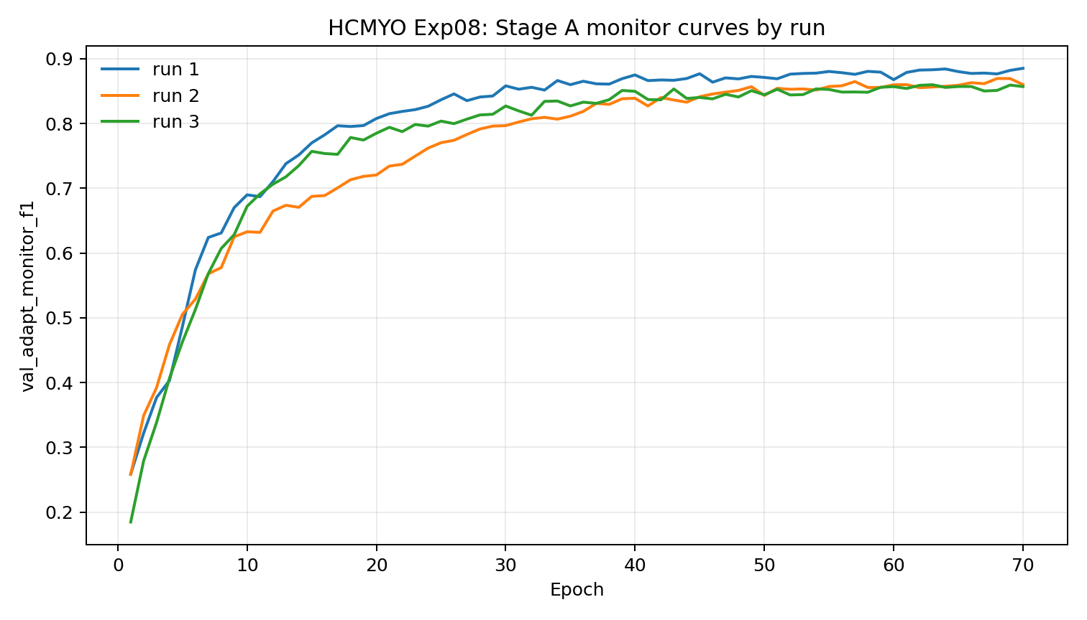
Figure A.25. Stage A monitor curves for the low-budget adaptation setup (all three runs).
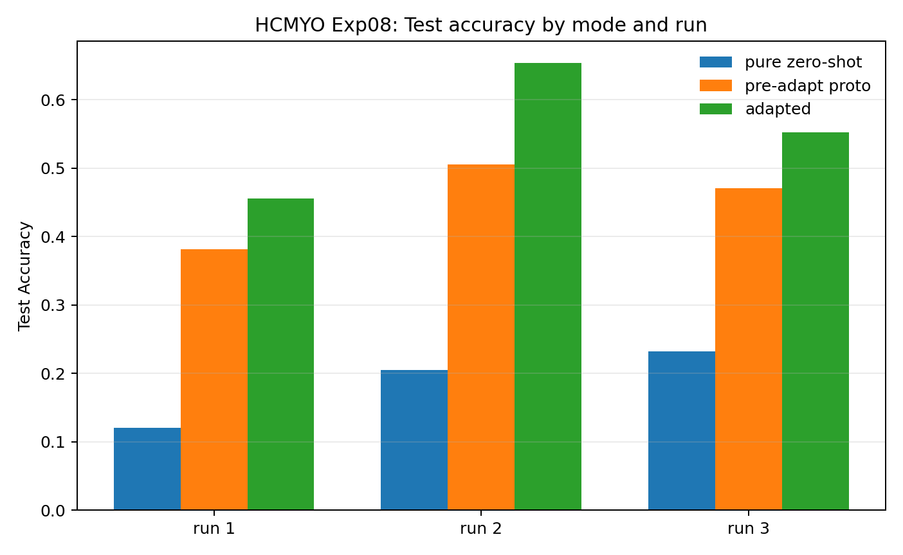
Figure A.26. Test accuracy by evaluation mode for each run.
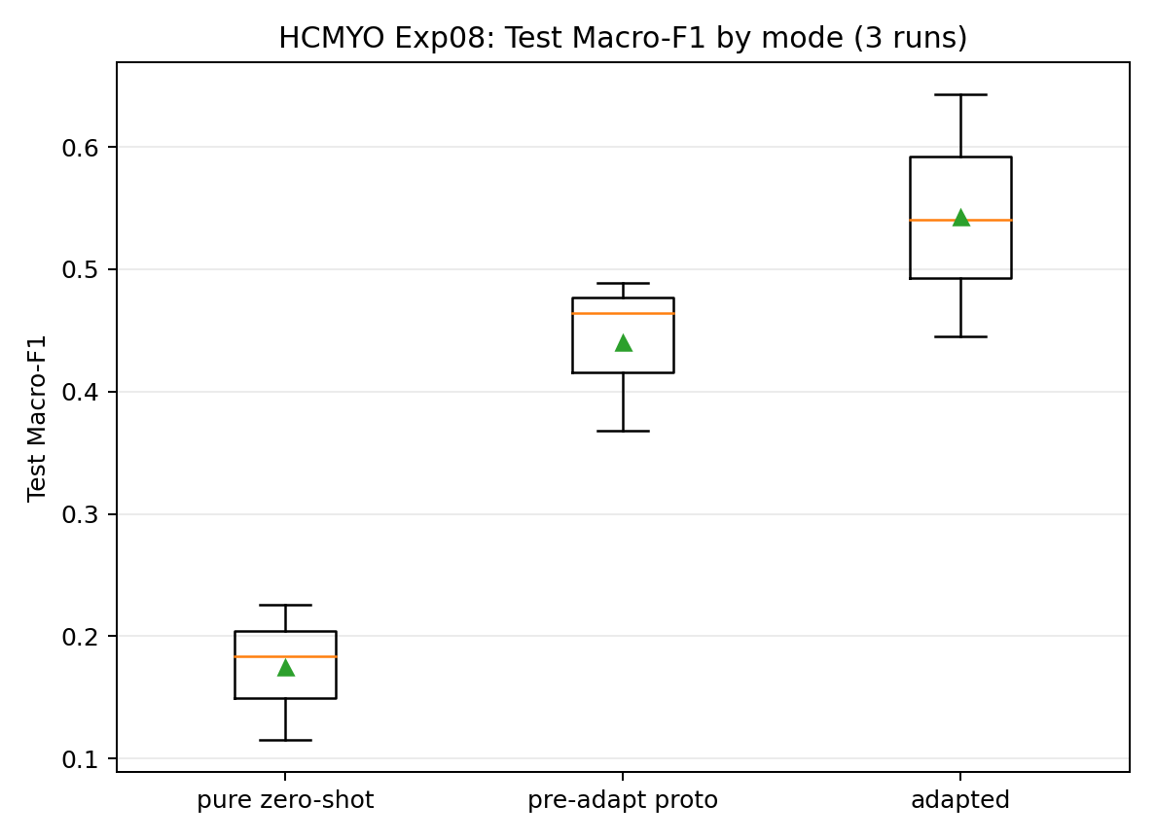
Figure A.27. Boxplot of test F1 across pure zero-shot, pre-adapt proto, and adapted modes.
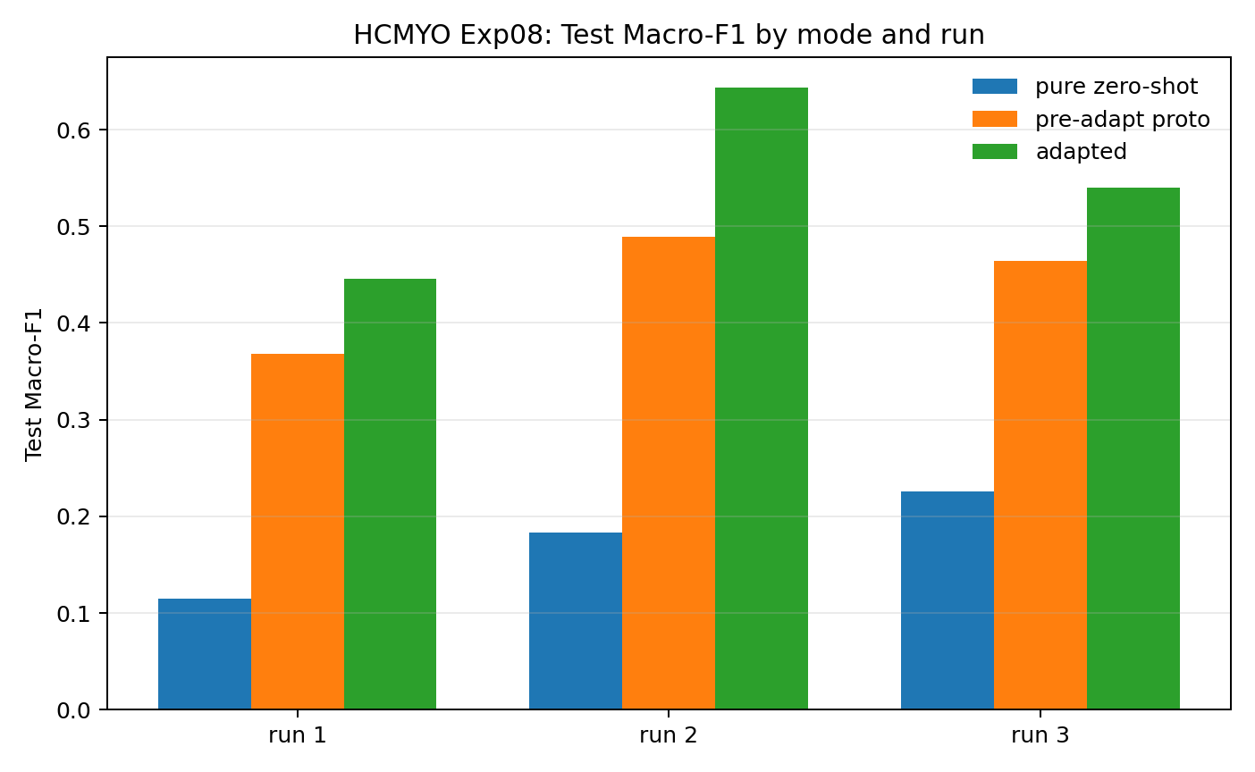
Figure A.28. Test F1 by evaluation mode for each run. Run 1 (S01) shows partial recovery after Stage B.

