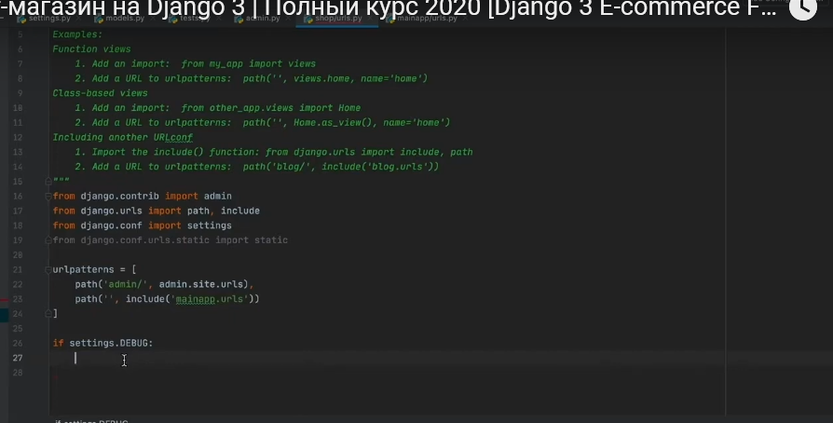

Degub rejimida ekanligimizda local content dan foydalanamiz. Debug rejimi o’chiq holdaligida esa static fayllarimiz serverlarda turishi kerak

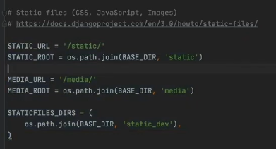

Media va static fayllar uchun path

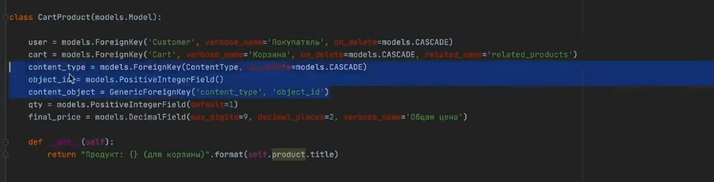

Bir nechta foreign keylardan foydalanmaslik uchun qilindi. Content_type

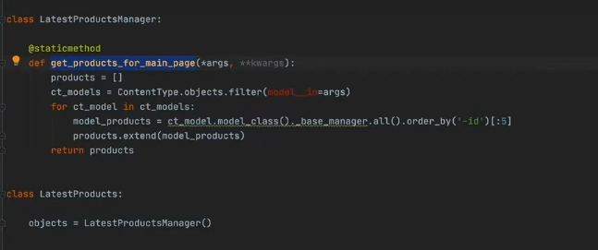

Model ko’pligida, get_products_for_main_page methodidan foydalanib har qanday modeldagi objectlarni olsa bo’ladi

03.10.2021

Pilow bu image lar bilan ishlashga mosalashgan package

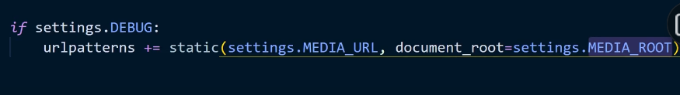

MEDIA_URL image larni topish uchun

MEDIA_ROOT fayllarni to’g’ri joyga saqlash uchun

<https://django.fun/docs/django/ru/3.2/topics/db/queries/#field-lookups-intro> poisk po polyam

timezone ni edit qilish esdan chiqmasin





Yuqorida path ni ichidagi int question_id bilan view ni ichida detail ni ichidagi question_id bir narsa. Django avtomatik tarzda url degi question_id ni detail function ni ichiga berib yuboradi

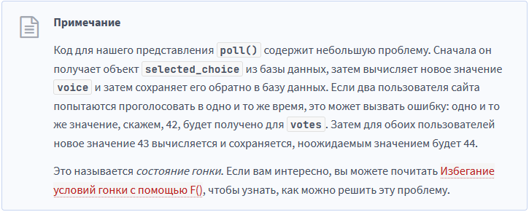

<https://django.fun/docs/django/ru/3.2/ref/models/expressions/#avoiding-race-conditions-using-f>

<https://django.fun/docs/django/ru/3.2/topics/class-based-views/> view lar class orqali

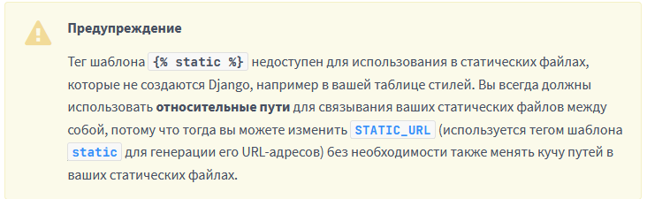

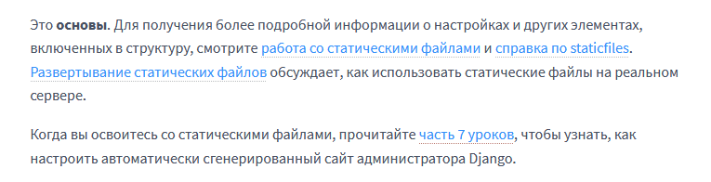

<https://django.fun/docs/django/ru/3.2/howto/static-files/>

<https://django.fun/docs/django/ru/3.2/ref/contrib/staticfiles/>

<https://django.fun/docs/django/ru/3.2/howto/static-files/deployment/>

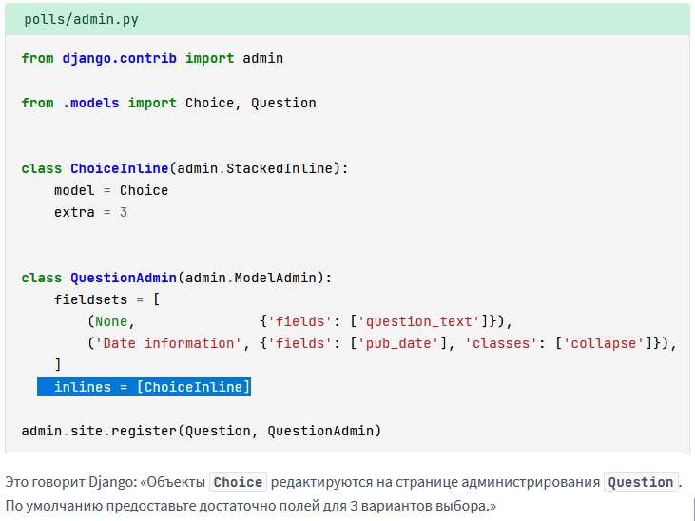

Srazu choice ni ham qo’shib ketadigan qilindi

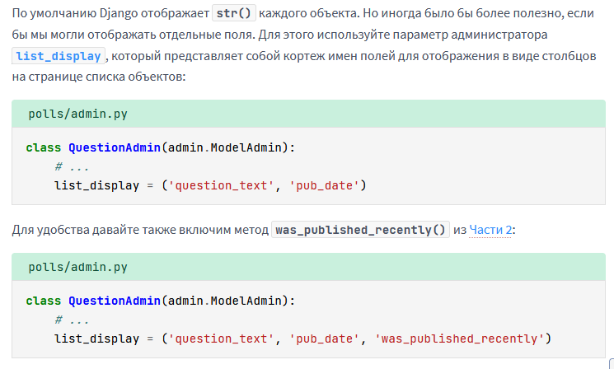

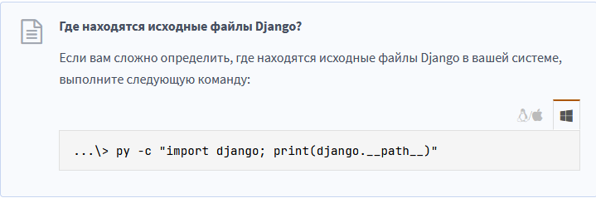

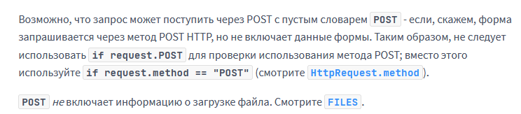

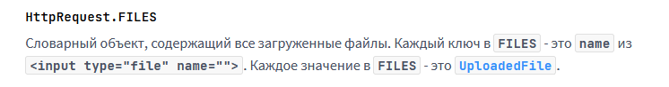

Htttp request files

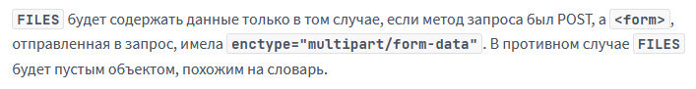

Formalar bilan ishlash

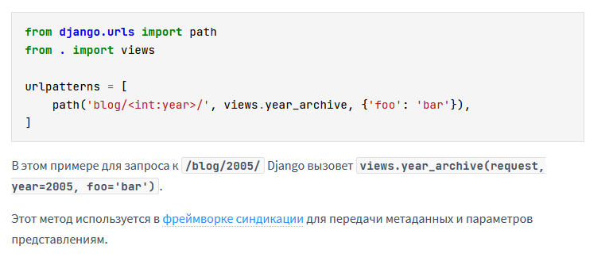

Url ga path berganda path ni ichida uchinchi majburoy bo’lmagan argumentni dictionary ko’rinishida berish mumkin. SHunda view chaqirilganda ishlaydigan functionga dict.key nomi bilan dict.value o’zgaruvchisi ham functionga berib yuboriladi

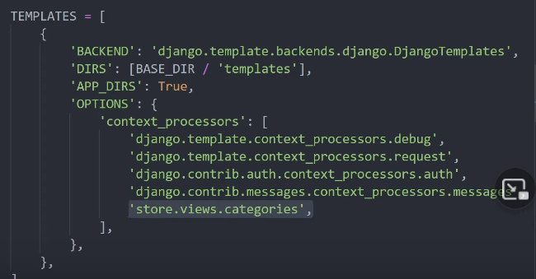

Templates settings ga view degi function ni qo’shish orqali ushbu function return qilgan ma’lumot hamma templatelarda ishlaydi.

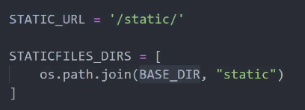

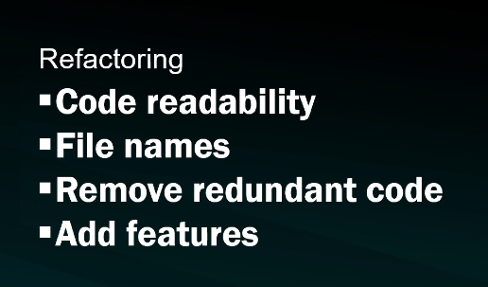

Refactoring steps

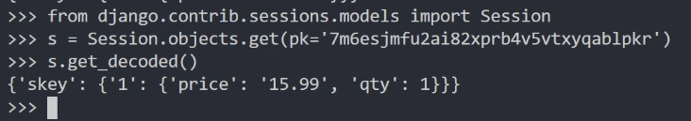

Seesions python manage.py shell

Yangilari

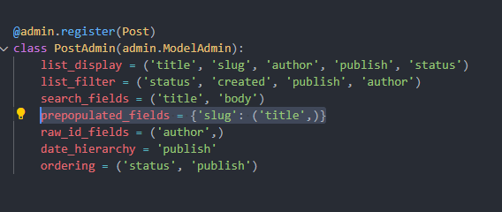

Slugni ni avtomatik tarzda title dan oladi

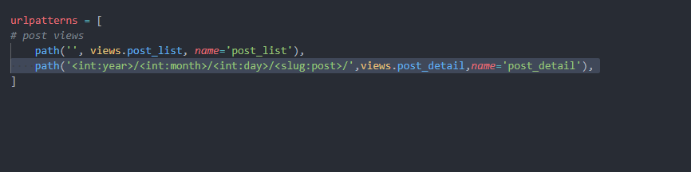

< > ni ichidegilar path converters deyiladi, “~~documentationdan qidirish uchun”~~

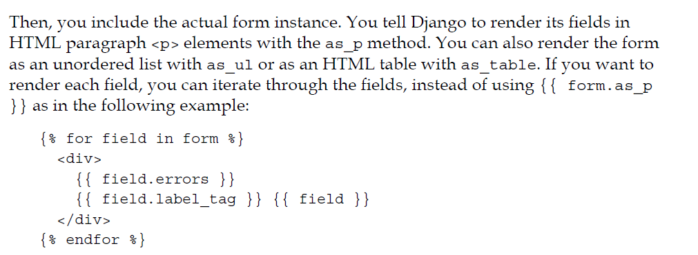

Custom form

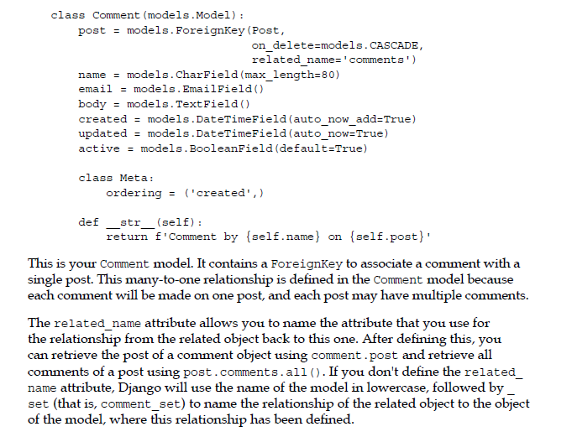

Related name definition

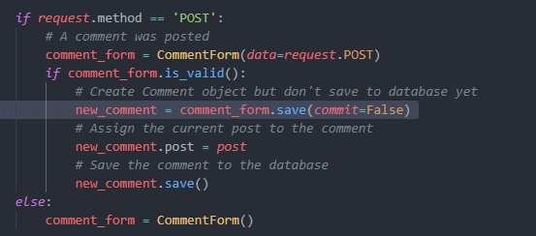

Objectni database ga saqlashdan oldin o’zgartirish kiritish kerak bo’lsa save(commit=False) dan foydalanamiz. Save() method faqatdina ModelForm uchun ishlatsa bo’ladi