Test example

Input data:

The decision of equalization of f(x) is close=0 by the method of Hord

For the function of kind:
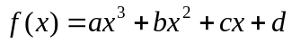

a= 2,1130
b= -6,4400
c= -3,1900
d= 15,1300

Left of limit of segment:
Left= 2,3
Right of limit of segment:
Right= 2,7
Initial of approaching: 2,3

Exactness of of calculation:0,00001

Calculation in Mathcad:
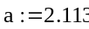
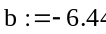
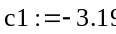
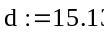
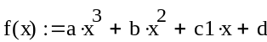
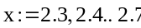
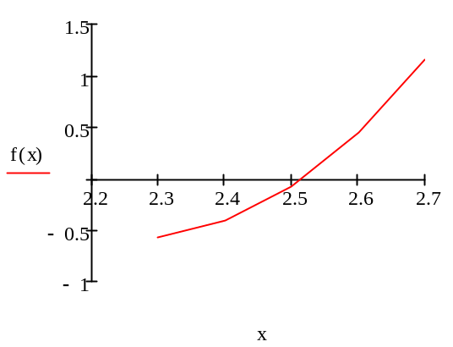
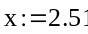
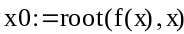
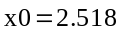

Program result:

Value of root: 2,5166

