Test example

Input data:

The decision of equalization of f(x) is close =0 by the method of bisection

Equation : tg (a*x) – bx = 0

a=0.9464
b=1.3825

Left of limit of segment:
Left= 0,5
Right of limit of segment:
Right= 1,5
Exactness of of calculation:0,00001

Calculation in Mathcad:
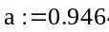
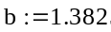
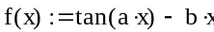
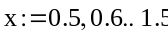
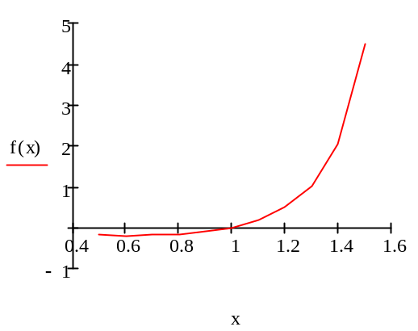
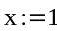
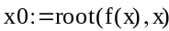
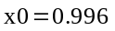

Program result:

Value of of root: 0,9961

