Test example

Input data:

The decision of equalization of f(x) is close=0 by the method of simple iteration.

For the function of kind:
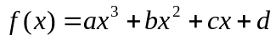

For and will utillize a function a iteration process: c*f(x)+x, choosing the constant of c= 0.1

a= 0,1697
b= -0,5693
c= -1,6000
d= 3,7300

Left limit of segment:
Left= 2
Right limit of segment:
Right= 3
Initial approaching:2
Exactness of calculation:0,000001

Calculation in Mathcad:
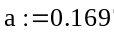
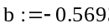
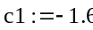
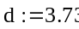
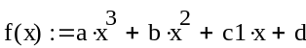
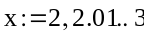
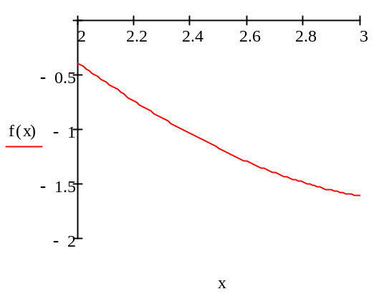
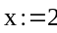
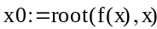
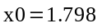

Program result:

Value of root: 1,7976

