Test example
Input data:

Will consider the function of such kind: f(x) = x³-x*y +8 on an interval [0,2],
at f(0)=1, will take the amount of iterations – 20.

Calculation in Mathcad:

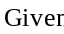
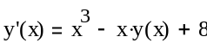
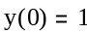
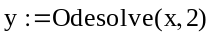
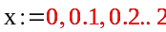

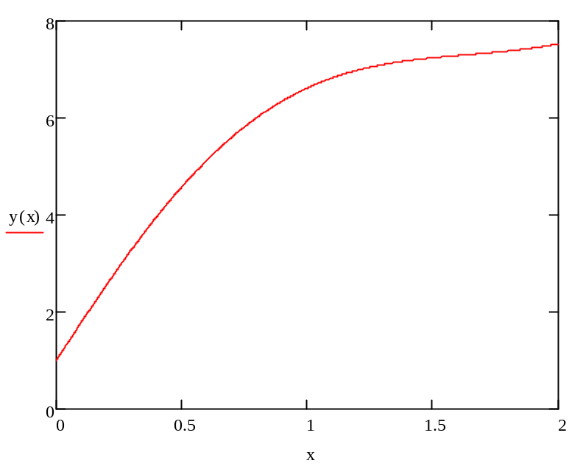

Program result:

h = 0,10
x y
---------------
0,00 1,0000
0,10 1,8000
0,20 2,5821
0,30 3,3313
0,40 4,0340
0,50 4,6791
0,60 5,2576
0,70 5,7638
0,80 6,1946
0,90 6,5502
1,00 6,8336
1,10 7,0502
1,20 7,2078
1,30 7,3157
1,40 7,3843
1,50 7,4249
1,60 7,4487
1,70 7,4665
1,80 7,4885
1,90 7,5238
2,00 7,5802

