Test example

Input data:

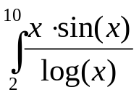

Calculation in Mathcad:

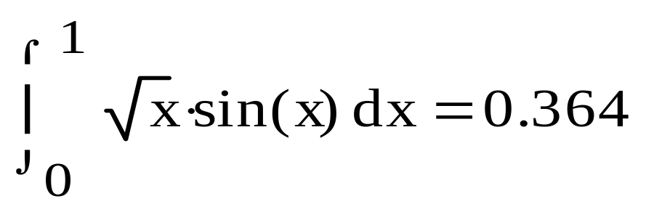

Program result:

Method Chebishev
h = 0,25 integral = 0,6030
h = 0,20 integral = 0,5509
h = 0,10 integral = 0,4531
h = 0,05 integral = 0,3642
h = 0,03 integral = 0,3928

