Test example

Input data:

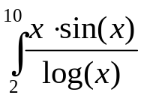

Calculation in Mathcad:

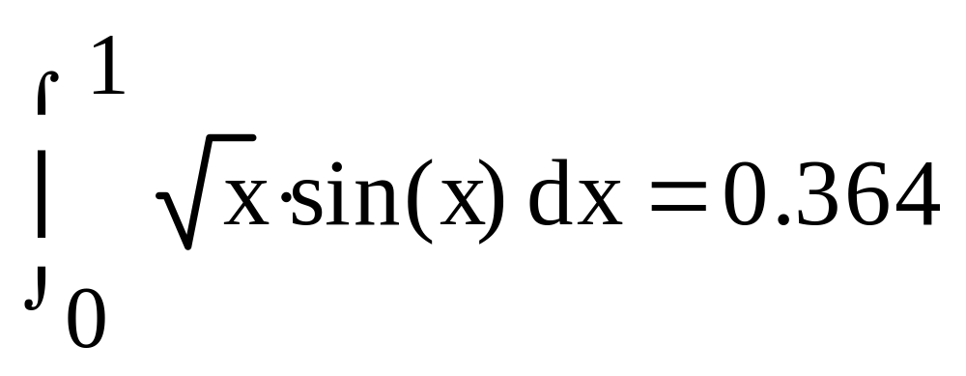

Program result:

Method Simpson
h = 0,0150 integral = 0,3684
h = 0,0160 integral = 0,3709
h = 0,0170 integral = 0,3667
h = 0,0180 integral = 0,3659
h = 0,0190 integral = 0,3648

