Test example

Input data:

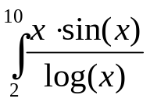

Calculation in Mathcad:

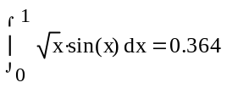

Program result:

Method Trapezium
Value of integral:

h = 0,25 integral = 0,3684
h = 0,20 integral = 0,3670
h = 0,10 integral = 0,4491
h = 0,05 integral = 0,3644
h = 0,03 integral = 0,3924

