Test example

Input data:

4.1*x1 + 0.1*x2 + 0.2*x3 + 0.2*x4 = 21.14

0.3*x1 + 5.3*x2 + 0.9*x3 -0.1*x4= -17.82

0.2*x1 + 0.3*x2 + 3.2*x3 + 0.2*x4= 9.02

0.1*x1 + 0.1*x2 + 0.2*x3 - 9.1*x4= 17.08

Calculation in Mathcad:

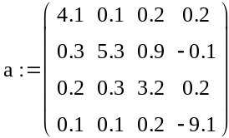
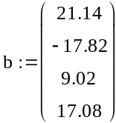
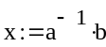
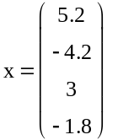

Program result:

Number of Iterations: 5

Solution found.

X1= 5,2
X2= -4,2
X3= 3
X4= -1,8

