Test example

Input data:

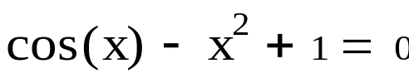

Calculation in Mathcad:
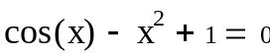
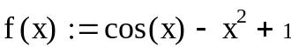
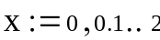
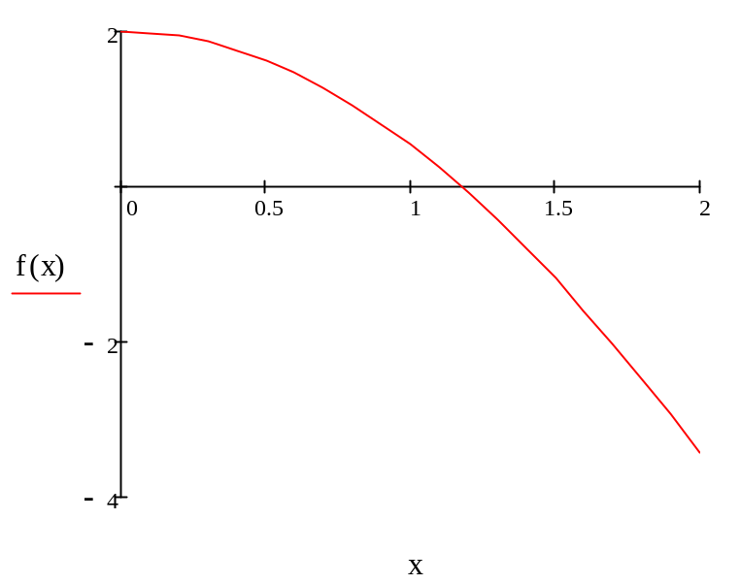
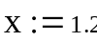
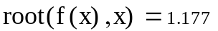

Program result:

Method half-note division

1,1770 => iterate 11

1,1768 => iterate 10

6,0000 => iterate 10

