Test example

Input data:

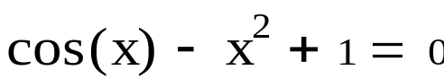

Calculation in Mathcad:
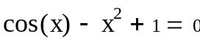
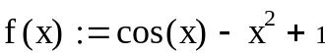
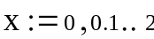
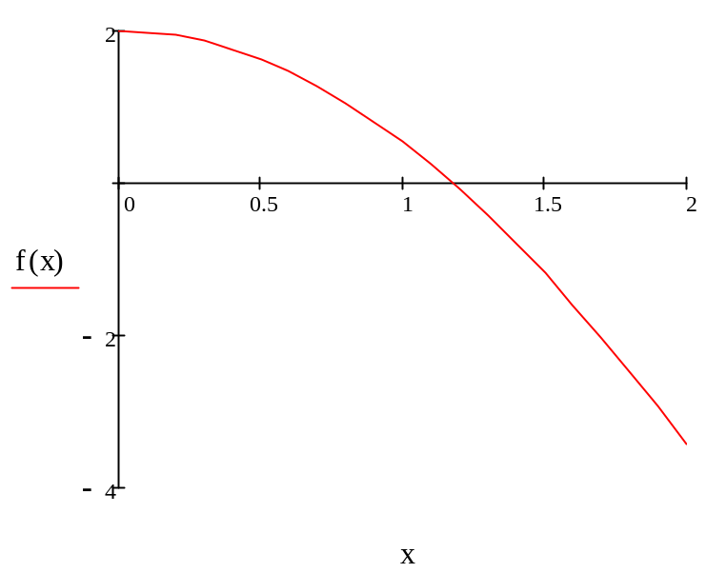
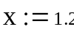
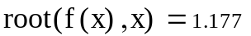

Program result:

Method Hord

RESULT:

x = 1,1680 iterations = 2

