Test example

Input data:

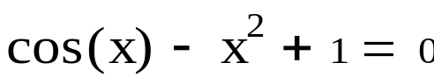

Calculation in Mathcad:
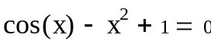
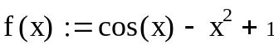
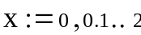
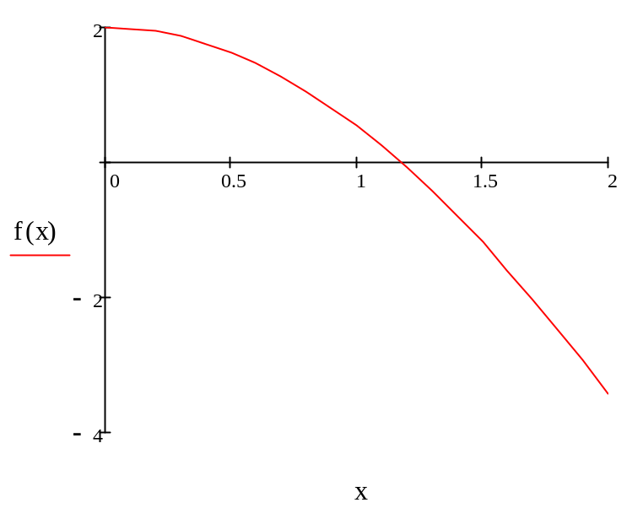
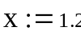
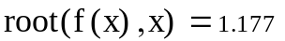

Program result:

Method Newton

0,9436 => iterate 1

1,1188 => iterate 1

1,9941 => iterate 3

