Test example

Input data:
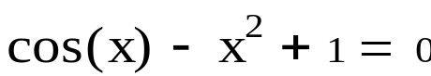

Calculation in Mathcad:
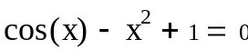
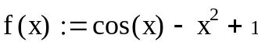
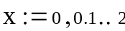
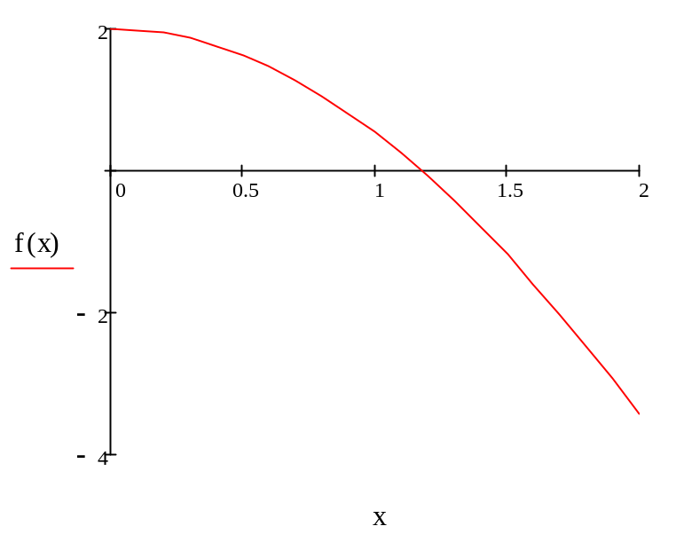
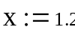
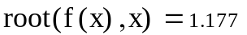

Program result:

Method Secant

x= 1,1768

