**Binary Tree Test Documentation**

|  |  |  |  |  |
| --- | --- | --- | --- | --- |
|  | Component | Expected Result | Actual Result | Comment |
| 1 | Fill Array | This button fills the tree with 10 nodes and displays them in listbox. | As expected. Tree is created and displayed. | Figure 1 |
| 2 | Insert | This button inserts integer from the text box next to this button into the binary tree. | As expected. Number was successfully inserted to the listbox. | Figure 2 |
| 3 | Remove | This button removes integer from the text box next to this button from the binary tree. | As expected. Number was successfully deleted. | Figure 3 |
| 4 | Find | This button reads input from the text box next to it and response in the window below weather number is found or not. | As expected. The button reads input from the text box next to it and response in the window below whether number is found or not. | Figure 4 |
| 5 | Find Min  Find Max  Root | This button finds the minimum/maximum or root value from the tree and populates that in the text box next to it. | As expected. This button finds the minimum/maximum or root value from the tree and populates that in the text box next to it. | Figure 5 |
| 6 | Is Empty? | This button check whether the tree is empty or not and populates the answer in status bar at the bottom of the program. | As expected. This button check whether the tree is empty or not and populates the answer in status bar at the bottom of the program. | Figure 6 |
| 7 | Make Empty | This button makes tree empty and populates the result in status bar at the bottom of the program. | As expected. This button makes tree empty and populates the result in status bar at the bottom of the program. | Figure 7 |
| 8 | Remove Min | This button removes the smallest int from the tree and displays the result in the list box | As expected. This button removes the smallest int from the tree. | Figure 8 |

# Test Table

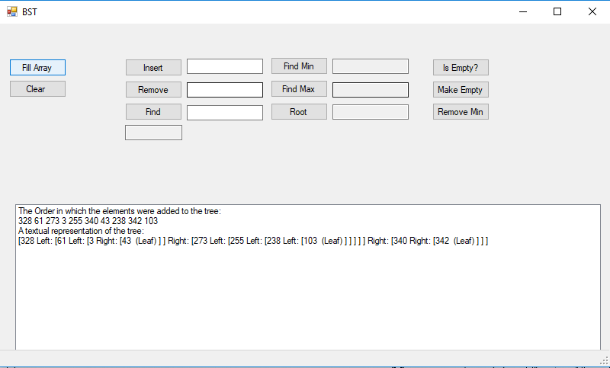

Figure 1

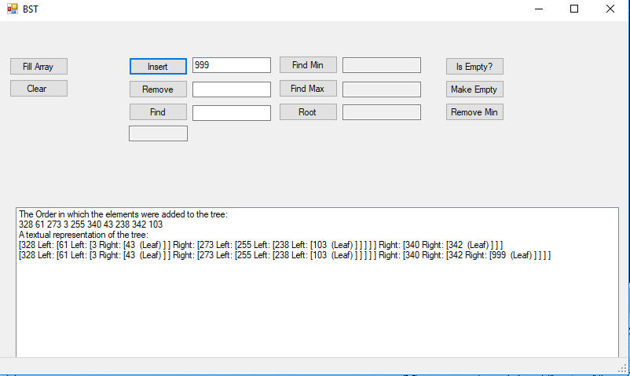

Figure 2

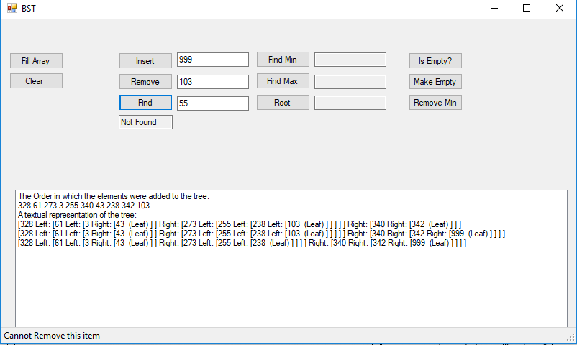

Figure 3

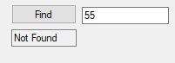

Figure 4

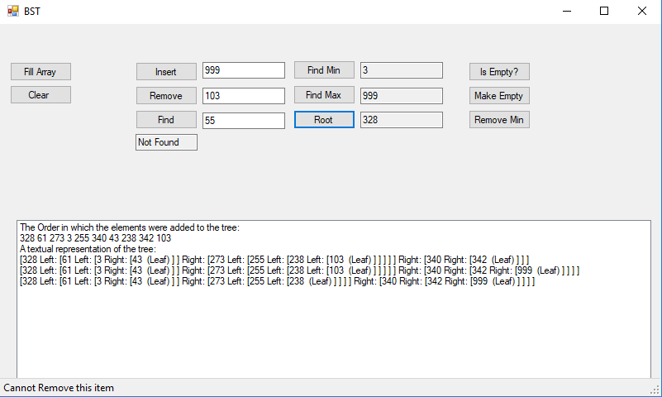

Figure 5

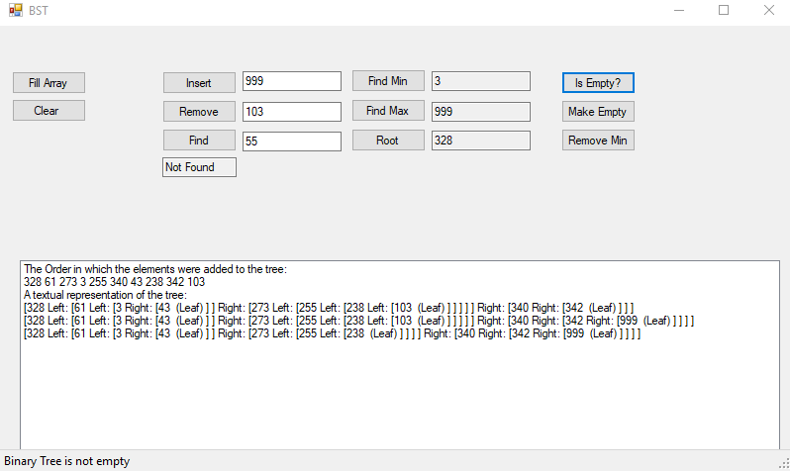

Figure 6

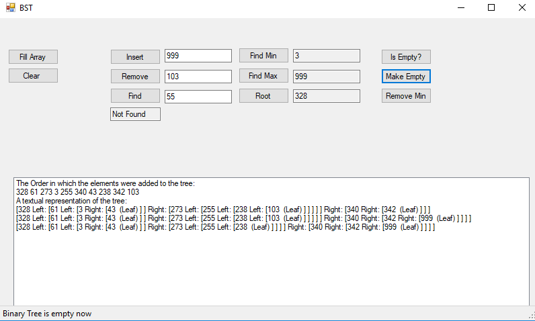

Figure 7

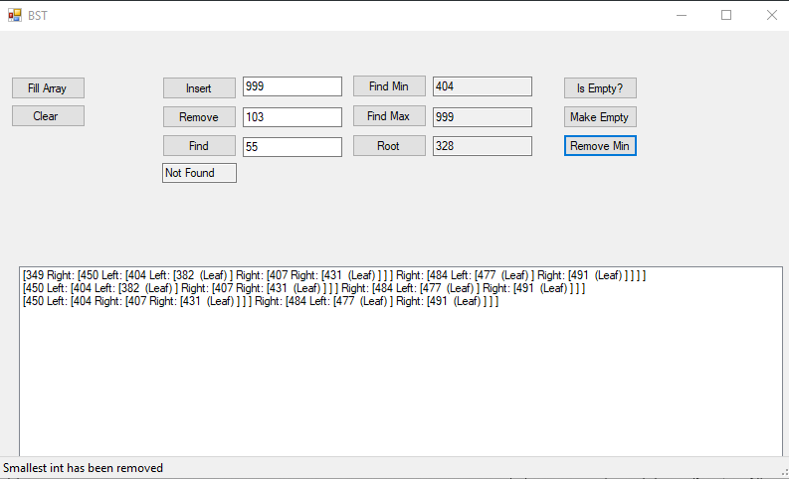

Figure 8