News Media Monitoring Pipeline — Extraction Sample
Normal layout · includes text, tables with/without borders, and images
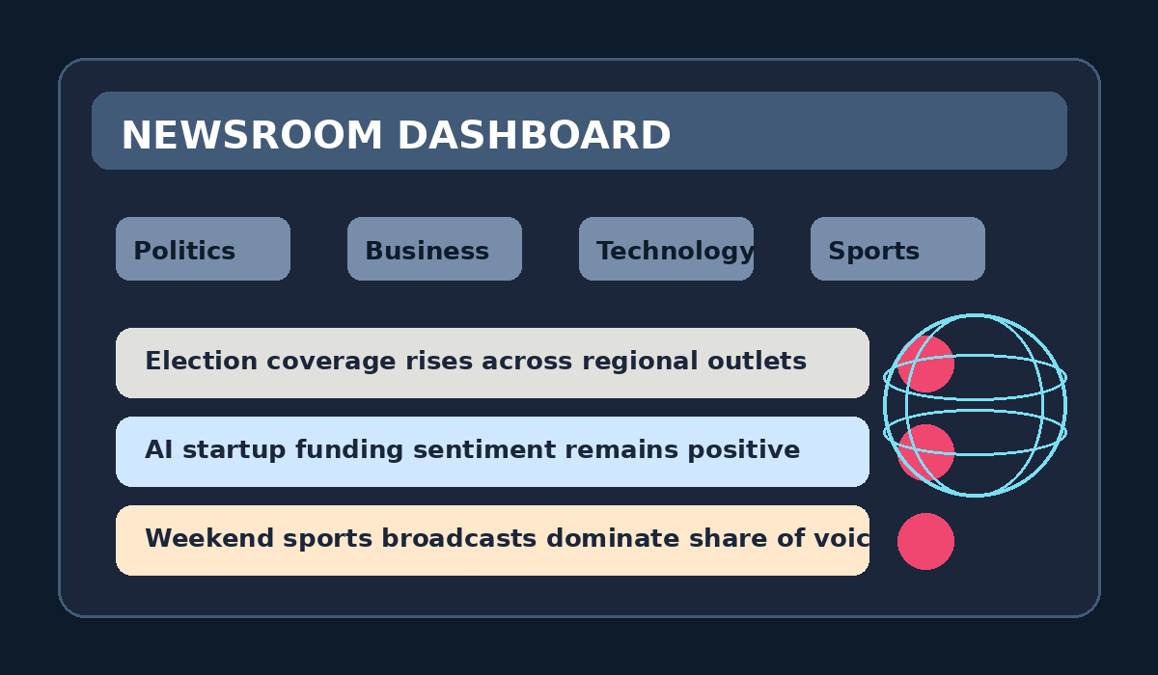
The News Media Monitoring Pipeline collects article metadata, summaries, and engagement signals from online outlets. This sample document is designed for document extraction tests and intentionally includes paragraphs, bordered tables, borderless tables, and several images.
During the latest monitoring window, editors tracked rising coverage of elections, AI investments, and live sports rights. The content below includes special characters such as Ž, č, š, and café so encoding-aware processing can be verified during extraction.
A downstream parser can extract body text with pdfplumber or python-docx, then store the normalized text and metadata in MongoDB together with source path, page number, and extraction timestamp.
Table with borders — sample source coverage
Source | Category | Articles | Avg. sentiment
BBC | Politics | 12 | 0.41
Reuters | Business | 10 | 0.63
CNN | Technology | 8 | 0.57
AP | Sports | 6 | 0.49

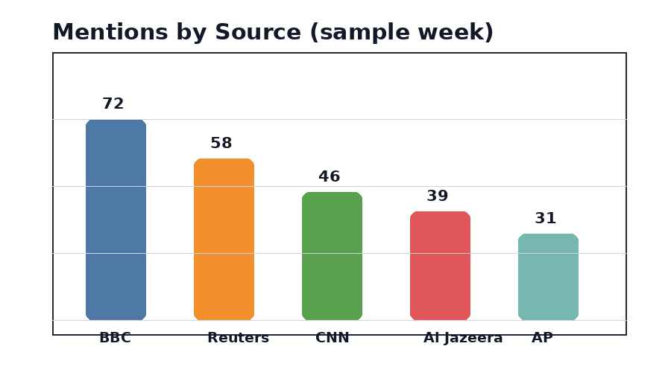
Table without borders — trending keyword snapshot
Month | Trending keyword | Mentions
January | election | 45
February | AI | 52
March | streaming | 61
April | inflation | 56

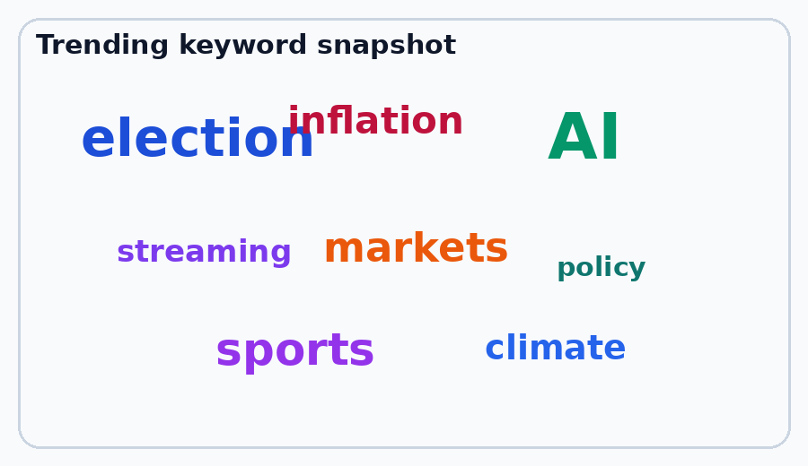
Suggested extraction metadata: file name, document type, source path, extraction timestamp, page number, and extraction library.

