News Monitoring Brief —
Two Column Sample
Two-column layout for extraction testing with pdfplumber crop strategy


This two-column briefing simulates a compact media report distributed to newsroom analysts. It contains short paragraphs and embedded images so you can test whether column-aware extraction produces readable output. The layout is intentionally narrow and mirrors the kind of print digest often used for morning media reviews.
Coverage this week highlighted policy debates, AI funding optimism, and a surge in weekend sports clips. Regional desks also logged multilingual mentions including Žurnal, São Paulo, München, and café references. These characters are useful for testing whether normalization preserves accented text during extraction.
A common strategy for multi-column PDFs is to split each page into left and right regions, extract both halves separately, normalize whitespace, and concatenate the results in reading order. This avoids jumbled lines when extractors read across the page instead of down the first column.
Analysts can further attach metadata such as source file, page number, extraction date, and processing library so that downstream search or audit tasks remain transparent. Once stored in MongoDB, the document content can be searched alongside article feeds gathered from APIs and scraped websites.
In production, a simple logging trail should capture document name, success state, encoding notes, and any extraction warnings. That makes it easier to compare normal PDFs, two-column PDFs, Word documents, and Excel sheets inside one reproducible pipeline.


Bordered table — source coverage snapshot
Source | Hits
BBC | 12
CNN | 8
AP | 6
Reuters | 10

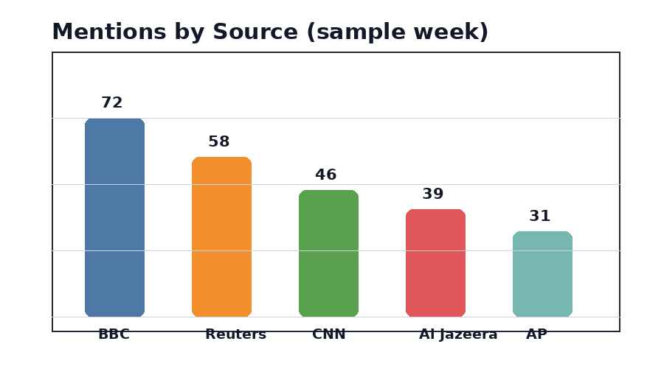
Borderless table — trending keyword snapshot
Keyword | Count
election | 18
markets | 21
AI | 26
sports | 16

Store extracted text with metadata such as file name, page number, source path, extraction date, and library used. This helps version and audit ingestion results inside the pipeline.

